## BOARDMAN RURAL FIRE PROTECTION DISTRICT

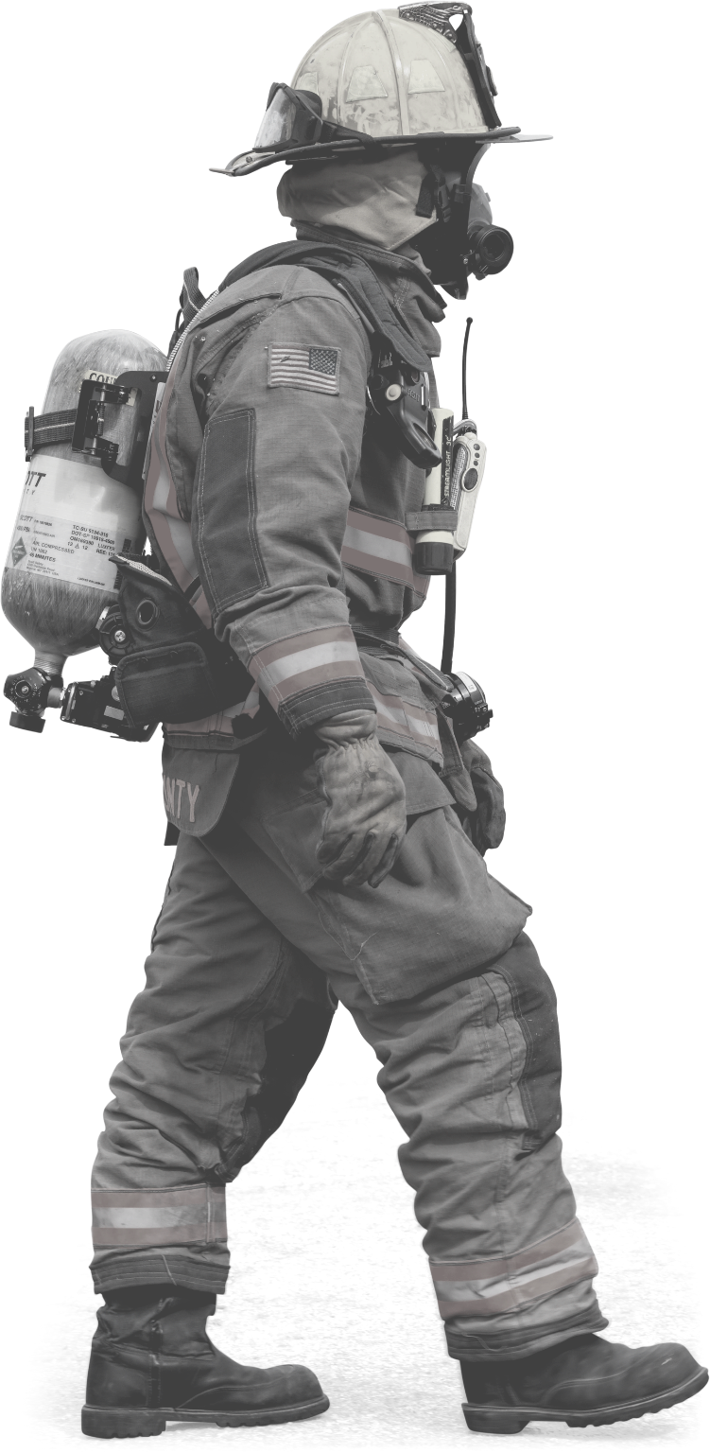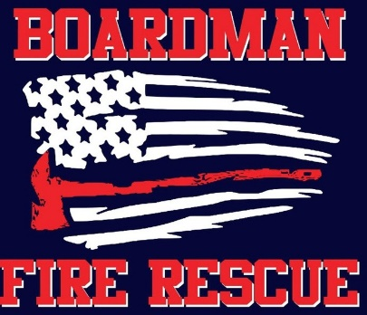

**P R O P O S E D B A L L O T M E A S U R E # 2 5 - 8 4**

**2020**

**General Obligation Bond**

**The Fire District covers 330 square miles from Gilliam County line to Umatilla County line.**

**The current fire station on SW Wilson Lane was designed to serve a community of 1,500 residents in the 1970s.**

**The Fire District now serves 7,000 residents and several hundred daily commuters to local job sites.**

**In 1998, the District responded to 98 calls. As of August 2020, call volume has tripled to 300 calls annually.**

**The current station was built prior to the establishment of the two elementary schools on SW Wilson Lane (Sam Boardman and Windy River). School activities have increased traffic during school days and school events.**

**The current building, forty years old, was remodeled in 1999. The station has expanded to the boundaries of the current lot and the Fire District is assessing a growing district to plan for the next fifty years. The proposed building's entrance and exit would be away from two elementary schools. In addition, it would comply with ADA and other national guidelines, regulations, and standards.**

PLEASE VOTE

## If you have any questions or would like more information please contact:

**Boardman Rural Fire Protection District**

## 300 SW Wilson Lane Boardman, OR 97818 Mike Hughes - Fire Chief

[**mhughes@boardmanfd.com**](mailto:mhughes@boardmanfd.com) **(541) 481-3473**

**Board of Directors: Loren Dieter**

**David Boor Ken Browne**

**Steve Myren Don Russell**

# OBJECTIVES OF PROPOSED BALLOT MEASURE #25-84

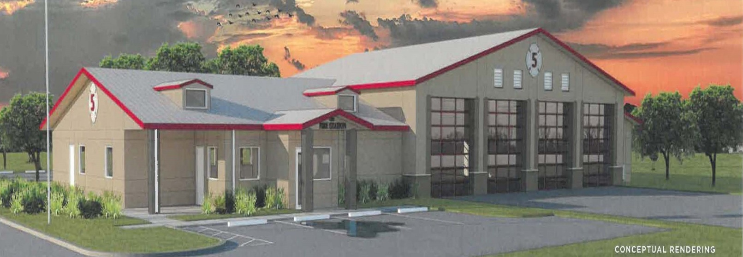

**Proposed one-level 15,000 sq. ft. Fire Station; vicinity of Willow Fork and Tatone**

Staff the station 24-hours, 7 days a week.

If proposed measure passes, it would fund a multi- use facility designed to accommodate fire and emergency medical services, as well as an emergency operations center. This would include a community meeting room for conferences, fire district training, and fire district board meetings. The proposed station could host state and national training.

If proposed measure passes, it would fund the replacement of six emergency vehicles, which have reached the end of their service lives, with four modern emergency vehicles that fit the District’s needs and response model.

If proposed measure passes, the project would include a 15,000 sq ft station with land (Willow Fork & Tatone), updated equipment, and include emergency vehicles.

If the proposed measure does not pass, the proposed station would not be constructed, the emergency vehicles would not be purchased and the tax rate would not change.

# PROPOSED BALLOT MEASURE #25-84 QUICK FACTS

If passed, the average annual tax rate for this proposed measure is estimated to be $0.24 per $1,000 of assessed value. On a $300,000 home, this would equal $72 annually. Total $8.475 million. This is an estimate based on available information at the time of publication.

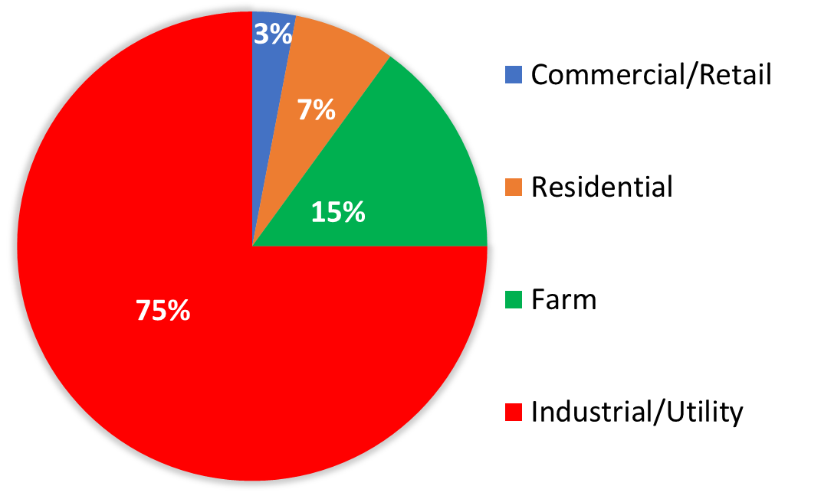

If passed, the majority of the proposed ballot measure would be paid for by the industries in the Port of Morrow. Industries and businesses with a tax exemption would pay the rate on this bond measure.

A general obligation bond is a fixed rate over the life of the bond. Proposed Ballot Measure #25-84, if passed, would authorize a 20-year bond.

# FREQUENTLY ASKED QUESTIONS AND ANSWERS

### WHY IS THE FIRE DISTRICT REFERRING THE PROPOSED BALLOT MEASURE?

To serve the Boardman Rural Fire District of 7,000 residents, the proposed building would include, if the measure passes:

4 new proposed emergency vehicle bays 24/7 sleeping quarters

ADA compliance Seismic standards

### CAN THE CURRENT STATION BE REMODELED/ EXPANDED?

Current location is at 100% buildup. Proposed location is near Boardman City Hall with easy access to serve the growing fire district area.

### IS THE STATION ON SW WILSON LANE 24 -HOURS?

Prior to August 1, 2020, calls after 5:00 pm were responded to by our on-call, full-time firefighters and volunteers that report to the station from their homes. On August 1st, we started staffing the station 24/7. We currently use a temporary dorm trailer for sleeping quarters, working a 48hr on/ 96hr off shift.