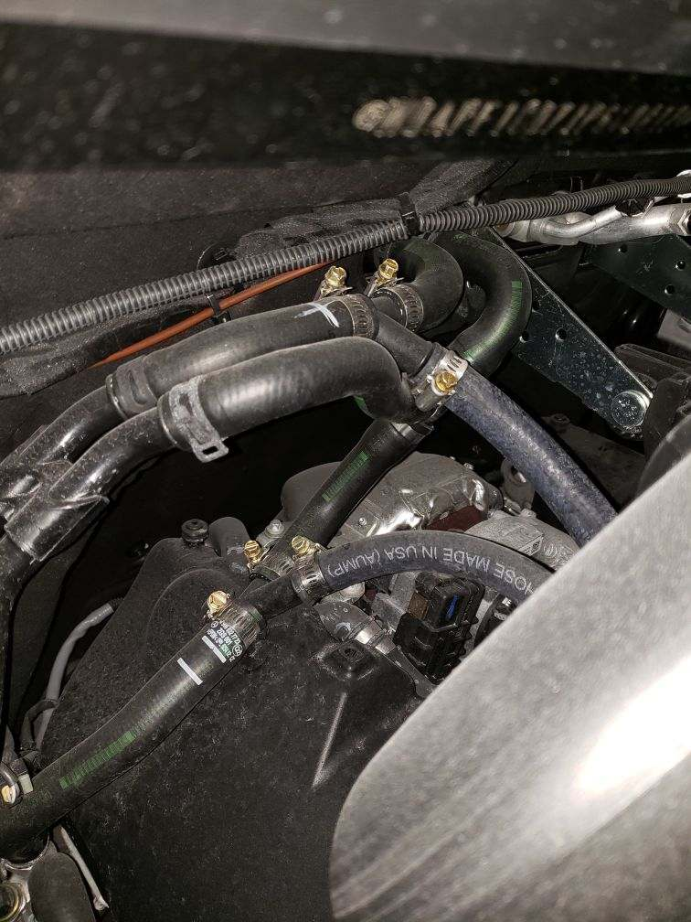

Push Line to Rear Heater.

Water Valve and Pump on this line.

Return Line from Heater