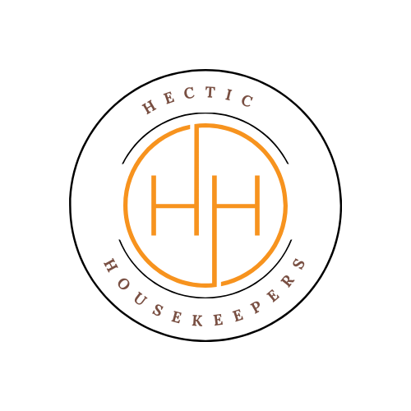
Hectic Housekeepers

Key, Code, Alarm & Key Safe Access Agreement
This Agreement applies where the Client provides Hectic Housekeepers with keys, key safes, entry codes, alarm codes, or any other access details to their property.
1. Client Details
Client Name: _________________________________
Property Address: ____________________________
Contact Number: _____________________________
Email Address: ______________________________
2. Access Details Provided (tick all that apply)
☐ Physical key(s)
☐ Key safe (location): ________________________
☐ Door / entry code
☐ Alarm code
☐ Other access method (please specify): ______________________________
3. Client Responsibilities
By signing this agreement, the Client confirms and agrees that:
All access details provided are accurate and up to date.
Any alarm system will be disarmed prior to our arrival or clear written instructions have been provided.
Hectic Housekeepers is authorised to use the provided access details solely for the purpose of carrying out cleaning services.
The Client will notify Hectic Housekeepers immediately of any changes to keys, codes, or alarm systems.
4. Security & Use of Access Details
4.1 Keys, codes, and alarm details will be handled with reasonable care and used only for agreed service visits.
4.2 Access details will not be shared with third parties, except where required for operational reasons within Hectic Housekeepers.
4.3 The Client acknowledges that alarm systems and access technology may fail or malfunction and accepts this risk.
5. Loss, Damage & Liability
Hectic Housekeepers will only be responsible for the replacement cost of keys if they are lost due to our proven negligence.
Liability for lost keys is limited to £15 per location.
Hectic Housekeepers is not liable for damage, loss, or costs arising from:
- Faulty locks, key safes, or alarm systems
- Incorrect codes supplied by the Client
- Lockouts, call-out fees, or security company charges
6. Key Return & Termination
Keys will be returned upon termination of services unless otherwise agreed.
The Client is responsible for changing any access codes or alarm codes once services end.
7. Indemnity
The Client agrees to indemnify and hold harmless Hectic Housekeepers against any claims, losses, or costs arising from the use of keys, codes, or access details provided by the Client, except where caused by proven negligence.
8. Governing Law
This Agreement is governed by the laws of England and Wales.
9. Client Declaration & Signature
I confirm that I have read, understood, and agree to the terms of this Key, Code & Alarm Access Agreement.
Client Name (print): ___________________________
Client Signature: _____________________________
Date: _______________________________________
Once signed please return a copy to Hecic Housekeepers

Hectic Housekeepers
Email: hectichousekeepers@gmail.com

