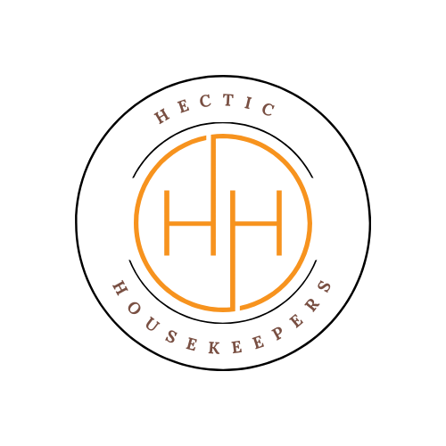
Hectic Housekeepers

Terms and Conditions for Domestic Cleaning Services
1. Introduction
These Terms and Conditions apply to all domestic cleaning services provided by Hectic Housekeepers ("we", "us", "our"). By booking our services via phone, text, WhatsApp, email, or social media, you agree to these Terms.
2. Services
We provide domestic cleaning services including general household cleaning of kitchens, bathrooms, floors, and living areas, as agreed at the time of booking. Services are domestic only unless confirmed in writing.3. Booking, Payment & Cancellations
- A booking is confirmed once service details are agreed and these Terms are accepted.
- Regular clients: Payment is due by the 27th of each month.
- New clients: Payment is required upon completion of each clean for the first four visits, unless agreed otherwise.
- Payments are accepted by bank transfer or cash.
- Late payments incur a fee of £5 per day from the 28th until paid.
- Any long term holidays for longer than 3 weeks will require a holding fee of £10.75 per cleaning day until the clean is reinstated.
Cancellations:
- At least 48 hours’ notice is required.
- Less than 48 hours’ notice will be charged at 100% of the booked fee.

4. Access to Property
Clients must provide safe and timely access to the property. If the Client is not present, keys or access details must be supplied in advance. A Key Holder Agreement will apply where keys or alarm codes are provided.5. Responsibilities
We will:
- Carry out cleaning services with reasonable care and skill.
- Use our own insured cleaning products and equipment.
- Inform the Client of any damage caused during cleaning.
If the Client requests use of their own products, a Product Liability Agreement must be signed.
The Client must:
- Ensure access to the property at the agreed time.
- Secure or remove fragile, valuable, or sentimental items.
- Inform us of specialist surfaces, allergies, or special requirements.

6. Damage & Liability
- We are not responsible for damage to fragile or valuable items unless caused by proven negligence.
- We are not liable for pre-existing damage, wear and tear, hidden defects, old stains, or unsealed/specialist surfaces unless advised in advance.
- We do not attempt stain removal from carpets, flooring, or furniture.
- If the cleaner cannot work due to lack of access, electricity, hot water, or working equipment, the full booking fee remains payable.
- We are not liable for issues caused by third parties present during the clean or by faulty equipment supplied by the Client.
- Claims will not be considered where invoices are 14 days or more overdue.
7. Health & Safety
We comply with all relevant health and safety legislation. We are COSHH trained and operate with full RAMS and health and safety policies. Clients must inform us of any allergies or health concerns in advance.8. Complaints
Any issues must be reported within 24 hours of the clean in writing to hectichousekeepers@gmail.com. We aim to resolve complaints within 5 working days.9. Termination
Either party may terminate services at any time with written notice. Any outstanding charges remain payable.10. Claims & Repairs
- Items not put away and known to be valuable or sentimental are cleaned at the Client’s own risk.
- Where damage is proven to be caused by us, we will repair or replace the item at our discretion.
- If repair is not possible, compensation is limited to the item’s current market value, and proof of value may be required.
- We are not responsible for damage caused by faulty installation, worn items, or incorrect surface information.
- Key replacement costs are covered only if lost by our operatives, with a liability limit of £15 per location.
11. Supplementary Terms
- Photo Consent: Discreet photos may be taken for marketing purposes. Clients may opt out at any time.
- No-Touch Policy: Cleaners will not handle money or loose change.
- Key Collection Fees: £10 for key collection outside the serviced postcode, plus £5 for return if required.
- If a cleaner is unavailable, an alternative date/time will be offered.
- All fragile items must be secured prior to cleaning.
- As a family-run business, emergency early departures may occur. In such cases, clients will be charged only for time spent on site.
12. Privacy & Governing Law
- Personal data is handled in accordance with the Data Protection Act 2018 and UK GDPR and retained for up to 6 years after services end.
- These Terms are governed by the laws of England and Wales and comply with the Consumer Rights Act 2015.

