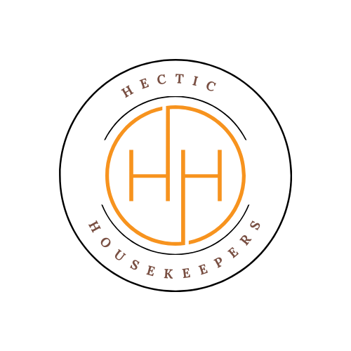
Hectic Housekeepers

Client Product Liability Agreement

This form applies where the Client requests Hectic Housekeepers to use cleaning products or equipment supplied by the Client.

Client Details
Client Name: ________________________________
Property Address: ___________________________
Contact Number: ____________________________
Email Address: ______________________________
Date : ___________________________

Client Declaration – Please tick all boxes
☐ I have requested that Hectic Housekeepers use cleaning products and/or equipment supplied by me.
☐ I understand that these products are not supplied, tested, or insured by Hectic Housekeepers.
☐ I accept full responsibility for any damage to surfaces, furnishings, flooring, fixtures, or fittings caused by the use of my products.
☐ I accept responsibility for any allergic reactions, sensitivities, or health-related issues arising from the use of my products.
☐ I confirm that all products supplied are clearly labelled, suitable for domestic use, and not expired.
☐ I agree that Hectic Housekeepers will not be held liable for any damage, loss, or injury caused wholly or partly by my supplied products or equipment.
☐ I understand that Hectic Housekeepers reserves the right to refuse to use any product deemed unsafe, unsuitable, or inappropriate.
☐ I agree to indemnify and hold harmless Hectic Housekeepers against any claims arising from the use of my products or equipment.

Limitation of Liability
I acknowledge that any instructions I give regarding my products are followed entirely at my own risk, and that Hectic Housekeepers are not responsible for indirect, hidden, or delayed damage that may become apparent after the cleaning service.
Governing Law
This Agreement is governed by the laws of England and Wales.
Client Signature
By signing below, I confirm that I have read, understood, and agree to all of the above terms.
Client Name (print): _________________________
Client Signature: ___________________________
Date: _____________________________________
Once completed please return to Hectic Housekeepers.

Hectic Housekeepers
Email: hectichousekeepers@gmail.com

