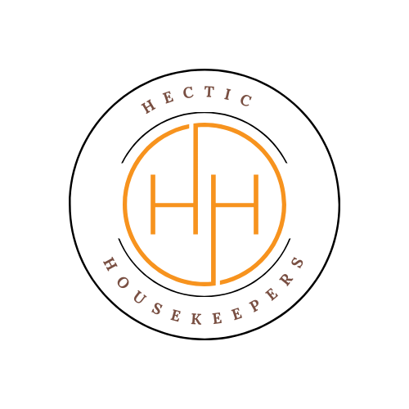
Upholstery Cleaning Aftercare Guide
Hectic Housekeepers
Thank you for choosing Hectic Housekeepers for your upholstery cleaning service. To help you maintain your freshly cleaned furniture and achieve the best results, please follow the guidance below.

Immediate Aftercare (First 24–48 Hours)
- Avoid using the furniture until it is fully dry.
- Keep children and pets off damp upholstery.
- If necessary, sit only on fully dry areas and use clean clothing.

Drying Your Upholstery
- Allow natural airflow by opening windows and doors.
- Use fans or heating to help speed up drying if needed.
- Drying times typically range from 4 to 24 hours, but may vary depending on fabric type and ventilation.

Cushion Care
- Remove and stand cushions upright where possible to allow even drying.
- Turn cushions periodically to help prevent moisture build-up.
- Ensure cushions are completely dry before placing them back.

Avoiding Marks & Damage
- Do not place items (such as throws, cushions, or covers) on damp upholstery.
- Avoid placing newspapers, coloured fabrics, or anything that may transfer dye onto damp material.
- Keep sharp or heavy objects away from damp fabric.

Dealing with Spots & Spills
- Act quickly if spills occur.
- Blot gently with a clean, dry cloth—do not rub.
- Use a mild upholstery cleaner if needed and always test on a hidden area first.

Odours
- A slight damp smell may occur while drying—this is normal and will fade.
- Keep the area well ventilated to help remove any temporary odours.

Ongoing Maintenance Tips
- Vacuum upholstery regularly using a suitable attachment.
- Rotate and plump cushions to maintain shape and even wear.
- Avoid eating or drinking on furniture where possible.
- Schedule professional upholstery cleaning every 6–12 months depending on use.

Important Notes
- Some stains may reappear (wick back) during drying. If this occurs, please contact us within 24 hours.
- Results may vary depending on fabric condition, age, and previous wear or damage.

Need Help?
If you have any questions or concerns after your clean, please contact us:
Hectic Housekeepers
Email: hectichousekeepers@gmail.com
Phone: 07456453195

Thank you for choosing Hectic Housekeepers!
We appreciate your business and look forward to serving you again.

