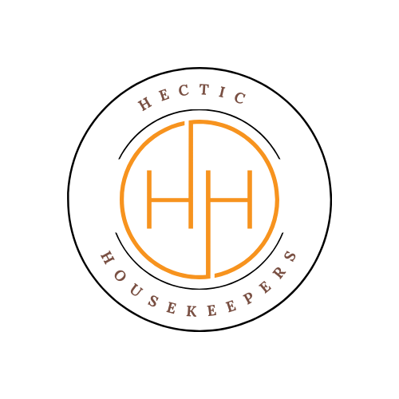
Carpet Cleaning Aftercare Guide
Hectic Housekeepers
Thank you for choosing Hectic Housekeepers for your carpet cleaning service. To help you get the best results and maintain your freshly cleaned carpets, please follow the aftercare advice below.

Immediate Aftercare (First 24–48 Hours)
- Avoid walking on damp carpets as much as possible.
- If you must walk on them, wear clean socks or use protective shoe covers.
- Keep children and pets off the carpet until fully dry.

Drying Your Carpets
- Open windows and doors to improve airflow.
- Use fans or heating to speed up the drying process if needed.
- Drying times typically range from 4 to 24 hours, but may take longer depending on ventilation and carpet thickness.

Furniture Placement
- Do not place furniture back onto the carpet until it is completely dry.
- When replacing furniture, use protective pads (e.g., foil, plastic tabs, or blocks) under legs to prevent staining or damage. We can supply these to you.
- Avoid dragging furniture across damp carpets.

Vacuuming
- Wait until the carpet is fully dry before vacuuming.
- Regular vacuuming (2–3 times per week) will help maintain the cleanliness and appearance of your carpet.

Dealing with Spots & Spills
- Attend to spills immediately to prevent staining.
- Blot (do not rub) with a clean, dry cloth or paper towel.
- Use a mild carpet cleaner if necessary, and always test on an inconspicuous area first.

Odours
- A slight damp smell may be noticeable while carpets are drying—this is normal and will disappear once fully dry.
- Ensure good ventilation to help eliminate any temporary odours.

Ongoing Maintenance Tips
- Use door mats to reduce dirt being brought into your home.
- Remove shoes indoors where possible.
- Schedule professional carpet cleaning every 6–12 months depending on usage.

Important Notes
- Some stains may reappear (wick back) as the carpet dries. If this happens, please contact us within 24 hours.
- Results may vary depending on carpet condition, age, and prior damage.

Need Help?
If you have any questions or concerns after your clean, please contact us:
Hectic Housekeepers
Email: hectichousekeepers@gmail.com
Phone: 07456453195

Thank you for choosing Hectic Housekeepers!
We appreciate your business and look forward to serving you again.

