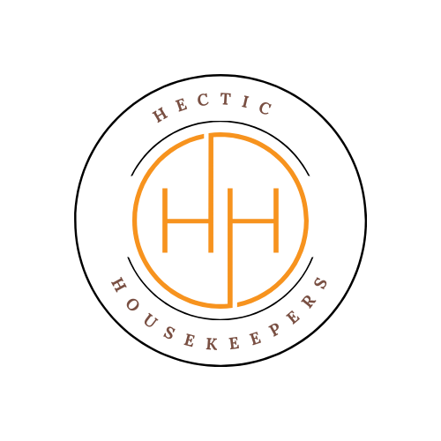
Hectic Housekeepers

Terms and Conditions for Holiday Let & Short‑Term Rental Cleaning Service1. Introduction
These Terms and Conditions apply to all holiday let, Airbnb, short‑term rental, and changeover cleaning services provided by Hectic Housekeepers ("we", "us", "our"). By booking our services, the client ("you", "the Client") agrees to these Terms.
2. Services Provided
2.1 We provide cleaning services for holiday lets and short‑term rental properties, including changeover cleans, deep cleans, and refresh cleans as agreed at the time of booking.
2.2 Services may include cleaning bathrooms, kitchens, floors, bedrooms, living areas, and internal bins. Linen changes, laundry, restocking, or additional tasks are not included unless agreed in advance and may incur additional charges.
2.3 Our service is based on the property being left in a reasonably tidy condition. Excessive mess, party waste, bodily fluids, or damage may result in additional charges or refusal of service.
3. Bookings, Payment & Cancellations
3.1 Bookings are confirmed once service details are agreed and these Terms are accepted.
3.2 Payment Terms:
- Payment is due by the 27th of each month, unless otherwise agreed in writing.
- New clients may be required to pay upon completion of each clean for an initial period.
3.3 Payments are accepted via bank transfer or cash.
3.4 Late Payments: Any payment not received by the due date will incur a late fee of £5 per day until paid in full.
3.5 Cancellations:
- At least 48 hours’ notice is required to cancel a booked clean.
- Cancellations with less than 48 hours’ notice will be charged 100% of the booked fee.
4. Access & Check‑Out Times
4.1 The Client is responsible for ensuring the property is fully vacated and accessible at the agreed time.
4.2 If cleaners are unable to start due to guests overstaying, lack of access, or delayed key handover, waiting time or full charges may apply.
4.3 Where keys, codes, or lockboxes are provided, a Key Holder Agreement may apply.

5. Standards & Time‑Sensitive Cleans
5.1 Holiday let cleans are often time‑critical. We are not responsible for delays caused by late guest departures, access issues, or utilities not being available.
5.2 If a clean cannot be completed due to time restrictions beyond our control, the Client remains liable for the full booking fee.
6. Responsibilities of Hectic Housekeepers
We will:
- Carry out cleaning services with reasonable care and professional skill.
- Use our own insured cleaning products and equipment.
- Report any visible damage, missing items, or excessive mess to the Client where possible.
7. Responsibilities of the Client
The Client agrees to:
- Provide accurate booking information, including property size and guest numbers.
- Inform us of short turnarounds, same‑day check‑ins, or priority deadlines.
- Ensure utilities (electricity, hot water) are available.
- Remove or secure fragile, valuable, or sentimental items.
8. Damage, Liability & Existing Conditions
8.1 We are not responsible for:
- Pre‑existing damage, wear and tear, or hidden defects
- Old stains, burns, limescale, mould, or ingrained dirt
- Damage caused by faulty fixtures, fittings, or appliances
8.2 We do not provide stain removal from carpets, upholstery, or soft furnishings.
8.3 We are not liable for damage unless caused by proven negligence.
8.4 We are not responsible for guest damage or losses discovered during cleaning.
8.5 Claims will not be considered where invoices are 14 days or more overdue.
9. Health & Safety
9.1 We comply with all applicable health and safety legislation.
9.2 We are COSHH trained and operate with full Risk Assessments and Method Statements (RAMS).
9.3 The Client must inform us of any known hazards, infestations, or biohazards before attendance.

10. Complaints
10.1 Any issues must be reported within 24 hours of the clean, in writing, to hectichousekeepers@gmail.com.
10.2 We will make reasonable efforts to resolve valid complaints within 5 working days.
11. Termination
11.1 Either party may terminate services with written notice.
11.2 Outstanding payments for services already provided remain payable.
12. Privacy & Data Protection
Client data is handled in accordance with the Data Protection Act 2018 and UK GDPR and retained for up to 6 years after services end.
13. Governing Law
These Terms are governed by the laws of England and Wales and comply with the Consumer Rights Act 2015.

