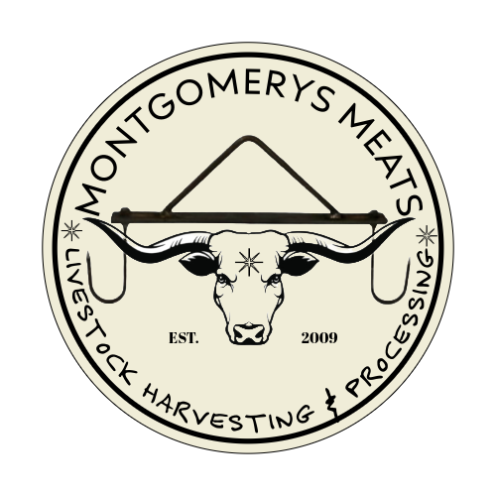

Mission

MONTGOMERYS MEATS is committed to working with small-scale, local meat producers who direct market meats. We work with over 1000+ small, independent farmers and companies between California and Oregon who produce and market natural and local meat. At Montgomery’s meats we understand the importance of attention to detail when it comes to handling your product. We believe that through effective communication and mutual trust, we can serve the needs of your growing meat business.

**Services Offered**

Montgomery’s Meats offers USDA inspected beef slaughter and Custom Exempt inspected slaughter for beef, pork, and lamb. Full fabrication, custom cutting and packaging in Roll Stock vacuum sealed packages for beef, pork, lamb, goat, and bison.

**Communicating with Us**

Any USDA Slaughter or processing needs must be communicated with Shawna or Eric Montgomery 530.905.2851 future scheduling is recommended and deposits may be required.

**Payment**

Payment for services is expected at pickup. Payment options include cash, personal or business check, Visa, Mastercard or Discover cards. We can also send a QuickBooks invoice. For your convenience, we are able to accept credit card payments over the telephone. A 3% charge will be assessed for credit card payments. Customers with returned checks will be charged $45. If scheduling future slaughter dates a deposit may be required. When your product is finished, we will call you and let you know. Your finished product must be picked up within 7 business days of notification that it is ready. Please understand that our facility has limited cold storage which is very expensive to run. Products left in our facility past 7 business days after notification may incur a storage fee.

**Scheduling**

Please do not bring animals for slaughter without prior scheduling. To schedule slaughter services please call 530.905.2851. Once a date is scheduled and all paperwork is received an address to the slaughter site and directions will be provided.

**FEES (Subject to change at any time)**

**USDA Kill including all disposal (liquid and solid)**

Kill Prices based on hot carcass hanging weight.

* Beef Slaughter $250
* Beef over 1000+ pounds hanging weight may occur an additional fee

**USDA Cut and Wrap**

* **$1.40/lb**. for USDA seal, apply generic label (black and white), bagged **not boxed**
* **$1.60/lb.** for USDA seal, apply custom label (black and white), **boxed**

We offer packaging in large heavy cardboard boxes with handles. These boxes hold 40-45# per box. The additional .20 cents a lb. cost difference quoted above covers the cost of these boxes. If you do not choose to use our boxes, the product will be bagged in clear plastic bags. If special boxing is requested prices may change.

* **$ 1.65/ lb.** for USDA seal, apply custom label **(Colored)** and **boxed**
* **USDA Further Processed Items**
* Ground Beef Patties: $1.00/lb. for 40# Minimum.
* Carne Asada Sliced .50/lb.

USDA grading services available upon request please inquire for costs.

**LABELS**

**Plant Generic**

Use of our in-house plant generic label is included with your packaging. The label will read “Montgomery’s Meats” at the top and show the plant’s address.

**Logo Branded**

Most Farmers, Meat Handlers prefer to use their logo/ farm name on our generic label to help differentiate their branded product in the marketplace and provide the consumer with contact information. There is a one-time fee of $100 to set up your logo and contact information on our label.

**Custom Color**

Some farmers prefer a custom designed, full color label. These labels must be designed. Custom colored labels additional cost difference referenced above is .05/lb. for ink and toner. If your color logo requires a special glossy label an additional charge may occur if special labels need to be ordered on your behalf.

**Special Labeling Claims**

Some farmers wish to use “Special Labeling Claims” such as “grass-fed”, “pasture-raised”, “no added hormones or antibiotics”, etc. These claims must be approved by USDA/FSIS Labeling Division . Montgomery’s Meats offers this application service at a charge of $200 per application. We can help you with this process! This process also takes time so please let us know well in advance.

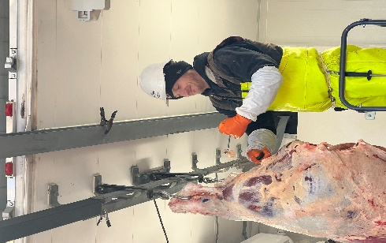

(These 3 pages along with your brand inspection are required prior to slaughter day.)

Business Name: _______________________________

Customer Name: ______________________________

Address: ____________________________________

Phone Number: _______________________________

E-Mail: _____________________________________

Description of Animal: (Brand Inspections are required and must be presented before slaughter date.)

|  |  |  |  |  |  |
| --- | --- | --- | --- | --- | --- |
| SEX | BRAND | BRAND LOCATION | BREED OR COLOR Please indicate if horned | EARTAG | AGE |
|  |  |  |  |  |  |
|  |  |  |  |  |  |
|  |  |  |  |  |  |
|  |  |  |  |  |  |
|  |  |  |  |  |  |

*We do not except down cattle if cattle become non ambulatory in the process it will be euthanized per USDA/FSIS guidelines. If an animal is deemed suspect by USDA/FSIS there is a possibility that your animal or parts may be retained or possibly euthanized. Slaughter services may still be assessed.

**ARE ANY OF YOUR ANIMALS OVER 30+ MONTHS? YES OR NO**

(Birth records are helpful and may be required by brand inspector) if you do not have birth record for your cattle, please sign below that you are providing an owner’s statement of cattle’s age listed above.

I certify that I am providing an owner’s statement of the age of the cattle listed above. Signature: __________________Date: ______

**Are your animals horned? YES OR NO**

**DO YOU HAVE ANY SPECIAL CLAIMS REGARDING YOUR ANIMALS? YES OR NO**

Some farmers wish to use “Special Labeling Claims” such as “grass-fed”, “pasture-raised”, “no added hormones or antibiotics”, etc. These claims must be approved by USDA/FSIS. Please attach supporting documentation. If you have special claims regarding feed, you will be required to provide feed at drop off.

Please indicate if you have any special information or specific handling requirements regarding your animals. _____________________  
______________________________________________  
___________________________________________________________________________________________________________________________________________________

Please check one of the following boxes

I am the legal owner of this animal and agree to the terms

I have been authorized by the legal owner of this animal to sign on their behalf and agree to the terms.

_______________________________________________ _______________________

Signature of Owner or Authorized Representative Date:

Release of Liability

RELEASE. THEREFORE under the terms of this Agreement and sufficiency of which is hereby acknowledged, do hereby release and forever discharge the Releasee including their agents, employees, successors and assigns, and their respective heirs, personal representatives, affiliates, successors and assigns, and any and all persons, firms or corporations liable or who might be claimed to be liable, whether or not herein named, none of whom admit any liability to the undersigned, but all expressly denying liability, from any and all claims, demands, damages, actions, causes of action or suits of any kind or nature whatsoever, which now have or may hereafter have, arising out of or in any way relating to any and all injuries and damages of any and every kind, to both person and property, and also any and all injuries and damages that may develop in the future, as a result of or in any way relating to the liability. It is understood and agreed that this Release is made and received in full and complete settlement and satisfaction the causes of action, claims and demands mentioned herein; that this Release contains the entire agreement between the Releasor and Releasee; and that the terms of this Release are contractual and not merely a recital. This Release shall be binding upon the undersigned, and his respective heirs, executors, administrators, personal representatives, successors, and assigns.