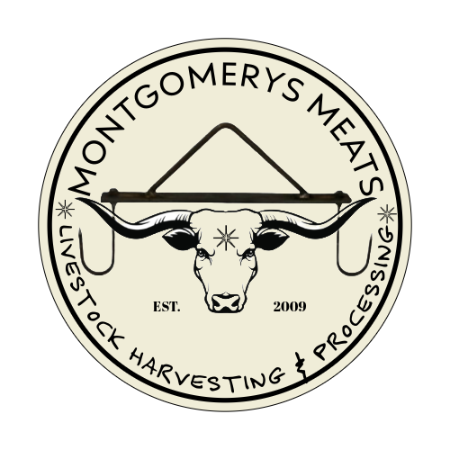

**2025 Wild Game Pricing**

**\*$150.00 Per Deer * ELK & BEAR $1.40 /LB.**

**Name:_____________________________** **Cutting Instructions: PICK ONLY ONE PER**

**Phone:___________________**  Shoulders: Steaks /Roasts /Stew / Grind

**D/L # & State________________** Backstrap: Chops /Roasts / Stew/ Grind

**Hunting License #____________** Legs: Steaks/ Roasts/ Stew/ Grind

**Species:____________________** Tenderloins: Whole/ Stew/ Grind

**Zone Killed:_________________** From Grind – Burger / Sausage (Country or Italian) Special Instructions: __________________________________________________________________________________________________________________________________________________________________________

**FURTHER PROCESSING**

CHOOSE 1 ITEM PER GAME ORDER: JERKY $8/LB SUMMER SAUSAGE $6/LB STICKS *$7/LB

(**ADD 1$ PER LB FOR JALAPENO & CHEESE SUMMER SAUSAGE OR STICKS)

(10# LB. MINIMUM) INDICATE AMOUNT OF LBS: MINIMUM 10# OR SPECIFIC AMOUNT_______#

FLAVOR CHOOSE ONE: PEPPERED PEPPERONI TERIYAKI JALAPENO *JALAPENO CHEESE

MISC PRICES

ADD BEEF FAT $ 1.00/LB. ADD PORK FAT $ 1.00/LB.

**EMPLOYEE SIGNATURE:____________________________________________________ DATE:______________________**

**CUSTOMER SIGNATURE : ___________________________________________________ DATE:______________________**