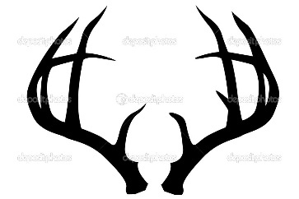

2022 Pricing
$125.00 per Deer if over 100# $1.25 /lb.* -ELK $1.25 /LB. * BEAR$ 125.00 IF OVER 100# $1.25/LB
MONTGOMERYS MEAT CO.
WILD GAME PROCESSING 2022
Name:____________________ Cutting Instructions:
Phone:____________________ Shoulders: Steaks /Roasts /Stew / Grind
D/L # & State________________ Backstrap: Chops /Roasts / Stew/ Grind
Hunting License #____________ Legs: Steaks/ Roasts/ Stew/ Grind
Species:____________________ Tenderloins: Whole/ Stew/ Grind
Zone Killed:_________________ From Grind – Burger / Sausage (Country or Italian)
Jerky Meat Yes or No NOT COOKED
Special Instructions: Package Sizes, Steak Thickness ect…. _______________________________________________________________________________________________________________________________________________________________________________________________________________________________________________________________
Game further processing #_________ (JERKY 10 # MINIMUM ON EACH FLAVOR- STICK OR SUMMER SAUSAGE 15# MINIMUM EACH FLAVOR!!)
Jerky- $ 6.00 /lb. Mild Teriyaki Hot Teriyaki Jalapeno
Sticks-$ 4.00/lb. PEPPER PEPPERONI TERIYAKI
Sticks-$ 5.50/lb JALAPENO HONEY PEPPER JALAPENO JALAPENO + CHEESE +.50
Summer Sausage $ 3.50 /LB REGULAR TERIYAKI JALAPENO JALAPENO +CHEESE +.50
ADD CHEESE TO ANY STICKS OR SS IS + .50/LB.***
MISC PRICES
ADD BEEF TO GRIND $4.00/LB. ADD BEEF FAT $ 1.00/LB.
ADD PORK TO GRIND $ 2.25/LB. ADD PORK FAT $ 1.00/LB.
SMOKE ANY PRIMALS (EXAMPLE: BEAR HAMS $ 25.00 EA)

