FAFP 2026
Annual Education Conference



Crystal River, Fl

May 19-21

The Plantation at Crystal River

President’s Welcome Letter

Fellow FAFP Members and Friends,

Welcome to the 81st Annual Education Conference (AEC) of the Florida Association for Food Protection! We’re excited to gather in beautiful Crystal River this May 19–21—where the water is clear, the manatees are friendly, and the conversations about food safety are even better.
This year, we’re proud to bring together an outstanding lineup of speakers from academia, industry, and regulatory agencies. Over the next two days, you’ll hear insights on current research, emerging challenges, and practical applications that help strengthen food safety systems across all sectors. Whether you’re here to learn something new, validate what you already know, or just finally understand that one regulation you’ve been side-eyeing, there’s something here for you.
A key part of the FAFP mission is supporting the future of our profession. Be sure to spend time with our student presenters and explore the research posters—they represent the next generation of food safety leaders, and they’ve brought some impressive work to share.
Of course, no conference would be complete without opportunities to connect outside the meeting room. We’ve planned several networking and social events where you can catch up with colleagues, make new connections, and maybe even debate the finer points of food safety over a good meal. These moments are just as valuable as the sessions (and often a bit more fun).
We also encourage you to visit our sponsors and exhibitors throughout the conference. Their support makes this event possible and helps advance the mission of FAFP.
On behalf of the Board and organizing team, thank you for being here and for your continued support of FAFP. Your commitment to food safety and to this community is what makes this conference so special.
We’re glad you’re here—now let’s make it a great few days together!

Warm regards,

Kelly Smekens

2026 FAFP President

Conference Agenda

FAFP AEC 2026
Tuesday, May 19th
1:30 pm – 3:30 pm | Volunteer Event− Ellie Schiller Homosassa Springs Wildlife State Park
3:30 pm – 6:00 pm | Registration
2:00 pm – 6:00 pm | Exhibitor Set-Up
6:30 pm – 8:00 pm | President’s Reception – Sunset Boat Cruise
Wednesday, May 20th
8:00 am – 5:00 pm | Exhibitor Area Open
8:15 am | President’s Welcome and Opening Comments
Morning Session Moderator: Kristina Schoen, Coastal Ag
8:25 am | KEYNOTE SPEAKER: Mind Your Melon: A Proactive Approach to Resilience – Marshal & Taylor Sewell
9:10 am | Food Traceability Rule – State of the Industry – Michael Roberson, Publix Super Markets, Inc
9:55 am –10:40 am | Networking Break
10:45 am | Management Responsibility in Food Safety – Debby Newslow, DL Newslow & Associates
11:30 am | Student Rapid Presentations
12:00 pm –1:00 pm | Lunch (included) – enjoyed in Magnolia Ballroom
Afternoon Session Moderator: Gabriella Branco, Disney
1:05 pm | Touchless, Continuous Pathogen Control – Tyler Mattson, Synexsis
1:50 pm | Sponsor Rapid Presentations
2:35 pm | Challenge Yourself! Crisis & Recall Mitigation and IAFP Update – Wendy White, IAFP
3:30 pm – 3:55 pm | Networking Break
4:00 pm | Identifying Food Safety Risk Factors – Robin Eychaner, Florida Department of Health
4:45 pm | FAFP Awards
6:00 pm – 8:00 pm | Networking Event- Activities & Good Times, Enjoyed in the Magnolia Ballroom

Thursday, May 21st
8:00 am – 3:00 pm | Exhibitor Area Open
8:15 am | Welcome
Morning Session Moderator: Morgan Smith, Publix Super Markets, Inc
8:20 am | Frozen Desserts in Florida – Dr. Matt Curran, FDACS
9:05 am | What is an Audit? And what to expect? – Industry Panel
9:50 am –10:25 am | Networking Break
10:30 am | What’s Bugging You? – Glen Ramsey, Amazon
11:15 am | Prevalence and Survival of Escherichia coli During Onion Production and Postharvest Storage  Basics of Hydrophobic Coatings and Their Use in Agriculture – Dr. Keith Schneider, UF
12:00 pm – 1:00 pm | Lunch (included) – enjoyed in the Magnolia Ballroom
Afternoon Session Moderator: Dr. Stephanie Brown, UF
1:05 pm | AI for Agriculture: Universal Truths, Many Lies and the Reality! – Faaiz Khan, Highland Ag Solutions
1:50 pm | DBPR: Divisions of Hotels & Restaurants – Douglas Peterson, DBPR
2:35 pm | Closing Remarks, Silent Auction winners
3:30pm – 4:30pm | FAFP Business Meeting (Open to All)
CEUs are available for this conference. Please send request to executive.board@fafp.net if printable document is needed.

Board of Directors

Executive Board
Kelly Smekens, Chipotle Mexican Grill President
Kristina Schoen, Coastal Ag Supply President- Elect
Morgan Madison, Duda Farm Fresh Foods Vice President
Jamie Irwin, Whole Foods Markets Treasurer
Stephanie Brown, University of Florida Secretary
Taylor O’Bannon, University of Florida Past President

Directors
Vijay Chhetri, Florida A&M University
Gabriella Branco, Disney
Kenneth Jones
Billy Mitchell, University of Florida
Roy Briggs, Food Manager Testing, LLC
Clara Diekman, Taylor Farms
Boce Zhang, University of Florida
Morgan Smith, Publix Super Markets, Inc

IAFP Affiliate Representative
Morgan Madison, Duda Farm Fresh Foods

Students Representatives
LaTaunya Tillman, University of Florida
Sherry Bansal, University of Florida

Director at Large
Michelle Danyluk, University of Florida
Natalie Dyenson, Boar’s Head Brands
Joey Yoo, SSP America

2026 AEC Speakers

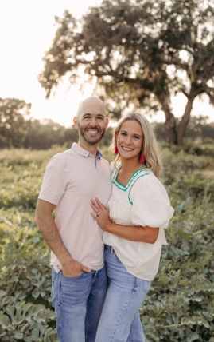
Marshal & Taylor Sewell – Mind Your Melon
What began as a local effort has grown into a broader movement. Through writing, workshops, speaking
engagements, and digital outreach, including social media and podcasting, the Mind Your Melon Foundation now reaches rural audiences across the country and beyond. At the heart of this work is a commitment to creating community and fostering resilience in agricultural spaces. The Foundation has a vision to cultivate a thriving agricultural community where farmers, ranchers, and agricultural families are empowered, resilient, and supported.

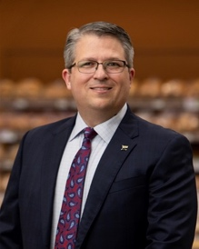
Michael Roberson - Publix Super Markets, Inc
Michael Roberson has been with Publix Super Markets, Inc since 2005. His team leads food safety, public health, brand integrity, quality assurance and compliance programs for the company. Under his leadership, Publix was recognized in 2013 by the International Association for Food Protection with the Black Pearl Award for Corporate Excellence in Food Safety and Quality. Publix went on to be recognized by the SQF Institute in 2015 as the SQF Food Processor and Distributor of the Year. Michael obtained a bachelor’s degree in microbiology from Mississippi State University and a master’s degree in food safety from the College of Veterinary Medicine at Michigan State University.

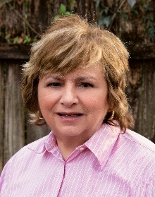
Debby Newslow – D.L. Newslow & Associates, Inc
Debby, President of D. L. Newslow & Associates, Inc. has over 40 years of experience in the food, chemical, and packaging industries. She has served and been a member of several food safety and quality organizations, currently being an active member of the Food Safety Tech Advisory Board. She is also a successful author of published articles and has authored two textbooks based on management systems. Her latest book, Food Safety Management Programs: Applications, Best Practices and Compliance has been identified as a best seller in the world of Food Safety and GFSI compliance guidance.

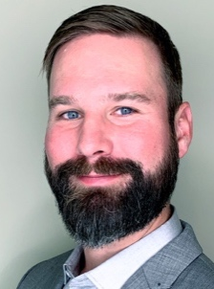
Tyler Mattson – Synexsis
Tyler Mattson is a food microbiology expert with more than 15 years of technical and business leadership experience in the food safety industry. He holds a master’s degree in food microbiology and safety and has a background in molecular and cellular biology. Throughout his career, Tyler has driven innovation across the food safety landscape, leading cross-functional initiatives that bridge science, operational risk management, and commercial strategy. At Synexis, Tyler works closely with food processing organizations to evaluate pathogen control strategies and integrate continuous microbial reduction technology into existing sanitation and environmental monitoring programs.

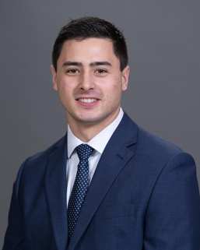
Cole Vaughan – Synexsis

Cole Vaughan is a food safety sales professional focused on advancing pathogen control strategies within complex production environments. With experience supporting large-scale food manufacturers, he specializes in implementing continuous microbial mitigation technologies from Synexis, LLC that address risks across air and surfaces. His work centers on helping organizations strengthen food safety programs, reduce contamination events, and improve operational outcomes through innovative, science-backed solutions.

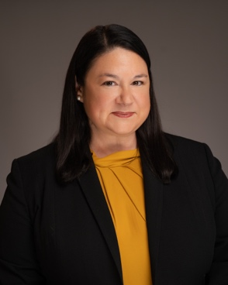
Wendy White – Georgia Institute of Technology, IAFP Past President and Current Executive Board Member
Wendy White is the Industry Manager for Food and Beverage at Georgia Tech’s Georgia Manufacturing Extension Program (GaMEP). She serves as the food safety expert to Georgia food businesses by providing educational outreach and help to improve food safety and quality systems. Before joining academia in 2019, Wendy spent the first 17 years of her career in manufacturing. Wendy received her BS in Biology at University of Georgia and stayed to complete her MS in Food Science. Over the years, she’s presented at industry conferences such as: IAFP, BRC Americas, and GFSI. She’s a prolific author for many well-known food safety publications and on the editorial board for Food Safety Magazine. Wendy is a Past President of the Georgia Association of Food Protection and is currently serving on the Executive Board of the International Association of Food Protection.

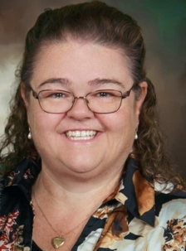
Robin Eychaner – Florida Department of Health
Robin Eychaner is the Food and Group Care Program Supervisor for the Florida Department of Health in Tallahassee and has 32 years of experience in Environmental Public Health. She specializes in food safety and institutional sanitation. She is passionate about food safety and can be reached at the email Robin.Eychaner@FLHealth.gov for inquiries.
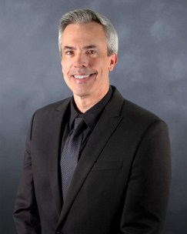
Dr. Matthew D. Curran – Florida Department of Agriculture and Consumer Services
Dr. Curran earned his Bachelor of Science in Chemistry from Mississippi State University and his Doctorate in Inorganic Chemistry from Florida State University. During his 28 years of public service, he has been fortunate to have had the opportunity to contribute in many roles protecting Florida’s environment as well as serving Florida’s industries and consumers. Early in his career Dr. Curran was appointed to multiple laboratory management positions with the Florida Department of Environmental Protection. He initially worked closely with the department's air program and later was heavily involved with many of the department's projects relating to surface and ground water quality issues, hazardous waste determinations, as well as laboratory investigations involving environmental crimes and perceived threat materials, such as anthrax.

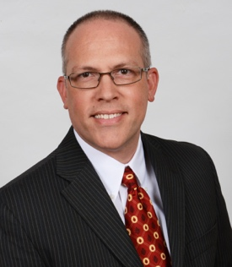
Glen Ramsey – Amazon
With more than 20 years of experience in entomology and pest management, Glen Ramsey is the Executive Leader of Retail Food Safety Pest Management for Whole Foods Market and Amazon. He previously served as the Director of the Rollins Entomology Department, assisting with technical requests, development and implementation of new products and procedures, and supporting ongoing education and training for service professionals in the Rollins family of brands across the country. A Board Certified Entomologist, Glen obtained his bachelor’s degree and master’s degree in entomology from the University of Georgia with a concentration in Integrated Pest Management for subterranean termites.

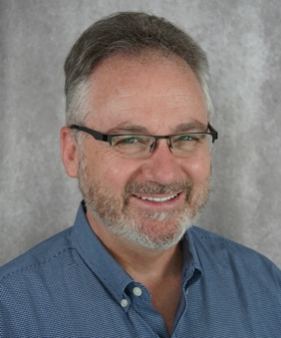
Dr. Keith Schneider – University of Florida
Keith R. Schneider is a Professor and Extension Specialist in the Food Science and Human Nutrition Department at the University of Florida. His research and extension work in food microbiology focuses on the production, harvest, packing, transportation, retail, and consumer handling of food products. In addition to his research and teaching duties, he is engaged in numerous extension outreach activities, generates educational materials, and conducts food safety training workshops. He received his master’s in public health from the University of South Florida and his PhD from the University of Florida’s Food Science and Human Nutrition Department.

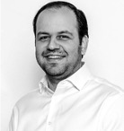
Faaiz Kahn – Highland Ag Solutions

With over 20 years in technology and innovation and several patents in electronic payments, digital data, machine learning, and human-computer interaction, Faaiz is new to agriculture but brings deep expertise. As CEO of Highland Ag Solutions, he is transforming the company into a vertically integrated, “Saas as a service” platform for growers, packers, marketers, and machinery. He founded Video Squirrel, a patented shoppable-video platform that has helped thousands raise funds through donations and ecommerce.

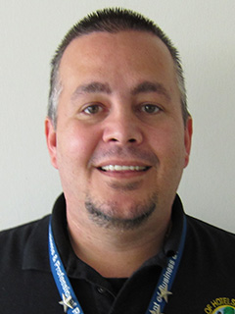
Douglas Peterson – Florida Department of Business & Professional Regulations
Douglas Peterson is a Training and Research Consultant and Federal Inspection Standardization Officer with the Florida Department of Business and Professional Regulation, Division of Hotels and Restaurants. He has 20 years of Regulatory Experience, in addition to 20 Years of Restaurant Industry experience. Douglas was a Moderator and guest speaker at the 2024 FDA Southwest Regional Food Safety Conference, sharing insights on Food Process, Risk-Based Inspections, and Standardization. In addition to speaking, Douglas is involved in the Standardization of Division Inspections Staff and Plan Review of Complex Vending Units, and in conducting ongoing demonstrations and training courses for hotels and restaurants, while demonstrating a commitment to protecting public health and safety.

2026 FAFP Student Presenters
Full abstracts available scan QR code:

Cody Scales
College of Agriculture and Food Sciences, Florida A&M University, Tallahassee, FL
Professor: Dr. Vijay Chhetri
“Effect of Plasma-Activated Water Treatment on Microbial Survival and Cilantro Growth in Deep Water Culture (DWC) Hydroponic Systems”

LaTaunya Tillman
Citrus Research and Education Center-Department of Food Science and Human Nutrition, University of Florida, Lake Alfred, FL
Professor: Dr. Michelle Danyluk
“Impact Of Real-Time Feedback on Cleaning and Sanitation Efficacy on Microbiological Loading on a Leafy Green Harvest Machine”

Philip J. Yeboah
Department of Food Science and Human Nutrition, University of Florida, Gainesville, FL
Professor: Dr. Boce Zhang
“Microbiological and Physicochemical Dynamics During Black Tea Kombucha Fermentation and the Survival of Salmonella enteritidis”

Razieh Sadat Mirmahdi
Department of Food Science and Human Nutrition, University of Florida, Gainesville, FL
Professor: Dr. Naim Montazeri
“Aggregation behavior of Tulane virus, a human norovirus surrogate, under various ionic conditions: Implications for thermal tolerance”

Rory Wang
Citrus Research and Education Center – Department of Food Science and Human Nutrition, University of Florida, Gainesville, FL
Professor: Dr. Michelle Danyluk
“Microbial risks of groundwater under the influence of surface water used in Florida specialty crop production”

Samuel Kwawukume
Anne Spencer Daves College of Education, Health and Human Sciences, Florida State University, Tallahasse, FL
Professor: Dr. Prashant Singh
“Development and Validation of an RNase H-Dependent PCR Assay for Differentiating Pleoticus robustus and Pleoticus muelleri in U.S. Shrimp Markets”

Sherry Bansal
Department of Food Science and Human Nutrition, University of Florida, Gainesville, FL
Professor: Dr. Boce Zhang
“Nanomaterial Interactions with Agri-Food Microbiome: Impacts on Microbial Communities and Pathogen Dynamics”

Victor Akao
College of Agriculture and Food Sciences, Florida A&M University, Tallahassee, FL
Professor: Dr. Vijay Chhetri
“Influence of Co-planting on Survival and Persistence of Escherichia coli in Hydroponic Systems”

2026 FAFP Gold Sponsors


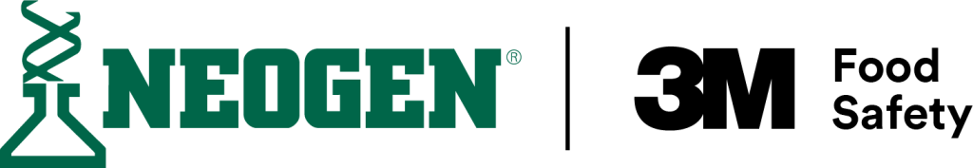





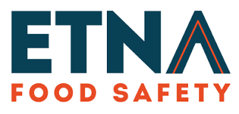




2026 FAFP Silver Sponsors

Advanced Fresh Concepts
SSP America
Taylor Farms

2025 FAFP Bronze Sponsors
Vikan
Primus Labs/Azzule Systems

Exhibitors

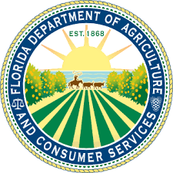

2026 FAFP Award Winners
President’s Award
Kristina Schoen, Coastal Ag Supply

Laboratorian of the Year Award
Vijay Chhetri, Florida A&M University

Bronson Lane Award
Debby Newslow, DL Newslow & Associates

Special Recognition Award
Morgan Smith, Publix Super Markets, Inc

New Professional Award
Rory Wang, University of Florida

Past President
Taylor O’Bannon, University of Florida



Upcoming Events

FAFP Board Nominations & Voting

FAFP Fall Educational Meeting – date to be announced soon

For more information, visit www.fafp.net

Or follow us on LinkedIn


