COMPONENTS OF SELF
By
Christina Maya Major

A Thesis Submitted to the Faculty of
Dorothy F. Schmidt College of Arts & Letters
In Partial Fulfillment of the Requirements for the Degree of
Master in Fine Arts

Florida Atlantic University
Boca Raton, Florida
May 2010
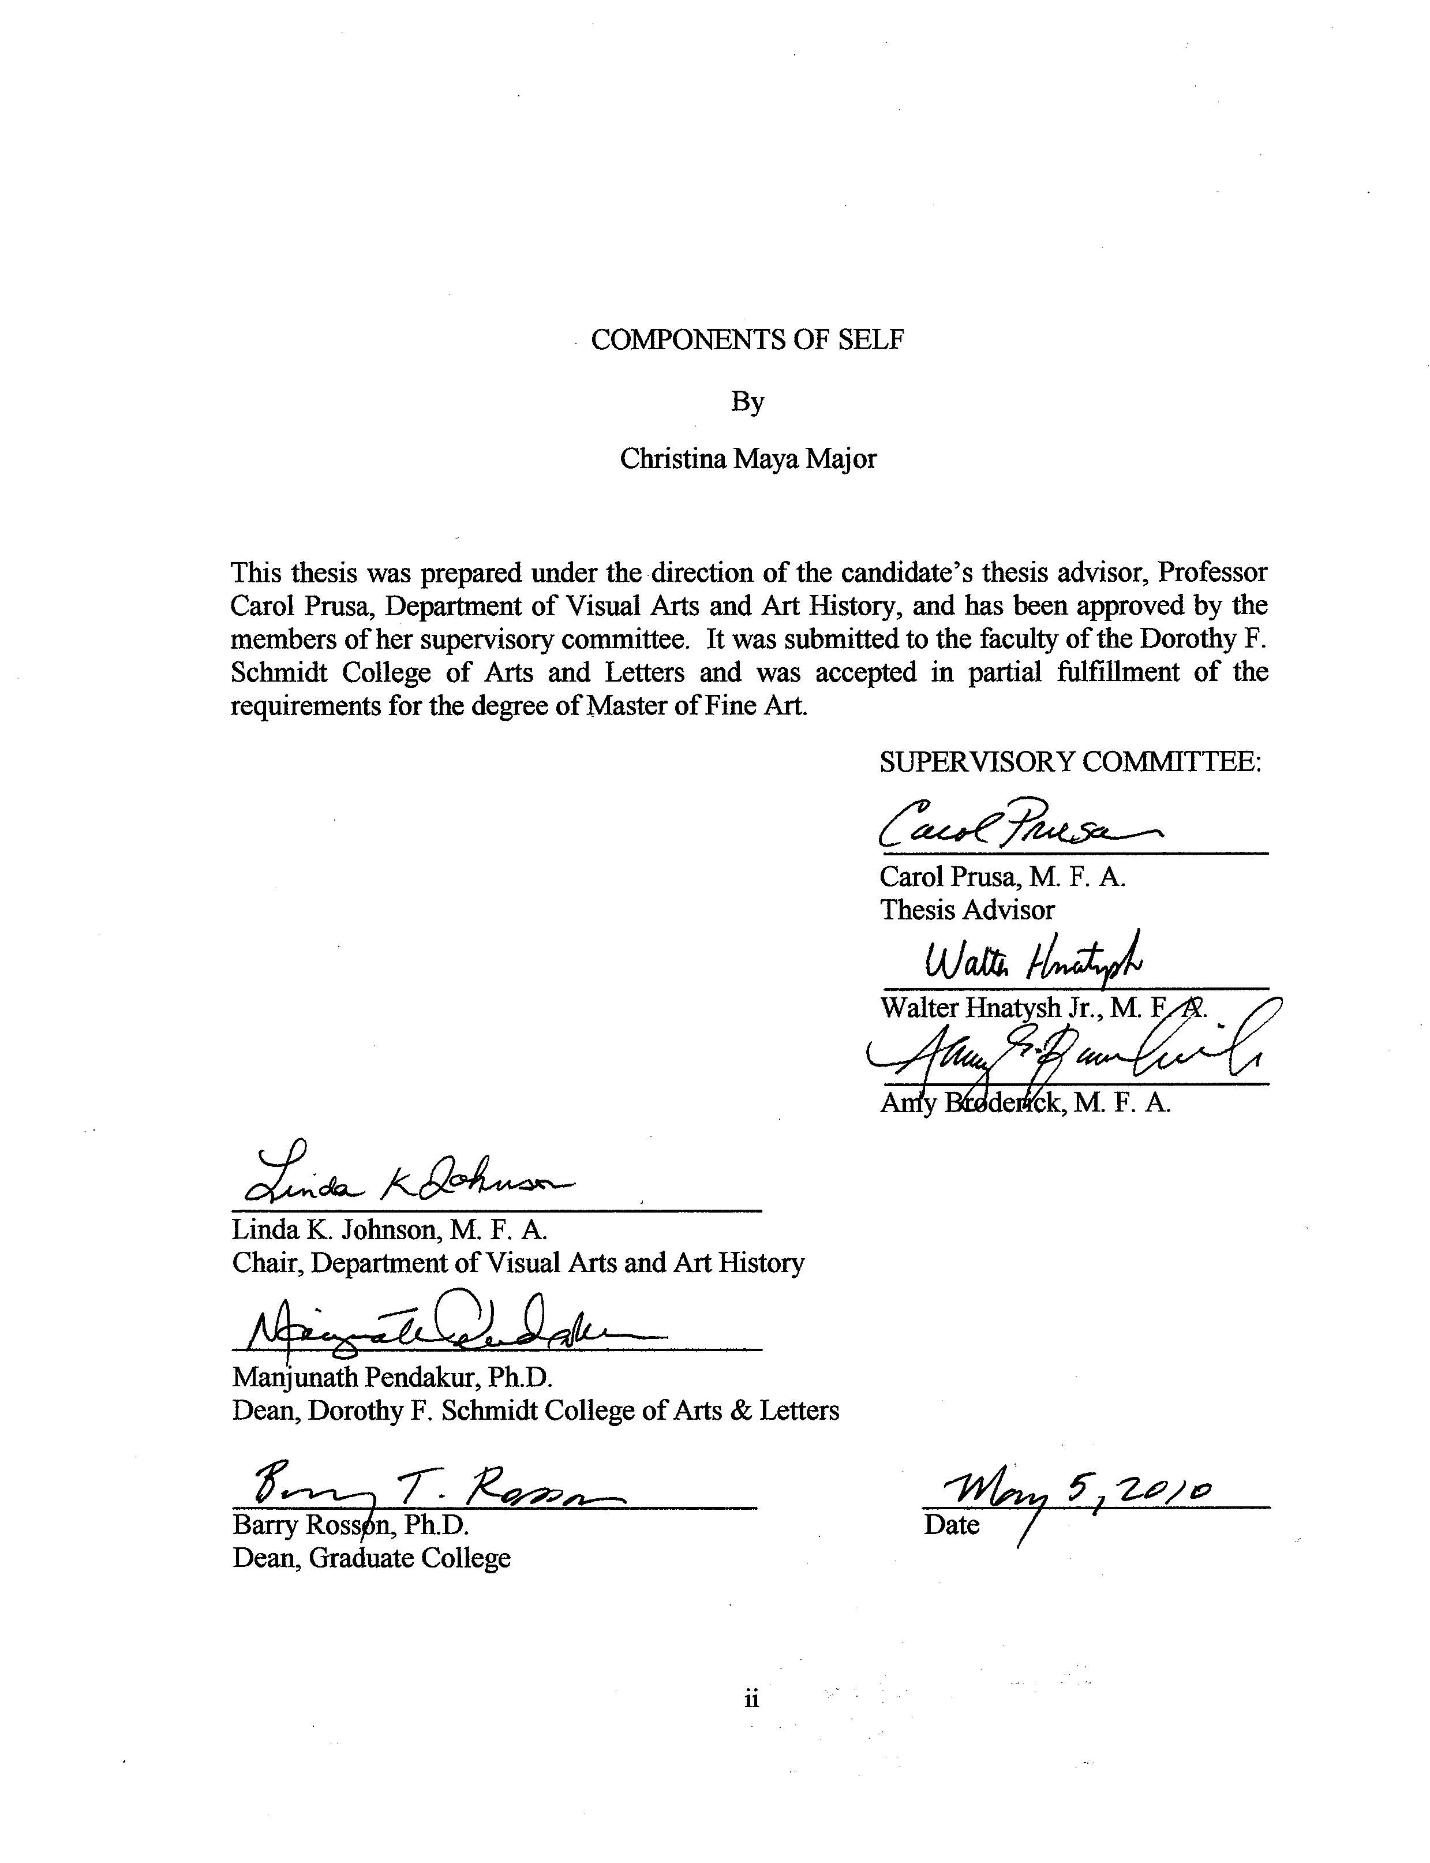

ABSTRACT

Author: Christina M. Major
Title: Components of Self
Institution: Florida Atlantic University
Thesis Advisor: Carol Prusa, MFA
Degree: Master of Fine Arts
Year: 2010
My thesis exhibition is comprised of approximately eleven large-scale portrait paintings done primarily in oil paint on canvas. This body of work investigates the ways the identity of both artist and subject can coexist in a portrait and evolved from my desire to combine portrait painting with writing as well as to develop methods of using paint to express a merging of myself with the individual depicted in the portrait. My creative research has focused on the traditional form of the portrait as a powerful form of representing an individual and how meaning can be expanded through scale, brushstroke, color, texture, composition and the many variables that portraiture deals with. I expanded on the traditional portrait painting by cataloguing my memories and thoughts along with the thoughts of the subject by painting under, into and over the subject in my own handwriting. My “hand” is visible both in the brushstroke and in the cursive writing, preserving my identity in a “readable” way both literally and through graphology, or handwriting analysis.

COMPONENTS OF SELF
List of Figures v
Introduction 1
Conventions/History of Western Portraiture 2
Portrait as Biography 2
Literary Portraiture 4
Contemporary Portraiture 4
Overview 10
Material and Methods 11
Color 13
Body of Work 13
Conclusion 20
Figures 22
Bibliography 32

LIST OF FIGURES
Figure 1. Submerged 22
Figure 2. Components of Self 23
Figure 3. Shelly I 24
Figure 4. Shelly II 25
Figure 5. Charlie (Ma’ma) 26
Figure 6.. Ma’ma 27
Figure 7. Kerwin 28
Figure 8. Sam 29
Figure 9. Schmidt Center Gallery Photo I 30
Figure 10. Schmidt Center Gallery Photo II 31

COMPONENTS OF SELF
As an undergraduate I developed into a portrait painter. I have been interested in the ways the identity of both artist and subject can coexist in a portrait. My graduate thesis exhibition work evolved from my desire to combine portrait painting with writing as well as to develop methods of using paint to express a merging of myself with the individual depicted in the portrait.
My creative research focuses on the traditional form of the portrait as a powerful form of representing an individual and how meaning can be expanded through scale, brushstroke, color, texture, composition and the many variables that portraiture deals with. I expand on the traditional portrait painting by cataloguing my memories and thoughts along with the thoughts of the subject by painting under, into and over the subject in my own handwriting. My “hand” is visible both in the brushstroke and in the cursive writing, preserving my identity in a “readable” way both literally and through graphology, or handwriting analysis.
The paintings are done primarily in oil on canvas grounds prepared with gesso and stretched. They are generally of monumental size ranging from 48” to 96” in each dimension. I want the portraits to feel Overwhelming and have a “larger-than-life” presence that cannot be ignored. The large scale also supports me in creating a different “reading” of the painting depending on the viewing distance. Areas read quite abstractly
when viewed up close and the emphasis appears to be brush stroke, dabs of color and texture that is related to the form of the cursive text. From a further viewing point, the image coalesces from the strokes and layers of writing.

CONVENTIONS/HISTORY OF WESTERN PORTRAITURE
To understand how portraits function, I turned to the history of western portraiture to research the conventions upon which to build. Portraiture is a powerful form of representation and it deals with many variables. Some variables include representing physical likeness, social position, artistic expression, identity, character, personality and gender. Portraits are expressed in different mediums: paint, sculpture, photography, literature and video. According to the Oxford History of Art, Portraiture, the history of portraiture takes a significant turning point in the 1500’s as a Western art form; portraiture at this time was seen as a professional specialized practice in Europe (West 17). The book Portraiture states: “ the Renaissance in western Europe was a period of increased self-consciousness in which concepts of unique individual identity began to be verbalized…the assigning of a specific identity to a represented face and body is thus a strongly Western phenomenon”(West 17). It was more commonly practiced in Western culture because portraiture represented specific people and Western culture supported individuality (West 16-17). The portraits of specific people were of named individuals of royalty, power and status; and were represented in paintings, prints, coins, and literature. Traditionally mimesis was the main practice in early forms of portraiture; artist self expression didn’t flourish until the 17th and 18th centuries as stated by Shearer West in her book Portraiture.

PORTRAIT AS BIOGRAPHY
Early forms of portrait painting functioned like a form of document. They represent the station of “a named individual” through details of clothing and staging of setting and props (West 53). One famous historical example is the painting by Jan Van Eyck, The Arnolfini Marriage. This work serves as a document of a marriage ceremony. Art historian Erwin Panofsky discusses “how a portrait might serve the function of a historical document and the way the written inscriptions on the portrait contribute to this purpose” (West 57). It is common for portraits to contain words similar to documents. These words are painted within the painting, often unobtrusively. A common method to incorporate writing was to paint a scroll or piece of paper within the painting to contain the written information (or on the canvas and or the frame) in “trompe l’oeil” which is an art technique involving extremely realistic imagery in order to create the optical illusion of three dimensional form. The more obvious use of words suggests authenticity of the individual depicted because it provided more information. “The dominance of these words in some portraits, such as the portrait (1616) of the native American Pocahontas, suggests that they were especially important in establishing the authenticity of the likeness” (West 54). The words contain information about the name of the sitter, the age, date, and location. Portrait documents were important because before the invention of photography, portrait painting was the only way to preserve a person’s image and record a specific moment. “In centuries before photography, portraits were the only way of conveying the appearance of an absent or unknown person, and they were a method of preserving the physical appearance of someone that would remain after their death” (West 54). This act of writing in or on the painting is a combination of literary portraiture and portraiture.
Literary portraiture is a tradition that uses words to evoke an image of an individual and dates back to the 2nd century AD (West 50). Literary portraits do not give as much information as a biography. However, they provide a snapshot moment similar to visual portraiture. The similarities between literature portraits and painted portraits are also found in their methodology. In each case, whether writer or painter, the subject or “sitter” is observed closely. Like portrait painting, literary portraiture incorporates self-consciousness – the ability of looking at itself in the act of looking, and that its text creates a relationship between the writer/observer, subject/sitter and reader/receiver and where who is being looked at is in flux.
Self-consciousness in literary portraiture is an aesthetic strategy, a dynamic and structural poetics that deploys sexuality as a figure of a larger twisting of relationships—those between the viewer and the viewed, the subject looking at himself, readers watching the subject looking at himself being looked at… In the same way, the portrait as a work of art relies not only on this personality produced by the sitter, but on the artist’s interpretation of this personality, an interpretation that creates the particular style or signature of the artist’s look (Hovey 7).
In painted portraiture, the painter is as revealed as the subject – an attribute of portraiture I am interested in engaging in my own painting.
In contemporary portraiture, one of the most straight forward definitions I have come across is: “The portrait should allow something of someone’s personal interior life to be made available in public, and this purpose- to bring out hidden information- should be important to both artist and the eventual viewing public” (Howgate 7). Artists that demonstrate this and inspire my work include: Chuck Close, Hung Liu, Tracey Emin and Jenny Saville. These are artists who use words, portraiture, identity, and narrative content within their work.
Chuck Close is an American portrait artist whose work is in large part about scale and fragmented information. His work plays with distance, where up close the image of the person depicted is broken up into strokes and shapes of color and value, appearing unrecognizable. When you step back from his paintings the image emerges as all the pieces of information get added together. I find that being able to discover different information within a painting is intriguing, and I am resolving the way in which words can contribute to different viewing points in the portraits. Close works from a gridded photograph of his subject. He applies a grid to the canvas and fills each box with information related to the color and tone of the photograph in the corresponding grid point giving the resulting painting the appearance of pixels. He uses a systematic approach by working top to bottom, left to right and numbered gridded lines. Over the years, Close's works have evolved from harsh black-and-white images to colorful and brightly patterned canvases with an almost abstract painterliness. An example of this is Self-Portrait(1986), were Close has made marks within marks. Comprised of incremental units, units of perceived color dotted over one another. At a close viewing point the surface is broken up by the application of multicolored dots. In areas of the mouth, it is unexpected to find colors unnatural to the face; here colors of Blue, Red, Green and Black overlap one another. Then something remarkable happens when viewed at a further distance; the image of a face emerges from the complex surface. Not only is the image recognizable, but it also is extremely realistic in representation of the face. Originally associated with photorealism, Close's now uses a visible grid to recreate a mosaic-like representation of his sitters resulting in an expressionistic quality.
One other artist of great interest is the Chinese artist Hung Liu. She is also a portrait painter who reference photographs as a resource in her work- a method of referencing that I employ. Liu’s series of works come from historical Chinese photographs. These images of reference are that of historical women-heroes, prostitutes and victims of war. She further communicates information of the portrait with Chinese symbolism painted under and trough the paint. Her surfaces are intriguing by her usage of dripping paint and aggressive paint strokes. Liu’s images are large an in your face. This scale forces the viewer to investigate the subtleties in her application of paint. An example of this is Harvest Season; a diptych organized horizontally depicting an older woman on one end and symbols on the other. This piece portrays a side view of a woman facing the other end of the painting. In it are aggressive marks of paint and dissolved dripping paint over the surface. The colors are cool with highlights of warmth. The paint on the woman’s face has been applied in a way where it has aged her face. The remaining painting is soft and light, with transparencies of paint and imagery overlapping. At a close glance on the surface of the face, the paint feels wet, thick and unplanned. One wouldn’t imagine that this surface would result in a well represented face. As a painter, Liu intentionally wants to destroy and preserve the image. Much of the meaning of Liu’s painting comes from the way the washes and drips dissolve the photo-based images, to reveal the concealed memory of the person. I work with similar methods of dissolved paint to give unexpected results and allow myself to respond to the paint.
Jenny Saville is a member of the YBA (Young British Artist group). She is a feminist portrait painter engaged with the history of how the body has been depicted in art. She paints bodies that are the opposite of the eroticized and perfected model bodies as determined by our culture. Her work is derived from documentary photographs of surgeries, injuries and herself. Jenny Saville has gone as far as observing cosmetic surgeries. While Saville references photography as a source, she is very interested in making a painting that reaches beyond the limits of photography. Saville states: “how can figure painting give you something that photographs of it can’t give you?”(Howgate 65). She references traditional portraiture by embracing the physicality of paint and thus has chosen a medium that is historical. Saville re-introduces the idea of recreating flesh from paint, similarly to Lucien Freud, where “the flesh becomes like the material”(Sylvester ).
Examples of Saville’s works that contain writing on the figure that is incised into the paint is the piece Branded, which communicates a multitude of messages to the viewer simultaneously, where she uses herself as the model, has a woman standing holding her fat. The act of the figure grabbing her fat gives the feeling that the subject is disgusted or perhaps proud of her fat. This piece is monumental in scale, taking over the entire wall. This in turn causes the viewer to be consumed by it, unable to ignore its presence. I am exploring how scale contributes to the viewing and the response of my portraits, and how can scale aide me in creating a cohesive relationship between word and image. This scale also forces the spectator to observe what they might consider ugly, and draw to question their ideas of beauty. The surfaces of the paintings are beautiful and aggressive in that paint has been smeared, slashed, stained and drizzled. Her work focuses on hybridity and pathology: she states, “I am interested in the pathology of painting, in that you put something down that’s ugly and make it desirable.”(Schwabsky 22-8) However, the interpretation of the painting changes when one considers the words that Saville has painted across her body. Words--as if cut into the skin--over the breasts, belly, face, and hips, say “Decorative,” “Support,” “Delicate,” among others. These words turn Saville’s body into a means of communication to the public. She is meant to be read, to be interpreted, as a written text would be. The words play against the conventional idealized image of how women are traditionally thought of in society - that they should be delicate and petite, feminine and well mannered. I am interested in how Saville is able to incorporate writing and image cohesively-while still maintaining the illusion of space. I find that the act of writing across the picture plane visually flattens the words; however this simultaneously makes the image behind the writing have more space and therefore more three dimensional, thus creating a cohesive relationship between subject and writing.
Tracey Emin studied at art colleges in Essex and in London before staging her first exhibition, at the White Cube Gallery in 1993 when she was thirty. Since the mid-1990s she has been recognized as one of the leading figures of the YBA (Young British Artist) group. She is a contemporary artist that incorporates words and writing into her work in an autobiographical manner. Emin’s works are self-referential as any self-portrait, but they avoid the portrayal of physical likeness. The primary concern may not be to convey self –likeness, but to reveal something more fundamental about her life. Tracey Emin does not use portraiture in the traditional sense, but her bodies of work are the kind of self-exploration that characterizes self-portraiture of the past. Instead of physical likeness, Emin’s work functions similarly to documents. “She is the artist who, perhaps more than any other, has laid bare her turmoil through her autobiographical art and writing, sometimes disguised in metaphorical and allegorical layers, sometimes barely disguised at all”(Beattie). Her work is very direct - it concentrates around her personal life which can be seen as very harsh and honest. “She sells her memories, even her family snapshots and mementos, to other people”(Stallabrass 36). As her work reads, it embeds the history of some of her most personal experience, such as sex, rape, pregnancy and so forth. Tracey Emin references these topics in a multiple range of media, at times by sewing a vulgar snapshot, making prints, writing and stitching words, installation and sculpture. “These are represented in words and pictures, in small, edgy monochrome prints and in large assemblages of sewn material carrying inarticulate messages of love and hate”(Stallabras 96). She is well-known for her art being confessional, by revealing intimate details from her life to engage the viewer. Her ability to integrate her work and personal life enables Emin to establish an intimacy with the viewer.
An intimate example of Emin’s work is a piece comprised of a tent called Everyone I Have Ever Slept With (1963-1995), where Emin has stitched the time frame on the outside and the information inside. This piece isn’t treated like a precious piece of art protected from the outside. The viewer is invited to participate and interact with the piece, because Emin placed the tent on the floor, un-barricaded, so the spectator can sit and look inside. The viewer discovers the story inside the walls of the tent, which tells the observer about every person and thing she has slept with - not only sexually as one may assume - but she includes her twin brother and grandmother, lovers, a teddy bear and her aborted fetus. “Through works such as this, Emin is able to challenge the traditional boundaries of self-portraiture…shift[ing] attention from the iconic qualities of portraiture to the indexical ones” (Smith).
Many artists have explored the use of words and writing within their work. These include Jenny Saville and Tracey Emin (described above). There is an array of approaches artists have utilized to include words and writing into their work; most of the time this involves painting the words directly on the ground or incising the letters directly into the ground and/or paint. Sometimes the words are printed or collaged from a print source. There is however, one method that expressed the individuality of the artist most directly and that is using one’s own handwriting to inscribe into and onto the painting. This brings forward what graphology can contribute to expression and communication in art. In graphology, an individual's physiological and psychological characteristics are deciphered from a person's handwriting. The act of writing contains spontaneous actions for the purpose of communicating ideas. The examination of written words is the legal basis for forensic identification of an individual. I approach portraiture by infusing my identity into the paint while still portraying another individual by incorporating my handwriting and brushstrokes. The final result is a hybrid of me and the person depicted. The painting becomes my autobiography - my story. My identity is infused in my work by physically writing into the paint. My brush stroke is my mark; my mark is my character, and therefore my identity.
Historically portraits are seen to be immortalizing. I desire to immortalize the people in my life because they make up who I am. I submerge my memory of the subject into, through and under the paint and the description of the face. Initially my large portrait paintings began with the canvas stapled to the wall where they were painted with the intention of displaying them this way. At this early stage, I would physically paste pages of personal, hand-written writing from the subject onto the canvas and then painting on top of the paper while allowing some traces of words to remain. I struggled with making the collaged words integrate into the paintings. I found the applied writing separated from the image and the viewer did not engage with the writing. The relationship was not cohesive, but competitive. This was also true for my first attempts to write onto the paintings. I would use oil sticks to freely write on the canvas and over the portrait. I found that this would in turn flatten the image and still wasn’t unified within the painting. With experimentation, I am able to discover more effective ways to combine word and image and a fluid relationship between them.
The most effective way I discovered through experimentation to incorporate writing with image was to write into the gesso when I prepared the ground for the painting. My process is to apply the white gesso thickly through broad brush strokes and then inscribe into the dense wet paint. This method provides a great foundation from which I can build multiple layers of painted words and portrait. The portrait image becomes fragmented by the overlapping words and strokes of paint, influenced in part by the work of Chuck Close. At close proximity, the individual is unrecognizable and the surface appears comprised of thick impastos and energetic strokes of swirling paint – reading almost non-objectively. The brush strokes form the contours of words that become imbedded in the skin of paint and complete the story of the subject housed in the painting. Legibility is not a concern, only that the writing be evident so that the viewer can engage with the “sense” of it. The text and stroke are suggestive of content and some words do assert themselves out of the more chaotic or less legible structure. At a distance, the individual subject emerges from the strokes making up the words. I must have an emotional connection between the individual depicted in the portrait, the words written on their body and the physicality of the paint to consider a painting resolved. I work intuitively and when I “write into the paint” I am in that moment, pure feeling. I seek to connect empathetically with my subject.
The genesis of my work is metaphorically and physically with water. The water acts as a vehicle for my paint as well as the words to have an environment in which they co-exist. My thesis exhibition primarily exhibits work where the person in the portrait is depicted under water. The fluidity of the water allows for the writing of the words to swirl with the description of the person. To facilitate my process I first work to capture the essence of the individual through underwater photography. I mine and employ the different connotations water can provide to each piece; ideas of being submerged, drowning, rebirth, and peace. The colors of water suggest even more meanings – of tranquility, cold, depression, dream, and death. My work involves the layers of meanings and feelings both water and color can give and I intentionally leave open the interpretation of each painting. Photographs are my source of reference, and therefore are carefully chosen to precipitate in me an emotion and desire to interpret the image through paint and text. For me the photograph cannot feel complete in itself nor have any over-arching emotion but offers an ambivalence to any one “read”. My work is about discovery, starting with my openness to the painting as it unfolds and resolving by creating a piece that supports each viewer/participant in finding their interpretation.
With the photographic sources, I reference many images for each painting to better understand the effects water has on light and hair and bubbles of air. The selected images are cropped and altered on the computer to determine the most favored composition, saturation and contrast. My portraits are dramatically cropped with intense focus on the face. For me, the identity of the individual lies in their face and expression. In my painting, I assert no reference of time and no specifics of a particular location.
Once the desired photographic composition has been printed for referencing, I then determine the scale for the painting. Scale plays an important role in my work because I want the paintings to be monumental and consume the viewer. Each piece is intentionally set up to be viewed at both close and far distance with each vantage point providing different information about the painting and a difference experience. For example, close-up the viewer is meant to focus on the writing and brush stroke as it dominates at that range. At this viewing point, the image of the portrait image is not to be the focal point. Instead the main focuses are the breaking up of the marks, paint, color, words and gestural strokes that read emphatically. In some paintings there are drips present to help break the information of the face and to spontaneously form unexpected results from multiple colors mixing. Hung Liu has inspired me by the way she has utilized drips in her work to break form and figure and make the surface visually interesting. Drips of paint help open up my work and keep it fresh while at the same time, help to create an intriguing surface. Viewed from a far range, the coalescing of strokes of color and paint dominates and the image of the portrait face resolves.
I intentionally use a variety of color pallets in my work to explore the ways in which all the elements of color can impact the viewing of my paintings. In my early undergraduate work, I was timid and inexperienced with color. Most of the early paintings were monochromatic and highly influenced by chiaroscuro lighting. Parts of my own challenges in grad school were: to become more aware on how color would dramatically make my work better and to employ different lighting environments. I was interested in the ways color affects emotional perceptions and the ways it communicates different environments. Cool color dominates most pieces to suggest the element of water as well as to use the duality of positive and negative connotations. For example, the color blue suggests a calm peaceful aquatic environment, as well as representing death and depression. I prefer colors with dualities in conjunction with neutral facial expressions to avoid directing the viewer. In the underwater portraits light reflects unpredictably, thus providing complex results by fragmenting the color.

BODY OF WORK
In my earlier portrait paintings, I was more concerned with describing the individual than the environment in which they lived. The space in my previous paintings was ambiguous and was created by layers and layers of drips, brush strokes and painted writing. This approach was effective in most pieces; however I was interested in investigating different environments the individuals and words could exist in. As I looked back on my previous work, I analyzed the areas in the paintings I responded to the most. What I found was that the areas where water was present - such as drips - were the areas I was most interested in. I employed the drips to dissolve the image, causing me to need to rebuild it which resulted in a more dynamic and complex surface. However, I wasn’t satisfied and wanted the water element to do more. I wanted to figure a way that I could make the water feel more of an environment than a layer. At this point, I was developing the research and methods in which I could resolve this desire. As a result, I took multiple photographs underwater of my subjects in varying conditions of light and activity to better understand the effects of water and light. In the painting, Submerged [fig 1], I attempted for the first time to work on a canvas already stretched. The painting is 50” by 72”, oil on canvas; and is an underwater self-portrait. I applied the thick gesso ground and scribed energetically into it. The text was written into the gesso aggressively, with words overlapping one another without my lifting my hand from the canvas. The image shows me slightly under the surface of the water calmly blowing air from my nose. The viewer might feel as though the person is drowning, losing air, but not struggling – almost as though they are at peace or accepting the unknown. Drama is enhanced by the dark, cool color and shimmering fragmented light coming from the surface. The textured from my stroke seeps through to the surface, acting as a layer of blur over the face; similar to the effect that brackish water gives. In addition to the blur effect, the face is also fragmented from the strokes of colors of words. The hair in this piece is flowing throughout the frame, encompassing the face.
Components of Self [fig 2] is a painting I created for an exhibition themed on the intersection between art and science. Components of Self is 48” by 60” and is stretched canvas painted with oil paint. In this painting I continued my focus on self-identity and portraiture but substituted in binary code for the text. I translated information about myself into the binary code and proceeded to treat it in the same fashion as I would words. This piece is a self-portrait, again submerged, with traces of water, such as bubbles, depicted visually within it. In this painting I determined to reveal more of the process in which I paint, meaning I would leave more visible the layers and process of my paint application. Of note is the raw canvas left remaining around the perimeter, acting as a frame around the portrait. The painting builds in surface towards the center with each successive layer spreading over less of the surface. Across the canvas, “0” and “1”’s are painted, scrapped and carved in the paint and image. The binary code both fragments the portrait and heightens the illusion of space. To demonstrate my process visually in my work is important because my process is very involved. At times when a viewer sees the end result, it can appear much more simplistic than it really was. I feel that allowing the viewer to visually understand the process in which I work would only add to the experience and create new challenges for me in my work.
Since I determined having the viewer/participant acknowledge the process of my work as an important visual element, additional paintings in my graduate exhibition demonstrate this. A strong example of a painting where the evolution of the painting over time is left highly visible is Shelly I [fig 3]. Here the piece, monumental in size (72”x96”), shows raw canvas encroaching on the image, forcing a framing of the face and making it the focal point. The successive layers used to build the image are clearly evident. Broader information reaches to the perimeter while more particular information builds in the center. Even though at most times the face already reads to be the dominant aspect of my paintings, I wanted to experiment simplifying the edges. The first layer is the gesso, which has been applied aggressively. The writing begins here, in the application of gesso. The text is directly from the subject. I requested for the subject of the painting to provide me writing that reflects some aspect of turmoil in her life. The new challenge of this painting was to discover a way in which I could give the viewer the feeling of drama and turmoil through the use of paint without it being made obvious in the facial expression depicted of the subject. To accomplish this, I used subjective color and employed cool colors unnatural to water. I build more layers of paint and worked on the expression of the brush stroke and calligraphic mark from the text. As you focus more to the center of the piece, you see the layers becoming thicker. The layers of paint are built from repeatedly painting words with both transparent layers of paint and opaque paint. The layers both fragment the portrait image as well as congeal it. In most cases, my paintings demonstrate the push and pull between construction of a coherent face and deconstruction. The viewer is left alternating between seeing the painting for text and brush stroke and expressive color and seeing it for description of a specific face. I desire to leave my paintings ambiguous in meaning and feeling – leaving the viewer somewhat uncomfortable as they cannot quite pin down a specific answer to what this portrait depicts.
Again, using my subject, Shelly, I created a two painting piece. I wanted to make one panel about the negative drama in her life and the second is about the happier side. The two paintings are not physically connected, however they are meant to be shown next to one another. Shelly II [fig 4] is 96” by 72” painted in oil paint on stretched canvas. It was created following the same approach as Shelly I. Depicted is a woman underwater with her hair flowing over her face. The words incorporated were from the subject’s writing of a positive view on her life. I responded to her words empathetically by painting her image with more positive expression but countered that by the aggressiveness of the fragmenting brush strokes from the text. There is a cool blue-hued color field to imbue the piece with the feeling of water as well as traces of drips running down the painting.
Up to this point my color palette was geared toward representing the element of water and tended towards blue hues and cool tones. I determined in the painting Charlie [fig 5], to work with a varied color scheme and introduce warmer colors to my palette. I used a yellow under-painting to force me to expand my use of color. In this large-scale piece (72”by 96”) a green over-tone evolved, punctuated with highlights of warm colors. This opened up more variety of color within my work and I learned color could be intensely interesting and complex and affect many things I was interested in. The portrait is painted as though I was writing the colors on the subject’s face. I used my memory of gesture from writing as a way to paint- instead of relying on the words themselves to generate an expressive surface.
My most recent painting is I Love You [fig 6], a triptych with each panel 48” by 48”. Each panel flows visually to the next, with more information added to each successive one. Within the first painting one can see the incised and compulsively repeated words “I Love You” embedded in the gesso across the expanse and even around the stretched edges of the canvas. The resulting texture is most evident in the grooves of the scrapped words, which in turn produces a different shade of white. The “I Love You” text transitions to shades of warm colors when looking towards the center of the first piece. The second piece initiates with the same surface treatment. It differs by the way the “I Love You” is exacted on the ground and reveals more information of an underlying image. In the third painting, the incised words have been painted over with more layers of color and stroke, revealing the portrait of my mother in water-eyes closed and smiling. For me, this triptych demonstrates the series of events where the image evolves with the words and cannot exist separate from them.
Before I focused on a theme of water and depicted my subjects underwater, I still utilized successive layers of paint energetically painted and allowed to drip from the pull of gravity. An example of an earlier work in this mode is Kerwin [fig 7], 96” by 50”, oil on un-stretched canvas. In this painting, I utilized writing taken from my journal and scribed linearly on the vertical axis on my canvas, from top to bottom-right to left. This was to suggest the influences Japanese culture had on this particular person. I also went further and used that individual’s “thought chakra” color of green. The portrait has no intentional emotional expression except of peace. The top of the head fades out into the light shades of green, yellow and blue with hints of cool browns. The paint drips around the engraved words, and at times catches itself it certain grooves of some letters and paint strokes. The result of this helped me both bring out the words softly and simultaneously dissolve the image.
Other early works include Sam [fig 8] where already my desire for dramatic scale and ambitious projects is present as it is 42” by 102”. I learned from this painting that I relish eliciting the viewer’s response and own interpretation of my work. I hesitate to give my personal meanings, because I am not interested in directing the viewer. This piece was an homage to a friendship on its way to failure. Again, ambiguous in expression, the subject stares out to viewer directly yet is situated on the far right side of the canvas. The left side of his face begins to appear dissolved at the extreme right of the painting, with words and dripping paint flowing down the surface horizontally. I experimented with effects of paint dripping opposite to gravity, and let it pool near the portrait. I freely wrote my feelings of this soon-to-end friendship. I intentionally allowed certain words to be more legible and accessible to the viewer for discovery.

CONCLUSION
It is important to me to motivate the viewer to participate with my work. I seek to create an emotional connection between the viewer and portrait subject, hoping to cause the viewer to investigate further. Or, perhaps, a curiosity with what is written will cause the viewer to attempt to decipher and step closer to the work. It is intentional to make the text difficult to read with only some words ultimately emerging with clarity. The few words that are legible steer the viewer in one direction and the individual’s expression steers them in another. And, my work functions up close to disclose complex and beautiful passages of abstract paint and brush stroke that create their own worlds. My story is important to me in that it provides the spark to create the work, but it is not necessary for others to know it. I am interested in creating art which allows the viewer the ability to connect to it from their own grounding, to participate with it rather than to merely observe it. And through their participation with my portrait paintings, I communicate myself.

FIGURES
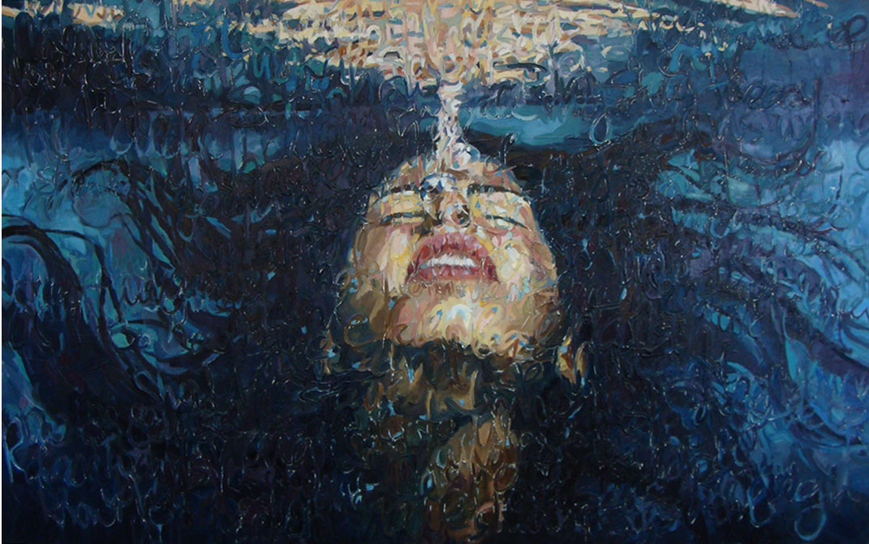
Figure 1
Submerged, oil on canvas 2009

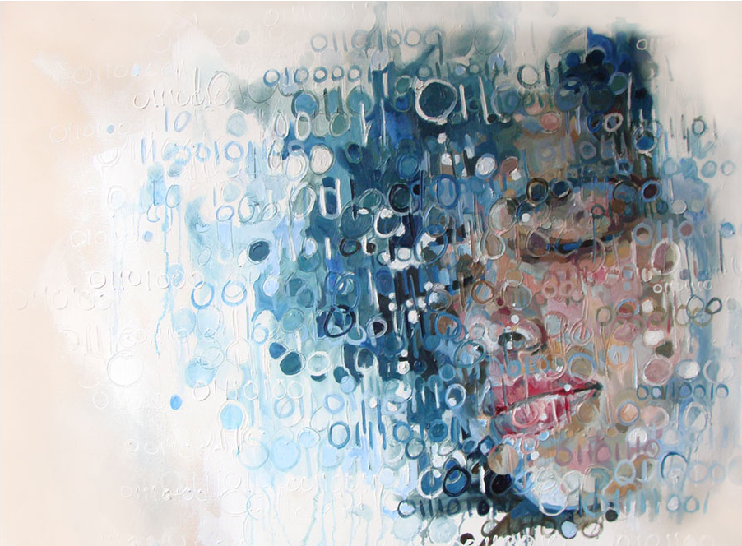
Figure 2
Components of Self, oil on canvas 2009

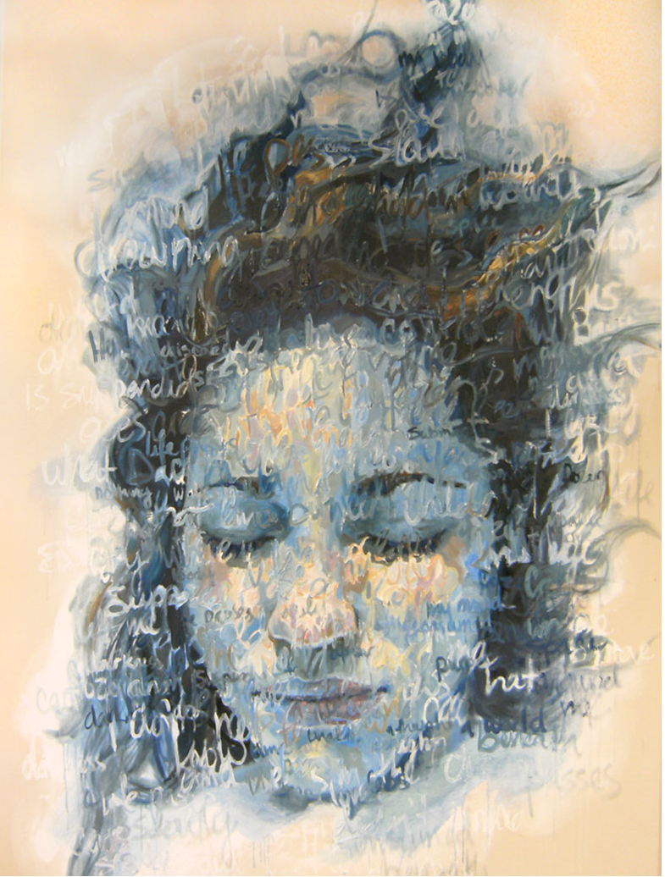
Figure 3
Shelly I, oil on canvas 2010
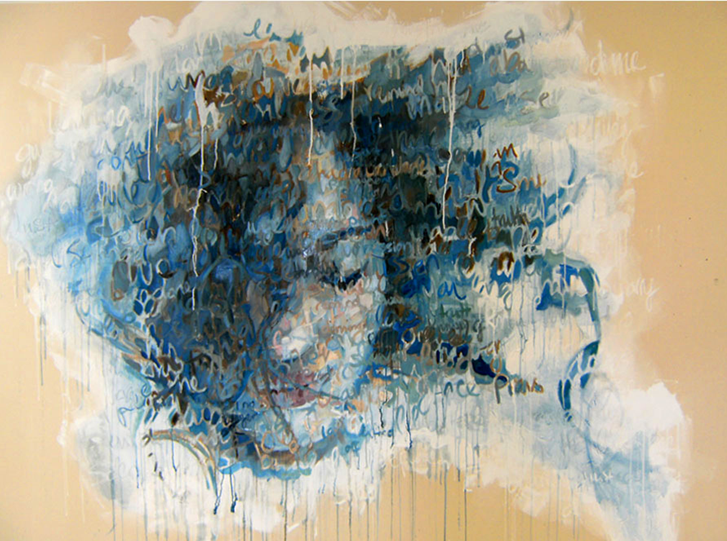
Figure 4
Shelly II, oil on canvas 2010

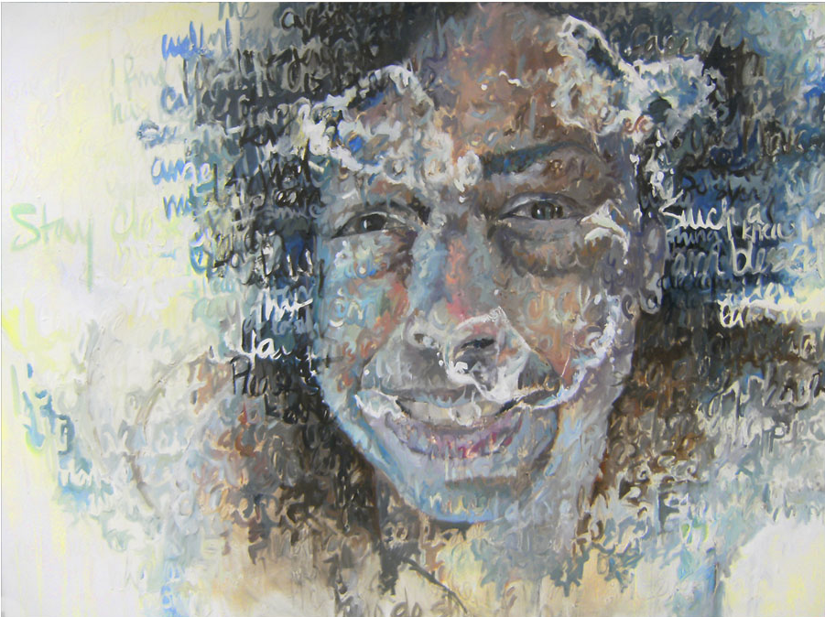
Figure 5
Charlie (ma’ma), oil on canvas 2010

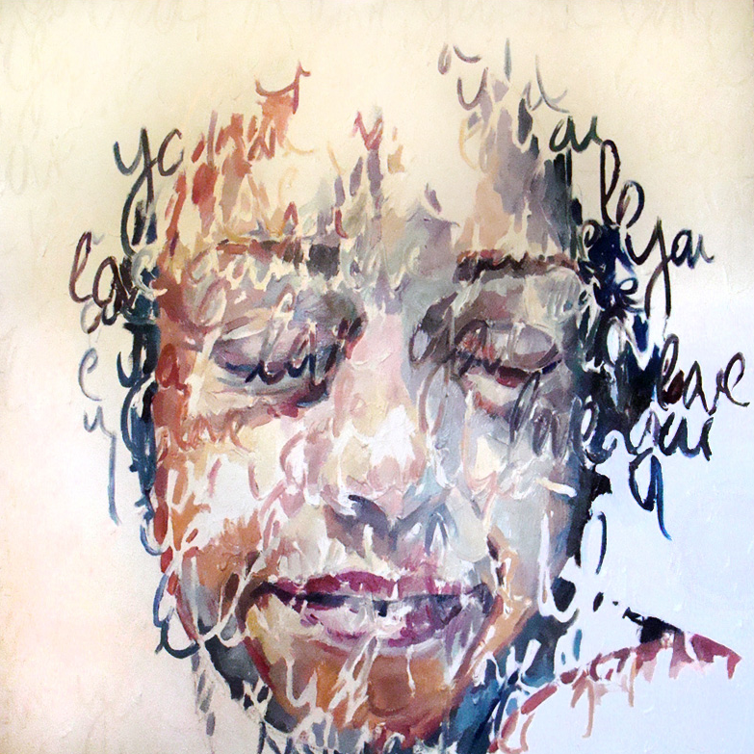
Figure 6
Ma’ma, oil on canvas 2010
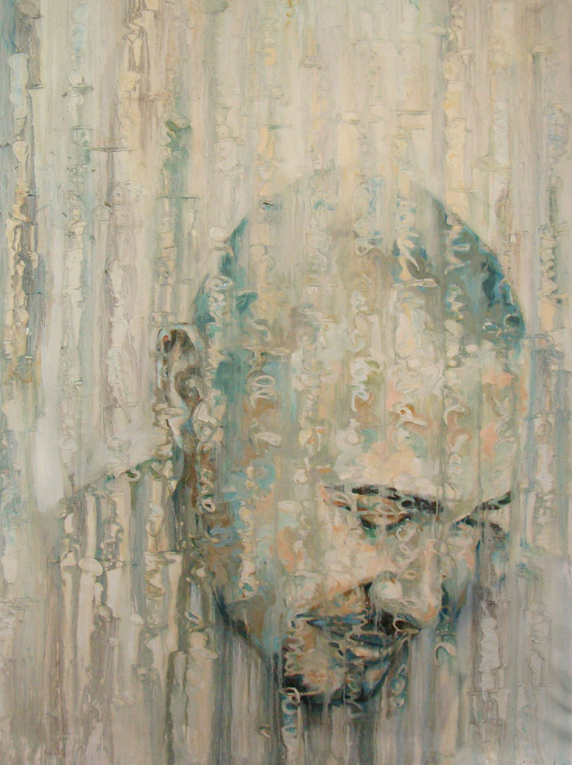
Figure 7
Kerwin, oil on canvas 2009
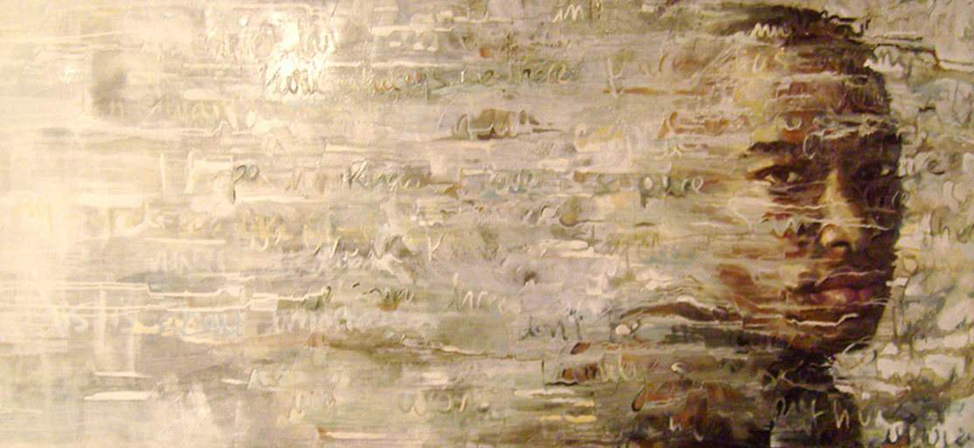
Figure 8
Sam, oil on canvas 2007

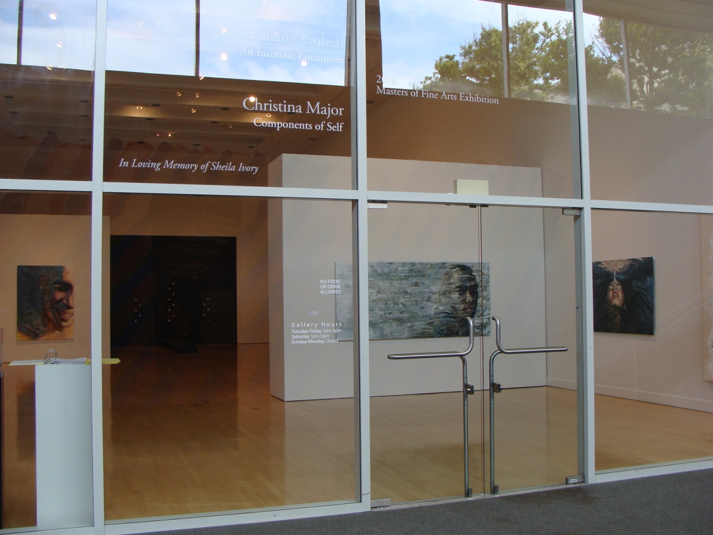
Figure 9
2010 Master in Fine Arts Exhibition, Photograph 2010
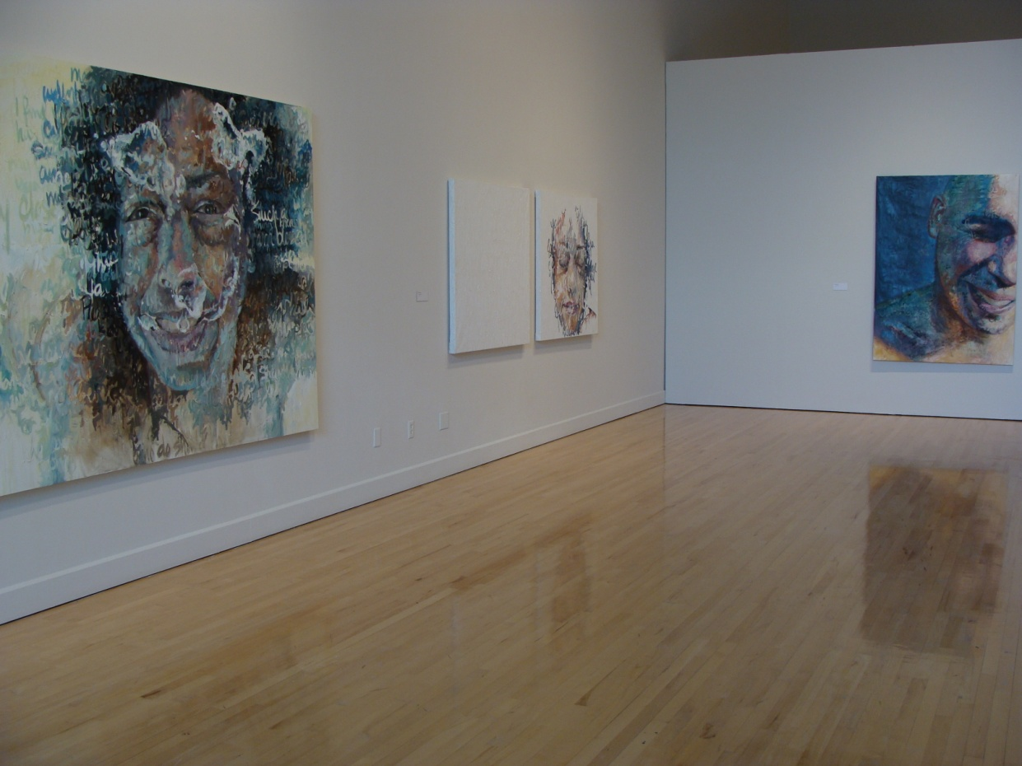
Figure 10
2010 Master in Fine Arts Exhibition, Photograph 2010

BIBLIOGRAPHY
Beattie, Geoffrey.”On The Couch With Tracey Emin.” The Observer . Web. 15 Jan. 2006.
Friedman, Martin. Close Reading: Chuck Close and the Artist Portrait. New York: Harry N. Abrams, 2005. Print.
Hovey, Jaime. A Thousand Words: Portraiture, Style, and Queer Modernism. Ohio: Thomson-Shore, 2006. Print.
Howgate, Sarah, and Sandy Nairne. The Portrait Now. Great Britain: National Portrait Gallery Publications, 2006. Print.
Schwabsky, Barry. Jenny Saville: “Unapologetic.” Tincelin, Aue, tr. Art Press. Feb 2004. Web.
Smith, Roberta. Tracey Emin – “Every Part of Me's Bleeding.”Art in Review. Friday, June 11, 1999. New York Times. Web. 10 Oct. 2009.
Stallabrass, Julian. High Art Lite: The Rise and Fall of Young British Art. New York: Verso, 2006. Print.
Sylvester, David. “Areas of Flesh.” The Independent. 20 Jan. 1994. Web. 5 Feb. 2010.

West, Shearer. Portraiture. England: Oxford University Press, 2004. Print.

