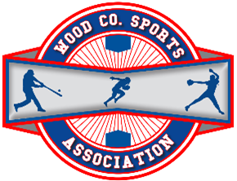

2026 Sponsorship Package
Wood County Sports Association, Godbey Fields

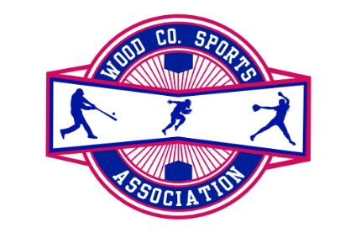
Wood County Sports Association, Inc.
PO Box 3373
Parkersburg WV, 26103
www.godbeyfields.com
IRS Recognized 501-C (3) Tax Exempt Organization
_______________________________________________________________________________________________________
Wood County Sports Association, Inc. is a Non-Profit organization dedicated to providing an opportunity for the children of our community to learn the basics of Teeball, Baseball and Softball while in a fun, family-oriented environment that promotes sportsmanship and a love of the game. In addition, we also would like to partner and promote area businesses willing to sponsor or donate to our facility by providing various sponsorship opportunities. We are contacting our prior sponsors to continue to be a part of our Godbey family, while we seek additional sponsors to join our organization. Together, we can achieve so much more!

Sponsorship Packages Include:
Tier 4 Sponsorship Package: $1,400 (save $500)
- 1 Field Sponsorship (1 year – 4/1 through 3/31)
- 1 Team Sponsorship
- 5 (3.5 x 3.5 foot) Signs to be placed on our 5 recreational fields
- 1 small metal sign placed on Gihon Road front
Tier 3 Sponsorship Package: $1,300 (save $450)
- 1 Field Sponsorship
- 1 Team Sponsorship
- 3 (3.5 x 3.5 foot) Signs to be placed on 3 of our 5 recreational fields
- 1 small metal sign placed on Gihon Road front
Tier 2 Sponsorship Package: $700 (save $225)
- 1 Team Sponsorship
- 5 (3.5 x 3.5 foot) Signs to be placed on our 5 recreational fields
Tier 1 Sponsorship Package:
- Team Sponsorship ($300) – This sponsorship item includes your business name/logo on the sleeve of a team shirt in a single color with a Godbey logo for the specified sport. The team will be labelled by your company name for the duration of the season. This will also include 1 field sign (3.5 x 3.5 foot) which will be placed at the home field for the team in which you are sponsoring for the duration of the season.

If you are interested in sponsorship, please submit this form via email at godbeyfields.wcsa@gmail.com, USPS mail, or by completing our new online sponsorship form. Please use the free space below to indicate which package/item above you are opting for. All checks should be payable to WCSA. Checks and forms may also be mailed to PO Box 3373, Parkersburg WV, 26103. Please email godbeyfields.wcsa@gmail.com with any questions you may have.

Please note: Spring team sponsorship payments/checks must be received by March 15th, Fall team sponsorship payments/checks must be received by August 1st.

Thank you for your consideration. We look forward to partnering with you!
_________________________________________________________________________________________________________________________________________________________________________________________________________________________________________________________________________________________________________________________________________________________________________________________________________________________________________________________________________________________________
Business Name |  | Color of Shirt  (See Color Pallette)
Sponsorship Tier |  | Color of Lettering
Type of Payment |  | Point of Contact  (Please provide name, phone & email)

Authorized Signature: ___________________________________ Printed name: _________________________________________

Color Palette
*Subject to Change Per Vendor

