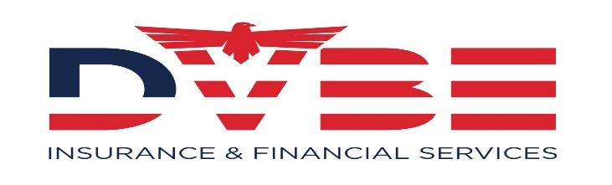

**Contact Information***David Reza Namazi*

*Chief Executive Officer*

*DVBE Insurance & Financial Services LLC*

*Financial Services Professional*

*CA Licenses #0G63146*

*Direct (951)318-8477*

*E-Fax (951)823-5017*

*7801 River Gulch Rd*

*Riverside, CA 92507*

[*www.dvbefinancialservices.com*](http://www.dvbefinancialservices.com/)

**Credentials - Certifications - Licensing**

* Certified Insurance Agent - 0G63145
* Life & Health License - 0G63145
* Property & Casualty License - 0G63145
* DVBE, SDVOSB, S.B, ID # 1763156
* Tax professional – PTIN: P01779853
* AHIP Certification - 0G63145

**NAICS Codes**

* 524114 – Direct Health & Medical Insurance
* 524113 - Direct Life Insurance Carriers
* 541611 - Financial Management Consulting
* 524121 – Income Tax Compilation Services

**SIC Codes**

* 6411 - Insurance Brokerage & Consulting
* 7389 - Legal & Tax Services - Consulting

**NIGP Codes**

* 953-80 - Retirement Benefit Plan Insurance
* 953-52 - Insurance & Financial Services
* [953-80] Retirement Benefit Plan Insurance
* [953-52] Insurance and Insurance Services (not Otherwise Classified)

**Our firm provides total financial needs analysis through a network of Experienced Professionals with expertise in:**

* Workers Comp & Employer Liability
* Retirement analysis and programs
* Estate strategies/Trust Services
* Employee benefit and retention services
* Business continuation strategies
* Credit Repair/ID Theft Reporting
* Group Health Insurance
* Professional Tax Preparation
* HR Consulting Services/Administration
* Professional Consulting Services

## Products & Services

1. **Professional Financial Services**

* Business Planning
* Special Needs
* Budget & Credit
* IRA & 401K
* Comprehensive Financial Services

1. **Insurance Brokerage and Consulting Services**

* Life/Accident/Health/Dental/Vision
* Medicare & Medicaid Planning
* Disability and LTC
* Fixed & Deferred Annuities
* Group Benefits
* SHOP & Covered CA
* AD&D
* Property & Casualty

1. **Tax Preparation and Consulting Services**
2. **Bookkeeping and Payroll Services**

* H.R. & Employee Benefit Management
* Small Business Advisory Services
* Non-Profit Management

1. **Estate Document Preparation**

* Trust and Estate Management
* Planned Giving
* 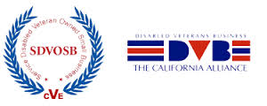

**Capability Statement**

**DVBE Insurance & Financial Services** **LLC.** is a company that is fully certified as a SB, DVBE & SDVOSB. We are currently seeking out companies bidding on public contracts that require participation and/or offer incentives to utilize subcontractors or primes with these certifications. **In utilizing our company to manage insurance brokerage accounts or employee benefits you can permanently meet your DVBE/SDVOSB set-asides requirements on all state and federal contracts**! We accomplish this with a unique blend of insurance benefit management and contracting analysis. Basically, our firms principal David Namazi combines his expertise in the government marketplace along with the firm’s capacity in all facets of insurance to create an approach that is unmatched in the industry.