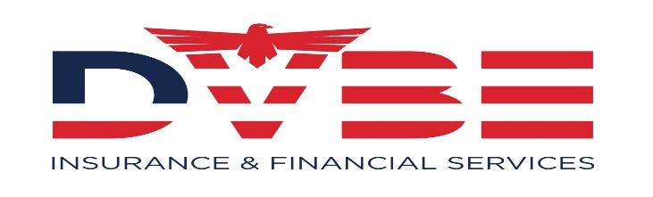
Contact Information
Namazi, David Reza
Financial Services Professional
DVBE Insurance & Financial Services LLC
Direct (951)318-8477
E-Fax (951)823-5017
dnamazi@dvbefinancialservices.com
4843 Arlington Ave
Riverside CA, 92504
https://www.dvberiskmanagement.com
DVBE RISK MANAGEMENT LLC.

OHSA Safety Training and Administration
Our firm provides a total risks management needs analysis through a network of experienced professionals through classroom, hands on & one to one training:
Fall Protection with competent person and user
Excavation and trenching with competent person
CPR First Aide & AED – Automatic Electronic Deregulator
Traffic Control and Flagger Training (CAMUTCD) California Manual Uniform Traffic Control Devices.
Confined Space Operations and Rescue
Raspatory Protection (Evaluation and training)
HAZMAT Refresher Training
Other Specialized (Supervisor Safety Training)
OSHA 10 & 30 General Industry Construction
  - Defensive Driving Class
  - Scissor Lift and Forklift Training
  - Firearm Safety TrainingBM

Company Overview
DVBE Risk Management LLC is committed to making workplace safety a top priority, we can help businesses and municipalities protect their employees and better control losses. As part of our comprehensive loss control offering, our Loss Control Team provides you with access to a broad array of safety and risk management services that include: Workplace safety evaluations - training to prepare for accident investigations - safety leadership education - advice and driver safety programs -safety and health research training - curriculum development -safety questions and Research - technical assistance- e-safety news - written program updates review - product and equipment research – overall safety program evaluations.
NAICS Codes
561499 - Business Support Services
562211 - Hazardous Waste Treatment and Disposal
221320 - Sewage Treatment Facilities
56299 - All Other Waste Management Services
923110 - Administration of Education Programs
541690 - Safety Consulting Services
541618 - Management Consulting Service
SIC Codes
8742 - Management Consulting Services
9229 - Public Order and Safety
2381 - Dress and Work Gloves, Except Knit and All-Leather
3151 - Leather Gloves and Mittens
NIGP Codes
120-96 - | Water Safety Equipment and Supplies
990-77 - | Safety Training and Awareness Services

- [953-80] Retirement Benefit Plan Insurance
- [953-52] Insurance and Insurance Services (not Otherwise Classified)

Credentials - Certifications - Licensing
Certified Insurance Agent - 0G63145
Life & Health License - 0G63145
Property & Casualty License - 0G63145
DVBE, SDVOSB, S.B, ID # 1763156
Tax professional – PTIN: P01779853
Certified Safety Professional – OHST – CSS - CFI

- AHIP Certification - 0G63145

Our firm provides total financial needs analysis through a network of Experienced Professionals with expertise in:
- W
- Retirement analysis and programs
- Estate strategies/Trust Services
- Employee benefit and retention services
- Business continuation strategies
- Credit Repair/ID Theft Reporting
- Group Health Insurance
- Professional Tax Preparation
- HR Consulting Services/Administration
- Professional Consulting Services

