Roger Rickard BIO
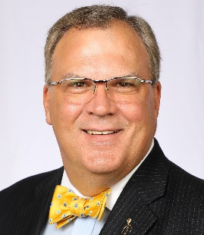
Roger is the Founder & President of Voices in Advocacy® and author of 7 Actions of Highly Effective Advocates. He has more than 30 years of experience as an advocacy professional, speaker, trainer, consultant, and author. As a recognized expert in advocacy engagement and grassroots activation, Roger works with a wide cross-section of organizations from diverse industries. His vibrant personality and a good sense of humor make for engaging and interactive programming that is packaged and delivered in an easy to understand, easy to apply format combining his education, experience, and enthusiasm to drive advocacy success.
Roger is a proud Penn State Nittany Lion and self-confessed political junky having received his education in Political Science. He has been an advocate for citizen involvement since the age of 13. Elected, three times to public office as a young man, served as a state legislative staff member, and have worked on many political campaigns from his very own clear up to presidential campaigns.
His work spans a cross-section of local, regional, national and international organizations. Roger authored The DMO Advocacy Toolkit for Destinations International. Voices in Advocacy® built a grassroots meetings industry advocacy platform for the Convention Industry Council called the CIC AdvocacyHub™. Developed an On-Line Advocacy Academy.
He has served in numerous industry associations’ leadership roles, is a recipient of several international industry awards, and is a member of Meeting Professional International’s prestigious “Community of Honoree’s”.
He is often interviewed by radio, print and television media, highlighted by the MSNBC show Your Business. Smart Meetings Magazine did a cover story on Roger, entitled Passion & Purpose, Roger Rickard’s Call to Action. Successful Meetings Magazine named Roger one of the Six People Worth Watching in the Meetings Industry. Meetings Focus Magazine named him to their inaugural list of Meetings Trendsetters. He is often called upon to comment on or write about the advocacy issues of the day.
Roger is a BIG man at 6’8”, a BIG thinker, and he has BIG ideas for helping you succeed with advocacy. He is casually known as the BIG GUY with a BOW TIE.

