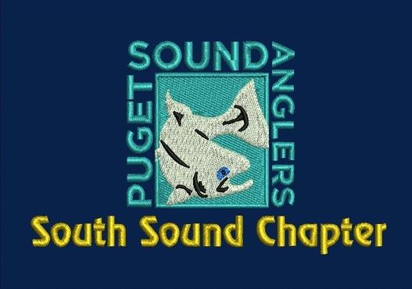

SSPSA Apparel Order -- Fall 2017

We will be taking club apparel orders at the November 2nd club meeting, and we plan to distribute the apparel at the following meeting (the Christmas Party). At the top of the page, is a graphic artist’s rendering of the club logo. Below is a graphic artist’s rendering of generally how the logo will look on the embroidered hats/garments (left chest on the garments, and front/center on the hats). All garments will be navy blue. T-shirts will be screen-printed, with a small logo on the left chest, and a larger logo on the back. All other garments will be embroidered. Baseball hats will be navy blue, with the mesh style hats having a navy blue front and a white back. Updated prices are listed on the next page.

If you have any questions, please feel free to contact
Chris Salp (chris.salp@gmail.com, 703-966-0961)

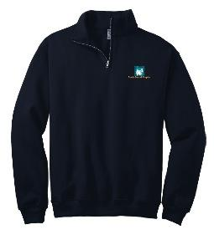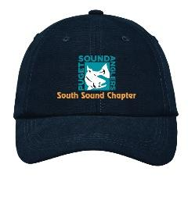

SSPSA Apparel Order -- Fall 2017 -- UPDATED PRICES

ITEM  Most items available from Small to 4XL;  Items marked (T) are also available in LT to 4XLT | Base Price | Extended Sizes  (above XL and/or Tall, per size) | Size and Qantity | Total
Ball cap, canvas | $14 | --
Ball cap, mesh | $14 | --
L/S T-shirt, pocket (T) | $19.50 | $2.50
L/S T-shirt (T) | $17.50 | $2.50
S/S T-shirt, pocket (T) | $16.50 | $2.50
S/S T-shirt (T) | $14 | $2.50
Port Authority Silk Touch Polo (T) | $19.50 | $2.00
Port Authority Digi Heather Performance Polo* | $24 | $2.00
Hvy Cot. Hoody, pullover * | $39 | $2.00
DWR Lt. Fleece Hoody | $48 | $2.00
65/35 Mid Hoody (T) | $33 | $2.00
65/35 Hoody, zip (T) | $38 | $2.00
Fleece, Pullover, ¼ zip (T) | $27.50 | $2.00
Fleece, full-zip (T) | $30 | $2.00
Jacket (T) | $52 | $2.00
Vest, Reversible | $36 | $2.00
Vest, Fleece | $28 | $2.00
Port and Company Beanie Cap | $8.50 | --
Acrylic Knit Cap, Fleece-lined | $10.50 | --
 |  | GRAND | TOTAL: | $

 | No current picture for  Ball cap, mesh | No current picture for  L/S T-shirt, pocket (T)
No current picture for  L/S T-shirt (T) | No current picture for  S/S T-shirt, pocket (T) | No current picture for  S/S T-shirt (T)
 | 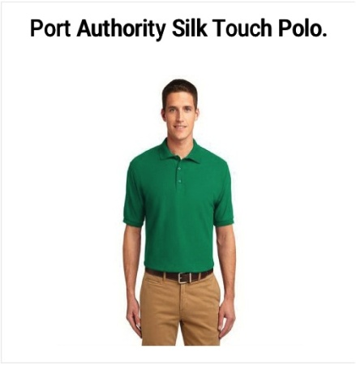 | "Please note that we are ONLY offering the PULLOVER version of this hoody."  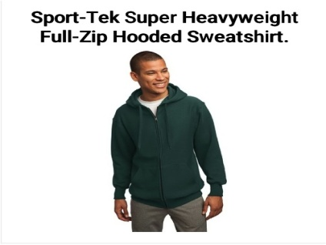
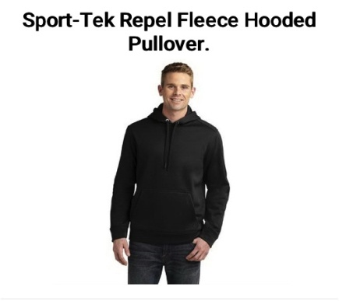  "This hoody is listed as 'DWR Lt. Fleece Hoody'" | 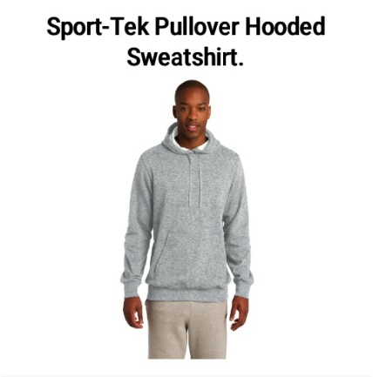 | 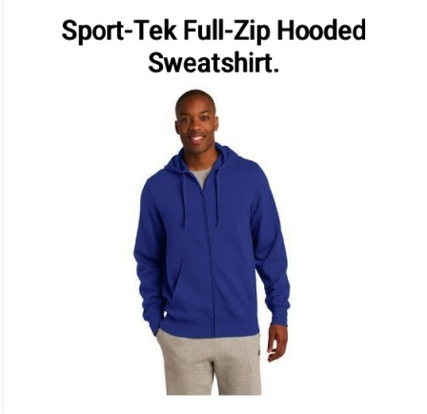
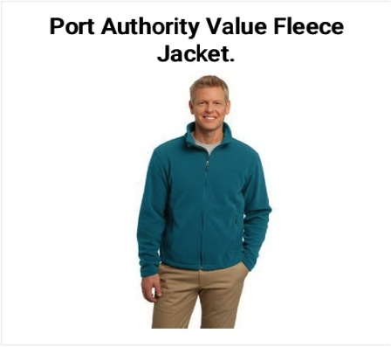 | 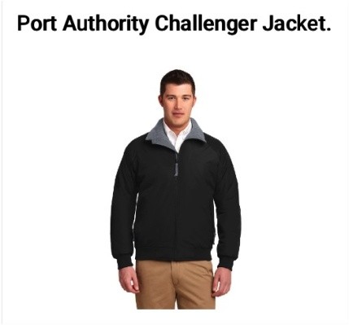 | 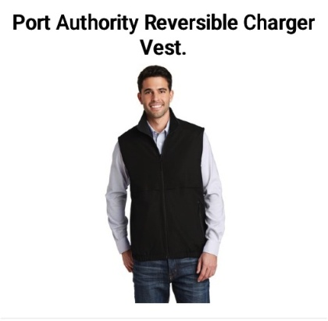
 | 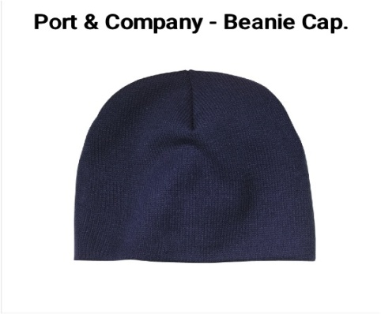 | No current picture for  Acrylic Knit Cap, Fleece-lined

