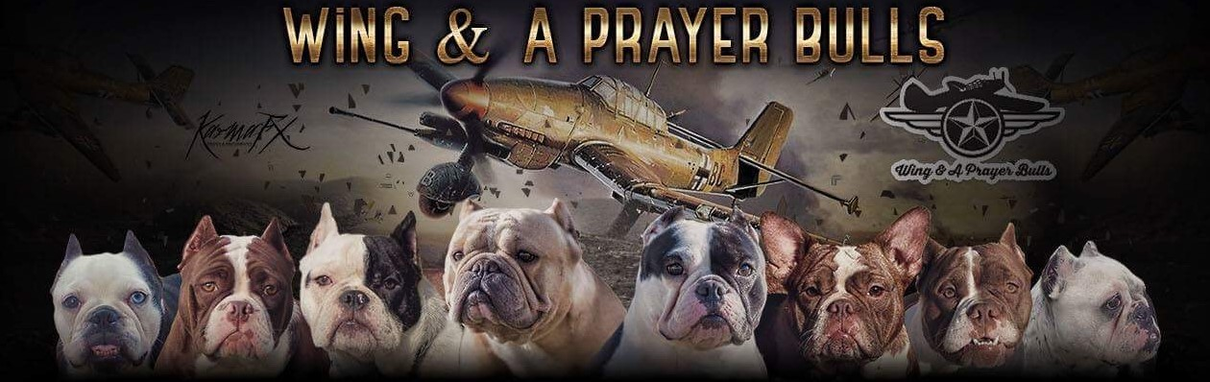

CONGRATULATIONS on your SHORTYBULL!

This agreement is made this *th day of ** 2018, and is between the seller and the buyer as named below:

Breeder: Rhiannon Barreda, “Wing & A Prayer Bulls” in Fredericksburg, VA

Buyer: ***

|  |  |
| --- | --- |
| **BREEDER**  Rhiannon Barreda, fly_army_copters@hotmail.com | **BUYER**  ***** |
| (571)581-5623  515 W. Rocky Run RD  Fredericksburg, VA 22406 | ***** |

The buyer agrees to obtain from the seller one *male/female Shortybull* puppy

Sex: ***, Color: ***

Date of birth: ***

For the cost of ***

Terms:

This dog is not being sold under co-ownership terms. Payment in full must be made at pickup unless a payment plan has been arranged and detailed in this contract. Payment is to be tendered in cash, money order or certified draft. In the event that the chosen puppy expires or is injured prior to Buyer taking possession, Seller will refund amount paid to date or apply to another puppy, whichever the Buyer prefers.

Health Guarantee:

The seller certifies that, upon receipt, the dog is in good health and has been immunized and wormed according to the accompanying heath record.

The Buyer's Responsibility:

The Buyer agrees to take good care of this dog, feed and house the dog properly (indoors- dogs will not be adopted out to outdoor only homes), maintain current vaccinations, and practice good stewardship by maintaining control of the dog on a leash when in public/ off the premises of the dog's home. The dog's outdoor area will be fenced in and secure, or acceptable provisions will be made to assure the dog is safe any time he/she is outdoors. Buyer agrees to give the dog proper physical and emotional care and welfare. If the dog is found to be allowed to run freely, running at large, creating a public nuisance, or found to be neglected, abused or allowed to live in poor health or poor conditions the seller has ALL rights to repossession of this dog with no refund to the buyer. The death, injury or loss of said dog due to theft, carelessness, recklessness, abuse, neglect, heat stroke or accident will not entitle the buyer to any compensation. Additionally, Wing & A Prayer Bulls has a lifetime “take back” policy should owner not wish to retain the dog. Owner must contact seller prior to rehoming or selling the dog. AT NO TIME will the dog be taken to a shelter. Any owners found to be responsible for bringing their dog to a shelter or for subjecting their dog to less than adequate care WILL be prosecuted to the fullest extent of the law. Again, seller MUST be notified if Buyer chooses to re-home the dog.

This dog is warranted only for the purpose of being a companion animal, not for any other purpose or reason. No warranty is given to the buyer for any special purpose or function of this dog. This dog is not to be used for any illegal or immoral activities such as dog fighting, and is not to be used for any type of “puppy mill,” dog farm or other mass producing/money making operation.

Any changes to this contract must be in writing and signed by both parties. This contract is legal and may be enforced by legal means at the buyer’s expense and all disputes must be settled in the breeder’s state of residence.

|  |  |  |
| --- | --- | --- |
| Rescue |  | Owner |
| Name: Rhiannon Barreda |  | Name: *** |
| Signature: |  | Signature: |
|  |  |  |