The Monthly Silence
The Monthly Newsletter for Hopewell Centre Meeting
of the Religious Society of Friends

Eleventh Month, November 2021

Hopewell Centre Meeting of the Religious Society of Friends
604 Hopewell Road, Clear Brook, VA 22624
Telephone: 540-667-9114 Website: www.winchesterquakers.org

Dick Bell, Clerk of the Meeting, 304-268-8510
Donna Knight, Assistant Clerk of the Meeting, 540-771-8118
Karen Nelson and Martha Hanley, Pastoral Care. Call Karen at 301-351-5538 or knel23@yahoo.com
Michele Christopher, Newsletter, Michele.christopher@hotmail.com, 540-908-8414
*If possible, The Monthly Silence will be published on or soon after the 20th of each month. Please send items you want included in the newsletter by the 17th of the month.

Please send donations to:
Hopewell Centre Friends
c/o Jim Riley
1321 Vanceright Circle
Winchester, VA 22601

Hopewell Centre has a New Website
www.winchesterquakers.org
Eventually we would like the website to be group supported. Michele Sunderlin, who built it for us, is coming up with a booklet of "how to's" so anyone in the Meeting can work with updating/editing/etc. Please check it out and decide how you might like to get involved with the content. Each committee will have its own page to update its activities for visitors to see. The committee pages are still in development.

Pastoral Care

Please hold in The Light:

Hilde's son Kenneth is being treated for severe neuropathy. He receives treatments three times a week. His condition has grown more serious. He is confined to a wheelchair and is unable to use his hands. Hilde is very worried about him. Lets keep him and his family in the Light.
Becky Ebert is doing well. Her surgery is tentatively scheduled for Nov. 17

Robyn and Gerry are doing well after their car accident a few weeks ago. Robyn's eye surgery rescheduled for Nov. 12.

Michele Christopher's knee surgery is set for Nov. 3.

Scott Lynch is doing very well after his heart attack a few weeks ago.

Please continue to hold in the Light:
Dick Bell's dad
Josh Riley
Karen Nelson's son Bobby

Eloise Haun is well and has thoroughly enjoyed lunch visits on her front porch with a few Hopewell members.

Meeting for Business

This month the Minutes of the Business Meeting held October 10 are attached to this email as a PDF.

Cookbook for Christmas

The meeting still has copies of Quake ‘N Bake, the 2011 cookbook featuring recipes from Hopewell Centre Friends. It was produced to raise money for the Hopewell interior renovations. It features more than 100 pages of recipes for appetizers, soups, salads, vegetables, main dishes, breads, and desserts. Proceeds from all sales go toward our shelter project. Cost is $10. If you want any mailed to you, include a few extra dollars. Donations more than $10 are gratefully accepted. Pick them up at Hopewell or drop us a note if you want some mailed. Christmas is coming and this gift keeps giving for many years to come! See recipes in photos below!
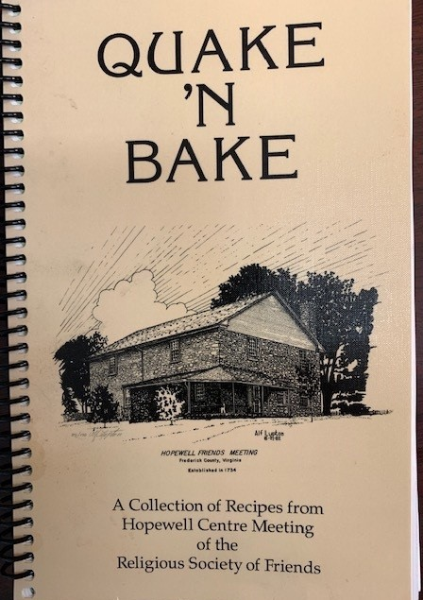
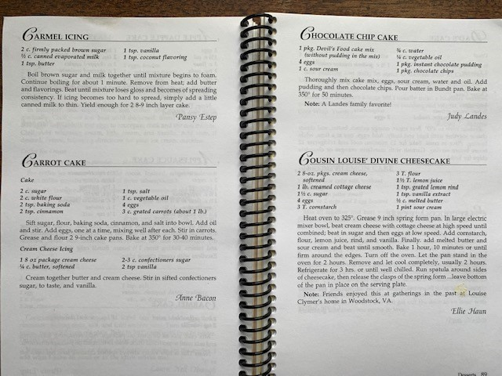

Community Prayer Group
Hosted by Hopewell Centre Religious Society of Friends (Quakers)

We invite all to community prayer,
A time and place for prayer, meditation, and silence,
With scripture, readings, song, and shared thought,
With a wish to unite in light, life, and healing.

Thursday evenings, 7:00 to 8:00 p.m.
2nd and 4th Thursdays of each month
At Centre Meeting House
203 N. Washington Street, Winchester, Virginia
(where Washington Street intersects with Piccadilly Street)
Why Host a Community Prayer Group?
We are deeply concerned about…
-community unrest and practices of inequality that are divisive forces in our neighborhoods and nation,
-the personal needs of our neighbors, both physical and spiritual,
-equitable education,
-public health issues such as drugs, violence, mental health, and incarceration,
-climate disruption and the need for stewardship of our natural resources,
-global unrest that leads to instability and violence.

How Does God Call Upon Us to Act?
We pray together to bring the power of collective prayer and positive energy to these concerns. We pray together to build unity and support for positive actions in all our areas of concern.

Please Join Us.
Are you unable to come, but have a prayer request? Please email hopewellcentrequakers@gmail.com and we will include your request in our prayers.

From the Clerk XVI

It was the week after July 4th in 1969. I was in Britain, specifically sitting in the late morning service of Common Prayer, at Westminster Abbey. I was situated several rows back in the northern transept of the great cathedral, surrounded by fellow members of the Potomac English Handbell Ringers, who were undertaking their first of many European tours. The PEHBR, as we short-styled ourselves, were a group of 13 teenagers and a genius of a director (though none of us would then have used that noun to characterize her) Nancy Poore Tufts, which played mostly short versions of classical music that Mrs. Tufts had arranged brilliantly herself. I was the eldest member, old enough to be the driver of our van, at 19. We weren’t there to play – though we would play our finest concert I ever recall there four years later. We were American kids going to church on a Sunday. Because we were in London. Because this was one of the most famous places of worship in all of Christendom.
I remember being overcome with the immense grandeur of it all. The history. The majesty. The sheer fact that Dick Bell of Oxon Hill, Maryland, born in Boyce, was sitting where monarchs were crowned, where so much of the soul of the English-speaking world was centered, was clearly more than I could process at the time. I was focused on the small things: the order of the service, rising, kneeling, and sitting at correct times, singing the hymns in my best voice, bowing my head earnestly in prayer. The fact that one of the most profound moments of my lifetime was about to take place was nowhere close to my consciousness.
Then I noticed it. I felt the warmth of it first. The light on my shoulder.
A shaft of light had broken through the clouds of the day and illuminated me. I opened my eyes from prayer and saw that I was perfectly framed in the shaft. None of the light touched my partners on either side or the person in front. It was as if I were alone in the vast, silent throng of worshippers, and for some reason this single ray of light spotlighted me. That’s when the intense emotions just beneath my calm burst out. Why was I being highlighted? Why was I the only one to be aware of my special favor? I closed my eyes and re-entered prayer, sure that the trick of the sun would soon play away.
The light did not move.
I looked up and saw the sun swimming through the mist of clouds in the clerestory window across the nave above me. It was perfectly centered. The shaft did not bleed right or left. It was as if the finger of God was pointing right at me. Immovable. Undiminished. Irrefutable. Honoring every thought I had ever dreamed about religion and its glory. The moment of Bernini’s The Ecstasy of St. Theresa was not art; it was real! Christ and his host of angels would surely descend, and the world would be made anew.
It was too much. I had to close my eyes.
I was determined to wait it out. The light had to move. Had to.
I opened my eyes again. It was still there. I was having my own private service, my own miracle. Every thought or feeling I had had about God or Jesus or church tumbled in a tsunami through my mind. Why was everyone around me silent and bowed? Could they not see the sign?
I closed my eyes and passed out of time.
When I became aware, the shaft of light was gone. Clouds filled all the windows I could see. There was no sun light in the cathedral. Just weak bulbs flickering.
The service soon ended, and we gathered ourselves to leave, everyone else making small talk and odd comments. I was silent.
What could I say? How could I explain to anyone what had just happened to me? Why had I been chosen? What did it mean?
Decades later I worked out the orientation of the abbey. And I came to realize that the sun was at its true midday, and because it was close enough to the solstice lingered at its apex. A ruse of the weather gave a break in the clouds through which it shone. And much as time seems endless at the moment of an accident where every detail emblazons itself on your memory as if you have stepped out of time so the moments must have been for me. But the realization of the event followed many years after its effect. The emotions I had felt forever invested me.
I had experienced a numinous moment. We all have them. Unexpected intersections with “that of God.” Ultimately this moment wordlessly confirmed in me that God was thunderously real and that Spirit loved me.
For years I could not utter “the power and the glory…” without thinking of it.
Respectfully submitted,
R. Dixon Bell, October 16, 2021

Happy Birthday, Friends!

November 1 Lisa Mortensen
November 7 Dick Bell
November 17 Betty McCormick
November 20 Michele Christopher
November 26 Pam Hambach

NOVEMBER 2021 CALENDAR

October 24—Potluck Fellowship at Centre

November 7—Religious Education (RE)“The Parables of Jesus" led by Paul Britner

Nov. 14—Meeting for Business

November 21—(RE) “The Way of the Pilgrim" led by Donna Knight.
November 28—Potluck Fellowship at Centre

Community Prayer Group
Thursday evenings, 7:00 to 8:00 p.m.
2nd and 4th Thursdays of each month
At Centre Meeting House

Hopewell Centre Meeting of the
Religious Society of Friends
604 Hopewell Road
Clear Brook, VA 22624

