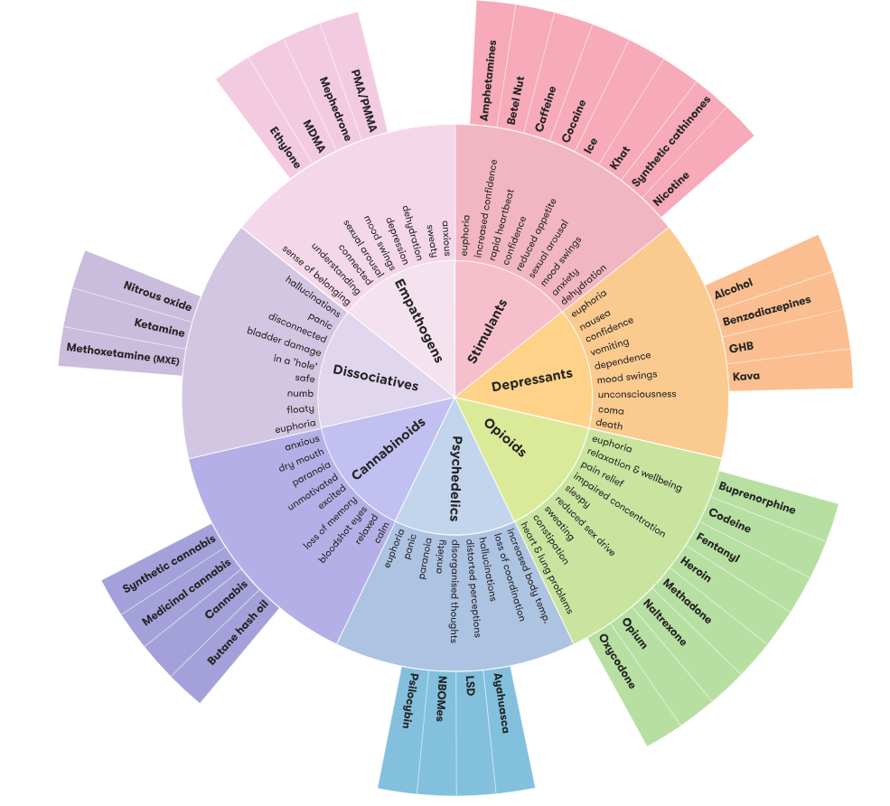
ADF

Drug Facts - Alcohol and Drug Foundation (adf.org.au)

