RVJFC – EMERGENCY ACTION PLAN & RISK ASSESSMENT V1.10
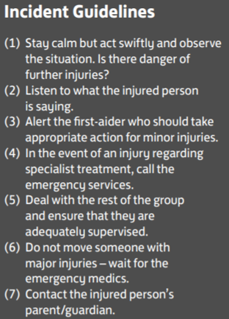
VENUE DETAILS
Venue Name: | ALDER GRANGE SCHOOL
Venue Address: | CALDER RD  RAWTENSTALL  ROSSENDALE
Venue Postcode: | BB4 8HW

FIRST AID EQUIPMENT AND FACILITY LOCATIONS
Item | Location
Defibrillator | N/A
First Aid Room | N/A
ACCESS ROUTES FOR EMERGENCY SERVICES
Route | Directions
Access To Main Area: | TURN LEFT AT THE MINI-ROUNDABOUT OUTSIDE THE SCHOOL ON CALDER ROAD (THROUGH THE NARROW OPENING) AND DRIVE UP TO THE CAR PARK AT THE TOP  **ENSURE BOTH BOLLARDS ARE REMOVED WHEN USING THIS VENUE**
Main Area To Pitch: | TAKE THE PATH UP FROM THE CAR PARK ON THE LEFT-HAND SIDE (PAST THE CONTAINER) AND THROUGH THE GATES AT THE TOP TO ACCCES THE PITCHES

NEAREST HOSPITAL (WITH EMERGENCY DEPARTMENT) DETAILS
Hospital Details: | ROYAL BLACKBURN HOSPITAL  HASLINGDEN RD, BLACKBURN  BB2 3HH  01254 263555
Journey Time: | APPROX 25 MINS (9.8 MILES)
Nearest Walk-In Centre Address: | ROSSENDALE MINOR INJURIES UNIT  PRIMARY HEALTH CARE CENTRE, BACUP RD, RAWTENSTALL  BB4 7PL
Journey Time: | APPROX 6 MINS (1.4 MILES)

RISK ASSESSMENT & MITIGATIONS
Player, spectator or coach suffers injury or incident and requires medical attention | First-aid qualified coach to attend every training session or match
General trip hazards on or around pitch could cause incident or injury | Pitch to be cleared of any hazardous items on or within vicinity of playing area
School goals situated at side of pitch present collision hazard | Goals to be carefully moved away from exterior of pitch depending on pitch size and format being used
3G surface hazardous if tears/seams present | Pitch to be inspected during setup and prior to training/match commencing. Session to be cancelled if pitch deemed unsafe
3G surface hazardous if icy | Session to be cancelled if pitch deemed unsafe
Hazardous items left on pitch after school use (pens, pencils, bottle tops, etc) | Pitch to be inspected during setup and prior to training/match commencing. Hazardous items to be removed and disposed of in bins
Injury from setting up or packing away equipment before and after sessions | Larger items of equipment (in particular goals) to be carried by a minimum of two adults. Where ladders are required to be used (e.g. placing netting on goals), two adults should be present to ensure ladders are stable and do not present fall hazard.  Children should not assist with lifting large items of equipment
Injury from equipment improperly assembled or used | Coaches to check all equipment (specifically goals) to ensure safety of players prior to session starting. All equipment only to be used for intended use case
Safe entry & exit to and from 3G playing area for coaches, players and spectators | Only the main, double-gated entrance to be used for entry/exit to/from 3G (steps and grass approaches to 3G at far end of pitch are not considered safe and are not to be used)

