|  |  |
| --- | --- |
| **Date:** |  |
| **Time:** |  |
| **Team:** |  |
| **Manager/Coach:** |  |
| **Event:** |  |

**ROSSENDALE VALLEY JFC – INCIDENT/ACCIDENT REPORT FORM V1.00**

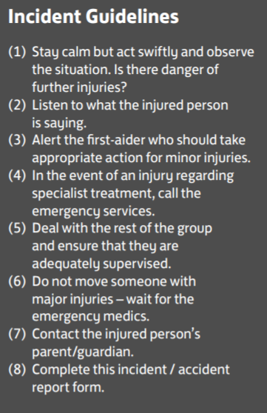

**INJURED PERSON’S DETAILS:**

|  |  |
| --- | --- |
| **First name:** |  |
| **Surname:** |  |
| **Date of birth:** |  |
| **Address:** |  |
| **Postcode:** |  |
| **Tel no:** |  |

**DETAILS OF ALL PERSONS INVOLVED IN INCIDENT:**

|  |  |
| --- | --- |
| **Full name of person** | **Contact no:** |
|  |  |
|  |  |
|  |  |

**DETAILS OF WITNESSES:**

|  |  |
| --- | --- |
| **Full name of person** | **Contact no:** |
|  |  |
|  |  |

|  |  |  |
| --- | --- | --- |
| **Describe incident and/or injury:** | **Describe treatment given (if any):** | |
|  |  | |
| **Emergency services called?** YES/NO | **Did person lose consciousness?** YES/NO | |
| **Advice given to person/parents:** | **Person sent to hospital?** YES/NO | |
|  | **Name:** |  |
| **Signed:** |  |
| **Date:** |  |

**PLEASE FORWARD TO RVJFC WELFARE OFFICER ASAP FOLLOWING INCIDENT**