RVJFC – EMERGENCY ACTION PLAN & RISK ASSESSMENT V1.10
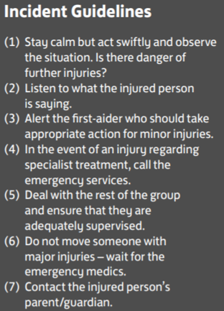
VENUE DETAILS
Venue Name: | ST PETER’S PLAYING FIELDS
Venue Address: | ST PETER’S AVENUE  HASLINGDEN
Venue Postcode: | BB4 6NZ

FIRST AID EQUIPMENT AND FACILITY LOCATIONS
Item | Location
Defibrillator | Nearys, 425-427 Helmshore Rd, Helmshore, Rossendale BB4 4JR
First Aid Room | N/A
ACCESS ROUTES FOR EMERGENCY SERVICES
Route | Directions
Access To Main Area: | TURN OFF ST PETER’S AVENUE THROUGH THE GATE AND FOLLOW THE DRIVEWAY DOWN THE RIGHT-HAND SIDE OF THE UPPER CAR PARK TO THE LOWER PARKING AREA
Main Area To Pitch: | PITCHES ACCESSIBLE DIRECTLY FROM LOWER PARKING AREA

NEAREST HOSPITAL (WITH EMERGENCY DEPARTMENT) DETAILS
Hospital Details: | ROYAL BLACKBURN HOSPITAL  HASLINGDEN RD, BLACKBURN  BB2 3HH  01254 263555
Journey Time: | APPROX 18 MINS (7.6 MILES)
Nearest Walk-In Centre Address: | ROSSENDALE MINOR INJURIES UNIT  PRIMARY HEALTH CARE CENTRE, BACUP RD, RAWTENSTALL  BB4 7PL
Journey Time: | APPROX 10 MINS (2.6 MILES)

RISK ASSESSMENT & MITIGATIONS
Player, spectator or coach suffers injury or incident and requires medical attention | First-aid qualified coach to attend every training session or match
General trip hazards on or around pitch could cause incident or injury | Pitch to be cleared of any hazardous items on or within vicinity of playing area
Pitch hazardous due to slippy/muddy surface, pot holes or dog excrement | Pitch to be inspected during setup and prior to training/match commencing. Session to be cancelled if pitch deemed unsafe
Injury from setting up or packing away equipment before and after sessions | Larger items of equipment (in particular goals) to be carried by a minimum of two adults. Where ladders are required to be used (e.g. placing netting on goals), two adults should be present to ensure ladders are stable and do not present fall hazard.  Children should not assist with lifting large items of equipment
Injury from equipment improperly assembled or used | Coaches to check all equipment (specifically goals) to ensure safety of players prior to session starting. All equipment only to be used for intended use case

