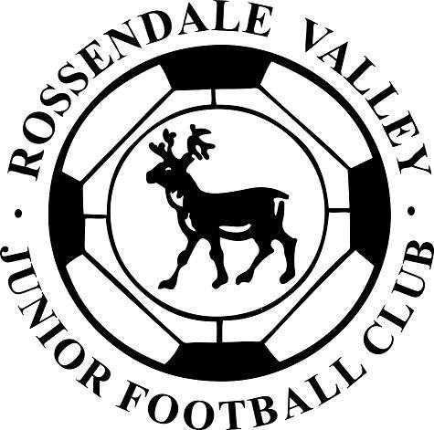

**I understand that if I do not follow the Code,**

**any/all of the following actions may be**

**taken by my club, County FA or The FA:**

**I may:**

• Be required to apologise to my team-mates,

the other team, referee or team manager

• Receive a formal warning from the coach or

the club committee

• Be dropped or substituted

• Be suspended from training

• Be required to leave the club.

**In addition:**

• My club, County FA or The FA may make my

parent or carer aware of any infringements of

the Code of Conduct

• The FA/County FA could impose a fine and

suspension against my club.

*All players will pay for all fines incurred (red and yellow cards) whilst playing for the Club

**TheFA.com/Respect**

**YOUNG PLAYERS**

**Respect code of conduct**

We all have a responsibility to promote

high standards of behaviour in the game.

As a player, you have a big part to play.

That’s why The FA is asking every player

to follow a Respect Code of Conduct.

**When playing football, I will:**

• Always play to the best of my ability

• Play fairly – I won’t cheat, complain

or waste time

• Respect my team-mates, the other team,

the referee or my coach/manager

• Play by the rules, as directed by

the referee

• Shake hands with the other team and

referee at the end of the game

• Listen and respond to what my coach/

team manager tells me

• Talk to someone I trust or the club welfare

officer if I’m unhappy about anything at

my club.

**By signing this form you agree to abide by the rules set out above in the RESPECT code of conduct for “young players”. This document was implemented in the club on 17th April 2012 by the RVJFC committee.**

Name of player: _______________________ Team signed for: ___________________

Signature of player: ____________________ Date: / / 2019

This section must be signed by the registered player and returned to the clubs secretary along with the players personal details form. Many thanks.