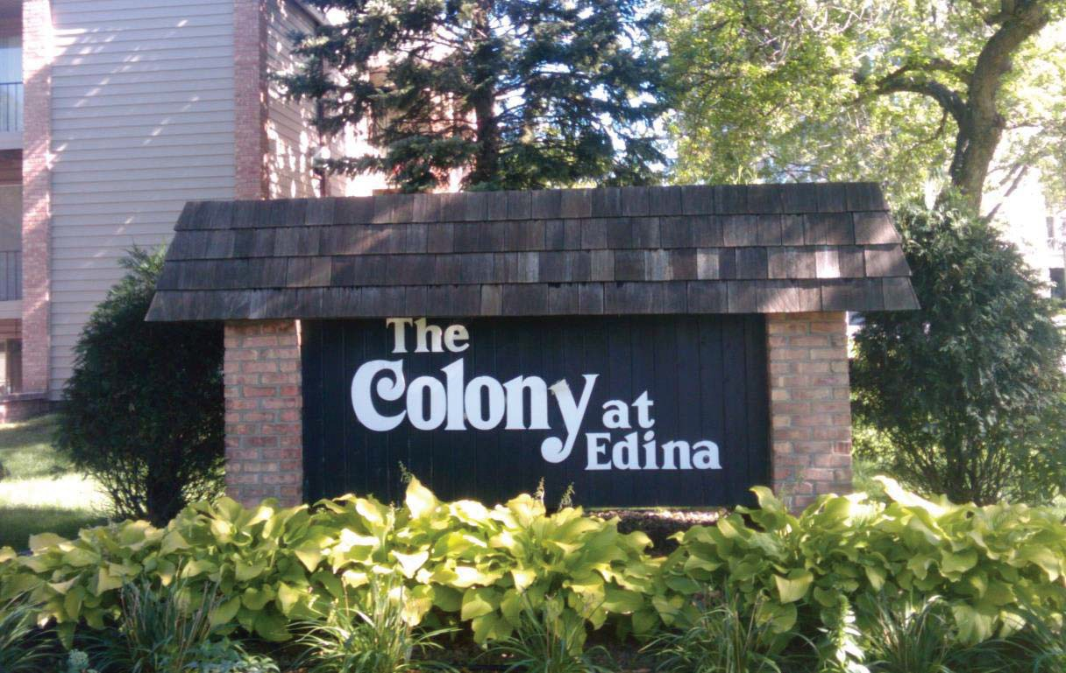

Articles of Incorporation Declaration Bylaws of
The Colony at Edina Condominium Association

6330 Barrie Road
Edina, Minnesota 55435
952.920.6464
www.colonyedina.com

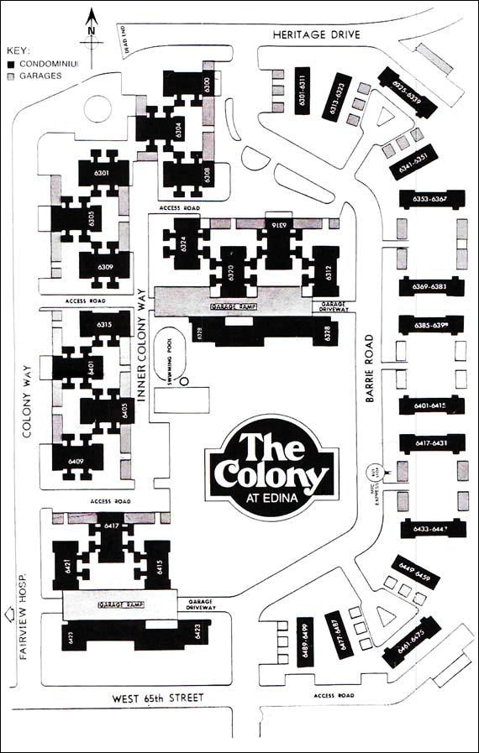

ARTICLE OF INCORPORATION OF
THE COLONY AT EDINA CONDOMINIUM ASSOCIATION

The undersigned, for the purpose of forming a corporation pursuant to the provisions of the Minnesota Nonprofit Corporation Act, Minnesota Statutes, Chapter 317, adopt the following Articles of Incorporation:
ARTICLE I

The name of this corporation shall be The Colony at Edina Condominium Association.

ARTICLE II

This corporation is organized and shall be operated for the purpose of constituting and acting as the association of apartment owners within the meaning of Minnesota Statutes Chapter 515, known as the Minnesota Condominium Act for The Colony of Edina Condominium which is to be duly constituted under said Chapter 515 upon certain land in Hennepin County, Minnesota. Such purposes shall include, but not be limited to the following:
- To maintain, manage and administer the affairs, the real estate and other property of the Association;
- To levy and collect assessments from the members and to use the proceeds thereof for the purpose of the Condominium;
- To carry insurance pertinent to the ownership, use and maintenance of the Condominium property, as well as on any personalty of the corporation, exclusive of any coverage for

contents and personal effects belonging to any of the members; to collect all premiums and charges for same from the members, and to use, reimburse, or expend the proceeds for the rebuilding, repair renovation, rehabilitation, and/or replacement of any loss or damage to any of the above property, as provided for in the By-Laws;
- To contract for and employ persons, firms or corporations to assist in the management, operation, maintenance and administration of said Condominium;
- To make and enforce reasonable regulations concerning the use and enjoyment of said Condominium;
- To own, maintain and improve and to buy, sell, convey, assign, mortgage or lease real and personal property and to borrow money or issue evidences of indebtedness in furtherance of any or all of the within objects, and to secure the same by mortgages, pledge or other lien, subject to limitations contained in the declaration.
- In general, to enter into any kind of activity, to make and perform any contract and to exercise all powers necessary, incidential or convenient to the administration, management, maintenance, repair, replacement and operation of said Condominium and to the accomplishment of any of the purposes thereof;
- To do anything required of or permitted to it as administrator of said Condominium or as the association of apartment owners by the Minnesota Condominium Act and any further laws amendatory thereof and supplementary thereto, and by the

Declaration and By-Laws of The Colony at Edina Condominium, as filed and amended from time to time;
- To exercise such other powers which are consistent with the foregoing purposes and which are afforded to the corporation by the Minnesota Nonprofit Corporation Act and any further laws amendatory thereof and supplementary thereto.
ARTICLE III

This corporation does not and shall not, incidentally or otherwise, afford pecuniary gain to, its members, directors, or officers; provided, however, that this corporation may pay to its members, directors, and officers out-of-pocket expenses incurred in the performance of their duties, and may lease and purchase from, sell to, and otherwise deal with, its members, directors, officers and others in real and personal property situated in Hennepin County, Minnesota and may hire members, with Association approval, to perform professional services, i.e., accountant or attorney, and shall have the power to own, encumber and sell units within this Condominium.
ARTICLE IV

The period of duration of this corporation shall be perpetual.

ARTICLE V

The registered office of this corporation in the State of Minnesota shall be located at 6328 Barrie Road in the City of Edina, County of Hennepin.
ARTICLE VI

In the event of dissolution of this corporation, all of its then assets shall be distributed as follows:

- The dissolution shall be conducted under court supervision if required or permitted under the statutes of the State of Minnesota, as now enacted or as hereafter amended, and, subject to prior compliance with Subdivision 1, clauses (2), (3) and (4) of Section
  - of the Minnesota Statutes, the assets of this corporation shall be distributed to the members of the corporation pro rata in accordance with their respective interests in the common areas and facilities of the condominium property.
- If the dissolution under court supervision is not required or permitted under the Statutes of the State of Minnesota, as now enacted or as hereafter amended, the assets of this corporation shall be distributed, subject to prior compliance with Subdivision 1, clauses (2), (3) and (4) of Section 317.57 of the Minnesota Statutes, to the members of the corporation pro rata in accordance with their respective interests in the common areas and facilities of the condominium property.
ARTICLE VII

The names and addresses of the incorporators, each of whom is a natural person of full age, are:
NAMES ADDRESSES

N. Walter Graff 4040 IDS Center, Minneapolis, MN 55402

Richard A. Peterson 4040 IDS Center, Minneapolis, MN 55402 Marinus W. Van Putten, Jr. 4040 IDS Center, Minneapolis, MN 55402
ARTICLE VIII

- The first Board of Directors of this corporation shall consist of three (3) persons; and the name and address of each of them are:

NAMES ADDRESSES
Allen C. Glorvigen Home Federal Savings & Loan 730 Marquette Ave. So.
Minneapolis, MN 55402

H.R. Swanson 4400 Briarwood Dr. Minnetonka, Minn. 55343

Jonathan P. Abbott 6750 France Ave. So.
Suite 123
Edina, Minn. 55435

- From time to time, the number of directors of this corporation may be increased or diminished by vote of the members or of the Board of Directors of this corporation in accordance with the By-Laws of this corporation, but shall be no less than three (3) in number.
ARTICLE IX

Members, directors and officers of this corporation shall not be personally liable to any extent whatsoever for obligations of this corporation.
ARTICLE X

This corporation shall have no capital stock, either authorized or issued, nor shall it have a corporate seal.
ARTICLE XI

These Articles may be amended by a vote of the holders of a majority of the undivided interest as shown in Exhibit A to the Declaration; provided that any amendments affecting the matters described in Article XII, Section D of the Declaration must have the prior written consent required by said Section and the prior written consent of the Declarant, so long as it is an Owner (as such terms are defined in the Declaration).

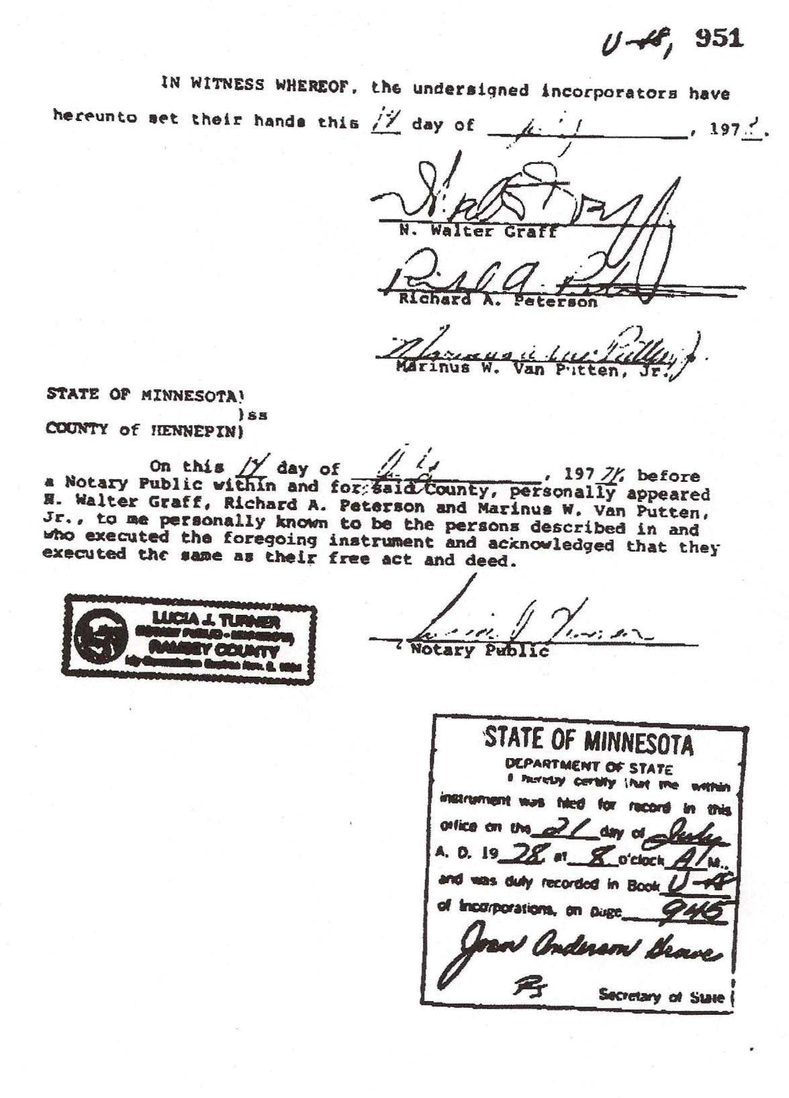

-6-

THIS PAGE LEFT BLANK INTENTIONALLY

DECLARATION ESTABLISHING A PLAN FOR APARTMENT OWNERSHIP PURSUANT TO THE MINNESOTA CONDOMINIUM ACT

APARTMENT OWNERSHIP NO. 120 THE COLONY AT EDINA CONDOMINIUM
THIS DECLARATION made, the 2nd Day of October , 1978, by The Colony at Southdale, a Limited Partnership, hereinafter called "Declarant", and made pursuant to, and submitted to the provisions and authority of Chapter 515, Minnesota Statutes Annotated, the "Minnesota Condominium Act", hereinafter called the "Act".

WITNESSETH:

The purpose of this Declaration, in conformity to the Act, is to submit the following described property, now owned by Declarant in fee simple, together with the buildings and improvements thereon, to all provisions of the Act.

LEGAL DESCRIPTION:

Par. I Lot 1, Block 1, Southdale Acres, the north line of said plat being marked by Judicial Landmarks set pursuant to Torrens Case No. 10266, according to the plat thereof on file or of record in the offices of the Registrar of Titles in and for Hennepin County, Minnesota.

Par. II Lot 1, Block 3, Southdale Acres, Hennepin County, Minnesota according to the plat thereof on file or of record in the office of the Registrar of Titles in and for said county.

Par. III Tract A, Registered Land Survey No. 1310, files of the Registrar of Titles, County of Hennepin.

ARTICLE I

For the purpose of this declaration, the following terms shall have the designated meaning and/or scope:

    - Apartment Owner.

The person or persons whose estates or interests, individually or collectively, aggregate fee simple absolute

ownership of an Apartment, including the vendee of a recorded Contract for Deed.

    - Perimeter Wall.

Any wall, door, or window separating one apartment from another or from the common areas. A perimeter wall, except for that part thereof included in an Apartment, is part of the common areas and facilities.

    - Apartments.

      - One-level Apartments.
A one-level apartment shall include the inner decorated surfaces of the ceilings and perimeter walls, including paint and wall paper and the floor covering the subfloor. The subflooring under the apartment, the pipes, wires, conduits, or other public utility lines running through the apartment which are utilized for or serve more than one apartment, the perimeter walls and ceilings except the inner decorated surfaces thereof, are common areas and facilities, and are not part of the apartment.

      - Townhouse Apartments.
A townhouse apartment shall include: the inner decorated surfaces of the second floor ceiling and perimeter walls including the paint and wall paper; the floor covering above the first floor subfloor; and the ceiling, joists, subfloor and floor covering within the apartment separating the first floor from the second floor. The subflooring under the first floor, the pipes, wires, conduits, or other public utility lines running through the apartment which are utilized for or serve more than one apartment, the perimeter walls and second floor ceiling except the inner decorated surfaces, are common areas and facilities, and are not part of the apartment.

    - Parcel.
Parcel refers to the entire tract of real estate herein described.

    - Buildings.
Buildings located on the parcel, containing the apartments, as more specifically hereinafter described in Article II.

    - Association.
An incorporated association known as The Colony at Edina Condominium Association.

    - All other terms shall have the meaning assigned by The Act, except as the context otherwise requires.

ARTICLE II

The Declarant, in order to establish a plan of condominium ownership for the Property, hereby divides the Property into the following separate estates in fee simple absolute:

- Apartments.
308 apartments for dwelling purposes separately designated and legally described estates in fee simple absolute, as shown on the Floor Plans for The Colony at Edina Condominium, to be filed in the office of the Registrar of Titles of Hennepin County, Minnesota contemporaneously herewith, which Floor Plans are incorporated herein by reference and made a part hereof, and are hereinafter referred to as Floor Plans.

Apartment Combinations. The Owner of adjoining Apartments, after notification and delivery of plans to the Board, and after the Board determines that the implementation of said plan will not adversely affect the structural soundness of the building or the functioning of any common pipes, conduits, wiring or other utilities, and after obtaining the written consent of holders of all first mortgages then of record against the affected Apartments, may remove, at the Owner's expense, and pursuant to such plans, any ceilings and floors or nonload-bearing partition walls between the owned Apartments for the purpose of using the Apartments together as an integrated whole, and may also make such modifications and alterations inside the owned Apartments, and to installations therein, or may restore any such removed ceilings, floors or walls, all as shown on said plans.

Failure of the Board to make such determination or to object to such plans within 30 days of delivery of a copy thereof to the Board shall be deemed to constitute such determination.

No such physical alterations, removals, or restorations shall affect the separate legal status of each such apartment established by this Declaration or the percentage of undivided interest in the common areas, profits, and expenses allocated to each hereby.

- Common Areas.
The remaining portion of the Property is described and referred to herein as the common areas and facilities or the common areas, which include but are not limited to: laundry rooms, utility rooms, storage areas, hallways, stairs, garages as shown in the Floor Plans, pool area and facilities, Association office/maintenance/recreation/guest room building, all the structural components, conduits, pipes, ducts, wires, utility lines and other conduits for matter and energy which are utilized for or service more than one apartment or the common areas, as well as all personal property owned by the Association intended for use in such common areas.

The Common Areas and Facilities shall not include, however, any areas within partition walls or floors which are removed for the purpose of making those areas a part of two or more adjoining Apartments used together as an integrated whole, so long as such wall or floor areas are used as part of such integrated Apartments, and, as long as so used, such areas shall be a part of the integrated Apartments.

The ownership of each apartment shall include a respective undivided interest in the common areas and facilities as is specified and established in Exhibit A attached hereto and made a part hereof by reference. The undivided interest in the common areas and facilities appertaining to each apartment hereby established cannot be changed, except as provided by the Act, and the undivided interest in the common areas and facilities and the fee title to the respective apartments conveyed therewith shall not be separated or separately conveyed and each said undivided interest shall be deemed to be conveyed or encumbered with its respective apartment even though the description in the instrument of conveyance or encumbrance may refer only to the fee title to the apartment.

- Limited Common Areas.
The following portions of the common areas and facilities herein referred to as "limited common areas", are hereby allocated for use only by holders of an interest and their respective family members, guests, and lessees of particular apartments:

Balconies and patios adjacent to apartments, and garages
identified by Apartment number as shown on the Floor Plans.

Limited common areas do not include garages identified as X 1 through X 10 on the Floor Plans, which shall constitute common areas, exclusive licenses to use each being assignable by the Board.
ARTICLE III
- The description of the land on which the buildings and improvements are located is as set forth above.

- There are Fourteen (14) Two (2) Story Buildings (Townhouse Buildings) containing Six (6) or Eight (8) Townhouse apartments for a total of One Hundred (100) units, Two (2) Three
- Story Buildings (Gallery Buildings) containing Twelve (12) one-level apartments on each floor for a total of Seventy-Two (72) units and Seven:teen (17) Two (2) Story Buildings (Cluster Buildings) containing Four (4) one-level apartments on each floor for a total of One Hundred Thirty-Six (136) units for a grand total of Three Hundred Eight (308) units; numerous garage buildings which are located in the proximity of the units which they service; one outside swimming pool; one outside wading pool; one pool facilities building; and an office/maintenance/recreation/guest room building adjacent to the pool area. These buildings contain no basements except the office/maintenance/recreation/guest room building.

The apartment buildings are principally of frame construction, each unit having its own central heating and air conditioning system.

- The apartment number of each apartment, and a description of its location, approximate area, number of rooms, declared value and percentage of undivided interest in the common areas and facilities and of the value of the property, and immediate common area to which it has access are set forth in Exhibit A and on the Floor Plans. The apartment values as stated therein may not necessarily be the same as the original sale price of a particular apartment.

- The purposes for which the buildings and each apartment are intended and restricted for use are as follows: the buildings shall be used for private residential dwellings or garages and for no other purposes, and apartments shall be occupied and used only by owners, their families, tenants and social guests. The Association may designate a portion of the common area for management and service purposes and may own one or more apartments for management and service purposes, for use by its employees or for other purposes for the benefit of the Association.

The Declarant, however, is irrevocably empowered to sell, lease or rent Apartments to any persons approved by it, including any Apartments reacquired by the Declarant. Said Declarant or its successors or assigns shall have the right to transact on the Condominium any business necessary to consummate sales of Apartments, including but not limited to the right to maintain models, post signs, maintain employees in a sales office, which may include the party room building, use the Common Areas and Facilities and show Apartments. For so long as the Declarant owns any Apartments, neither the Apartment Owners nor the Association nor their use of the Condominium shall interfere with the Declarant's disposition of the Apartments.
Sales office equipment and furnishings, signs and all items pertaining to sales shall not be considered Common Areas and Facilities, and shall remain the property of the Declarant. In the event that there are unsold Apartments, the Declarant retains the right to be the Owner thereof, under the same terms and conditions as other Owners save for this right to sell, lease or rent, as contained in this paragraph.

- The person to receive service of process is Allen C. Glorvigen, Home Federal Savings and Loan Association of Minneapolis, 730 Marquette Avenue, Minneapolis, Minnesota 55402, or other persons as may be designated by the Board of Directors of the Association and filed in the office of the Registrar of Titles, Hennepin County, Minnesota.

- This Declaration may be amended by consent of the holders of 75% of the votes as defined in the attached By-Laws, which consent must be in writing, provided that such amendment shall not be effective unless at least seventy-five percent (75%) of the first mortgages of the apartments or their assigns (based upon one vote

for each first mortgage owned), and owners (other than any sponsor, developer or builder including the Declarant) of the individual apartments based upon the percentage of ownership in the common areas and facilities as set forth in Exhibit A, and Declarant, so long as Declarant is an apartment owner, have given their prior written approval. The percentage of undivided interests assigned to each apartment in the common areas and facilities shall not be altered without the consent of all owners and all mortgagees of record.

ARTICLE IV
Covenants
Declarant, its successors and assigns, by this Declaration, and all future holders of an interests, by their acceptance of their interest, covenant and agrees as follows:

- Encroachments.
If in fact there is a minor encroachment of the common areas and facilities upon an apartment, an appurtenant easement for the encroachment and for the maintenance thereof, so long as it remains, shall and does exist. If in fact there is a minor encroachment of an apartment or limited common area appurtenant to an apartment upon the common areas and facilities or upon an adjoining apartment or apartments, an appurtenant easement for the encroachment and for the maintenance thereof, so long as it remains, shall and does exist. In the event the improvements are partially or totally destroyed, and then restored, the holders of an interest shall permit minor encroachment of parts of the common areas and facilities and of the other apartments upon their respective apartments and of an apartment on the common areas and facilities and appurtenant easements for said encroachments and the maintenance thereof shall exist.

Such encroachments and easements shall not affect marketability of title.

- Easements.
Each apartment is subject to and includes an appurtenant easement through other apartments and common areas for maintenance and repair of the apartments, common areas and facilities, and utilities. Access to the apartments shall be limited to reasonable hours, except that access may be had at any time in case of emergency.

- Membership in the Colony at Edina Condominium Association.
An owner of an apartment shall by virtue of such interest be a member of The Colony at Edina Condominium Association, herein referred to as the Association. When one or more persons hold an interest in an apartment, all such persons shall be members, subject to provisions set forth hereinafter and in the By-Laws.

- Administration.
The administration of the Property shall be in conformity with this Declaration and the By-Laws attached hereto as Exhibit B.

Notwithstanding the foregoing, until the first annual meeting of the Association as provided by the By-Laws, the rights, duties, and functions of the Association shall, at Declarant's option, be exercised by Declarant.

- Compliance with Declaration, By-Laws, Rules and Regulations.
Each holder of an interest or occupant of an apartment shall comply with the provisions of this Declaration, the By-Laws, rules and regulations of the Association properly adopted according to the By-Laws, as either of the same may be amended from time to time, and failure to comply with any such provisions, rules or regulations, shall be grounds for an action to recover damages, or for injunctive relief.

- No Waiver Allowed.
No holder of an interest may exempt himself from liability for his contribution towards the common expenses by waiver of the use of enjoyment of any of the common areas and facilities or by the abandonment of his apartment.

ARTICLE V
Lien of Assessments
All sums assessed by the Association for annual and special assessments for the share of common expenses chargeable to any apartment shall be payable quarterly in advance and as designated by the Board, and shall constitute a lien on such apartments for the full amount of the assessments, effective as of the date due and payable as fixed by the By-Laws, or, in the case of a special assessment, as fixed by the Board, prior to any and all other liens except only
  - tax liens on the apartment, including special assessments, in favor of the State of Minnesota or any taxing subdivision thereof, and (ii) all sums unpaid on the first mortgage of record against such apartment. If any such assessment or installment thereof is not paid within thirty
- days after the date due, such amount not so paid shall bear interest at the rate of eight percent (8%) per annum, or any other legal rate that may be set by the Board, from the end of said thirty (30) day period until paid and such assessment while it or any installment is so delinquent for more than thirty (30) days may be declared due and payable by the Board and such assessment lien with interest may be foreclosed by the Board or by the manager employed by the Board pursuant to the By-Laws, acting on behalf of the Association in like manner as a mortgage of real property. In any such foreclosure on behalf of the Association, all holders of an interest in the apartment shall also be required to pay the costs of such foreclosure, including reasonable attorneys' fees and a reasonable rental for the

apartment, so long as permitted by law, and the plaintiff in such foreclosure action shall be entitled to the appointment of a receiver to collect the same. The Association shall have the power to bid in the apartment at foreclosure sale, and to acquire and hold, lease, mortgage and convey the same. All such holders of an interest shall be jointly and severably liable for such assessments. Suit to recover a money judgment for unpaid common expenses, with interest as above stated shall be maintainable without foreclosing or waiving the lien securing the same, and in such event, the parties liable therefore shall also pay all costs of collection, including reasonable attorney fees.

The purchaser at a foreclosure sale pursuant to a first mortgage of record, or grantee in deed in lieu or other proceedings in lieu of foreclosure, and his successors in interest shall upon expiration of the period of redemption hold title to the apartment free and clear of any lien for assessments to the date thereof and any such purchaser and his successors in interest shall not be personally liable for such assessments. Such unpaid assessments, to the extent not collected from the person personally liable therefore, shall become a common expense collectible by future assessment from all owners including such purchaser or successor.

In a voluntary conveyance of a condominium apartment the grantee of the apartment shall be jointly and severally liable with the grantor for all unpaid assessments by the Association against the latter for his share of the common expenses up to the time of the grant or conveyance, without prejudice to the grantee's right to recover from the grantor the amounts paid by the grantee therefor.

ARTICLE VI
Rental of Apartments
Apartments shall not be rented for transient or hotel purposes nor for any period less than thirty (30) days. Other than the foregoing, an apartment may be leased, provided that said lease is made subject to this Declaration and the By-Laws and rules and regulations established by the Board of Directors as permitted therein.

ARTICLE VII
Insurance
  - General.
The Board of Directors shall be required to obtain and maintain, to the extent obtainable, the following insurance: (a) fire insurance with extended coverage insuring the buildings containing the apartments (including all of the apartments and the fixtures initially installed therein by the Declarant, and specifically including, without limiting the generality of the foregoing, interior walls, interior doors, built-in cabinets

and counters and electrical and plumbing conduits, pipes and fixtures initially installed by the Declarant, but not including carpeting, drapery, wallcoverings, fixtures, furniture, furnishings, or other personal property supplied or installed by apartment owners or tenants) and covering the interest of the Association, the Board of Directors and all apartment owners and their mortgagees, as their interests may appear, for full insurable replacement cost, as determined annually by the Board of Directors; (b) workmen's compensation insurance; (c) public liability insurance in such amounts and with such coverage as the Board of Directors shall from time to time determine, but at least covering each member of the Board of Directors, the managing agent and each apartment owner and with cross liability endorsement to cover liabilities of the apartment owners as a group to an apartment owner and with a "Severability of Interest Endorsement" which would preclude the insurer from denying liability because of the negligent act of an owner or the Association; (d) Officers and Directors liability insurance; and (e) such other insurance as the Board of Directors may determine. All such policies shall provide that adjustment of loss shall be made by the Board of Directors and that the net proceeds thereof shall be payable to the Board of Directors as trustees as provided in the Act. The Board of Directors as trustee for the holders of an interest in the apartments shall pay the proceeds of Insurance for losses in excess of $5,000.00 to a Title Insurance Company (hereinafter referred to as Title Company) acceptable to them to be held in escrow for restoration or division, as is set forth in Article VIII. The proceeds from hazard insurance for losses to the Property subject to this Declaration, or any part thereof, shall be used by the Board of Directors solely for the repair, replacement or reconstruction of the damage Property except in the event of total or substantial damage or destruction of the Property, as provided in Article VIII hereinbelow, unless 75% of the owners (other than the Declarant) of apartments have given their prior written approval not to restore.

All policies of physical damage insurance shall contain waivers of subrogation and waivers of any reduction of pro-rate liability of the insurer as a result of any insurance carried by apartment owners or of invalidity arising from any acts of the insured or any apartment owners. Provision shall be made for issuance of certificates of physical damage insurance to mortgagees.

  - Owner's Responsibility.
Each apartment owner is responsible for insurance for his own benefit insuring his personal liability, and his carpeting, wallcovering, fixtures, furniture, furnishings and other personal property, and fixtures and other property supplied or installed by him or a previous owner or tenant, provided that all such policies shall contain waivers of subrogation and further provided that the liability of the carriers issuing insurance obtained by the Board of Directors shall not be affected or diminished by reason of any such additional insurance carried by any apartment owner.

  - Insurance Premiums.
Insurance premiums for any blanket insurance coverage and the other insurance coverages purchased by the Board of Directors, shall be common expenses to be paid by assessments levied by the Association. An owner, in accepting title to an apartment, irrevocably consents, constitutes and appoints the Association or its representative as his true and lawful attorney-in-fact to act in connection with all matters concerning the purchase and maintenance of all types of property and liability insurance pertaining to the Property, the ownership of his respective apartment and all of the common and limited common areas and facilities appurtenant thereto with any insurance company or group of insurance companies, except such insurance as may have been obtained by the apartment owner himself. Without limitation on the generality of the foregoing, the Association or its representative shall have full power and authority to purchase and maintain such insurance, to collect proceeds and to distribute same to the respective parties entitled to same, or to the owners and their respective mortgagees, as their interests may appear, and to execute all documents, releases and waivers and to do all things on behalf of each owner as shall be necessary or convenient to the accomplishment of the foregoing.

ARTICLE VIII
Damage to the Property
- Decision to Restore.
In the event all or any portion of the Property is substantially damaged, or is taken by exercise of the power of or in the nature of eminent domain, or by an action or deed in lieu thereof, the restoration or disposition of the Property shall be determined in the following manner:

  - If a majority of the total number of apartments are tenantable after the damage, then the damaged portion of the improvements shall be restored, provision for reconstruction to be made not later than one hundred twenty (120) days from the day of damage.

  - If less than a majority of the total number of apartments are tenantable after the damage, the provisions for reconstruction of the damaged portion of the property shall be made within one hundred twenty (120) days from the date of damage unless within said one hundred twenty (120) days at least seventy-five percent (75%) of the first mortgagees of the apartments or their assigns (based upon one vote for each first mortgage owned), and at least seventy-five percent (75%) of the owners (other than any sponsor, developer or builder including the Declarant) of the individual apartments based upon the percentage of ownership in the common areas and facilities as set forth in Exhibit A and Declarant, so long as Declarant is an apartment owner, have given their prior written approval not to restore.

- Non-Restoration.
If by reason of the above, the damaged improvements are not to be restored, then the Board of Directors of the Association shall file for record with the Registrar of Titles, a Notice setting forth such fact, and upon the recording of such Notice:

  - The Property shall be deemed to be owned in common by the apartment owners, each in the percentage of undivided interest previously owned by such owner in the common areas and facilities, such apartment owners holding their undivided interests subject to the interest of holders of an interest as defined herein and to the interest of the holders of Sheriff's Certificates of Sale; and

  - Any liens affecting any of the apartments shall be deemed to be transferred in accordance with the existing priorities to the percentage of undivided interest of the apartment owners in the Property as above provided; and

  - The Property shall be subject to an action for partition at the suit of any holder of an interest, in which event the net proceeds of sale, together with the net proceeds of the insurance on the Property, if any, shall be considered as one fund and shall be divided among all holders of an interest in a percentage equal to the percentage of undivided interest held by such holder of an interest in the Property as their respective interests may appear, after first paying out of the respective shares, to the extent sufficient for the purpose, all liens on the undivided interest in the Property.

- Restoration.
In the event of restoration:

  - Any restoration shall be substantially in accordance with this Declaration and the Floor Plans.

  - If the proceeds of insurance are not sufficient to defray the estimated or actual cost of restoration, special assessments shall be made against all the apartments in sufficient amounts to provide funds to pay the estimated or actual costs of restoration.

  - If the damage exceeds $5,000.00, then within thirty (30) days after insurance proceeds are deposited with the Title Company in accordance with the provisions set forth in Article VII, the manager or Board shall enter into a firm contract with a qualified builder providing for the restoration of the damaged or destroyed apartments to substantially the same condition as existed immediately prior to the insured loss, provided, however, that no contract shall be entered into by the manager or Board for an amount in excess of insurance proceeds then held by the Title Company, until additional funds are deposited pursuant to

c.2. above, with the Title Company sufficient to cover all construction costs as determined by the Board. The restoration shall be commenced and completed with due diligence and in no event shall said contract provide for a completion date later than one hundred eight (180) days after the execution of the contract. The Board and mortgagees of record of the apartment affected shall have the right but not the obligation to deposit such additional funds in excess of insurance proceeds as may be required to permit restoration herein provided.

If the damages are $5,000.00 or less, then repairs shall be made and paid for by the Board of Directors.

In the event the manager or Board fails to enter into a contract as provided above for the restoration of the apartments, or in the event the restoration is not commenced or completed as provided above, then the mortgagee of record of an apartment with the consent of the Title Company shall have the right but not the obligation to enter into those contracts which it deems necessary to complete the restoration, and the trustee or mortgagee shall have the right to have said insurance proceeds applied in satisfaction of any obligations incurred pursuant to said contracts without liability of an apartment, including but not limited to liability for interest on the insurance proceeds.

  - Disbursement of funds on deposit pursuant to the provisions above for contracts for restoration entered into shall be made by Title Company, subject to the following:

Receipt by the Title Insurance Company of such sworn construction statements, lists of contractors, lien waivers and receipts as it shall determine to be appropriate.
Disbursements may be by periodic or progress payments as the Title Company may determine, and the Title Company may make such inspections and withhold such payments as it deems necessary to assure completion in compliance with the plans and specifications for the restoration. The Title Company shall be entitled to charge, and the trustee shall be empowered to pay a reasonable fee for the services rendered by the Title Company, and such fee shall be paid as and constitute a common expense.

  - Nothing contained herein shall be construed to make the mortgagee or mortgagees, if any, responsible for the collection or non-collection of any insurance proceeds, said mortgagees being responsible solely for the insurance proceeds coming into their hands.

  - If insurance proceeds are not sufficient to pay the full cost of repair or construction, and the manager or Board pays any additional funds for restoration, the amount so paid shall be a common expense and shall be assessed as a special assessment by the Association, except that a holder of an interest shall be personally liable for any loss or damage not covered by insurance proceeds that is due to the holder's intentional or negligent act.

- Waiver of Claims.
Anything herein to the contrary notwithstanding, the Association agrees that it shall make no claim against any holder of an interest, and each holder of an interest agrees that he shall make no claims against the Association, the manager or any other holder or holders of an interest, for any loss or damage to any of the property or any holder's personal property or apartment, even if caused by the act or neglect of the Association, the manager or such other owner or owners, due to a peril insured against as is provided in Article VII, but only to the extent that said loss or damage is covered by such insurance, and all such claims are hereby waived and released.

ARTICLE IX
Storage Lockers
Each apartment shall have a license for the exclusive use of a storage locker in a storage area within the same Building said license running with the apartment, except in the case of townhouse apartments which have storage in the garages.

ARTICLE X
Maintenance and Repair of Common Area and Apartments
- The Association, at its expense, shall be responsible for the maintenance, repair and replacement of all portions of the common area, except as herein specifically excluded, including:

  - all portions of the Apartment which contribute to the support of the building including, without intending to limit the same to, outside walls of the building, structural slabs, roofs, interior boundary walls of Apartments and interior load-bearing columns and load bearing walls within an apartment, excluding, however, ceiling, walls and floor surfaces, exterior apartment windows and exterior apartment doors.

  - all conduits, ducts and plumbing to the apartment; wiring from the main service to the circuit breaker box; domestic hot water heaters and plumbing thereto from the main service; whether within the apartment or within common areas or other apartments; the central TV antenna system; and other facilities to the apartment for the furnishing of utility service which may be contained in the apartment, but excluding therefrom the following: appliances, plumbing fixtures, electrical wiring and fixtures, and heating and air conditioning equipment which include roof-top condenser units with plumbing and wiring thereto from the apartment.

  - all other portions of the common area not within any apartment except garage doors and storage lockers assigned to individual owners.

  - all incidental damage caused to an apartment by such work as may be done or caused to be done by the Association in accordance therewith.

- The Apartment Owner is responsible as follows:
  - to maintain, repair and replace, at his expense exterior doors and windows; fireplaces and fireplace systems; appliances; heating and air conditioning systems; electrical wiring from circuit breakers box; parquet, tile, carpeting and other floor coverings; light fixtures; TV antenna wiring within the apartment; plumbing fixtures; decorating; storage lockers and doors of garages allocated to the individual owner; patio landscaping and improvements; and all other portions of the Apartment except the portions of each to be maintained, repaired, and replaced by the Association;

  - to perform his responsibilities in such manner so as not unreasonably to disturb other persons residing within the Building or cause expense to the Association by waste of water, gas or other;

  - not to paint or otherwise decorate or change the outside appearance of any balcony, patio or any other portion of the Building not within the walls of the Apartment, unless the written consent of the Board of Directors is obtained;

  - to promptly report to the Association or its agent any defect or need for repairs, the responsibility for the remedying of which is with the Association;

  - An apartment owner shall not make any changes within an apartment that affects the structural support of the building or utility services that service other apartments in the building without prior written consent from the Board of Directors which consent shall include a determination to the same effect as the determination required under Article II, paragraph A hereinabove.

- The Association may, at the owners expense, repair, maintain or replace any items, utility or fixture which is otherwise the obligation of the owner. Nothing herein contained, however, shall be construed so as to impose a contractual liability upon the Association for maintenance, repair, or replacement but the Association's liability shall be limited to damages resulting from negligence.

ARTICLE XI
The provisions hereof shall be deemed independent and severable, and the invalidity or partial invalidity or unenforceability of any other provision or portion thereof as may be determined by a court of competent jurisdiction shall not affect the validity or unenforceability of any provision hereof. The singular shall be deemed to include the plural wherever appropriate; and unless the context clearly indicates to the contrary, any obligation imposed shall be joint and several.
Exhibit I

ARTICLE XII
The following provisions shall take precedence over all other provisions of this Declaration, and in the event of any inconsistency or contradiction, the following provisions shall control:

- A first mortgagee of an apartment or its assigns, upon request, will be entitled to written notification from the Association of any default in the performance by the apartment owner of any obligation under this Declaration or By-Laws which is not cured within sixty (60) days.

- Any first mortgagee or its assigns who obtains title to an apartment pursuant to the remedies provided in the mortgage, or foreclosure of the mortgage, or deed (or assignment) in lieu of foreclose will be exempt from any "right of first refusal" which may be contained in this Declaration or By-Laws.

- Any first mortgagee or its successors in interest who obtains title to an apartment pursuant to the remedies provided in the mortgage or foreclosure of the mortgage or deed (assignment) in lieu of foreclosure will not be liable for such apartment's unpaid assessments which accrue prior to the acquisition of title to such apartment by the mortgagee or its successors in interest in the case of a deed, or prior to the expiration of the statutory period of redemption in the case of a mortgage foreclosure.

- Unless at least seventy-five percent (75%) (or such higher percentage as is required by law) of the first mortgagees of the apartments or their assigns (based upon one vote for each first mortgage owned), and at least seventy-five percent (75%) of the owners (other than any sponsor, developer, or builder including the Declarant) of the apartments based upon the percentage of ownership in the common areas and facilities as set forth in Exhibit A, and Declarant, so long as Declarant is an apartment owner, have given their prior written approval, the Association shall not be entitled to:

  - by act or omission, seek to abandon or terminate the Condominium;

  - change the pro rata interest or obligation of any individual apartment unit for the purpose of: (i) levying assessments or charges or allocating distributions or hazard insurance proceeds or condemnation awards, or (ii) determining the pro rata share of ownership of each apartment in the common areas and facilities;

  - partition or subdivide any apartments (which shall not mean a physical combination or reseparation of apartments as provided herein);

  - by act or omission, seek to abandon, partition, subdivide, encumber, sell or transfer the common areas and facilities. (The granting of easements for public utilities or for other public purposes consistent with the intended use of the common areas and facilities by the Condominium shall not be deemed a transfer within the meaning of this clause) ;

  - use hazard insurance proceeds for losses to any Condominium property (whether to apartments or to the common areas and facilities) for other than the repair, replacement or reconstruction of such Condominium property, except as provided by statute in case of substantial loss to the apartments and/or common areas and facilities of the Condominium.

- First mortgagees of apartments and their successors in interest shall have the right to examine the books and records of the Association or the Condominium.

- Condominium assessments for common expenses shall include an adequate reserve fund for maintenance, repairs and replacement of those common areas and facilities that must be replaced on a periodic basis, and shall be payable in regular installments rather than by special assessments.

- All taxes, assessments and charges which may become liens prior to the first mortgage under local law shall relate only to the individual apartments and not to the Condominium as a whole.

- No provision of this Declaration or of By-Laws shall be deemed to give an apartment owner, or any other party, priority over any rights of first mortgagees of apartments, or their successors in interest, pursuant to their mortgages in the case of a distribution to the apartment owners of insurance proceeds or condemnation awards for losses to or a taking of apartments and/or common areas of facilities.

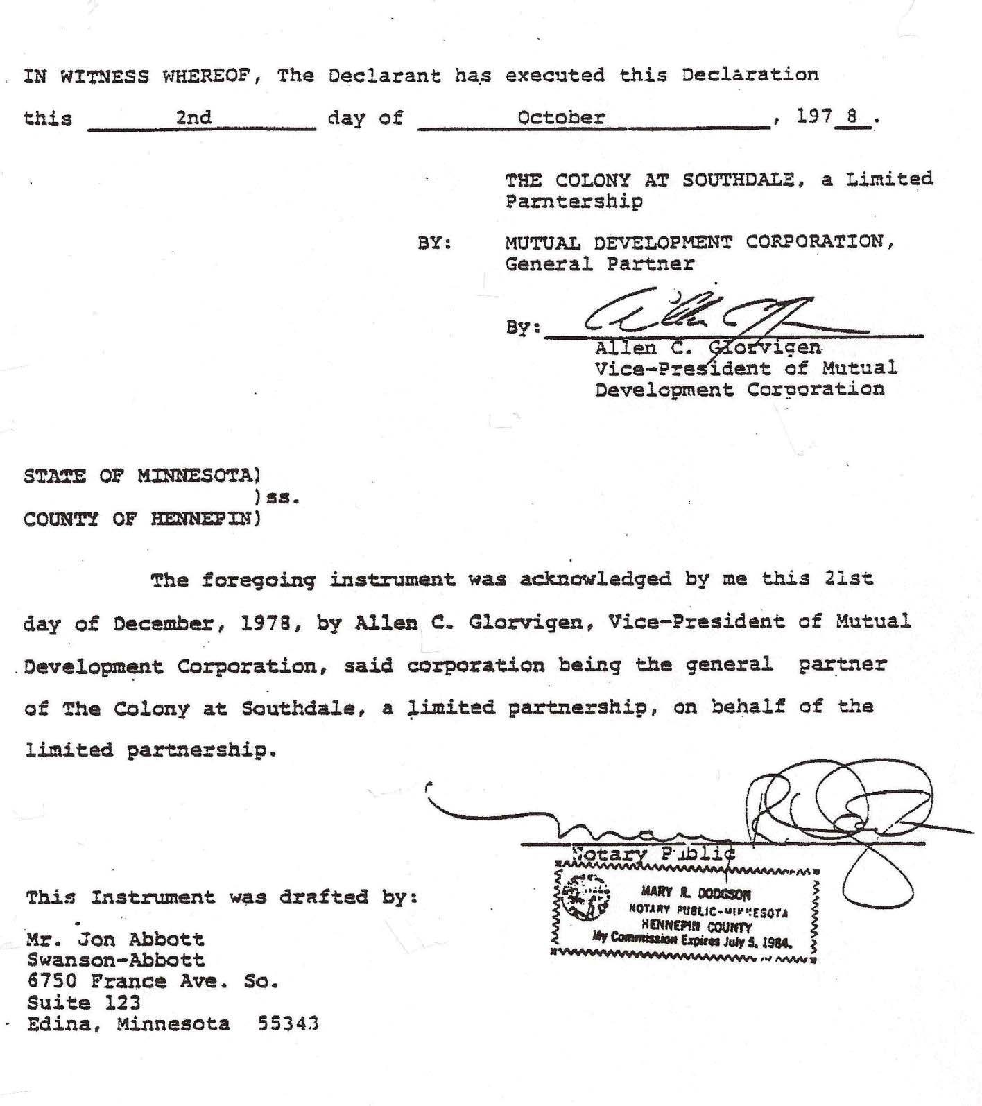

EXHIBIT A
NUMBER AND DESCRIPTION OF INDIVIDUAL APARTMENTS
The individual apartments and locations are as shown on floor plans filed contemporaneously herewith. The identifying letter and number of each apartment building, building address, apartment number, type, number of rooms, approximate square footage of each apartment, declared value, and percentage of undivided interest, total value of all apartments.
Immediate common area of all units are the adjoining halls or walks.
Approximate Square
Apt. Bldg. No. | Apartment Building Address | Apt. No. | Type | Rooms | Footage Not  Including Balcony or Patio | Declared Value | Percentage  of Undivided Interest
GALLERY BUILDINGS
G2 | 6328 Barrie Rd. | 1A | 2BR | 4 + 1 Bath | 960 | $950.00 | 0.310
" | " | 1B | 1BR | 3 + 1 Bath | 706 | 800.00 | 0.262
" | " | 1C | 1BR | 3 + 1 Bath | 706 | 800.00 | 0.262
" | " | 1D | 1BR | 3 + 1 Bath | 706 | 800.00 | 0.262
" | " | 1E | 1BR | 3 + 1 Bath | 706 | 800.00 | 0.262
" | " | 1F | 1BR | 3 + 1 Bath | 706 | 800.00 | 0.262
" | " | 1G | 1BR | 3 + 1 Bath | 706 | 800.00 | 0.262
" | " | 1H | 1BR | 3 + 1 Bath | 706 | 800.00 | 0.262
 |  | *
" " 1J |  |  | 1BR | 3 + 1 Bath | 706 | 800.00 | 0.262
" " 1K |  |  | 1BR | 3 + 1 Bath | 706 | 800.00 | 0.262
" " 1L |  |  | 1BR | 3 + 1 Bath | 756 | 800.00 | 0.262
" " 1M |  |  | 2BR | 4 + 1 Bath | 948 | 950.00 | 0.310
" " 2A |  |  | 2BR | 4 + 1 Bath | 960 | 950.00 | 0.310
" " 2B |  |  | 1BR | 3 + 1 Bath | 706 | 800.00 | 0.262
" " 2C |  |  | 1BR | 3 + 1 Bath | 706 | 800.00 | 0.262
" " 2D |  |  | 1BR | 3 + 1 Bath | 706 | 800.00 | 0.262
" " 2E |  |  | 1BR | 3 + 1 Bath | 706 | 800.00 | 0.262
" " 2F |  |  | 1BR | 3 + 1 Bath | 706 | 800.00 | 0.262
" " 2G |  |  | 1BR | 3 + 1 Bath | 706 | 800.00 | 0.262
" " 2H |  |  | 1BR | 3 + 1 Bath | 706 | 800.00 | 0.262
 |  | *
" " 2J |  |  | 1BR | 3 + 1 Bath | 706 | 800.00 | 0.262
" " 2K |  |  | 1BR | 3 + 1 Bath | 706 | 800.00 | 0.262
" " 2L |  |  | 1BR | 3 + 1 Bath | 756 | 800.00 | 0.262
" " 2M |  |  | 2BR | 4 + 1 Bath | 948 | 950.00 | 0.310
" " 3A |  |  | 2BR | 4 + 1 Bath | 960 | 950.00 | 0.310
" " 3B |  |  | 1BR | 3 + 1 Bath | 706 | 800.00 | 0.262
" " 3C |  |  | 1BR | 3 + 1 Bath | 706 | 800.00 | 0.262
" " 3D |  |  | 1BR | 3 + 1 Bath | 706 | 800.00 | 0.262
" " 3E |  |  | 1BR | 3 + 1 Bath | 706 | 800.00 | 0.262
" " 3F |  |  | 1BR | 3 + 1 Bath | 706 | 800.00 | 0.262
" " 3G |  |  | 1BR | 3 + 1 Bath | 706 | 800.00 | 0.262
" " 3H |  |  | 1BR | 3 + 1 Bath | 706 | 800.00 | 0.262
 |  | *
" " 3J |  |  | 1BR | 3 + 1 Bath | 706 | 800.00 | 0.262
" " 3K |  |  | 1BR | 3 + 1 Bath | 706 | 800.00 | 0.262
" " 3L |  |  | 1BR | 3 + 1 Bath | 756 | 800.00 | 0.262
" " 3M |  |  | 2BR | 4 + 1 Bath | 948 | 950.00 | 0.310

 |  |  |  |  |  | Approximate
 |  |  |  |  |  | Square
 |  |  |  |  |  | Footage Not |  | Percentage
Apt. | Apartment |  |  |  |  | Including |  | of
Bldg. | Building |  | Apt. |  |  | Balcony or | Declared | Undivided
No. | Address |  | No. | Type | Rooms | Patio | Value | Interest
G1 | 6423 Colony Way |  | 1A | 2BR | 4 + 1 Bath | 960 | $950.00 | 0.310
" | " |  | 1B | 1BR | 3 + 1 Bath | 706 | 800.00 | 0.262
" | " |  | 1C | 1BR | 3 + 1 Bath | 706 | 800.00 | 0.262
" | " |  | 1D | 1BR | 3 + 1 Bath | 706 | 800.00 | 0.262
" | " |  | 1E | 1BR | 3 + 1 Bath | 706 | 800.00 | 0.262
" | " |  | 1F | 1BR | 3 + 1 Bath | 706 | 800.00 | 0.262
" | " |  | 1G | 1BR | 3 + 1 Bath | 706 | 800.00 | 0.262
" | " |  | 1H | 1BR | 3 + 1 Bath | 706 | 800.00 | 0.262
 |  |  | *
" " 1J |  |  |  | 1BR | 3 + 1 Bath | 706 | 800.00 | 0.262
" " 1K |  |  |  | 1BR | 3 + 1 Bath | 706 | 800.00 | 0.262
" " 1L |  |  |  | 1BR | 3 + 1 Bath | 756 | 800.00 | 0.262
" " 1M |  |  |  | 2BR | 4 + 1 Bath | 948 | 950.00 | 0.310
" " 2A |  |  |  | 2BR | 4 + 1 Bath | 960 | 950.00 | 0.310
" " 2B |  |  |  | 1BR | 3 + 1 Bath | 706 | 800.00 | 0.262
" " 2C |  |  |  | 1BR | 3 + 1 Bath | 706 | 800.00 | 0.262
" " 2D |  |  |  | 1BR | 3 + 1 Bath | 706 | 800.00 | 0.262
" " 2E |  |  |  | 1BR | 3 + 1 Bath | 706 | 800.00 | 0.262
" " 2F |  |  |  | 1BR | 3 + 1 Bath | 706 | 800.00 | 0.262
" " 2G |  |  |  | 1BR | 3 + 1 Bath | 706 | 800.00 | 0.262
" " 2H |  |  |  | 1BR | 3 + 1 Bath | 706 | 800.00 | 0.262
 |  |  | *
" |  | " | 2J | 1BR | 3 + 1 Bath | 706 | 800.00 | 0.262
" |  | " | 2K | 1BR | 3 + 1 Bath | 706 | 800.00 | 0.262
" |  | " | 2L | 1BR | 3 + 1 Bath | 756 | 800.00 | 0.262
" |  | " | 2M | 2BR | 4 + 1 Bath | 948 | 950.00 | 0.310
" |  | " | 3A | 2BR | 4 + 1 Bath | 960 | 950.00 | 0.310
" |  | " | 3B | 1BR | 3 + 1 Bath | 706 | 800.00 | 0.262
" |  | " | 3C | 1BR | 3 + 1 Bath | 706 | 800.00 | 0.262
" |  | " | 3D | 1BR | 3 + 1 Bath | 706 | 800.00 | 0.262
" |  | " | 3E | 1BR | 3 + 1 Bath | 706 | 800.00 | 0.262
" |  | " | 3F | 1BR | 3 + 1 Bath | 706 | 800.00 | 0.262
" |  | " | 3G | 1BR | 3 + 1 Bath | 706 | 800.00 | 0.262
" |  | " | 3H | 1BR | 3 + 1 Bath | 706 | 800.00 | 0.262
 |  |  | * | 1BR
" |  | " | 3J | 1BR | 3 + 1 Bath | 706 | 800.00 | 0.262
" |  | " | 3K | 1BR | 3 + 1 Bath | 706 | 800.00 | 0.262
" |  | " | 3L | 1BR | 3 + 1 Bath | 756 | 800.00 | 0.262
" |  | " | 3M | 2BR | 4 + 1 Bath | 948 | 950.00 | 0.310
CLUSTER BUILDINGS
C11 | 6300 Barrie Rd. |  | 1A | 2BR | 4 + 1½ Bath | 999 | 1,000.00 | 0.320
" | " |  | 1B | 3BR | 5+ 2 Bath | 1,318 | 1,300.00 | 0.420
" | " |  | 1C | 3BR | 5+ 2 Bath | 1,338 | 1,300.00 | 0.420
" | " |  | 1D | 2BR | 4 + 1½ Bath | 1,012 | 1,000.00 | 0.320
" | " |  | 2A | 2BR | 4 + 1½ Bath | 1,036 | 1,000.00 | 0.320
" | " |  | 2B | 2BR | 4 + 1½ Bath | 1,036 | 1,000.00 | 0.320
" | " |  | 2C | 2BR | 4 + 1½ Bath | 1,036 | 1,000.00 | 0.320
" | " |  | 2D | 2BR | 4 + 1½ Bath | 1,036 | 1,000.00 | 0.320
C12 | 6304 Barrie Rd. |  | 1A | 3BR | 5+ 2 Bath | 1,338 | 1,300.00 | 0.420
" | " |  | 2B | 3BR | 5+ 2 Bath | 1,338 | 1,300.00 | 0.420
" | " |  | 1C | 3BR | 5+ 2 Bath | 1,318 | 1,300.00 | 0.420
" | " |  | 1D | 3BR | 5+ 2 Bath | 1,318 | 1,300.00 | 0.420

 |  |  |  |  | Approximate
 |  |  |  |  | Square
 |  |  |  |  | Footage Not |  | Percentage
Apt. | Apartment |  |  |  | Including |  | of
Bldg. | Building | Apt. |  |  | Balcony or | Declared | Undivided
No. | Address | No. | Type | Rooms | Patio | Value | Interest
C12 | 6304 Barrie Rd. | 2A | 2BR | 4 + 1½ Bath | 1,036 | $1,000.00 | 0.320
" | " | 2B | 2BR | 4 + 1½ Bath | 1,036 | 1,000.00 | 0.320
" | " | 2C | 2BR | 4 + 1½ Bath | 1,036 | 1,000.00 | 0.320
" | " | 2D | 2BR | 4 + 1½ Bath | 1,036 | 1,000.00 | 0.320
C13 | 6308 Barrie Rd. | 1A | 3BR | 5 + 2 Bath | 1,338 | 1,300.00 | 0.420
" | " | 1B | 3BR | 5 + 2 Bath | 1,338 | 1,300.00 | 0.420
" | " | 1C | 3BR | 5 + 2 Bath | 1,318 | 1,300.00 | 0.420
" | " | 1D | 3BR | 5 + 2 Bath | 1,318 | 1,300.00 | 0.420
" | " | 2A | 2BR | 4 + 1½ Bath | 1,036 | 1,000.00 | 0.320
" | " | 2B | 2BR | 4 + 1½ Bath | 1,036 | 1,000.00 | 0.320
" | " | 2C | 2BR | 4 + 1½ Bath | 1,036 | 1,000.00 | 0.320
" | " | 2D | 2BR | 4 + 1½ Bath | 1,036 | 1,000.00 | 0.320
C17 | 6312 Barrie Rd. | 1A | 2BR | 4 + 1½ Bath | 999 | 1,000.00 | 0.320
" | " | 1B | 3BR | 5 + 2 Bath | 1,318 | 1,300.00 | 0.420
" | " | 1C | 3BR | 5 + 2 Bath | 1,338 | 1,300.00 | 0.420
" | " | 1D | 2BR | 4 + 2 Bath | 1,012 | 1,000.00 | 0.320
" | " | 2A | 2BR | 4 + 2 Bath | 1,036 | 1,000.00 | 0.320
" | " | 2B | 2BR | 4 + 2 Bath | 1,036 | 1,000.00 | 0.320
" | " | 2C | 2BR | 4 + 2 Bath | 1,036 | 1,000.00 | 0.320
" | " | 2D | 2BR | 4 + 2 Bath | 1,036 | 1,000.00 | 0.320
C16 | 6316 Barrie Rd. | 1A | 3BR | 5 + 2 Bath | 1,338 | 1,300.00 | 0.420
" | " | 1B | 3BR | 5 + 2 Bath | 1,338 | 1,300.00 | 0.420
" | " | 1C | 3BR | 5 + 2 Bath | 1,318 | 1,300.00 | 0.420
" | " | 1D | 3BR | 5 + 2 Bath | 1,318 | 1,300.00 | 0.420
" | " | 2A | 2BR | 4 + 1½ Bath | 1,036 | 1,000.00 | 0.320
" | " | 2B | 2BR | 4 + 1½ Bath | 1,036 | 1,000.00 | 0.320
" | " | 2C | 2BR | 4 + 1½ Bath | 1,036 | 1,000.00 | 0.320
" | " | 2D | 2BR | 4 + 1½ Bath | 1,036 | 1,000.00 | 0.320
C15 | 6320 Barrie Rd. | 1A | 3BR | 5 + 2 Bath | 1,338 | 1,300.00 | 0.420
" | " | 1B | 3BR | 5 + 2 Bath | 1,338 | 1,300.00 | 0.420
" | " | 1C | 3BR | 5 + 2 Bath | 1,318 | 1,300.00 | 0.420
" | " | 1D | 3BR | 5 + 2 Bath | 1,318 | 1,300.00 | 0.420
" | " | 2A | 2BR | 4 + 1½ Bath | 1,036 | 1,000.00 | 0.320
" | " | 2B | 2BR | 4 + 1½ Bath | 1,036 | 1,000.00 | 0.320
" | " | 2C | 2BR | 4 + 1½ Bath | 1,036 | 1,000.00 | 0.320
" | " | 2D | 2BR | 4 + 1½ Bath | 1,036 | 1,000.00 | 0.320
C14 | 6324 Barrie Rd. | 1A | 3BR | 5 + 2 Bath | 1,318 | 1,300.00 | 0.420
" | " | 1B | 3BR | 5 + 2 Bath | 1,318 | 1,300.00 | 0.420
" | " | 1C | 3BR | 5 + 2 Bath | 1,338 | 1,300.00 | 0.420
" | " | 1D | 3BR | 5 + 2 Bath | 1,338 | 1,300.00 | 0.420
" | " | 2A | 2BR | 4 + 1½ Bath | 1,036 | 1,000.00 | 0.320
" | " | 2B | 2BR | 4 + 1½ Bath | 1,036 | 1,000.00 | 0.320
" | " | 2C | 2BR | 4 + 1½ Bath | 1,036 | 1,000.00 | 0.320
" | " | 2D | 2BR | 4 + 1½ Bath | 1,036 | 1,000.00 | 0.320

 |  |  |  |  | Approximate
 |  |  |  |  | Square
 |  |  |  |  | Footage Not |  | Percentage
Apt. | Apartment |  |  |  | Including |  | of
Bldg. | Building | Apt. |  |  | Balcony or | Declared | Undivided
No. | Address | No. | Type | Rooms | Patio | Value | Interest
C10 | 6301 Colony Way | 1A | 3BR | 5 + 2 Bath | 1,318 | $1,300.00 | 0.420
" | " | 1B | 3BR | 5 + 2 Bath | 1,318 | 1,300.00 | 0.420
" | " | 1C | 3BR | 5 + 2 Bath | 1,338 | 1,300.00 | 0.420
" | " | 1D | 3BR | 5 + 2 Bath | 1,338 | 1,300.00 | 0.420
" | " | 2A | 2BR | 4 + 1½ Bath | 1,036 | 1,000.00 | 0.320
" | " | 2B | 2BR | 4 + 1½ Bath | 1,036 | 1,000.00 | 0.320
" | " | 2C | 2BR | 4 + 1½ Bath | 1,036 | 1,000.00 | 0.320
" | " | 2D | 2BR | 4 + 1½ Bath | 1,036 | 1,000.00 | 0.320
C9 | 6305 Colony Way | 1A | 3BR | 5 + 2 Bath | 1,338 | 1,300.00 | 0.420
" | " | 1B | 3BR | 5 + 2 Bath | 1,338 | 1,300.00 | 0.420
" | " | 1C | 3BR | 5 + 2 Bath | 1,318 | 1,300.00 | 0.420
" | " | 1D | 3BR | 5 + 2 Bath | 1,318 | 1,300.00 | 0.420
" | " | 2A | 2BR | 4 + 1½ Bath | 1,036 | 1,000.00 | 0.320
" | " | 2B | 2BR | 4 + 1½ Bath | 1,036 | 1,000.00 | 0.320
" | " | 2C | 2BR | 4 + 1½ Bath | 1,036 | 1,000.00 | 0.320
" | " | 2D | 2BR | 4 + 1½ Bath | 1,036 | 1,000.00 | 0.320
C8 | 6309 Colony Way | 1A | 3BR | 5 + 2 Bath | 1,338 | 1,300.00 | 0.420
" | " | 1B | 3BR | 5 + 2 Bath | 1,338 | 1,300.00 | 0.420
" | " | 1C | 3BR | 5 + 2 Bath | 1,318 | 1,300.00 | 0.420
" | " | 1D | 3BR | 5 + 2 Bath | 1,318 | 1,300.00 | 0.420
" | " | 2A | 2BR | 4 + 1½ Bath | 1,036 | 1,000.00 | 0.320
" | " | 2B | 2BR | 4 + 1½ Bath | 1,036 | 1,000.00 | 0.320
" | " | 2C | 2BR | 4 + 1½ Bath | 1,036 | 1,000.00 | 0.320
" | " | 2D | 2BR | 4 + 1½ Bath | 1,036 | 1,000.00 | 0.320
C7 | 6315 Colony Way | 1A | 2BR | 4 + 1½ Bath | 999 | 1,000.00 | 0.320
" | " | 1B | 3BR | 5 + 2 Bath | 1,318 | 1,300.00 | 0.420
" | " | 1C | 3BR | 5 + 2 Bath | 1,338 | 1,300.00 | 0.420
" | " | 1D | 2BR | 4 + 1½ Bath | 1,012 | 1,000.00 | 0.320
" | " | 2A | 2BR | 4 + 1½ Bath | 1,036 | 1,000.00 | 0.320
" | " | 2B | 2BR | 4 + 1½ Bath | 1,036 | 1,000.00 | 0.320
" | " | 2C | 2BR | 4 + 1½ Bath | 1,036 | 1,000.00 | 0.320
" | " | 2D | 2BR | 4 + 1½ Bath | 1,036 | 1,000.00 | 0.320
C6 | 6401 Colony Way | 1A | 3BR | 5 + 2 Bath | 1,338 | 1,300.00 | 0.420
" | " | 1B | 3BR | 5 + 2 Bath | 1,338 | 1,300.00 | 0.420
" | " | 1C | 3BR | 5 + 2 Bath | 1,318 | 1,300.00 | 0.420
" | " | 1D | 3BR | 5 + 2 Bath | 1,318 | 1,300.00 | 0.420
" | " | 2A | 2BR | 4 + 1½ Bath | 1,036 | 1,000.00 | 0.320
" | " | 2B | 2BR | 4 + 1½ Bath | 1,036 | 1,000.00 | 0.320
" | " | 2C | 2BR | 4 + 1½ Bath | 1,036 | 1,000.00 | 0.320
" | " | 2D | 2BR | 4 + 1½ Bath | 1,036 | 1,000.00 | 0.320
C5 | 6405 Colony Way | 1A | 3BR | 5 + 2 Bath | 1,338 | 1,300.00 | 0.420
" | " | 1B | 3BR | 5 + 2 Bath | 1,338 | 1,300.00 | 0.420
" | " | 1C | 3BR | 5 + 2 Bath | 1,318 | 1,300.00 | 0.420
" | " | 1D | 3BR | 5 + 2 Bath | 1,318 | 1,300.00 | 0.420

 |  |  |  |  | Approximate
 |  |  |  |  | Square
 |  |  |  |  | Footage Not |  | Percentage
Apt. | Apartment |  |  |  | Including |  | of
Bldg. | Building | Apt. |  |  | Balcony or | Declared | Undivided
No. | Address | No. | Type | Rooms | Patio | Value | Interest
C5 | 6405 Colony Way | 2A | 2BR | 4 + 1½ Bath | 1,036 | $1,000.00 | 0.320
" | " | 2B | 2BR | 4 + 1½ Bath | 1,036 | 1,000.00 | 0.320
" | " | 2C | 2BR | 4 + 1½ Bath | 1,036 | 1,000.00 | 0.320
" | " | 2D | 2BR | 4 + 1½ Bath | 1,036 | 1,000.00 | 0.320
C4 | 6409 Colony Way | 1A | 3BR | 5 + 2 Bath | 1,318 | 1,300.00 | 0.420
" | " | 1B | 3BR | 5 + 2 Bath | 1,318 | 1,300.00 | 0.420
" | " | 1C | 3BR | 5 + 2 Bath | 1,338 | 1,300.00 | 0.420
" | " | 1D | 3BR | 5 + 2 Bath | 1,338 | 1,300.00 | 0.420
" | " | 2A | 2BR | 4 + 1½ Bath | 1,036 | 1,000.00 | 0.320
" | " | 2B | 2BR | 4 + 1½ Bath | 1,036 | 1,000.00 | 0.320
" | " | 2C | 2BR | 4 + 1½ Bath | 1,036 | 1,000.00 | 0.320
" | " | 2D | 2BR | 4 + 1½ Bath | 1,036 | 1,000.00 | 0.320
C1 | 6415 Colony Way | 1A | 2BR | 4 + 1½ Bath | 999 | 1,000.00 | 0.320
" | " | 1B | 3BR | 5 + 2 Bath | 1,318 | 1,300.00 | 0.420
" | " | 1C | 3BR | 5 + 2 Bath | 1,338 | 1,300.00 | 0.420
" | " | 1D | 2BR | 4 + 1½ Bath | 1,012 | 1,000.00 | 0.320
" | " | 2A | 2BR | 4 + 1½ Bath | 1,036 | 1,000.00 | 0.320
" | " | 2B | 2BR | 4 + 1½ Bath | 1,036 | 1,000.00 | 0.320
" | " | 2C | 2BR | 4 + 1½ Bath | 1,036 | 1,000.00 | 0.320
" | " | 2D | 2BR | 4 + 1½ Bath | 1,036 | 1,000.00 | 0.320
C2 | 6417 Colony Way | 1A | 3BR | 5 + 2 Bath | 1,318 | 1,300.00 | 0.420
" | " | 1B | 3BR | 5 + 2 Bath | 1,318 | 1,300.00 | 0.420
" | " | 1C | 3BR | 5 + 2 Bath | 1,338 | 1,300.00 | 0.420
" | " | 1D | 3BR | 5 + 2 Bath | 1,338 | 1,300.00 | 0.420
" | " | 2A | 2BR | 4 + 1½ Bath | 1,036 | 1,000.00 | 0.320
" | " | 2B | 2BR | 4 + 1½ Bath | 1,036 | 1,000.00 | 0.320
" | " | 2C | 2BR | 4 + 1½ Bath | 1,036 | 1,000.00 | 0.320
" | " | 2D | 2BR | 4 + 1½ Bath | 1,036 | 1,000.00 | 0.320
C3 | 6421 Colony Way | 1A | 2BR | 4 + 1½ Bath | 1,012 | 1,000.00 | 0.320
" | " | 1B | 3BR | 5 + 2 Bath | 1,338 | 1,300.00 | 0.420
" | " | 1C | 3BR | 5 + 2 Bath | 1,318 | 1,300.00 | 0.420
" | " | 1D | 2BR | 4 + 1½ Bath | 999 | 1,000.00 | 0.320
" | " | 2A | 2BR | 4 + 1½ Bath | 1,036 | 1,000.00 | 0.320
" | " | 2B | 2BR | 4 + 1½ Bath | 1,036 | 1,000.00 | 0.320
" | " | 2C | 2BR | 4 + 1½ Bath | 1,036 | 1,000.00 | 0.320
" | " | 2D | 2BR | 4 + 1½ Bath | 1,036 | 1,000.00 | 0.320
TOWNHOUSE BUILDINGS

TH1 | 6301 Barrie Road | ** | 2BR | 4 + 1½ Bath | 909 | 900.00 | 0.290
" | 6303 Barrie Road | ** | 2BR | 4 + 1½ Bath | 909 | 900.00 | 0.290
" | 6305 Barrie Road | ** | 2BR | 4 + 1½ Bath | 909 | 900.00 | 0.290
" | 6307 Barrie Road | ** | 2BR | 4 + 1½ Bath | 909 | 900.00 | 0.290
" | 6309 Barrie Road | ** | 2BR | 4 + 1½ Bath | 909 | 900.00 | 0.290
" | 6311 Barrie Road | ** | 2BR | 4 + 1½ Bath | 909 | 900.00 | 0.290

 |  |  |  |  | Approximate
 |  |  |  |  | Square
 |  |  |  |  | Footage Not |  | Percentage
Apt. | Apartment |  |  |  | Including |  | of
Bldg. | Building | Apt. |  |  | Balcony or | Declared | Undivided
No. | Address | No. | Type | Rooms | Patio | Value | Interest
TH2 | 6313 Barrie Road | ** | 2BR | 4 + 1½ Bath | 909 | $ 900.00 | 0.290
" | 6315 Barrie Road | ** | 2BR | 4 + 1½ Bath | 909 | 900.00 | 0.290
" | 6317 Barrie Road | ** | 2BR | 4 + 1½ Bath | 909 | 900.00 | 0.290
" | 6319 Barrie Road | ** | 2BR | 4 + 1½ Bath | 909 | 900.00 | 0.290
" | 6321 Barrie Road | ** | 2BR | 4 + 1½ Bath | 909 | 900.00 | 0.290
" | 6323 Barrie Road | ** | 2BR | 4 + 1½ Bath | 909 | 900.00 | 0.290
TH3 | 6325 Barrie Road | ** | 2BR | 4 + 1½ Bath | 1,084 | 1,100.00 | 0.360
" | 6327 Barrie Road | ** | 2BR | 4 + 1½ Bath | 1,084 | 1,100.00 | 0.360
" | 6329 Barrie Road | ** | 2BR | 4 + 1½ Bath | 918 | 900.00 | 0.290
" | 6331 Barrie Road | ** | 2BR | 4 + 1½ Bath | 918 | 900.00 | 0.290
" | 6333 Barrie Road | ** | 2BR | 4 + 1½ Bath | 918 | 900.00 | 0.290
" | 6335 Barrie Road | ** | 2BR | 4 + 1½ Bath | 918 | 900.00 | 0.290
" | 6337 Barrie Road | ** | 2BR | 4 + 1½ Bath | 1,084 | 1,100.00 | 0.360
" | 6339 Barrie Road | ** | 2BR | 4 + 1½ Bath | 1,084 | 1,100.00 | 0.360
TH4 | 6341 Barrie Road | ** | 2BR | 4 + 1½ Bath | 909 | 900.00 | 0.290
" | 6343 Barrie Road | ** | 2BR | 4 + 1½ Bath | 909 | 900.00 | 0.290
" | 6345 Barrie Road | ** | 2BR | 4 + 1½ Bath | 909 | 900.00 | 0.290
" | 6347 Barrie Road | ** | 2BR | 4 + 1½ Bath | 909 | 900.00 | 0.290
" | 6349 Barrie Road | ** | 2BR | 4 + 1½ Bath | 909 | 900.00 | 0.290
" | 6351 Barrie Road | ** | 2BR | 4 + 1½ Bath | 909 | 900.00 | 0.290
TH5 | 6353 Barrie Road | ** | 2BR | 4 + 1½ Bath | 1,084 | 1,100.00 | 0.360
" | 6355 Barrie Road | ** | 2BR | 4 + 1½ Bath | 1,084 | 1,100.00 | 0.360
" | 6357 Barrie Road | ** | 2BR | 4 + 1½ Bath | 918 | 900.00 | 0.290
" | 6359 Barrie Road | ** | 2BR | 4 + 1½ Bath | 918 | 900.00 | 0.290
" | 6361 Barrie Road | ** | 2BR | 4 + 1½ Bath | 918 | 900.00 | 0.290
" | 6363 Barrie Road | ** | 2BR | 4 + 1½ Bath | 918 | 900.00 | 0.290
" | 6365 Barrie Road | ** | 2BR | 4 + 1½ Bath | 1,084 | 1,100.00 | 0.360
" | 6357 Barrie Road | ** | 2BR | 4 + 1½ Bath | 1,084 | 1,100.00 | 0.360
TH6 | 6369 Barrie Road | ** | 2BR | 4 + 1½ Bath | 1,084 | 1,100.00 | 0.360
" | 6371 Barrie Road | ** | 2BR | 4 + 1½ Bath | 1,084 | 1,100.00 | 0.360
" | 6373 Barrie Road | ** | 2BR | 4 + 1½ Bath | 918 | 900.00 | 0.290
" | 6375 Barrie Road | ** | 2BR | 4 + 1½ Bath | 918 | 900.00 | 0.290
" | 6377 Barrie Road | ** | 2BR | 4 + 1½ Bath | 918 | 900.00 | 0.290
" | 6379 Barrie Road | ** | 2BR | 4 + 1½ Bath | 918 | 900.00 | 0.290
" | 6381 Barrie Road | ** | 2BR | 4 + 1½ Bath | 1,084 | 1,100.00 | 0.360
" | 6383 Barrie Road | ** | 2BR | 4 + 1½ Bath | 1,084 | 1,100.00 | 0.360
TH7 | 6385 Barrie Road | ** | 2BR | 4 + 1½ Bath | 1,084 | 1,100.00 | 0.360
" | 6387 Barrie Road | ** | 2BR | 4 + 1½ Bath | 1,084 | 1,100.00 | 0.360
" | 6389 Barrie Road | ** | 2BR | 4 + 1½ Bath | 918 | 900.00 | 0.290
" | 6391 Barrie Road | ** | 2BR | 4 + 1½ Bath | 918 | 900.00 | 0.290
" | 6393 Barrie Road | ** | 2BR | 4 + 1½ Bath | 918 | 900.00 | 0.290
" | 6395 Barrie Road | ** | 2BR | 4 + 1½ Bath | 918 | 900.00 | 0.290
" | 6397 Barrie Road | ** | 2BR | 4 + 1½ Bath | 1,084 | 1,100.00 | 0.360
" | 6399 Barrie Road | ** | 2BR | 4 + 1½ Bath | 1,084 | 1,100.00 | 0.360

 |  |  |  |  | Approximate
 |  |  |  |  | Square
 |  |  |  |  | Footage Not |  | Percentage
Apt. | Apartment |  |  |  | Including |  | of
Bldg. | Building | Apt. |  |  | Balcony or | Declared | Undivided
No. | Address | No. | Type | Rooms | Patio | Value | Interest
TH8 | 6401 Barrie Road | ** | 2BR | 4 + 1½ Bath | 1,084 | $1,100.00 | 0.360
" | 6403 Barrie Road | ** | 2BR | 4 + 1½ Bath | 1,084 | 1,100.00 | 0.360
" | 6405 Barrie Road | ** | 2BR | 4 + 1½ Bath | 918 | 900.00 | 0.290
" | 6407 Barrie Road | ** | 2BR | 4 + 1½ Bath | 918 | 900.00 | 0.290
" | 6409 Barrie Road | ** | 2BR | 4 + 1½ Bath | 918 | 900.00 | 0.290
" | 6411 Barrie Road | ** | 2BR | 4 + 1½ Bath | 918 | 900.00 | 0.290
" | 6413 Barrie Road | ** | 2BR | 4 + 1½ Bath | 1,084 | 1,100.00 | 0.360
" | 6415 Barrie Road | ** | 2BR | 4 + 1½ Bath | 1,084 | 1,100.00 | 0.360
TH9 | 6417 Barrie Road | ** | 2BR | 4 + 1½ Bath | 1,084 | 1,100.00 | 0.360
" | 6419 Barrie Road | ** | 2BR | 4 + 1½ Bath | 1,084 | 1,100.00 | 0.360
" | 6421 Barrie Road | ** | 2BR | 4 + 1½ Bath | 918 | 900.00 | 0.290
" | 6423 Barrie Road | ** | 2BR | 4 + 1½ Bath | 918 | 900.00 | 0.290
" | 6425 Barrie Road | ** | 2BR | 4 + 1½ Bath | 918 | 900.00 | 0.290
" | 6427 Barrie Road | ** | 2BR | 4 + 1½ Bath | 918 | 900.00 | 0.290
" | 6429 Barrie Road | ** | 2BR | 4 + 1½ Bath | 1,084 | 1,100.00 | 0.360
" | 6431 Barrie Road | ** | 2BR | 4 + 1½ Bath | 1,084 | 1,100.00 | 0.360
TH10 | 6433 Barrie Road | ** | 2BR | 4 + 1½ Bath | 1,084 | 1,100.00 | 0.360
" | 6435 Barrie Road | ** | 2BR | 4 + 1½ Bath | 1,084 | 1,100.00 | 0.360
" | 6437 Barrie Road | ** | 2BR | 4 + 1½ Bath | 918 | 900.00 | 0.290
" | 6439 Barrie Road | ** | 2BR | 4 + 1½ Bath | 918 | 900.00 | 0.290
" | 6441 Barrie Road | ** | 2BR | 4 + 1½ Bath | 918 | 900.00 | 0.290
" | 6443 Barrie Road | ** | 2BR | 4 + 1½ Bath | 918 | 900.00 | 0.290
" | 6445 Barrie Road | ** | 2BR | 4 + 1½ Bath | 1,084 | 1,100.00 | 0.360
" | 6447 Barrie Road | ** | 2BR | 4 + 1½ Bath | 1,084 | 1,100.00 | 0.360
TH11 | 6449 Barrie Road | ** | 2BR | 4 + 1½ Bath | 909 | 900.00 | 0.290
" | 6451 Barrie Road | ** | 2BR | 4 + 1½ Bath | 909 | 900.00 | 0.290
" | 6453 Barrie Road | ** | 2BR | 4 + 1½ Bath | 909 | 900.00 | 0.290
" | 6455 Barrie Road | ** | 2BR | 4 + 1½ Bath | 909 | 900.00 | 0.290
" | 6457 Barrie Road | ** | 2BR | 4 + 1½ Bath | 909 | 900.00 | 0.290
" | 6459 Barrie Road | ** | 2BR | 4 + 1½ Bath | 909 | 900.00 | 0.290
TH12 | 6461 Barrie Road | ** | 2BR | 4 + 1½ Bath | 1,084 | 1,100.00 | 0.360
" | 6463 Barrie Road | ** | 2BR | 4 + 1½ Bath | 1,084 | 1,100.00 | 0.360
" | 6465 Barrie Road | ** | 2BR | 4 + 1½ Bath | 918 | 900.00 | 0.290
" | 6467 Barrie Road | ** | 2BR | 4 + 1½ Bath | 918 | 900.00 | 0.290
" | 6469 Barrie Road | ** | 2BR | 4 + 1½ Bath | 918 | 900.00 | 0.290
" | 6471 Barrie Road | ** | 2BR | 4 + 1½ Bath | 918 | 900.00 | 0.290
" | 6473 Barrie Road | ** | 2BR | 4 + 1½ Bath | 1,084 | 1,100.00 | 0.360
" | 6475 Barrie Road | ** | 2BR | 4 + 1½ Bath | 1,084 | 1,100.00 | 0.360
TH13 | 6477 Barrie Road | ** | 2BR | 4 + 1½ Bath | 909 | 900.00 | 0.290
" | 6479 Barrie Road | ** | 2BR | 4 + 1½ Bath | 909 | 900.00 | 0.290
" | 6481 Barrie Road | ** | 2BR | 4 + 1½ Bath | 909 | 900.00 | 0.290
" | 6483 Barrie Road | ** | 2BR | 4 + 1½ Bath | 909 | 900.00 | 0.290
" | 6485 Barrie Road | ** | 2BR | 4 + 1½ Bath | 909 | 900.00 | 0.290
" | 6487 Barrie Road | ** | 2BR | 4 + 1½ Bath | 909 | 900.00 | 0.290

 |  |  |  |  | Approximate
 |  |  |  |  | Square
 |  |  |  |  | Footage Not |  | Percentage
Apt. | Apartment |  |  |  | Including |  | of
Bldg. | Building | Apt. |  |  | Balcony or | Declared | Undivided
No. | Address | No. | Type | Rooms | Patio | Value | Interest
TH14 | 6489 Barrie Road | ** | 2BR | 4 + 1½ Bath | 909 | $900.00 | 0.290
" | 6491 Barrie Road | ** | 2BR | 4 + 1½ Bath | 909 | 900.00 | 0.290
" | 6493 Barrie Road | ** | 2BR | 4 + 1½ Bath | 909 | 900.00 | 0.290
" | 6495 Barrie Road | ** | 2BR | 4 + 1½ Bath | 909 | 900.00 | 0.290
" | 6497 Barrie Road | ** | 2BR | 4 + 1½ Bath | 909 | 900.00 | 0.290
" | 6499 Barrie Road | ** | 2BR | 4 + 1½ Bath | 909 | 900.00 | 0.290

TOTAL DECLARED VALUE $309,200.00

TOTAL PERCENTAGE OF UNDIVIDED INTEREST 100.00%

* The Letter "I" has been intentionally omitted from the sequence of apartment numbers.

** Townhouse apartment numbers are the same as the Apartment Building Address.

-25-

THIS PAGE LEFT BLANK INTENTIONALLY

EXHIBIT B

BY-LAWS OF
THE COLONY AT EDINA CONDOMINIUM ASSOCIATION

- IDENTIFY, DEFINITIONS:

Whereas certain real property situated in the City of Edina, County of Hennepin, State of Minnesota, has been submitted to the provisions of the Minnesota Condominium Act, Minnesota Statutes, Chapter 515, by a Declaration filed in the office of the Registrar of Titles of said Hennepin County simultaneously herewith, and shall hereinafter be known as "The Colony at Edina Condominium" (hereinafter called the "Condominium").

The following shall and do constitute the By-Laws of The Colony at Edina Condominium Association (hereinafter called the Association). The by-laws are subject to the Declaration of Apartment Ownership of the Condominium, hereinafter referred to as the Declaration. The Association has been organized for the purpose of administering the Condominium.

Terms used in these By-Laws shall have the same meaning ascribed by the Declaration.
The term "majority of members," as used herein, shall mean members with more than 50 percent of the votes in accordance with the percentages assigned in the Declaration to the apartments for voting purposes.

- MEMBERS:

The qualifications of members and the manner of their admission into the Association shall be as follows:

  - An owner of an apartment in the Condominium shall by virtue of such interest be a member of this Association. A Contract for Deed Vendee of a recorded contract shall be deemed an owner.

  - When one or more persons hold an interest in an apartment, all such persons shall be members, subject to the qualifications set forth hereafter.

  - It shall be the duty of each owner to register his name and the nature of his interest with the Secretary of the Association, who shall maintain a Roll of Members ("Roll"). If the owner does not register his interest, he may not exercise his right to vote, but his other rights and obligations under the Declaration, By-Laws and Rules of Regulations shall not be impaired.

  - The share of a member in the funds and assets of the Association cannot be assigned, pledged, encumbered or transferred in any manner, except as an appurtenance to his apartment in the condominium.

- APARTMENT OWNERS' MEETINGS AND VOTING:

  - Annual Meetings – Subsequent to the earlier of a) five years from the date of recording the Declaration or b) when apartments representing sixty (60%) (3/5) in undivided interests in the common areas and facilities are owned by apartment owners (including those holding interests as vendees under contracts for deed from declarant) other than Declarant, the Declarant shall notify all apartment owners thereof, and the first annual meeting of the apartment owners shall be held within forty-five (45) days thereafter on a call issued by the Declarant. At said first annual meeting all of the officers and directors of the Declarant shall resign as members of the Board of Directors. At said first annual meeting of apartment owners, the apartment owners shall elect two (2) members of the Board of Directors for terms to expire with the second annual meeting and three (3) for terms to expire with the third annual meeting of the apartment owners.

  - Thereafter the annual meeting of the members shall be held on the third Saturday in April in every year commencing in the next year following at such time and place as is specified by the Board of Directors for the purpose of electing a Board of Directors and transacting any other business authorized to be transacted by the members.

  - Special Meetings of the members may be called at any time by the President, or the Vice President, or by the Board of Directors, and must be called by the President upon receipt of written requests from a majority of the members.

  - Notice of all meetings of the members starting the time and place and the objects for which the meeting is called shall be given by the Secretary. The Secretary shall, at least twenty-one days in advance of any annual meeting and at least seven days in advance of any other meeting, send to each member notice of the time, place and complete agenda of the meeting. The notice shall be sent by United States mail to all members of record at the addresses as any of them may have designated to the Secretary.

  - The mortgagee of any individual apartment may attend and participate in any general or special meeting but shall have no vote unless granted by written proxy or otherwise provided for in the Declaration.

  - Only members shown on the Roll as of the date of meeting shall be entitled to attend and vote.

  - A quorum at meetings of the members shall consist of a majority of the voting power of the members computed in accordance with the percentage of interest in the common areas and facilities as set forth in Exhibit A attached to the Declaration.

  - All holders of an interest in an apartment shall collectively have that percentage vote set forth in Exhibit A to the Declaration. In the case of joint ownership of an apartment, the vote may be cast by any fee owner of an apartment shown on the Roll; however, should any other fee owner of that apartment raise an objection to the casting of the vote, then neither joint owner shall be recognized. In other cases where there is more than one holder of an interest in an apartment, either all the holders may collectively cast the vote, or all the holders may designate, by appropriate certificate delivered to the Secretary prior to the meeting, one of their number to cast their vote for all purposes at the meeting. Such certificate shall be valid until revoked by any of the holders of an interest. In the event no such certificate is filed and if all the holders do not agree as to the manner of casting their collective vote on any matter, then the percentage vote associated with the apartment shall not be recognized.

  - No vote in the Association shall be deemed to inure to any apartment during the time when the owner thereof is the Association and such apartment shall not be counted in determining the number of votes needed for quorum or other percent of votes.

  - Votes may be cast in person or by written proxy. Proxies must be filed with the Secretary before the appointed time of the meeting and shall be valid until revoked in writing.

  - If any meeting cannot be organized for lack of a quorum, the meeting shall be adjourned from time to time until a quorum is present.

  - When a quorum is present at any meeting, any questions brought before the meeting shall be decided by a majority of the voting power present in person or by proxy unless the question is one where a different vote is required to express provision of law, the Declaration or these By-Laws.

  - At the beginning of each meeting, the Secretary shall render and certify the Roll showing a list of all the members entitled to vote at such meeting, the percentage voting power to each and the name of the person entitled to cast each such member's vote by virtue of a certificate or proxy then in effect.

  - There shall be no cumulative voting.

  - The order of business at the annual meetings of the members and as far as is practical at all other meetings of members shall be:

    - Calling meeting to order by President or other presiding Board Member
    - Calling of the roll and certifying of proxies
    - Proof of notice of meeting or waiver of notice
    - Reading and disposal of any unapproved minutes
    - Reports of officers
    - Reports of committees
    - Appointment of inspectors of election
    - Election of directors
    - Unfinished business
    - New business
    - Adjournment

  - Any action which might be taken at a members' meeting may be taken upon the written consent of all those entitled to vote at any meeting, determined at such time as is designated by the President, and where there is more than one holder of an interest in an apartment, all holders must give consent unless the certificate above mentioned is on file with the Secretary, in which event only the consent of the named party need be obtained.

- BOARD OF DIRECTORS:

  - The first Board of Directors shall consist of three (3) persons, as set forth in the Articles of Incorporation. Said first Directors shall serve until the first meeting of the members. At that time a new board of five (5) persons shall be elected as provided in 3a herein.

  - Election of the second Board of Directors and of all subsequent Boards shall be conducted in the following manner:

    - Nominations for all available directorships shall be taken before voting. Only one ballot shall be taken with no more than one name for each available directorship, and those nominees receiving the most number of votes shall be elected to fill the number of directorships with the nominee(s) receiving the most votes filling the position(s) of the longest term(s).

    - Vacancies on the Board of Directors occurring between meetings may be filled by the remaining Directors, and such appointed Directors shall serve until the next annual meeting of the Association, and thereafter until their successors are duly elected and qualified.

    - The term of each Director's service shall be two years, or until the next respective annual meeting of the members, and until his successor is duly elected and qualified.

  - A Director may be removed by a sixty percent (60%) vote of the voting power at a special meeting noticed for that purpose.

  - Regular meetings of the Board of Directors may be held at such time and place as shall be determined from time to time by a majority of the Directors. Written notice of regular meetings shall be given to each Director personally or by mail, at least seven (7) days prior to the date established for such meeting unless such notice is waived in writing.

  - Special meetings of the Board of Directors may be called by the President and must be called by the Secretary at the written request of one-third (1/3) of the Directors. Not less than seven (7) days written notice of the meeting shall be given personally or by mail, which notice shall state the time, place and purpose of the meeting.

  - Any Director may in writing waive notice of a meeting before or after the meeting and such waiver shall be deemed equivalent to the giving of notice.

  - Any quorum at a Directors meeting shall consist of a majority in number of the Directors. The acts of the Board approved by a majority at a meeting at which a quorum is present shall constitute the acts of the Board of Directors. If at any meeting of the Board,

there should be less than a quorum present, the majority of those present may adjourn the meeting from time to time until a quorum is present. At an adjourned meeting any business which might have been transacted at the meeting originally called may be transacted without further notice.

  - The presiding officer of the meeting of the Directors shall be the President, and in his absence the Vice President. In the absence of the President and Vice President, the majority in number of the Directors may designate one of their number to preside.

  - Directors shall receive no compensation for their services.

  - Any action that could be taken at a meeting of the Board of Directors may be taken without a meeting when authorized in writing by all of the Directors.

- POWER AND DUTIES OF THE BOARD OF DIRECTORS:

  - All of the powers and duties of the Association shall be exercised by the Board of Directors, including those existing under the common law, statutes, the Articles of Incorporation and those powers and duties designated for the Association of Apartment Owners by the Act and the documents establishing the condominium. Such powers and duties shall include, but shall not be limited to, the following:

    - To elect annually the officers of the Association.

    - To prepare and render to the members annually, on or before thirty (30) days prior to the first day of each fiscal year showing anticipated income and operating expenses, including reasonable reserves.

    - To submit at each annual meeting of the members a statement of the business transacted during the preceding year, a report of the general financial condition of the Association and its tangible property, and the proposed budget for the current fiscal year. This statement and report may be incorporated in an Annual Report, which the Directors shall also prepare and mail to the members in the same manner as provided in Paragraph 3.d. of the By-Laws. The Annual Report shall contain at a minimum, the following:

      - A statement of any capital expenditures in excess of $1,000.00 anticipated by the Association during the current year or succeeding two fiscal years;

      - A statement of the status and amount of any reserve or replacement fund and any portion of the fund designated for any specified project by the Board of Directors;

      - A copy of the statement of financial condition for the Association for the last fiscal year;

      - A statement of the status of any pending suits or judgments in which the Association is a party;

      - A statement of the insurance coverage provided by the Association; and

      - A statement of any unpaid assessments by the Association on individual apartments, identifying the apartment number and the amount of the unpaid assessment.

    - To make and collect assessments to defray the costs of the condominium expenses.

    - To use the proceeds of assessments in the exercise of its powers and duties.

    - To maintain, repair, replace and operate the common areas and facilities and portions of the apartments as outlined in Article X of the Declaration.

    - To restore improvements after damage except as provided for in the Declaration.

    - To establish and amend rules and regulations respecting the use of the Property.

    - To appoint from the members committees as it deems advisable for the purpose of recommending action or policy in respect to any matter otherwise within the control of the Directors.

    - To enforce by legal means the provisions of the condominium documents, the Articles of Incorporation, the By-Laws of the Association and the rules and regulations for the use of the property.

    - To contract for management of the Property except no such contract shall exceed two (2) years and may be terminated by either party without payment of

penalty upon ninety (90) days written notice, and to delegate to such manager all powers and duties except when the condominium documents or the Act require approval of the Board of Directors or the membership of the Association.

    - To purchase such policies of insurance as allowed by the Declaration.

    - To pay all statements rendered for common expenses.

    - To employ personnel at a reasonable compensation to perform the services required for proper administration of the purposes of the Association.

    - To give the mortgagee notice in writing of any loss to, or taking of, the common elements of the condominium project if such loss or taking exceeds
$10,000.00 or damage to a condominium unit covered by a mortgage exceeds
$1,000.00.

    - To own, convey, encumber, lease or otherwise deal with apartments for the benefit of the Association primarily for the purpose of providing living accommodations for maintenance and staff personnel or as a result of enforcement of the lien for assessments or otherwise. In the event the Board deems it to be in the best interest to sell or to purchase (except in the case of the original purchase of three (3) apartments on or about the time of the filing of the Declaration by the Declarant) thirty (30) days notice of such action must be given all apartment owners after which time the Board may take action unless the Secretary of the Association is notified in writing of the disapproval of twenty five percent (25%) of the unit owners, computed according to the aggregate percentage of undivided interest in the common areas and facilities represented thereby, at which time the action will be delayed until the Board directs a special meeting of the unit owners by resolution to consider such sale or purchase. Notification of said special meeting will be given, and voting thereat will be in accordance with the notice and voting provisions of the By- Laws.

    - To collect rentals for extra garages, party room and guest apartment.

- OFFICERS:

  - The officers of this Association shall be a President, who shall be a Director, a Vice President, a Treasurer, and a Secretary. Each officer shall be a member or an

officer or agent of a corporate member. Each officer may be preemptorily removed by vote of the Directors at any meeting. Any person may hold two or more offices except that the offices of President and Vice President, and the offices of President and Secretary shall be held by different persons. The Board of Directors shall from time to time elect such other officers and designate their powers and duties as the Board shall find to be required to manage the affairs of the Association.

  - The President shall be the chief executive officer of the Association. He shall have all the powers and duties which are usually vested in the office of the President of a corporation, including, but not limited to, the duty to preside at all Directors and members meetings at which he is present, and the general supervision over other officers and the affairs of the Association. He shall execute all contracts, agreements and obligations of the Association except as such authority may be otherwise delegated by resolution of the Board of Directors.

  - The Vice President shall in the absence or disability of the President exercise the powers and perform the duties of the President. He shall also generally assist the President and exercise such other powers and perform such other duties as shall be prescribed by the Directors.

  - The Secretary shall keep the minutes of all proceedings of the Directors and the members. He shall attend to the giving and serving of all notices to the members and Directors and other notices required by law.

He shall keep the records of the Association, except those of the Treasurer, and shall perform all other duties incident to the office of Secretary of a corporation and as may be required by the Directors or the President.

  - The Treasurer shall have custody of all intangible property of the Association, including funds, securities, and evidences in indebtedness and shall give bond in such sum and with such sureties as the Directors may require. He shall keep the assessment rolls and accounts of the members. He shall keep the books of the Association in accordance with good accounting practices and shall submit them together with all his vouchers, receipts, records and other papers to the Directors for their examination and approval as often as they may require. He shall deposit all monies and other valuable effects in the name of or to the credit of the Association in such depositories as may be designated by the Board of Directors and shall disburse the funds of the Association as ordered by the Board and shall perform all other duties incident to the office of Treasurer. If a managing agent or manager be employed, the Board of Directors may designate some or all of the foregoing functions to be entrusted to him or it

subject to overseeing control by the Treasurer.

  - Officers of the corporation shall receive no compensation for their services in such capacity.

FISCAL MANAGEMENT:

- All funds and the titles of all properties acquired by the Association, and the proceeds thereof, after deducting therefrom the costs incurred by the Association in acquiring the same, shall be held for the benefit of the members for the purposes stated in the Declaration and herein.

- The depository of the Association shall be such saving and loan associations, bank, or banks as shall be designated from time to time by the Directors and in which the monies of the Association shall be deposited. Withdrawal of monies from such accounts shall be only by checks or withdrawal requests signed by such persons as are authorized by the Directors.

- The books, accounts and records of the Association shall be open to inspection by any Director at all times. Members of the Association shall have the right to inspect the books, accounts and records of the Association during reasonable business hours.

- Annual fiscal reports of the accounts of the Association shall be made and a copy of the report shall be furnished to each member not later than the annual meeting in April of the year following the year for which the report is made.

- Fidelity bonds may be required by the Board of Directors from all officers and employees of the Association and from any contractor handling or responsible for Association funds. The amount of such bonds shall be determined by the Directors. The premiums on such bonds shall be paid by the Association.

- Payment vouchers shall be approved by the Board of Directors or authority to approve vouchers may be delegated to the manager at the discretion of the Board of Directors.

ASSESSMENTS:

Assessments shall be levied by a majority vote of the Board Directors of the Association and paid by the members to the sociation in accordance with the following provisions:

- Notwithstanding the foregoing, any special assessment for alterations or additions to improvements of the common areas

or facilities, involving the expenditure of $10,000.00 or more shall first be approved by a majority of the voting power of the Association.

- Each member shall be jointly and severally liable with all other holders of an interest for the common expenses which are assessed against the apartment in which he has an interest. The assessments shall be computed in accordance with the percentage of interest in the common areas and facilities allocated to his apartment. Any common surplus shall be allocated to each apartment in accordance with the percentage of interest in the common areas and facilities and shall be jointly owned by the holders of an interest in each apartment.

- Assessments shall include an adequate reserve fund, as determined by the Board of Directors, for maintenance, repairs and replacement of those common areas and facilities that must be replaced on a periodic basis.

- All sums collected by the Association as assessments may be comingled in a single fund but they shall be held for and allocated for the apartments in the respective shares in which they are paid and shall be credited to accounts from which shall be paid the expenses for which the respective assessments are made.

- All assessments, both annual and special, shall become a lien on the apartment on the date they become due and payable.

Annual assessments for common expenses shall be made in advance on or before twenty (20) days prior to the first day of the fiscal year for which the assessments are made, and special assessments at such other additional times as in the judgment of the Board of Directors, additional common expenses assessments are required for the proper management, maintenance and operation of the common areas and facilities. Such annual assessments shall be due and payable in equal quarterly installments beginning with the first day of the first quarter and the first day of each quarter thereafter. Special assessments shall be due and payable as determined by the Board of Directors. If an annual assessment is not made, there shall be an assessment in the amount of the last prior annual assessment which shall be due and payable as above set forth.

- The assessments against all apartments shall be set forth upon the roll which shall be available in the office of the Association for inspection at all reasonable times by members or their duly authorized representatives. Such roll shall indicate for each apartment the name, address and interest of the member, the assessments for all purposes

and the amounts of all assessments paid and unpaid. A certificate made by the Association as to the status of a member's assessment account shall limit the liability of any person for whom such certificate is made. The Association shall issue such certificates to such persons as a member may authorize in writing or to a lender, attorney, title company, or real estate agent acting on behalf of a buyer.

- Assessments and installments thereof paid on or before thirty (30) days after the date when due shall not bear interest, but all sums not paid on or before thirty (30) days after the date when due shall bear interest at the rate of eight percent (8%) per annum, or any other legal rate that may be set by the Board, from the end of said thirty (30) day period until paid. All payments upon account shall be applied first to interest and then to the assessment payment first due. All interest collected shall be credited to the Common Expense Account.

- COMPLIANCE AND DEFAULT:

Each member shall be governed by and shall comply with the terms of the Declaration, By-Laws and regulations adopted pursuant thereto as any of the same may be amended from time to time. A default shall entitle the Association or other members to the following relief.

  - Failure to comply with any of the terms of the Declaration, By-Laws and regulations adopted pursuant thereto, shall be grounds for relief which may include, without intending to limit the same, to an action to recover sums due for damages, injunctive relief, foreclosure of lien, or any combination thereof, and which relief may be sought by the Association or if appropriate, by an aggrieved member.

  - In the event of foreclosure of lien for assessments, a reasonable rental for the apartment shall be due and the plaintiff shall be entitled to the appointment of a receiver to collect the same, all as provided in the Declaration.

  - If any member fails to perform any obligation imposed under the Declaration or these By-Laws or rules and regulations, then the Association may, but is not obligated to, perform the same for the member's account and for such purpose may enter upon the apartment, may make necessary repairs, advance expenses or other sums necessary to cure the default, and for any such expense, may levy a special assessment upon the apartment.

Each member shall be liable for the expense of any maintenance, repair or replacement rendered necessary by

his act, neglect or carelessness or by that of any member of his family or his or their guests, employees, agents or lessees, but only to the extent that such expense is not met by the proceeds of insurance carried by the Association. Such liability shall include any increase in fire insurance rates occasioned by use, misuse, occupancy, or abandonment of any apartment or its appurtenances. Nothing herein contained, however, shall be construed so as to modify any waiver by insurance companies of rights of subrogation.

  - In any proceeding arising because of an alleged default by a member, the prevailing party shall be entitled to recover the costs of the proceeding and such reasonable attorneys' fees as may be determined by the court.

  - The failure of the Association or a member to enforce any right, provision, covenant or conditions which may be granted by the Declaration or By-Laws shall not constitute a waiver of the right of the Association or member to enforce such right, provision, covenant, or condition in the future.

  - All rights, remedies and privileges granted to the Association or a member, pursuant to any terms, provisions, covenants or conditions of the Declaration or By-Laws shall not be deemed to be cumulative, and the exercise of any one or more shall not be deemed to constitute an election of remedies.

- OTHER OBLIGATIONS AS TO USE AND OCCUPANCY:

  - Each apartment shall be used only for residential purposes, by the owner, member of his immediate family, guests, household staff and tenants as authorized by owner.

  - No child under the age of eighteen (18) years shall be permitted as permanent resident or tenant, except by special permission of the Board of Directors. In the event a child is born to an owner while residing in his or her condominium unit, said child may remain for a reasonable time approved by the Board not to exceed two (2) years.

  - A resident (occupant) may have guests under eighteen (18) years of age in temporary occupancy as visitors; provided however, that the visit by such guests shall not exceed a period of fourteen (14) days at any time except by special permission of the Board of Directors, and provided such occupancy does not create a nuisance. No such guests will be allowed in the common areas of the property unless under the supervision of a responsible adult or unless directly entering or leaving the premises.

  - No nuisances shall be allowed upon the property nor any use or practice which is the source of nuisance to owners or injurious to the reputation of the condominium complex, or which interferes with the peaceful possession and proper use of the property by its owners. Neither shall there be an obstruction of the common areas nor any storage thereon except in assigned storage lockers.

  - Nothing shall be done or kept in an apartment or in the common areas which will increase the rate of insurance on the building, or contents thereof, applicable for residential use, without the prior written consent of the Board. No owner shall permit anything to be done or kept in his apartment or in the common areas which will result in the cancellation of insurance on the building, or contents thereof, or which would be in violation of any law. No waste will be placed in the common areas except in designated areas.

  - Owners shall not cause or permit anything to be hung or displayed on the outside windows or placed on the outside walls or balconies or patios of the building and no sign, awning, canopy, shutter, radio or television antenna shall be affixed to or placed upon the exterior walls or roof or any part thereof or visible from the exterior of the building without prior consent of the Board.

  - No clothes, sheets, blankets, laundry of any kind or other articles shall be hung out of or on balconies, patios or in or out of windows and the same shall be kept free and clear of rubbish, debris, and other unsightly materials.

  - Nothing shall be altered or constructed in or removed from the common area, except upon the written consent of the Board, and in no event contrary to the terms of the Declaration and By-laws as then in force.

  - An owner shall not individually paint or otherwise decorate or change the appearance of any portions of the exterior of his apartment. The installation of any appliance or fireplace and any addition to the exterior of the building, shall first require the approval of the Board of Directors. Repairs of such items installed by an owner shall be at owner's expense, unless covered by Association insurance policy.

  - Common areas, including laundry rooms, garages, stairways, hallways, and other common areas shall not be obstructed littered, defaced or misused in any manner; and patios, or balconies, shall be used only for the purposes intended, and they shall not be used for hanging garments or other objects or for cleaning of rugs and other household items.

  - Except as specified in Article II of the Declaration for alterations between adjacent apartments, no structural changes or alterations shall be made in any apartment without prior approval of the Board of Directors

and no change shall be made which would adversely affect the structural soundness of the building in which such apartment is located or is otherwise prohibited by the Declaration and By-Laws as then in force.

  - Garage stalls are to be used for motor vehicles and storage only, except by special permission by the Board.

  - Outside car stalls are to be used for licensed and operable passenger vehicles only. Trucks (except for delivery), trailers, boats, camper buses larger than small vans, etc., shall not be permitted.

  - Pets are allowed in the apartments but, because of potential problems and nuisance, shall be subject to strict rules and regulations as determined by the Board of Directors and as may be amended from time to time. In the event the Board, in its sole judgment, determines that a pet is a nuisance, the Board may order the owner to remove the pet within ten (10) days after written notice to the owner. Nuisances may include, but are not limited to: presence in the common area except as provided herein, noise, damage and obnoxious odors. In the event pets become a major problem, irritant or nuisance this privilege to keep pets may be eliminated or modified by seventy-five (75%) of the owners as provided under paragraph "14. Amendments" herein. Pets are not allowed in the common areas other than balconies, patios and areas that the Board may, but is not obligated to, designate from time to time except when being carried or driven directly between an apartment and any such aforementioned area or an off-premise location.

- LIMITATION ON CONTRACT DURATION:

No contract, lease, management contract, employment contract, or lease of recreational areas or facilities, which is directly or indirectly made by or on behalf of the Association shall be entered into for a period exceeding two (2) years. Any contract for professional management of the condominium or any other contract providing for services by any developer, sponsor or builder, including the Declarant, shall provide for termination by either party without cause or payment of a termination fee on ninety (90) days or less written notice.

- NOTICE TO FEDERAL HOME LOAN MORTGAGE CORPORATION:

In the event of a sale of a mortgage loan to the Federal Home Loan Mortgage Corporation (FHLMC), the Directors shall give FHLMC notice (in care of the Servicer at the Servicer's address) in writing of any loss to, or taking of, the common areas and facilities of the condominium if such loss or taking exceeds $10,000.00 or damage to an apartment covered by a mortgage purchased in whole or in part by FHLMC exceeds $1,000.00

- AMENDMENTS:

These By-Laws shall not be amended unless not less than seventy-five percent (75%) of the owners based on percentage of undivided interest and not less than seventy-five percent (75%) of the mortgagees of the apartments or their assigns (based on one vote for each first mortgage owned) agree to such amendment, provided that any amendments affecting the matters in Article XII, Sec. 4 of the Declaration must have the prior written consent required by said Section and the prior written consent of the Declarant, so long as it is an owner.

- REGULATIONS AND HOUSE RULES:

Rules and Regulations concerning the use of the units and the common areas and facilities may be promulgated and amended by the Board of Directors, to be effective unless the Secretary of the Association is notified in writing within thirty (30) days of the publishing of the rule or regulation of the disapproval of twenty-five (25%) of the unit owners, computed according to the aggregate percentage of undivided interest in the common areas and facilities represented thereby, at which time the rule, regulation or amendment will be rescinded. The Board of Directors may direct a special meeting of the unit owners by resolution to consider said rule, regulation or amendment. Notification of said special meeting will be given and voting thereat will be in accordance with the notice and voting provisions of the By-Laws.
Copies of such rules, regulations and amendments shall be furnished by the Secretary to each owner prior to the time when they shall become effective.

- SEVERABILITY:

If any part of these By-Laws shall be ruled invalid or ineffective for any reason whatsoever, the balance shall nevertheless remain in full force and effect.

- CONFLICTS:

In the case of any conflict between the Articles of Incorporation and these By-Laws, the Articles shall control; and in the case of any conflict between the Declaration and these By- Laws, the Declaration shall control, and in the case of any conflict with the Act, the Act shall control.

-16-

THIS PAGE LEFT BLANK INTENTIONALLY

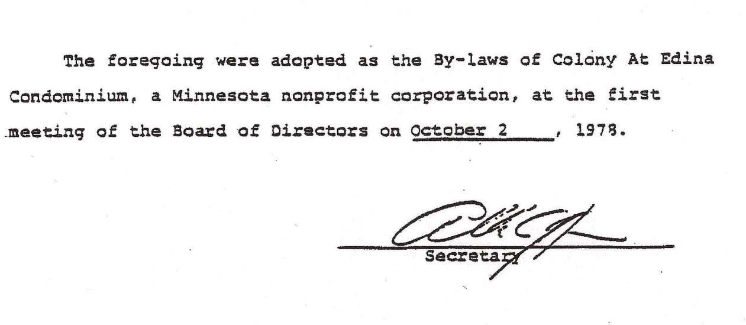

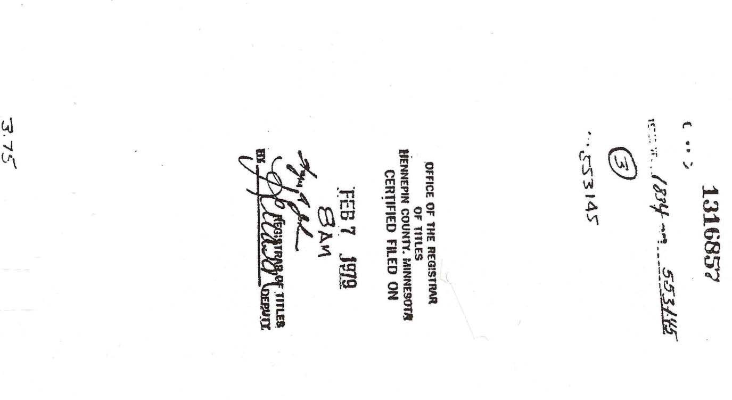

THIS PAGE WAS LEFT BLANK INTENTIONALLY

656

EXHIBIT A

AMENDMENT TO THE DECLARATION AND BY-LAWS OF
THE COLONY AT EDINA CONDOMINIUM

- The Declaration dated October 2, 1978, recorded February 7, 1979 as Document No. 1316857 is hereby amended to read as follows:

  - The following section is added to the Declaration:

ARTICLE XIII

Notwithstanding anything contained in this Declaration to the contrary, the Board of Directors of the Association shall have the power and authority to enter into an agreement for right of access and easement with the approved cable franchisee for the City of Edina for operation of a cable communications system within the City of Edina, upon such terms and conditions as the Board of Directors deems advisable.

  - All other sections of the Declaration shall remain the same.

- The By-Laws, which are attached to the Declaration as Exhibit B, are hereby amended as follows:

  - The following section is added to the By-Laws:

18. Central Television System

Notwithstanding anything contained in these By-Laws to the contrary, the Board of Directors of the Association shall have the power and authority to enter into an agreement for right of access and easement with the approved cable franchisee for the City of Edina for operation of a cable communications system within the City of Edina, upon such terms and conditions as the Board of Directors deems advisable.

  - All other sections of the By-Laws shall remain unchanged.

656
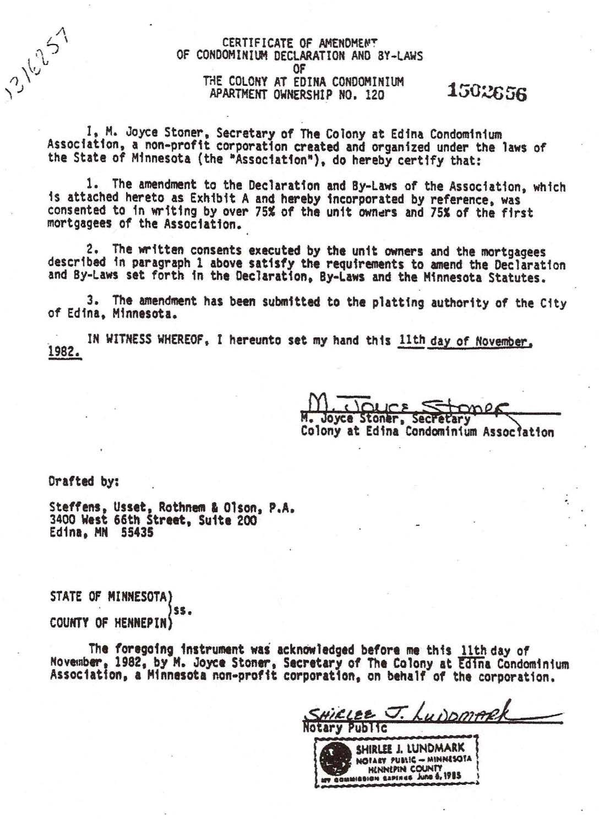

THIS PAGE WAS LEFT BLANK INTENTIONALLY

SECOND AMENDMENT TO THE DECLARATION AND THE BY-LAWS OF THE COLONY AT EDINA CONDOMINIUM ASSOCIATION
THIS AMENDMENT made as of this 19th day of July , 1988, by the Colony at

Edina Condominium Association, a Minnesota non-profit corporation (hereinafter referred to as "Association"), pursuant to Section 515A.2-119 of the Minnesota Uniform Condominium Act (the "Act"), and laws amendatory thereof and supplemental thereto,
WITNESSETH:

WHEREAS, the Colony at Edina Condominium, Apartment Ownership Number 120 (the "Condominium"), was established by recording in the Office of the Registrar of Titles for Hennepin County on the 7th day of February, 1979, as Document No. 1316857, a Declaration of Condominium Ownership dated October 2, 1978 (the "Declaration"), and the By-laws of the Association were attached to the Declaration as Exhibit B thereto (the "By-laws"); and
WHEREAS, the Declaration and By-laws were amended by an Amendment to the Declaration and By-laws dated November 11, 1982 and filed with the Registrar of Titles for Hennepin County on the 28th day of February, 1983, as Document No. 1502656; and
WHEREAS, seventy-five percent (75%) of the owners of units in the Condominium have, in two separate actions, approved in writing the amendments to the Declaration and to the By- laws as provided below; and

WHEREAS, seventy-five percent (75%) of the first mortgagees of units in the Condominium have, in two separate actions, approved in writing the amendments to the Declaration and to the By-laws as provided below.
NOW, THEREFORE, the Declaration and the By-laws are amended as follows:

- The first paragraph of Article V of the Declaration is hereby amended to read as follows:

All sums assessed by the Association for annual assessments for the share of common expenses chargeable against any apartment for any fiscal year shall constitute a lien against such apartment for the full amount of such share of assessments effective as of the first day of such fiscal year, and shall be payable quarterly in advance in equal installments in such fiscal year. All sums assessed by the Association as special assessments for the share of common expenses chargeable to any apartment shall constitute a lien for the full amount of such share as of a date specified by the Board, and shall be payable in amounts and at times determined by the Board. All such annual and special assessment liens shall be prior to any and all other liens against an apartment excepting (i) tax liens on the apartment, including special assessments, in favor of the State of Minnesota or any taxing subdivision thereof, and (ii) all sums unpaid on the first mortgage of record against such apartment. All holders of a property interest shall be jointly and severally liable for such assessments. If any such assessment or installment thereof is not paid within thirty (30) days after the due date thereof, the Board may, in its discretion, declare the entire unpaid amount of such assessment immediately due and payable. Assessments or installments thereof that are more than thirty (30) days past due shall bear interest at the rate of eight percent (8%) per annum, or any other legal rate that may be set by the Board, from the end of such

30-day period until paid. If any assessments or installments thereof are more than thirty (30) days past due, and regardless of whether acceleration has occurred, the lien of such assessment and interest thereon may be foreclosed by the Board or by the manager employed by the Board pursuant to the By-laws, acting on behalf of the Association, in the manner provided in the Minnesota statutes for foreclosure of a mortgage lien by advertisement. The Association shall have the power to bid for the apartment at any foreclosure sale, and to acquire and hold, lease, mortgage and convey the same. Suits to recover a money judgment for unpaid assessments with interest and all costs of collection including reasonable attorneys' fees shall be maintainable by the Association without foreclosing or waiving the lien securing the same.

- Paragraph a of Section 5 of the By-laws is hereby amended to include the following:

(19) To declare the entire unpaid amount of any assessment due and payable in full from any apartment owner who is more than thirty (30) days past due in the payment of any annual or special assessment or installment thereof.

- Paragraph b of Section 3 of the By-laws is hereby amended to read as follows:

b. Commencing in the year following the annual meeting described in Paragraph a above, the annual meeting of the members shall be held on a Saturday in April at such time and in such place as specified by the Board of Directors for the purpose of electing a Board of Directors and transacting any other business authorized to be transacted by the members.

- All other terms and provisions of the Declaration and the By-laws remain the same.

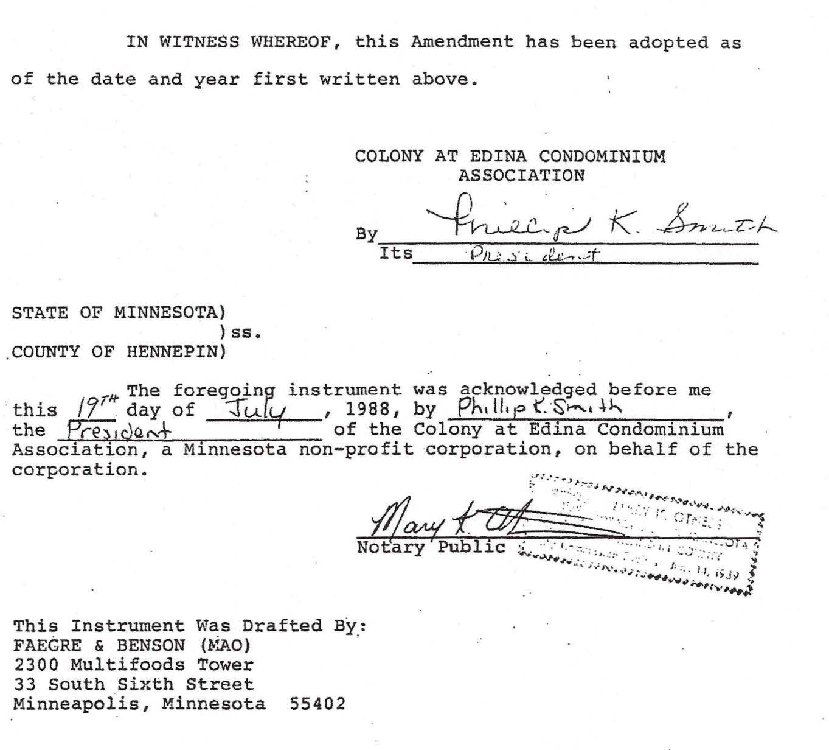

-4-

APARTMENT OWNERSHIP NUMBER 120 COLONY AT EDINA CONDOMINIUMS
STATE OF MINNESOTA)
) ss.
COUNTY OF HENNEPIN) AFFIDAVIT OF SECRETARY OF COLONY AT EDINA
CONDOMINIUM ASSOCIATION

Pursuant to Section 515A.2-ll9(e) of the Minnesota Uniform
Condominium Act

Polly Berg, being duly sworn on oath, disposes and says that: she is the duly elected and acting Secretary of The Colony at Edina Condominium Association, a Minnesota non-prifit
corpc,ratio_n., _1.the. . A oc a t i on_"l•. _.aJl.dJna. e.s thi s _ Af f i da v i t .
pursuant to Section 515A.2-119(e) of the Minnesota Uniform Condominium Act (the "Act•). ·
Seventy five percent (751) of the unit owners of units in Colony at Edina Condominiums (the "Condominium"), in two separate actions, consented and agreed in writing to the l'unendment to the Declarat on and to the By-laws dated 19th day o July · i , 1988 of the Colony at Edina Condominium.
Association to which this Affidavit is attached. In addition, seventy-five percent (75J) of the first mortgagees of units in the Condominium, in two separate actions, consented to and approved in writing this Amendment. Accordingly, the Amendment shall, for all purposes,·be deemed to have been confirmed and approved by all of the u it owners and first mortgagees of units in.t he Condominium pursuant to Section 515A.2-119(a) and (c) of the Act. Further,: your affiant says that this Affidavit is made pursuant to Section 115A.2-119(e) of the Act in order to constitute prima facie evidence of the recitals and representations contained in the Amendment.

