Greetings!

We at the Silver Baron Lodge are thrilled to welcome you, our valued owners, into the new year. We wish all of you a prosperous and healthy 2021 and remain dedicated to providing you with exceptional service at every juncture. Your continued satisfaction remains a top priority for our staff. Furthermore, as the new year progresses, we encourage input from each of you as a means of perfecting our service and strengthening our relationships. Your feedback is always valued, and we love to hear your thoughts!

Here are a few updates concerning January:

***\*\*\*Sundance Film Festival, January 28 – February 3, 2021\*\*\****

This year, Sundance strives to be "together like never before" as we all continue to prioritize public health. Nevertheless, the show must go on, and as a result, Sundance will be providing an enjoyable, yet conscientious experience for patrons. For more information regarding Sundance, please view the link provided. Amongst other pertinent information, the website will provide showtimes, program schedules, ticketing information, and tips for how to maximize your experience, safely.

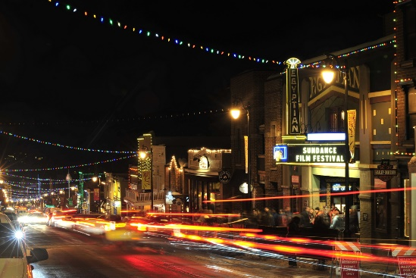

<https://fpg.festival.sundance.org/>

***\*\*\*2021 Freestyle International Ski World Cup February 4-6, 2021\*\*\****

Ski fans rejoice! The beloved World Cup will proceed as scheduled here at Deer Valley. However, due to safety concerns, spectator areas will be unavailable for in person viewing. We welcome you to observe these events virtually, as your wellbeing remains paramount. We at the Silver Baron Lodge are continuously grateful for our owner's compliance during these difficult times.

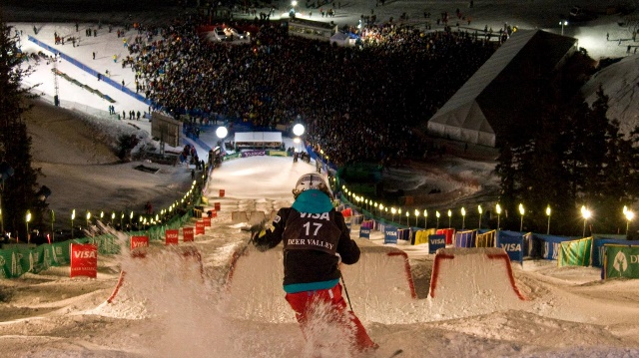

<https://www.deervalley.com/things-to-do/activities/world-cup>

Lastly…this month’s newsletter author would like to share some of their favorite local dining haunts, what are yours?

***\*\*\*Chimayo/Grappa/Riverhorse/Firewood/Flying Sumo\*\*\****