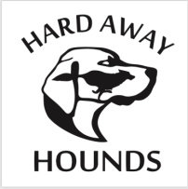

**Agreement of Release and Waiver from Liability – Adult Liability Form**

I request permission to participate in cross-country riding and fox hunting with the Hard Away Hounds.

I fully understand that cross-country riding and fox hunting (which includes riding over fences, other obstacles, steep and rough terrain) are very dangerous activities. I wish to participate in these activities knowing they are dangerous. I accept and assume all risks of injury (including death) to my property or me.

In exchange for being permitted to participate in these activities for my child, myself, my heirs, guardians, and legal representatives, I release and agree not to make or bring any claims of any kind against HARD AWAY HOUNDS, or its Masters, Officers, Directors, Members, Employees, Guest, Landowner, Landholder, or other persons making property available to Hard Away Hounds, for any injury (including death) to me or any damage to my property whether from anyone’s negligence, or not, or any other cause, arising out of my participation in these dangerous horseback riding, fox hunting related activities.

Furthermore, I also agree that if anyone makes any claim because of an injury to me (including death), or for any damages to my property, I will keep all those released by this agreement free of any damages or cost because of those claims.

DATE:__________________

SIGNATURE:____________________________________________

PRINT NAME:___________________________________________

EMAIL: ________________________________________________