MEDIA KIT
The Millennium 2000 edition of Who’s Who in America is added to the National Millennium Time Capsule commissioned by the White House. The title becomes a venerated American biographical reference included in the time capsule along with a copy of the Bill of Rights, film reel of Neil Armstrong’s moon landing, a piece of the Berlin Wall, and a recording of Louis Armstrong’s trumpet among the many artifacts preserved for eternity.
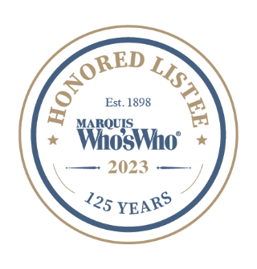
A KIND OF HUSH
FROM THE AWARD-WINNING AUTHOR OF LIFE IN A BOX
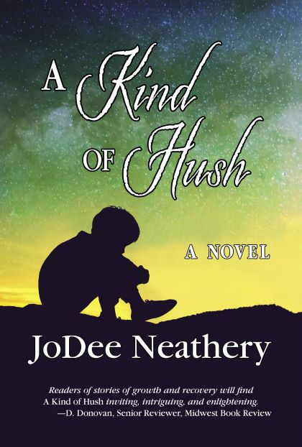
2024 FINALIST AMERICAN LEGACY BOOK AWARDS, Literary Fiction
https://www.americanlegacyawards.com/2024 press release.html
https://www.americanlegacyawards.com/2024award announcement.html
2022 SILVER MEDAL WINNER, READERS’ FAVORITE ANNUAL INTERNATIONAL BOOK AWARDS, Literary Fiction
https://www.readersfavorite.com/2022-award-contest-winners.htm#a-kind-of-hush

2022 WINNER INTERNATIONAL FIREBIRD BOOK AWARDS, Literary Fiction
https://www.speakuptalkradio.com
https://www.speakuptalkradio.com/boombangohmygoshwow (podcast - author tip)
2022 FINALIST, NATIONAL INDIE EXCELLENCE AWARDS, Mystery
www.indieexcellence.com
2022 MILLENNIUM BOOK AWARDS SHORTLISTED CANDIDATE AND CATEGORY WINNER, Literary Fiction
https://bookviralreviews.com/2022-millennium-book-award-winners/?fbclid=1wAR3DktWPmEuWErKhMKFsOg_rgMyxwR9K95x3AFOF1KloKYYm9ZH-yB_r0sQ
Press releases announcing awards sent to Dallas, Tyler, Athens, The Monitor, Corsicana, Ennis news outlets
Publication Date: July 2021
Imagery Lit
315 St. Andrews Drive
Mabank, Texas 75156
Available:
https://www.amazon.com/dp/B098M282NP (A Kind of Hush)
https://www.amazon.com/dp/B073PF7D7V (Life in a Box)
https://www.jodeeneathery.com (both)
www.IngramSpark.com (both)
https://www.smashwords.com (both)
https://www.barnesandnoble.com
https://www.walmart.com
https://books.apple.com
https://www.booksamillion.com
https://www.kobo.com
Physical copies are available at Bookish Bookstore, Malakoff, Texas, B4R online bookstore, The Last Bookstore, Tyler, Texas, Dead Tree Dreams and Bosslight bookstores, Nacogdoches, Texas.
RETAIL: RELEASED:
Hardcover:
978-1-7373920-2-6 $30.95 7-14-2021(with jacket)
ASIN: 173739202X
Hardcover: $24.95 11-14-2021(case laminate)
978-1-7373920-4-0
ASIN: 1737392046
Paperback:
978-1-7373920-0-2 $19.95 7-1-2021
ASIN: 1737392003
E-book:
978-1-7373920-3-3 $4.99 7-3-2021
ASIN: B098M282NP
Audio: Qualified for KDP audiobooks with virtual voice beta test.
PAGES: 340
WORD COUNT: 106,000
SIZE & BINDING: 6x9x1 paperback
BARCODED: YES
DISCOUNTS: Independent Booksellers
WHOLESALE: IngramSpark
Approved: United States Copyright Office
SYNOPSIS
A Kind of Hush examines how life is seldom a tidy affair exploring whether there is a gray area between right and wrong. The Mackie family, after enduring an unthinkable tragedy with the death of their young son, finally moved toward a new life until one June day while enjoying an outing at a nearby rugged park, their lives again turned upside down. A plunge off a shale cliff left one parent dead and the other solely responsible for their teenage daughter and seven-year-old son. Was this an accident or something more heinous, and if so whodunnit and whydunit? The heart of the novel centers on how each survivor deals with the circumstances and subsequent revelations surrounding the incident while a mantle of ambiguity – a kind of hush – hangs between them like a live grenade without its pin.
Advanced praise, Diane Donovan, Sr. Reviewer, Midwest Book Review and included on Donovan’s Bookshelf Recommended Reading:
http://donovansliteraryservices.com/july-2021-issue.html
Midwest Book Review:
http://www.midwestbookreview.com/mbw/jul_21.htm#dianedonovan
Kirkus Review:
https://www.kirkusreviews.com/book-reviews/jodee-neathery/a-kind-of-hush/
Self-Publishing Review magazine (SPR)
https://www.selfpublishingreview.com/?s-A+Kind+of+Hush
Readers Favorite 5-star review:
https://readersfavorite.com/book-review/a-kind-of-hush
Book Viral Review:
https://bookviralreviews.com/book-reviews/literary-fiction/new-literary-fiction-novels/
http://bookviralreviews.com/readers-favourites/
http://bookviralreviews.com/
https://www.facebook.com/Bookviral-208302829365066/
https://www.facebook.com/groups/BookViral/
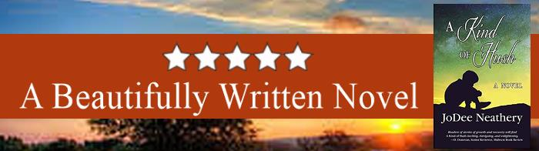
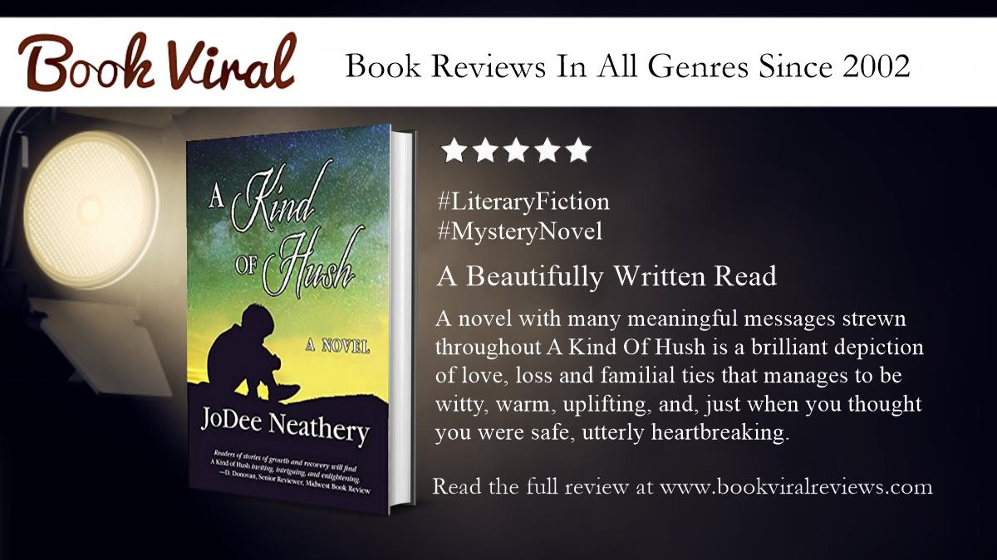
Chick Lit Café Review:
https://chicklitcafe.com/?s=A+Kind+of+Hush+
Amy Shannon of Bookshelf Reviews. 5 Stars, “Tragedy and Triumph Can Blur The Line.”
https://www.instagram.com/amysbookshelfreviews/
https://www.twitter.com/ABSR_amyreviews
www.linkedin.com/in/Amy-Bookself-reviews
https://www.writeramyshannon.wixsite.com/bookshelfreviews
https://www.writeramyshannon.wixsite.com/amyshannonblog
https://www.facebook.com/bookshelfreviews/
https://www.facebook.com/amyshannonnovelist
https://www.facebook.com/bookshelfeviews/
https://www.youtube.com/channel/UCVyM4_pE_TX60B-nWwz5ww0
https://www.bookbub.com/reviews/988593075
https://www.amazon.com/gp/customer-reviews/R23KLTHR18EANT
Fiction Café Book Club Facebook Group: Author of the Week” feature. https://www.facebook.com/JoDee315Neathery/videos/2766578723641078/
Oct/Nov/December issue of De Mode Magazine on-line and print featured in Books and Authors segment – Ten Must Reads for Fall – Interview, Links to purchase.
Reedsy Discovery Program: 5 Star Review, posted by Laura Hartman on Goodreads and Amazon. “A Kind of Hush is one of the best books I have read this year. I could not put this book down.”
https://www.reedsy.com/author/jodee-neathery
https://reedsy.com/discovery/book/a-kind-of-hush-jodee-neathery#review
Grace Jackson, independent reviewer:
Goodreads- https://www.goodreads.com/review/show/4423828827
Facebook- https://www.facebook.com/106919625154892/posts/119951593851695/
Independent Reviewer: Lydia Efobi, LinkedIn connection review posted: https://tinyurl.com/3apy9234
Tapnet.com guest post: https://www.tapnet.com/a-kind-of-hush-jodee-neathery posted on Twitter & Facebook pages.
Sassy 5-star Reviews: https://www.instagram.com/p/CaNFRnoi_y
https://passionduniva.wordpress.com/2023/01/09/a-kind-of-hush https://www.goodreads.com/review/show/5248027842 https://book.google.co.in/books?id=x1MZGEACAAJ&sitesec=reviews

OnlineBookClub.org 5-Star Review: February 2024: https://forums.onlinebookclub.org/viewtopic.php?f=2&t=435801

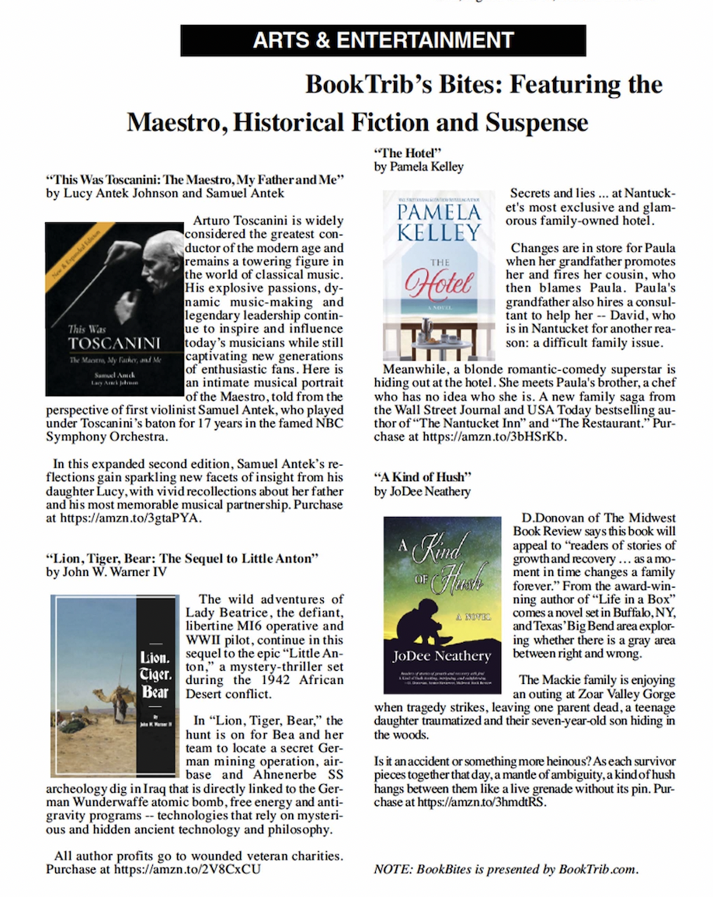
BookView Review awarded the Gold Recommended medallion
https://www.bookviewreview.com/2021/08/31/book-excerpta-kind-of-hush-by-jodee-neathery/
https://www.facebook.com/bookviewreview bookviewreview@yahoo.com 
Prairies Book Editorial Review:
https://theprairiesbookreview.com/2021/08/26/a-kind-of-hush-by-jodee-neathery/
https://www.facebook.com/theprairiesbookreview
Inside Emotion of Fiction:
http://chrisricecooper.com/262-inside-the-emotion-of-fiction-jodee-neatherys-a-kind-of-rush/?fbclid=IwAR2z3a5rBX2S_aL8kdtVaYGcK5pVslOFVVlHZsyzpjlmWLszDzY-sh9Fij0
Writers’ League of Texas Meet the Members spotlight. https://writersleague.org/2021/08/02/meet-the-members-jodee-neathery-2/
Live on-air conversation GMAP1 network, Chicago, Illinois. Recorded conversation aired Comcast cable networks: https://www.youtube.com/watch?v=o6bm04i7RjE
The Making of A Kind of Hush, article posted November 2022, https://www.tapnet.com/a-kind-of-hush-jodee-neathery
URL: https://tapnet.com/A-Kind-of-Hush-jodee-neathery

May 26, 2023: Featured Author of the Day and featured book: https://manybooks.net/featured-authors/jodee-neathery-rich-and-colorful-descriptive-storytelling

SOCIAL MEDIA LINKS:
https://www.amazon.com/author/jodeeneathery
https://www.facebook.com/JoDeeNeatheryAuthor/
https://www.twitter.com/authorihope
https://www.pinterest.com/jodeeneathery
https://www.instagram.com/jodee741/
https://www.linkedin.com/in/jodee-neathery-94b2b33b/
https://www.tumblr.com
https://www.reddit.com
https://www.goodreads.com/authorihope/
https://www.reedsy.com/author/jodee-neathery
https://www.bookbub.com/profile/Jodee-Neathery
https://www.booklife.com/my/project/a-kind-of-hush-79314
BOOK SIGNINGS AND PRESENTATIONS:
American Business Women’s Association, Rotary Clubs, Book Clubs, Women’s Clubs, Literary Clubs, Writing Guilds, Retirement villages, Independent bookstores, Book Festivals and Fairs, Public Libraries.
WHAT READERS SAY ABOUT JODEE NEATHRY’S WRITING:
“JoDee’s writing is vivid, lyrical and has the capability of placing you in the time and setting of the story. Her characters become part of your life.” Dauphin Island Book Club
“JoDee has a very clever way of grabbing the reader’s attention with a unique style of presentation as she writes from the heart.” Retired educator & avid reader
“JoDee has a special knack for putting readers right in the moment.” Amazon reviewer
“I admire her ability to string words together. Her writing is lyrical taking readers on a journey full of twists and turns.” Avid Reader & Multiple book club member
“Incredibly lyrical. Lovely, yet powerful. The character development creates friends you want to keep forever in your circle.” Book Club Chairman
“Characters so clearly defined you will not forget them.” Author
“Ms. Neathery’s detailed and vivid descriptions have the reader feeling as if they’re in the midst of every conversation and setting.” Author
“JoDee Neathery is a writer who understands how we should embrace the wisdom of generations of those who have come before us.” Editor, Women’s magazine
CRITICAL ACCLAIM
“She writes as a painter paints. A work of art.” Amazon Reviewer
“Couldn’t put it down. Kept me up past my bedtime.” Amazon Reviewer
“Loved the characters and the way she pulled you into the scenes.” Amazon Reviewer
“Tragedy and triumph can blur the line.” Amazon & Goodreads Reviewer
“Story telling at its best. Lyrical and almost magical at times.” Amazon Reviewer
“Engaging. Flows nicely. Well-written and plotted.” Amazon Vine Voice Reviewer
“Even after you put it down you are still thinking about it.” Amazon Reviewer
“Story is well-written and filled with thrilling descriptive writing.” Amazon Reviewer

