20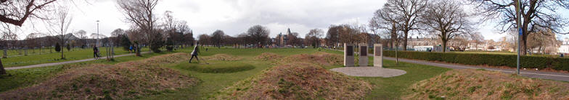

Leith Rules Golf Society             **The aim of the Society is to increase the recognition of Leith Links as the home of the earliest recorded rules of golf and one of the game's prominent early locations**

Foulis medal : Friday 11th July 2025 6:30pm

The Foulis Medal is open to ***Leith-based*** organisations, businesses and groups, so if you “qualify” we invite you to enter a team (or teams) in the event. Each team will comprise 2 players playing alternate shots. The games will be played over 10 holes on Leith Links using hickory clubs.

There is a limit on the number of teams who can play, so if you wish to enter more than one team this will depend on space being available.

This competition is part of our annual hickory golf which culminates with our Open on Saturday 13th July. Entries for this are also being accepted.

The entry fee is £20.00 per team which includes the hire of clubs and balls and also includes the pie and beans to restore you after your game. The cost of pie and beans for guests is to be paid for separately.

If you would like to enter a team(s) please return the form below to us on **leithrulesoffice@gmail.com**

We look forward to hearing from you. If you have any questions about the event then please contact us on our usual Email address or Alastair Chalmers ([alastairchalmers1948@gmail.com](mailto:alastairchalmers1948@gmail.com)), Mike Turner ([mikejtucker007@googlemail.com](mailto:mikejtucker007@googlemail.com))

*Leith Rules Golf Society*

|  |  |
| --- | --- |
| **TEAM NAME** |  |
| **Player 1** |  |
| Name |  |
| Contact details |  |
| Own clubs? | YES / NO (Please delete as appropriate) |
|  |  |
| **Player 2** |  |
| Name |  |
| Contact details |  |
| Own clubs? | YES / NO (Please delete as appropriate) |
|  |  |
| Entry Fee (Team) | £20 (Pay on the night) |