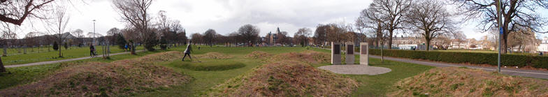

Leith Rules Golf Society
The aim of the Society is to increase the recognition of Leith Links as the home of the earliest recorded rules of golf and one of the game's prominent early locations

19th hickory open : Saturday 9th July 2022

The format will be 3 rounds medal play, no matchplay play offs. Scratch and Handicap trophies to be competed for.

Please fully complete the form below and return to us at lrginfo@blueyonder.co.uk.

TEAM NAME
Player 1
Name
Contact details
WHS Handicap
Own clubs? | YES / NO (Please delete as appropriate)
Player 2
Name
Contact details
WHS Handicap
Own clubs? | YES / NO (Please delete as appropriate)
Entry Fee (Team) | £15. Payable on the day or by bank transfer (bank details below)  Sort Code: 80-02-38  Account Number: 00914608  Please include your name and “HO” as a reference

WHS System We will calculate suitable playing handicaps based on what we know from other courses – no appeals permitted!! If you don’t have a WHS handicap, please provide an accurate idea of your regular scores.

We will issue tee times nearer the event.

