20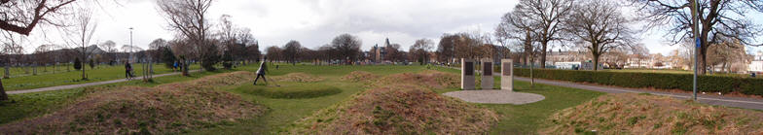

Leith Rules Golf Society
The aim of the Society is to increase the recognition of Leith Links as the home of the earliest recorded rules of golf and one of the game's prominent early locations

Foulis medal : Friday 10th July 2026 6:00pm

The Foulis Medal is open to local organisations, businesses and group. We invite you to enter a team (or teams) in the event. Each team will comprise 2 players playing alternate shots. The games will be played over 10 holes on Leith Links using hickory clubs. Clubs and balls will be provided or bring your own hickory clubs.

There is a limit on the number of teams who can play, so if you wish to enter more than one team this will depend on space being available.

This competition is part of our annual hickory golf which culminates with our Open on Saturday 11th July. Entries for this are also being accepted.

The entry fee is £20.00 per team which includes the hire of clubs and balls and also includes the pie and beans to restore you after your game. The cost of pie and beans for guests is to be paid for separately.

If you would like to enter a team(s) please return the form below to us on leithrulesoffice@gmail.com

We look forward to hearing from you. If you have any questions about the event then please contact us on our usual Email address or Alastair Chalmers (alastairchalmers1948@gmail.com), Mike Tucker (mikejtucker007@googlemail.com)

Leith Rules Golf Society

TEAM NAME
Player 1
Name
Contact details
Own clubs? | YES / NO (Please delete as appropriate)
Player 2
Name
Contact details
Own clubs? | YES / NO (Please delete as appropriate)
Entry Fee (Team) | £20 (Pay on the night)

