How to Set Up a Simple Inexpensive Homeschool Classroom
posted by: lauren

In preparation for this post, I just searched “homeschool classrooms” in Pinterest to look at what other moms are doing that might be different than me…um…wow! I saw some of the most amazing furniture, decorating, storage, and learning stations!
It made me a little bit sad because we do not have the space or budget for anything even close to some of those classrooms. But then I remembered that I have a successful homeschool – and I know most of that is not required. There are many homeschools that don’t have a classroom at all!
I do believe that having a homeschool space is important because of this, but it does NOT have to be so complicated or expensive.
When we first started homeschooling, we had just moved to one of the most expensive places in the country to live. We were living carefully on a budget as we started to realize how much homeschooling was going to cost.
We looked at our new house and found a small extension off the living room that we felt we could turn into a classroom.
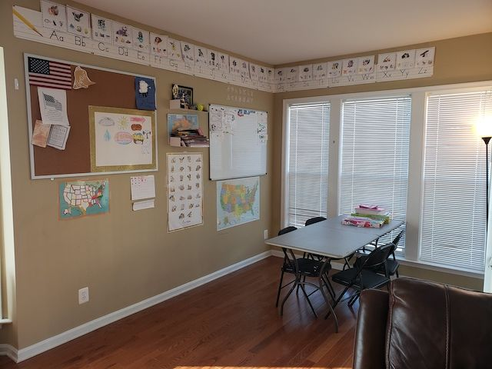
Yes, that is a folding table and folding chairs. I wasn’t joking about simple!

I want to share with you what we bought, what I would do differently now, and what I want to buy in the future as money allows. The items below are prioritized by how important they are, so consider buying what your budget can allow and then saving for the next item on the list and so on.
So here we go!

How to Set Up a Simple Homeschool Room
1. Writing Surface and Chairs
You do not need to buy special desks or rolling ergonomic chairs for your students. But, your students do need a good-sized flat, sturdy surface to write and work on with a comfortable chair. Depending on where you want to set up your classroom, you may already own something that meets this requirement. We bought folding chairs to go with a folding table we already owned. Check!

2. Wall Space
The classroom is going to take up a good amount of wall space. Depending on where you are planning to set up your homeschool, some pictures may need to come down.

You probably already own or rent the walls in your home…so check!

3. White Board
I asked my daughter what the most important item in our classroom is and without hesitation, she said, “Our whiteboard! We use it for every subject.” So true. She is a visual learner and sometimes just writing something in bigger letters or numbers on the board helped her to understand more clearly.
We bought a Lockways Magnetic Dry Erase Board on Amazon. It is 3 feet x 4 feet and also came with magnets and markers – nice touch!
The dimensions seemed enormous when I ordered it online, but once I started teaching I realized that my teaching style really lends itself to the use of a big whiteboard.
Ours is also magnetic (not necessary) which is a nice feature if that fits your budget. I love using magnets to display our daily schedule, important sheets I use often, and of course those nifty Magnetic Markers that are always just sitting there when you need to grab them.
Magnetic boards can be a bit pricey (which is why mine is smaller), but you can DIY your own enormous whiteboard for about $20. Check this blog post out if you’re feeling up to making your own!

4. Shelves
Shelves are so nice to have in the classroom to keep your daily supplies close at hand. I have younger children, so I also wanted a place to put things that would be far out of reach of curious fingers.
We ended up buying some floating shelves that are smaller than we thought but have been okay for us. As my kids are getting older and I am getting more students in my classroom, I am going to be needing some larger shelves soon to hold all their daily supplies.
You may already have shelves near or in your homeschool that can serve this purpose just fine. If not, Amazon, Ikea, Walmart, and others have many affordable options.

5. Storage
The Pinterest images mentioned above showed some truly amazing storage options for homeschool materials that you may not be using every day. Mine are stored in two kitchen cabinets I emptied out. Works just fine for us and did not cost anything. I would like to eventually upgrade to some fancier storage containers for the classroom, just for convenience, but what we have now works just fine.
You may already have some storage space available or that you can at least clean out and repurpose. If you’re not sure, don’t sweat it! Your needs for storage largely depend on how many kids you have, their ages, and what curriculum you choose.
Once the year gets going, take an inventory and see if you really do need to purchase something or if you can just repurpose something in your home.

6. School Supplies
It is no surprise that you will need to buy school supplies. I have seen some pictures and videos of homeschool rooms and I have been floored at the amount and variety that people buy.
I would strongly recommend not buying anything until you have chosen your curriculum. There will likely be a list in front of the teacher’s manual that will tell you what you need to have on hand.
I was really surprised that I did not need to purchase very much for Oldest when we first started. Her shopping list was pretty small compared to what I had to buy when she was in public school. I did pick up this Alphabet with Photographs Bulletin Board Set from Amazon and have found it very helpful to the girls to have it displayed.
As a side note on school supplies, I bought a laminator and have used it I think twice. Definitely something to put lower on the budget priority list in my opinion.

7. Bulletin Board
This is last on the list because it is the least necessary, but a nice to have. I love that I can display projects and crafts all year long. I see it give a sense of pride to my kids when they see their work displayed for the whole family to see.
It is also fun to look back over the year at what they have accomplished. This past summer we did a unit study on zoology and had a blast! Here is our finished bulletin board with all the crafts the kids made:
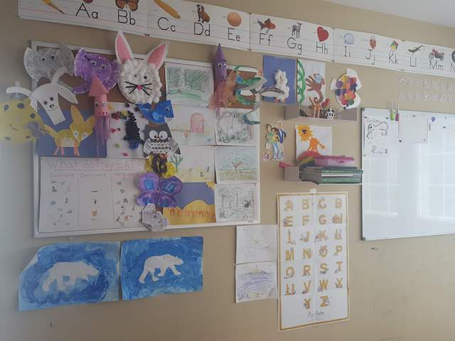
Again, not at all necessary, but a fun touch. We ordered one from Walmart and it was about $50.

Recap of How to Set Up a Simple Homeschool Room
So if you have been following along with your calculator, depending on what you have in your house already, setting up a homeschool classroom can be very affordable.
You will likely build on it as the years go on and you need more or different things to meet your homeschooler’s needs. There is no rush and there is no need to spend a lot of money when you are starting out.
Keep your eyes open on Craigslist, eBay, LetGo, or even garage sales. You may find even better deals to make your homeschool space work for your family.
If you already have a classroom set up, share a picture in the comments – I would love to see what works for you!

Update:
Writing this post made me really start thinking about getting a new bookshelf. I looked around on Amazon and found this very reasonable 2-Shelf Cherry Bookcase. It was so heavy that I had to carefully drag it into our house because I couldn’t lift the box! It is very well made (especially considering the price) and a nice addition to our little classroom. I envision this bookcase will be filling up soon!
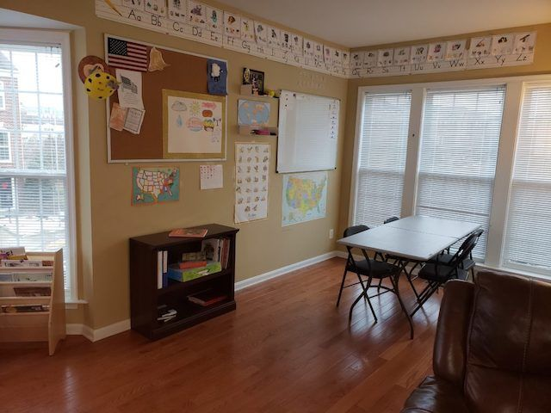

Update (January 2020):
We actually moved and I wanted to link this post to a tour of our new classroom!
Our homeschool room has changed and grown with us over the years and I’m excited to share it with you how we set it up!
Check it out and take a tour by clicking on the image below:
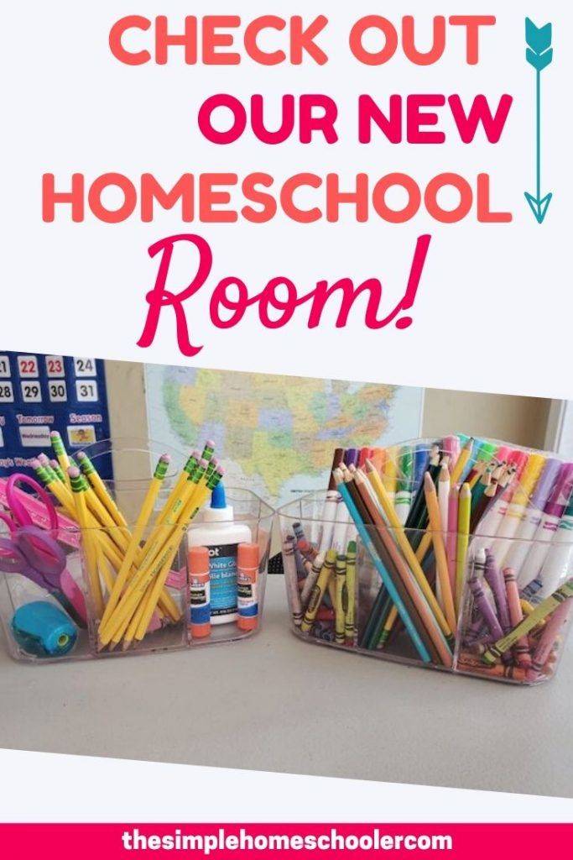

https://www.thesimplehomeschooler.com/how-to-set-up-a-simple-homeschool-classroom/

