SUPPLEMENTAL PATIENT INTAKE FORM
Due to new requirements from the United States Department of Health and Human Resources, we are requesting that all patients complete the following questionnaire.
PATIENT NAME: ___________________________________________________________________ TODAY’S DATE: _____________________________
DATE OF BIRTH: __________________________________________________________________ SEX:  Male  Female

MELANOMA:
Have you ever been diagnosed with Melanoma?  YES  NO
If YES, did you ever have an X-ray, Catscan, MRI, or Petscan?  YES  NO

TOBACCO USE:
Please choose the option that best describes your tobacco use:

 Never  Current smoker  Previous smoker  Less than 100 cigarettes in lifetime

For current tobacco users, select the option that best describes use:

 1-3 cigarettes per day  Up to 1 pack per day  1-2 packs per day  2 or more packs a day

ALCOHOL USE:
How often do you have an alcoholic beverage?
 Never  Monthly or less  2-4 times per month  2-3 times per week  4+ times per week
If you do drink, how many drinks do you typically have (based on 1 small glass of wine or half a can of beer)?
 1-2  3-4  5-6  7-9  10+
On a single occasion in the last year, how often have you had 3 (females) or 4 (males) drinks?
 Never  Less than monthly  Monthly  Weekly  Daily or almost daily

CONTINUE TO BACK ⇨

SUPPLEMENTAL PATIENT INTAKE FORM (CONTINUED)

Vaccinations :
Between your 9th and 13th birthdays, did you receive the following vaccinations?
Meningococcal vaccine:  YES  NO
Td/Tdap vaccine:  YES  NO
HPV vaccine:  YES  NO

Have you received the following?
Covid Vaccination:  YES  NO
Covid Booster:  YES  NO

Itch:
Are you currently experiencing any itchiness?  YES  NO
If yes, please circle the number that corresponds with the amount of itch you currently feel:
Numeric Itch Rating Scale
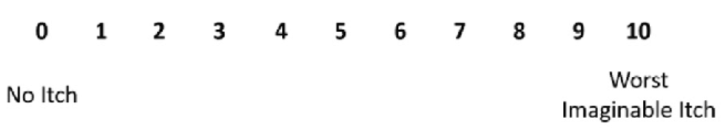
AGE 65 AND OVER ONLY:
Do you have one of the following?
 Power of Attorney (Surrogate Decision Maker)  Living Will (Advance Care Plan)  None

PRIMARY CARE PHYSICIAN:
Please list the name, phone and fax number for your primary care physician:
Name: __________________________________________________ Practice: _________________________________________________________
Phone: __________________________________________________ Fax: ______________________________________________________________

FOR PHYSICIAN’S USE ONLY: SCORE: _________________________ INITIALS: _________________________

