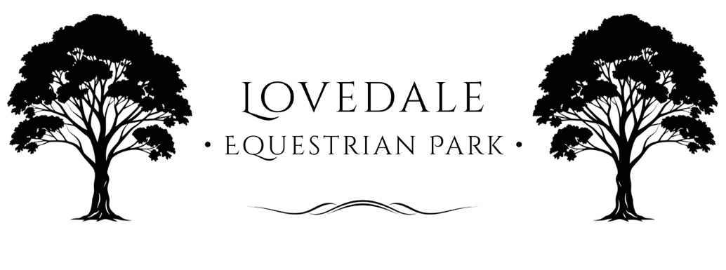

Participant Liability Waiver
Rider and Participant Waiver and Release of Liability
Participant Name: _________________________________________
Address: _________________________________________________
Phone: ___________________ Email: ___________________

1. Acknowledgment of Risk
I acknowledge that horse riding, handling, and participation in equestrian activities involve inherent risks, including falls, collisions, unpredictable animal behaviour, and exposure to environmental hazards.
I voluntarily accept all risks associated with my participation at Lovedale Equestrian Park (“the Park”).

2. Release and Waiver
To the fullest extent permitted by law, I hereby release and discharge Lovedale Equestrian Park, its owners, employees, volunteers, agents, and representatives from all claims, demands, or causes of action arising from:
- Injury or death to myself or my horse;
- Damage to personal property;
- Any negligence or omission by the Park or its representatives;
except where liability cannot be excluded under the Australian Consumer Law or NSW legislation.

3. Indemnity
I agree to indemnify and hold harmless Lovedale Equestrian Park from all costs, losses, or damages arising from my actions, negligence, or failure to comply with the Park’s rules and directions.

4. Safety and Compliance
I agree to:
- Wear an approved EA Tagged riding helmet (AS/NZS 3838 or equivalent) and correct footwear at all times while mounted.
- Follow all Park rules, signage, and staff instructions.
- Ensure that any horse I ride or handle is fit, healthy, and under my control.
- Refrain from alcohol or drug use prior to or during participation.

5. Horse Welfare and Conduct
I agree to handle and ride all horses humanely, in accordance with the NSW Animal Welfare Code of Practice – Horses, and will not engage in any act of cruelty or mistreatment.

6. Medical and Emergency Consent
I consent to first aid being administered if required, and to medical treatment being sought on my behalf in an emergency.
I agree to pay any associated costs arising from such treatment.

7. Photography and Media
I consent to the Park using photographs or videos of my participation for promotional purposes, unless I notify management otherwise in writing.

8. Legal Age and Understanding
I confirm that I am over 18 years of age and have read and understood this document.
If under 18, this waiver must be signed by a parent or legal guardian.

9. Signature
I have read and understood this Waiver and Release of Liability and voluntarily agree to its terms.
Participant Signature: _________________________ Date: ____________
Print Participant Name: __________________________________________
Parent/Guardian Signature (if under 18): ____________________________
Print Parent/Guardian Name (if under 18): ____________________________

Lovedale Equestrian Park
info@LovedaleEquestrianPark.com.au
66 Wills Hill Road, Lovedale, 2325

