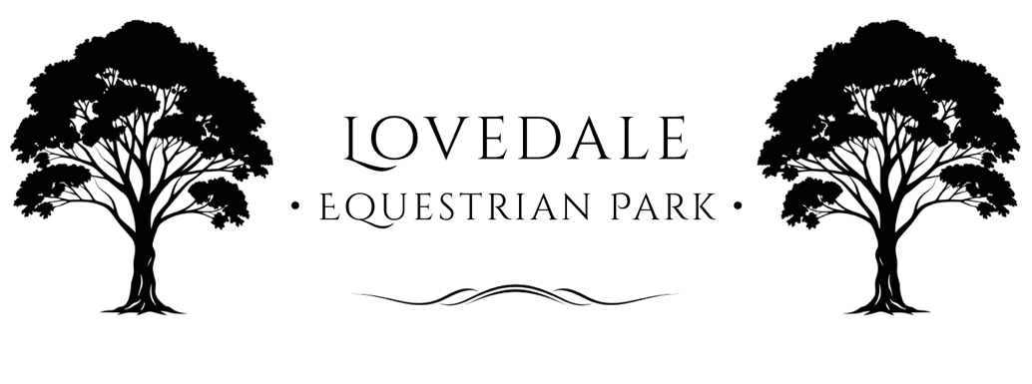

2025 Casual Arena Hire Prices
-
80x80 Geo-fibre Sand Arena
$55/hour: 1-2 People NO JUMPS
$65/hour: 1-2 People WITH JUMPS

$70/hour: 3-5 People NO JUMPS
$80/hour: 3-5 People WITH JUMPS

90x90 Grass Arena
$50/hour: 1-2 People NO JUMPS
$60/hour: 1-2 People WITH JUMPS

$65/hour: 3-5 People NO JUMPS
$75/hour: 3-5 People WITH JUMPS

20x60 Sand Dressage Arena
$30/hour: 1-2 People NO JUMPS
$40/hour: 1-2 People WITH JUMPS

$35/hour: 3-5 People NO JUMPS
$45/hour: 3-5 People WITH JUMP

Event Hire
For Event Hire inquiries, please email your request.

Contact
Lovedale Equestrian Park
info@LovedaleEquestrianPark.com.au
66 Wills Hill Road, Lovedale, 2325

