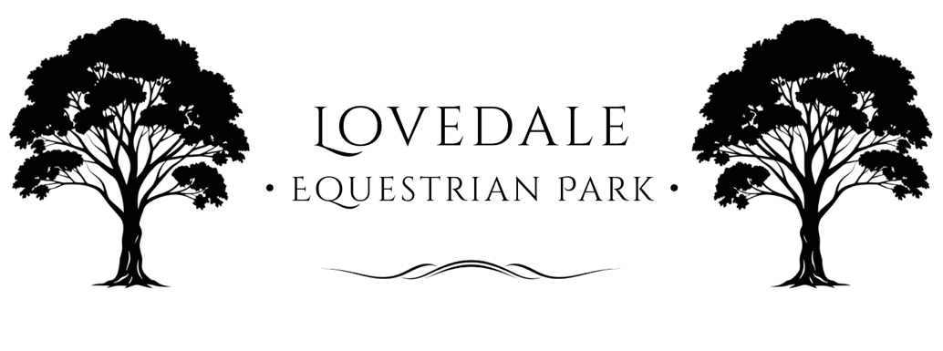

Terms and Conditions

Effective Date: 10th Octoer 2025
Location: Lovedale Equestrian Park – 66 Wills Hill Rd, Lovedale 2325, NSW, Australia

1. General Conditions of Entry
1.1 By entering or participating at Lovedale Equestrian Park (“the Park”), you agree to comply with these Terms and Conditions, all Park signage, and any reasonable directions from Park staff.
1.2 The Park operates in accordance with the Work Health and Safety Act 2011 (NSW) and related Regulations to provide, as far as reasonably practicable, a safe environment for workers, participants, and visitors.
1.3 All persons entering the property do so at their own risk and are responsible for their own safety and that of their horses, guests, and property.
1.4 The Park reserves the right to refuse entry or remove any person or horse from the premises if conduct is unsafe, inappropriate, or in breach of these Terms.

2. Work Health and Safety (WHS)
2.1 Lovedale Equestrian Park is committed to maintaining compliance with Australian Work Health and Safety (WHS) standards.
2.2 All staff, contractors, volunteers, and participants share a duty of care to ensure their own health and safety and that of others.
2.3 Participants must:
- Follow all safety signage and instructions.
- Report hazards, injuries, or unsafe behaviour immediately to management.
- Use personal protective equipment (PPE) including approved helmets and suitable footwear.
2.4 Emergency procedures, including first aid and evacuation points, are displayed on-site. Riders and visitors must familiarise themselves with these procedures.
2.5 Any accidents or incidents must be reported to Park management immediately for recording in accordance with WHS reporting requirements.

3. Assumption of Risk
3.1 Horse riding and related activities involve inherent risks, including serious injury or death.
3.2 By participating at the Park, you acknowledge and voluntarily assume all such risks.
3.3 Lovedale Equestrian Park, its owners, staff, and representatives are not liable for any loss, injury, or damage unless required by law.

4. Safety Requirements
4.1 All riders must wear an approved safety (EA Tagged) helmet (AS/NZS 3838, EN1384, or ASTM/SEI) and proper riding boots at all times while mounted.
4.2 Horses must be under control at all times; reckless riding or handling is prohibited.
4.3 Lunging, jumping, and riding are permitted only in designated areas.
4.4 Smoking, alcohol consumption, and the use of drugs are strictly prohibited in all working and riding areas.
4.5 Children under 18 must be supervised by a responsible adult at all times.

5. Animal Welfare and Care Standards
5.1 Lovedale Equestrian Park upholds the principles of the Prevention of Cruelty to Animals Act 1979 (NSW) and the NSW Animal Welfare Code of Practice – Horses.
5.2 All horses on-site must:
- Be in good health and free of infectious diseases.
- Receive appropriate nutrition, hydration, shelter, and veterinary care.
- Be handled and trained humanely at all times.
5.3 Harsh treatment, excessive use of aids, or cruelty toward animals will result in immediate removal from the property and possible referral to authorities.
5.4 Owners and handlers must provide current vaccination and worming records upon request.
5.5 Injured or ill horses must be reported immediately to Park staff. The Park reserves the right to seek veterinary attention (at the owner’s cost) if urgent care is required.

6. Facility Use and Conduct
6.1 Facilities include arenas, stables, paddocks, wash bays, and cross-country or showjumping areas as designated.
6.2 Users must only access areas authorised or booked for their use.
6.3 All equipment (including jumps, poles, and machinery) must be used correctly and returned in good condition.
6.4 All riders must respect arena etiquette, including right-of-way rules and shared space courtesy.
6.5 Clinics and lessons only to be hosted by EA Affiliated Coaches OR relevant insurance body and provide Certificate Of Currency.
6.6 Dogs must be kept on a lead and under control at all times.

7. Agistment, Storage, and Equipment Hire
7.1 Separate agreements apply for agistment, storage, and equipment hire.
7.2 While the Park takes reasonable care, it accepts no responsibility for loss, theft, injury, illness, or escape of horses or property.
7.3 Horse owners are encouraged to maintain public liability and mortality insurance.
7.4 The Park retains the right to move or isolate horses in emergencies or for safety reasons.

8. Bookings, Fees, and Cancellations
8.1 All lessons, clinics, and arena bookings must be confirmed and paid in advance unless otherwise arranged.
8.2 Cancellations require at least 24 hours’ notice; refunds or credits are issued at management’s discretion.
8.3 The Park reserves the right to postpone or cancel activities due to unsafe weather, ground conditions, or operational requirements.
8.4 All Bookings, editing and cancellation of entries and hires through Event entries platform (Global Entries Online/Nominate/Equipe) or in writing to event organisers at info@lovedaleequestrianpark.com.au

9. Photography, Media, and Privacy
9.1 The Park may record photos or videos of events for marketing and social media purposes.
9.2 Participants who do not wish to appear in media must notify staff in writing prior to participation.
9.3 All photography for commercial or promotional use requires prior written approval.
9.4 Personal information collected by the Park will be handled in accordance with the Privacy Act 1988 (Cth).

10. Property, Vehicles, and Equipment
10.1 Vehicles and floats must be parked in designated areas only.
10.2 Speed limits apply within the property and must be strictly observed.
10.3 The Park is not responsible for damage or loss to vehicles, floats, tack, or other equipment.

11. Indemnity
11.1 By entering Lovedale Equestrian Park, all participants agree to indemnify and hold harmless the Park, its owners, staff, and agents from any claims, demands, or costs arising from their participation, except as required by law.

12. Amendments and Acceptance
12.1 Lovedale Equestrian Park reserves the right to update these Terms and Conditions at any time.
12.2 The most current version will be available on-site and on the Park’s official website.
12.3 Entry or participation signifies acceptance of these Terms and Conditions and acknowledgment of inherent risk.

Lovedale Equestrian Park
info@LovedaleEquestrianPark.com.au
66 Wills Hill Road, Lovedale, 2325

