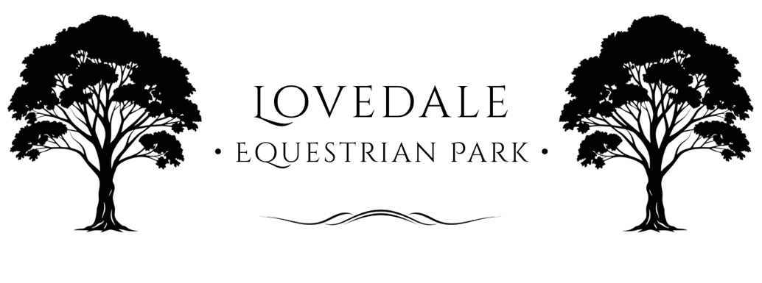

Risk Management Policy
Effective Date: 10th Octoer 2025
Location: Lovedale Equestrian Park – 66 Wills Hill Rd, Lovedale 2325, NSW, Australia
Review Date: Revise Anually
Applies to: All staff, coaches, contractors, participants, spectators, and visitors.

1. Purpose
Lovedale Equestrian Park (“the Park”) is committed to providing a safe environment for all participants, animals, and visitors by identifying, assessing, and controlling risks associated with equestrian activities.
This policy follows the principles of Equestrian Australia’s Risk Management Guidelines, the Work Health and Safety Act 2011 (NSW), and the WHS Regulation 2017 (NSW).

2. Objectives
- To protect the health, safety, and welfare of all persons at the Park.
- To comply with relevant Australian and NSW legislation.
- To maintain a culture of proactive risk awareness and continuous improvement.
- To uphold animal welfare and environmental responsibility.

3. Scope
This policy applies to all activities at the Park, including but not limited to:
- Horse riding lessons, clinics, and competitions
- Agistment and horse handling
- Equipment hire and arena use
- Public and private events
- Maintenance, training, and general facility operations

4. Legislative and Standard References
- Work Health and Safety Act 2011 (NSW)
- Work Health and Safety Regulation 2017 (NSW)
- Prevention of Cruelty to Animals Act 1979 (NSW)
- Equestrian Australia Code of Conduct and Risk Management Guidelines
- NSW Animal Welfare Code of Practice – Horses
- Safe Work Australia: Managing Risks in Sport and Recreation (2022)

5. Responsibilities
Management:
- Implement and maintain a documented risk management system.
- Ensure staff are trained and competent in WHS procedures.
- Provide safe facilities, equipment, and emergency plans.
- Record and investigate all incidents and near-misses.
Staff and Contractors:
- Follow safety instructions, signage, and procedures.
- Report hazards and incidents immediately.
- Participate in safety briefings and training.
Participants and Visitors:
- Comply with all Terms and Conditions, safety signage, and directions.
- Ride within their ability and use approved safety equipment.
- Supervise minors and control horses at all times.

6. Risk Identification and Assessment
The Park maintains a Risk Register covering physical, environmental, and operational risks.
Examples include:
Risk Category | Example Hazard | Control Measures
Horse handling | Kicking, biting, bolting | Training, PPE, supervision
Riding | Falls, collisions, jumps | Arena rules, helmets, supervision
Facility | Slippery surfaces, poor lighting | Maintenance schedule, hazard signage
Weather | Storms, heat, fire | Weather monitoring, cancellation policy
Public safety | Unsupervised spectators | Designated zones, supervision
Animal welfare | Dehydration, illness | Regular welfare checks, vet on call
All risks are assessed using a likelihood–consequence matrix and managed according to their severity.

7. Control Measures
- Use of approved helmets and safety gear mandatory.
- Horses must be in good health and appropriately vaccinated.
- Facility maintained to prevent hazards (fencing, footing, signage).
- First Aid kits and emergency contacts available on-site.
- All instructors to hold relevant EA or NCAS accreditation (if applicable).
- Regular review and testing of emergency procedures.

8. Incident Reporting
All incidents, accidents, or near-misses must be reported to Park management immediately.
A WHS Incident Report Form must be completed and stored in the Park’s records for a minimum of five years.
Serious incidents will be reported to SafeWork NSW as required by legislation.

9. Training and Induction
- New staff, contractors, and volunteers will complete an induction covering safety, animal welfare, and emergency response.
- Participants in clinics or lessons receive a safety briefing before activities begin.

10. Emergency Management
- Emergency plans and contact numbers are displayed throughout the property.
- Fire extinguishers, first aid kits, and water access points are maintained and checked regularly.
- Evacuation assembly points are signposted.

11. Monitoring and Review
The Risk Management Policy and Risk Register will be reviewed:
- Annually, or
- After any serious incident, or
- When changes occur in operations, legislation, or standards.

12. Commitment Statement
Lovedale Equestrian Park is dedicated to continuous improvement in risk management and safety, ensuring a safe, respectful, and welfare-focused environment for people and horses alike.

Lovedale Equestrian Park
info@LovedaleEquestrianPark.com.au
66 Wills Hill Road, Lovedale, 2325

