White River Mountain Apartments
115 White River Mountain Blvd.
Hollister, MO 65672
417-335-6767
www.whiterivermountain.com OR www.apartments.com
499 Deposit Special
***Security Deposit Special good for 12-month lease ONLY, with approved credit***
One Bedroom One Bath: 600 Square Feet
789 per month
Two Bedroom Two Bath: 860 Square Feet
889 per month
***6-month leases require a full deposit and $50.00 more per month***
All UNITS NON-SMOKING
Application Fee: 50.00 per Adult Fees are Non-refundable and Must be in Money Order Form ONLY
Pet Policy: Pets must be over 12 months old, under 25 pounds, 2 pets per apartment maximum.
PET POLICIES: * MUST HAVE A Completed and approved pet screening at https://whiterivermountain.petscreening.com
599.00 Non-refundable Pet Privilege fee *Pet fee does not cover any damages caused by animal.
***Anyone wishing to upgrade to another unit of larger size after 6 months must pay a new deposit and Non-refundable $150.00 transfer fee and must pass the inspection process***
Features in our apartment homes:
-24-hour video surveillance -Unique Floor plans
-Children’s Playground -Private Patio or BALCONIY
-Free Little Library on-site -Fully equipped kitchen
-Grills Picnic Tables, Basketball court - 24-hour emergency Maintenance on Site
-Resort Style Pool -Water Sewer Trash paid
-Coin operated Laundry as well as hook ups in every unit
-Convenient location across from Hollister schools and walk to shopping

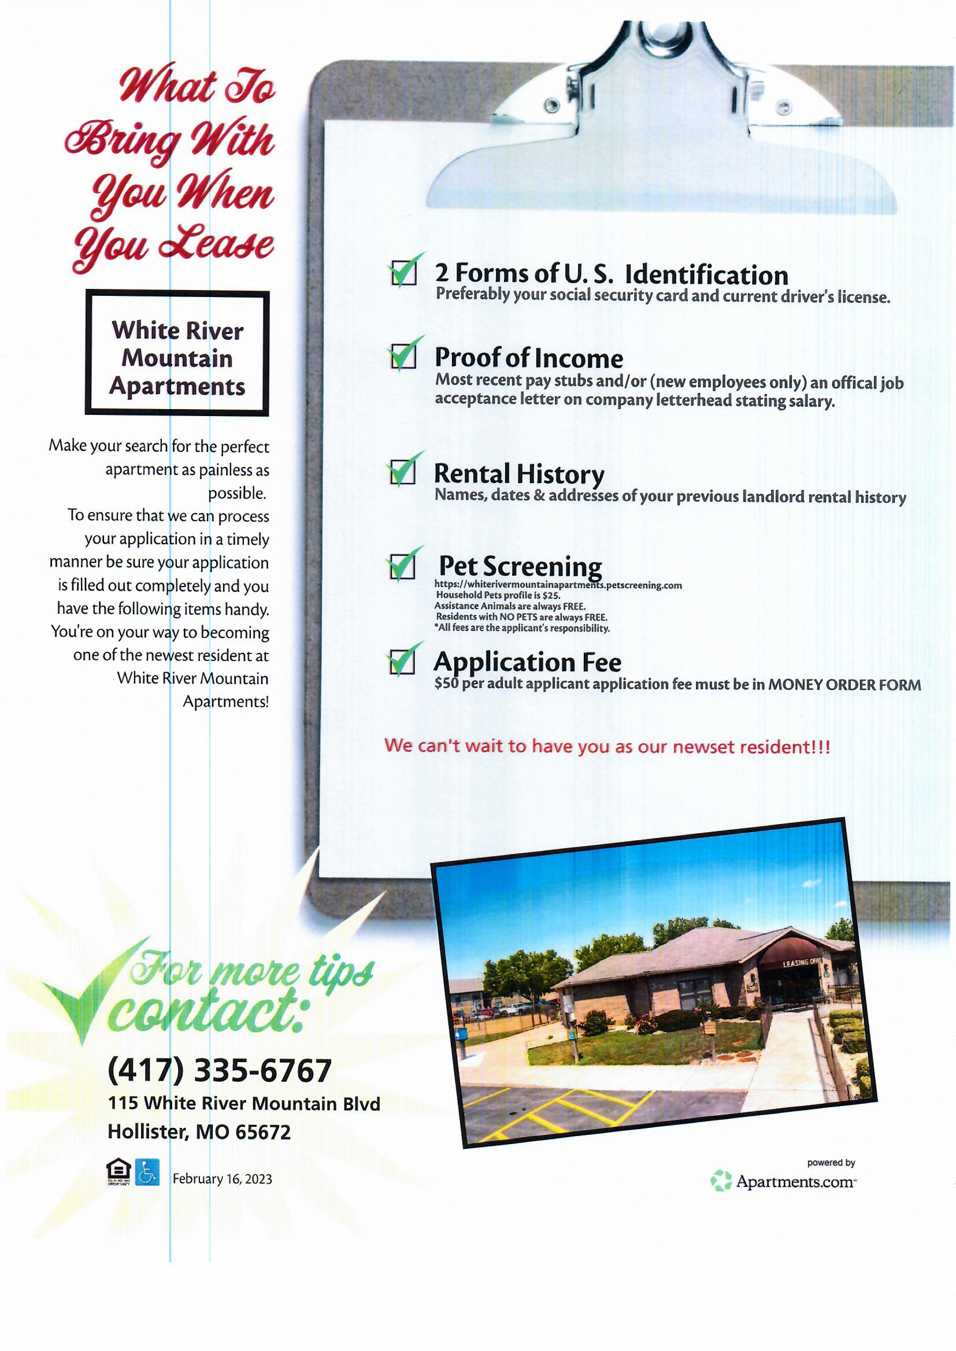
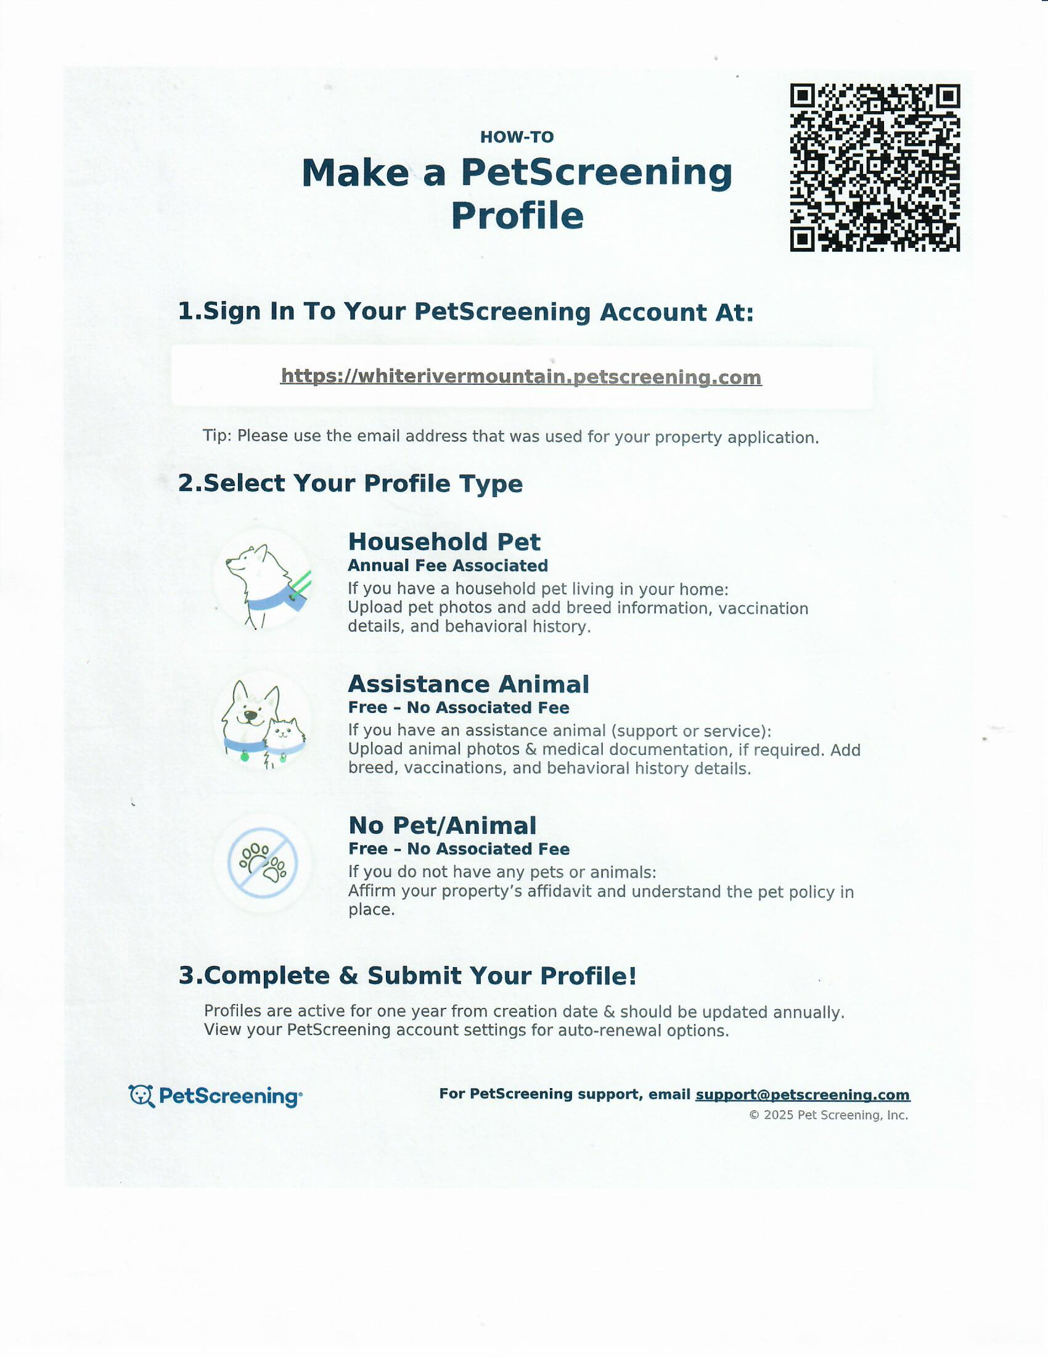
Tell us who we can thank for your business!
(Circle One) Google.com Apartments.com Newspaper
Resident Referral: ___________________________ Other: ______________________________
Reason for Moving: ____________________________ Business Referral: _______________________
Needed By: ________________ 1BR / 2BR / Balcony / Non-Balcony FIRST AVAILABLE
Applicant Information
First Name: ________________ Middle Initial: _____ Last Name: ________________
Any Other Aliases: ________________ Phone Number: _______________________
Social Security Number: ________________ Date of Birth: ________________
Current Residence
- Name of Landlord: ________________ Current Address: ______________ City, State, Zip: ___________
Monthly Rent: _________ Length of residency? ________________ Phone #: ______________________
Previous Rental History (If needed attach additional rental history to application)
- Name of Landlord: ________________ Address:_____________City, State, Zip______________
Monthly Rent: _________ Length of residency? ________________ Phone #: __________________
Co-Applicant
First Name: ________________ Middle Initial: _____ Last Name: ________________
Any Other Aliases: ________________ Phone Number: _______________________
Social Security Number: ________________ Date of Birth: ________________
Current Residence
Name of Landlord: ________________ Current Address: ____________________________________
Monthly Rent: _________ Length of residency? ________________ Phone #: __________________
Previous Rental History
Name of Landlord: ________________ Address: ____________________________________
Monthly Rent: _________ Length of residency? ________________ Phone #: __________________

Mortgage: (If applicable)
Address: ________________________ Monthly Mortgage: ___________ Lender: _________________
Names of other tenants including children and anyone who will reside with you even on a temporary basis.
Name 1: ________________ Name 2: ________________ Name 3: ________________
Date of Birth: _____________ Date of Birth: ____________ Date of Birth: _______________
Relationship: _____________ Relationship: _____________ Relationship: ________________
School: ________________ School: ________________ School: ________________
Applicant Employer:
- Employer: _____________________________________ Business Phone: (____)____________________
Street Address: _________________________________ City, State, Zip: __________________________
Position: __________________________________ How Long: _________Annual Income: ____________
- Employer: _____________________________________ Business Phone: (____)____________________
Street Address: _________________________________ City, State, Zip: __________________________
Position: __________________________________ How Long: _________Annual Income: ____________
Other Income sources:
Child support/Alimony: $___________ SSI: $__________ Disability: $___________ Other: $__________
Co-Applicant Employer:
Employer: _____________________________________ Business Phone: (____)____________________
Street Address: _________________________________ City, State, Zip: __________________________
Position: __________________________________ How Long: _________Annual Income: ____________
Other Income sources:
Child support/Alimony: $___________ SSI: $__________ Disability: $___________ Other: $_________
References:
Please provide two references. One personal and one professional, only one of which may be a blood relative.
- Name: ________________________________ Relationship: ____________________
Address: ______________________________ City, State, Zip: ___________________
Phone: (___)___________________________ How Long: _______________________
- Name: ________________________________ Relationship: ____________________
Address: ______________________________ City, State, Zip: ___________________
Phone: (___)___________________________ How Long: _______________________
Vehicles:
Make: ___________________ Model: _________________ Year: ________ Color: _________ Make:___________________ Model: _________________ Year: ________ Color: _________
Pets: YES NO
* All Pet owners must set up an account and have their household and/or service animals screened before approval. List Pets:
Type: ________ Breed: ________ Name: _________ Age: ____ Weight: _________________ Color_________ Spayed/Neutered _Yes ___NO__ Housebroke: Yes __NO__
*If you answered NO to the above question, you will still be required to answer the no pet questioner before renting a unit.
Have you ever been convicted of a crime? Yes No
If yes please explain: _______________________________________________________________________________________________________________________________________________________________________________________________________________________________________________________________
Have you ever been evicted from any rental? Yes / No
Have you ever willfully and intentionally refused to pay rent when due? Yes / No
Are you a smoker? Yes No Sign: ______________________________________
We are a non- smoking property as of June 2020. If you answered yes, you are a smoker, please sign stating you understand that smoking in the unit is prohibited. Furthermore, smoking outside the unit is a privilege and you will be fined for not cleaning up after yourself? Failure to comply can result in evictions for lease violations.
White River Mountain Apartments
115 White River Mountain Blvd.
Hollister, MO 65672
417-335-6767

Rental Qualifications:
Credit score above 650 Total gross monthly income must be at least three times the amount of monthly rent. Clean Criminal background Good Rental history (No evictions, or debt to previous property will be accepted) A complete rental criteria sheet must be signed by all applicants before processing applications

Permissions for soft credit check and criminal background:
Landlord does not discriminate against any applicant based on an illegal purpose Including, race, color, religion, sex, national origin, age, disability, or family status. Such discrimination as the sole basis of refusal to rent is illegal throughout the United States. Local or State laws may provide additional protected classes from discrimination. You can call the U.S. Department of Housing and Urban Development (HUD) at 1-800-424-8590 to ask questions about discrimination. I represent that the information provided in this application is true and correct to the best of my knowledge.
I understand that this Application is not a rental agreement, and that this Application does not create any obligation on the Landlord.
I understand that the information provided might be used by Landlord to determine whether to accept this application. I authorize Landlord to verify all the information given in this application, including banking and personal references and employment information provided.
I also authorize Landlord to perform a credit check and a criminal history check. I consent to the release of information relating to my credit and the information provided in this application.
I understand that failure to provide required legal identification, any information needed to process the application, or willfully giving false information during the application process will be cause for denial.
I understand that a criminal background will be checked and a felony conviction for any member of the household could be cause for denial.

Applicant’s Signature: ___________________________________ Date: ______________
Applicant’s Signature: ___________________________________ Date: ______________
Co-Signer’s Signature: ___________________________________ Date: ______________

