Discovery of Secrets and
Essential Physics of Tornado phenomena
(hypothesis of tornado formation).

Boris N. Bankovsky, Ph.D., in tech.

Announce.
"Theory of Tornado create the understanding of physics this natural phenomena, and my goal was to find right explanations to well known facts and transformations from start of mesocyclone to the appearing tornado. Analysis of researches were done for long time, and developed some models to approach the understanding. Here is my own version of the Physical Theory of Tornado Phenomena.
/Boris N. Bankovsky/*
theoryoftornado.com, /
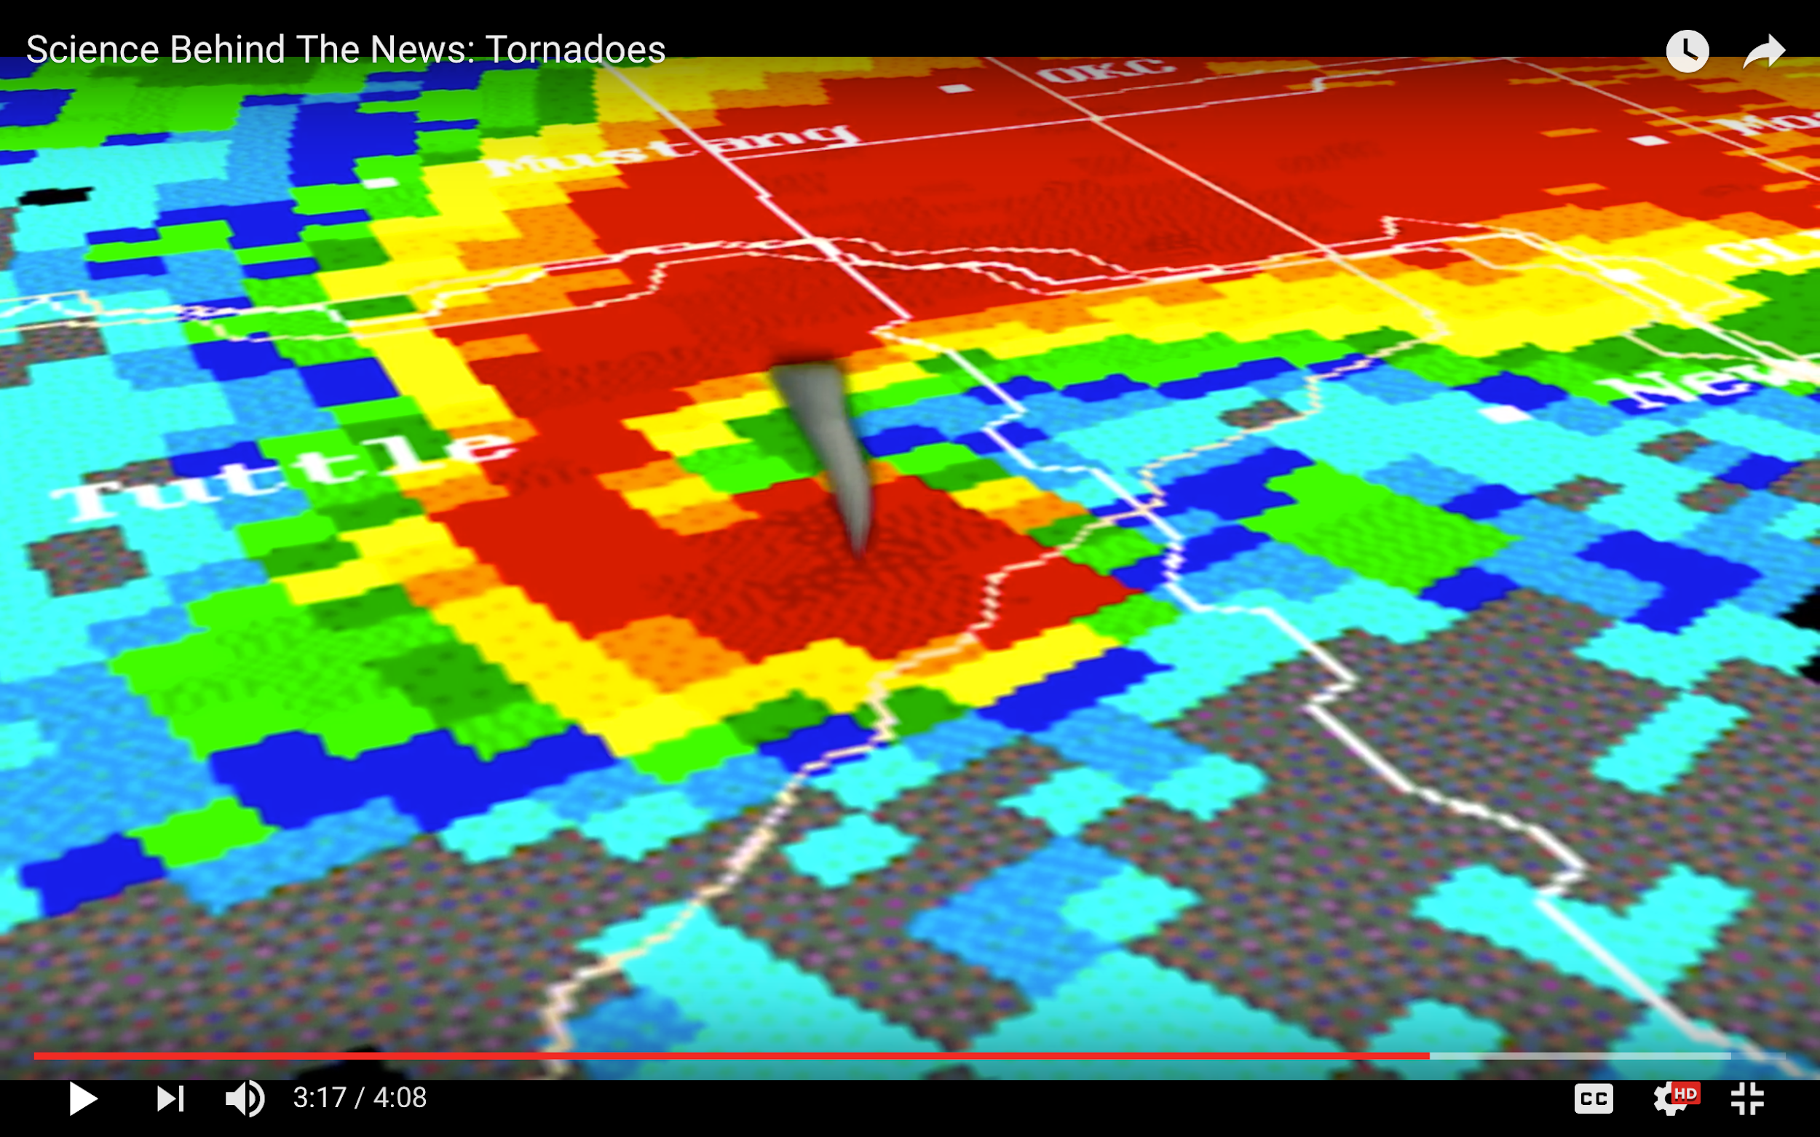

Tornado phenomena is hiding a few stages of energy transformations - from the start of two air fronts spiral rotation into mesocyclone’s vertex – updraft, and later, then it is going to the protuberance of tornado under the surface.
Tornado is a very small part of mesocyclone structure. But it is accumulated the outstanding and distractive energy.
From there it is coming, and how accumulates the energy? - This is the main question need to be answered first. That is the goal of this note.
A lot of hypothesis and scientific researches were done …, and a lot of facts of this phenomena were registered; “Big Data" of meteorology's statistics had gotten and used for modeling mesocyclone and tornado /1,2,3,4,5,6,7,8,9,10,11,12,13…/.
Unfortunately, on my view, the scale of real physics of this natural phenomena are tremendously bigger then this data. The hypothesis that was used and developing of approximation into 3-D model is not proved by scale and has some contra arguments of physics. It is wrong conclusion about updraft contraction with mass and speed increasing, that pushed vertex down to the surface and create tornado. It should be opposite – increasing speed of updraft rotation will have destroyed it.

Now about worm wet air updraft’s convection, condensing and freezing on upper high. Condensing is started on the first mixed and contact with cold air. High of freezing start on
h_{f} = 5000.0 - 10 000,0 m. Condensing provide new warm energy. This new energy of updraft has done enough job to drive up all condensed water to the ice crystallization zone of the upper high atmosphere of mesocyclone. So we at the end found the zone there the mass of all job has to accumulate, and this accumulation of ice crystals has negative charge, unlike condensed water drops under have positive charge and all of them are rotated by updraft vortex of mesocyclone.
Get back to the data from wide science researches that is basic and obvious. Data of some very obvious facts is a basic for start any theory:
1. The direction of tornado vertex is opposite to updraft vertex of mesocyclone. So, tornado is a downdraft vertex, it is now obvious too.
2. And, the second very important fact is about the place of tornado vertex: it is running down from the "cloud wall" of mesocyclone under the "Big Updraft Vertex" (BUV).

So, the first we need to determinate that is the Big Updraft physics?
- Big updraft of mesocyclone is a vertex.
The scientists as Dr. K. Meyl /18 / knows more than others about vertex in our nature. Structure of any vertex has TWO of them. ONE exist as the energy of warm air spiral movement, because of cold air resistant. And the SECOND born from that resistant and start be the contra potential vertex for the first one. It supports to the stable structure of this phenomena - a whole vertex, because the heavier density, it is colder, and has bigger pressure, then worm updraft. That is why updraft is going up from spiral concentration of both kinetics energies. Mass of them and speed transformed into vertex updraft.
They are going to spiral movement together in updraft convection. But cold air not only keep the structure of updraft, but all time it is mixed with warm flow from the start of spiral contact. That started process of condensing.
The process of condensation creates water drops. It started with the first mix, and we see clouds as a result. Additional energy of condensing warmed air to more updraft, and it rotate stable and get stronger and push more and more condensate upper. They are getting additional energy to move into upper to the “freezer” high level of atmosphere and freeze there to ice.
Ionization of condensed water drops create powerful electrostatics system inside mesocyclone.
As science researches from Arizona University /6/ had shown drops of condensate water are getting positive charge. Charging positive is growing as much as condensed water drops came from new warm air put in updraft to the upper level, and all this is continue going quickly and constantly proportionally to time and speed of air is taken into updraft.

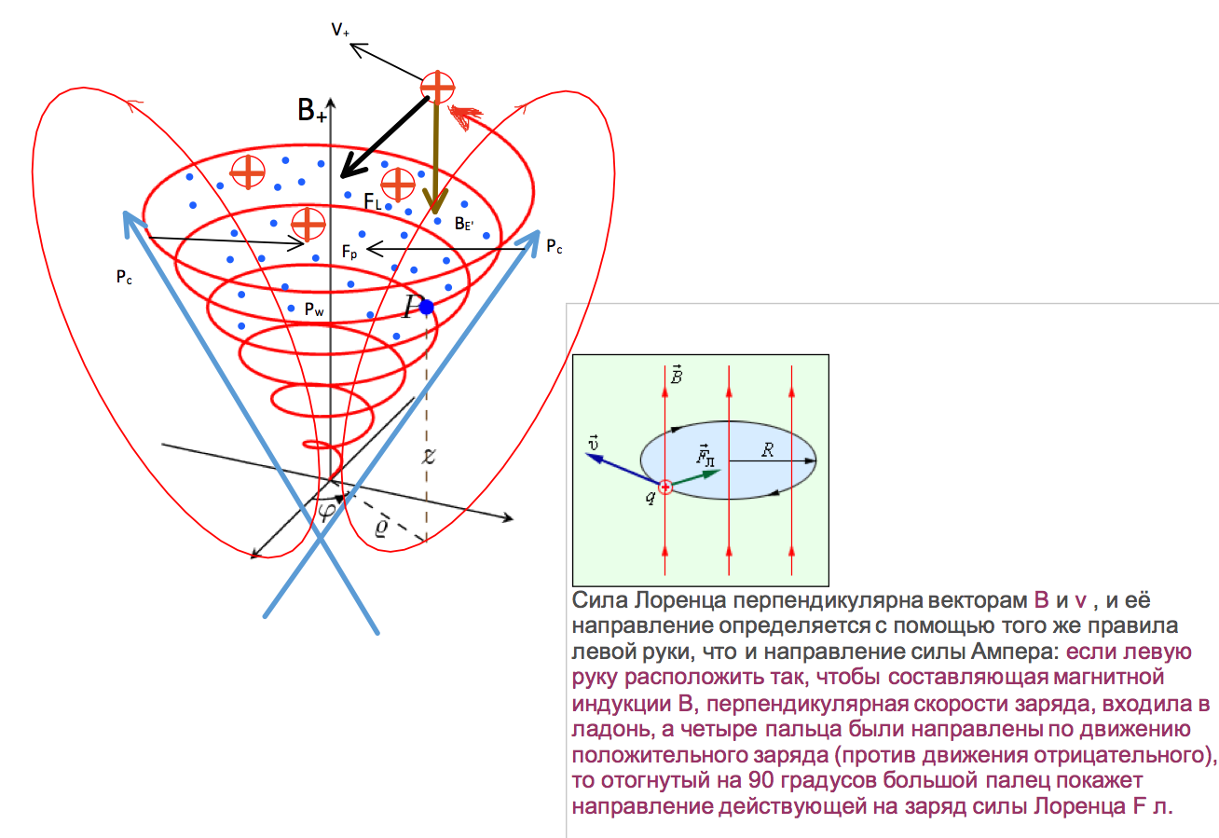
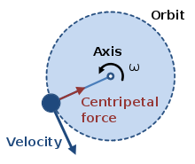
Pic.1. "Big Updraft" first form positive charge of water drops of condensate.
The Lorentz force stabilized the rotated positive vertex inside in the field of vertical geo-magnet vector, that is forming a centripetal force on this case.

On some stable interval of time, Speed of mass coming is stable,

V_{x0} = const; V_{up} = V_{x0} ;
dm/dt >0. (1)

So, mass of positive charged water drops is increasing into vortex of updraft, that can increased centrifugal force even if the speed will be constant:

F_{cf} = M(t) V²_{up}/ R². (2)

And if we are using “old” hypothesis about increasing speed, it must destroy vortex of mesocyclone, because we don’t have any additional forces to keep it.
But the reality of the tornado formation need has additional researches and theory development to find the reason of speed increased inside the vertex of updraft, and can be transformed to the vertex of tornado as energy of distraction.
So, start do it to reach the result. …
Updraft is going to continue convection and pushing up all masses of water drops on a higher level of atmosphere. The energy for additional updraft is gotten from the warming of transformation a steam of air to a water drops. Water delivery to updraft over a zone of concentration of air streams of warm and cold front, as you can see on pic. 2, with coefficient of contracting K_{c} = 5-15, and speed inside the spiral can increase the same and in real can reach the speed of sound. Then it can be heard as a very thunder and big loud noice…

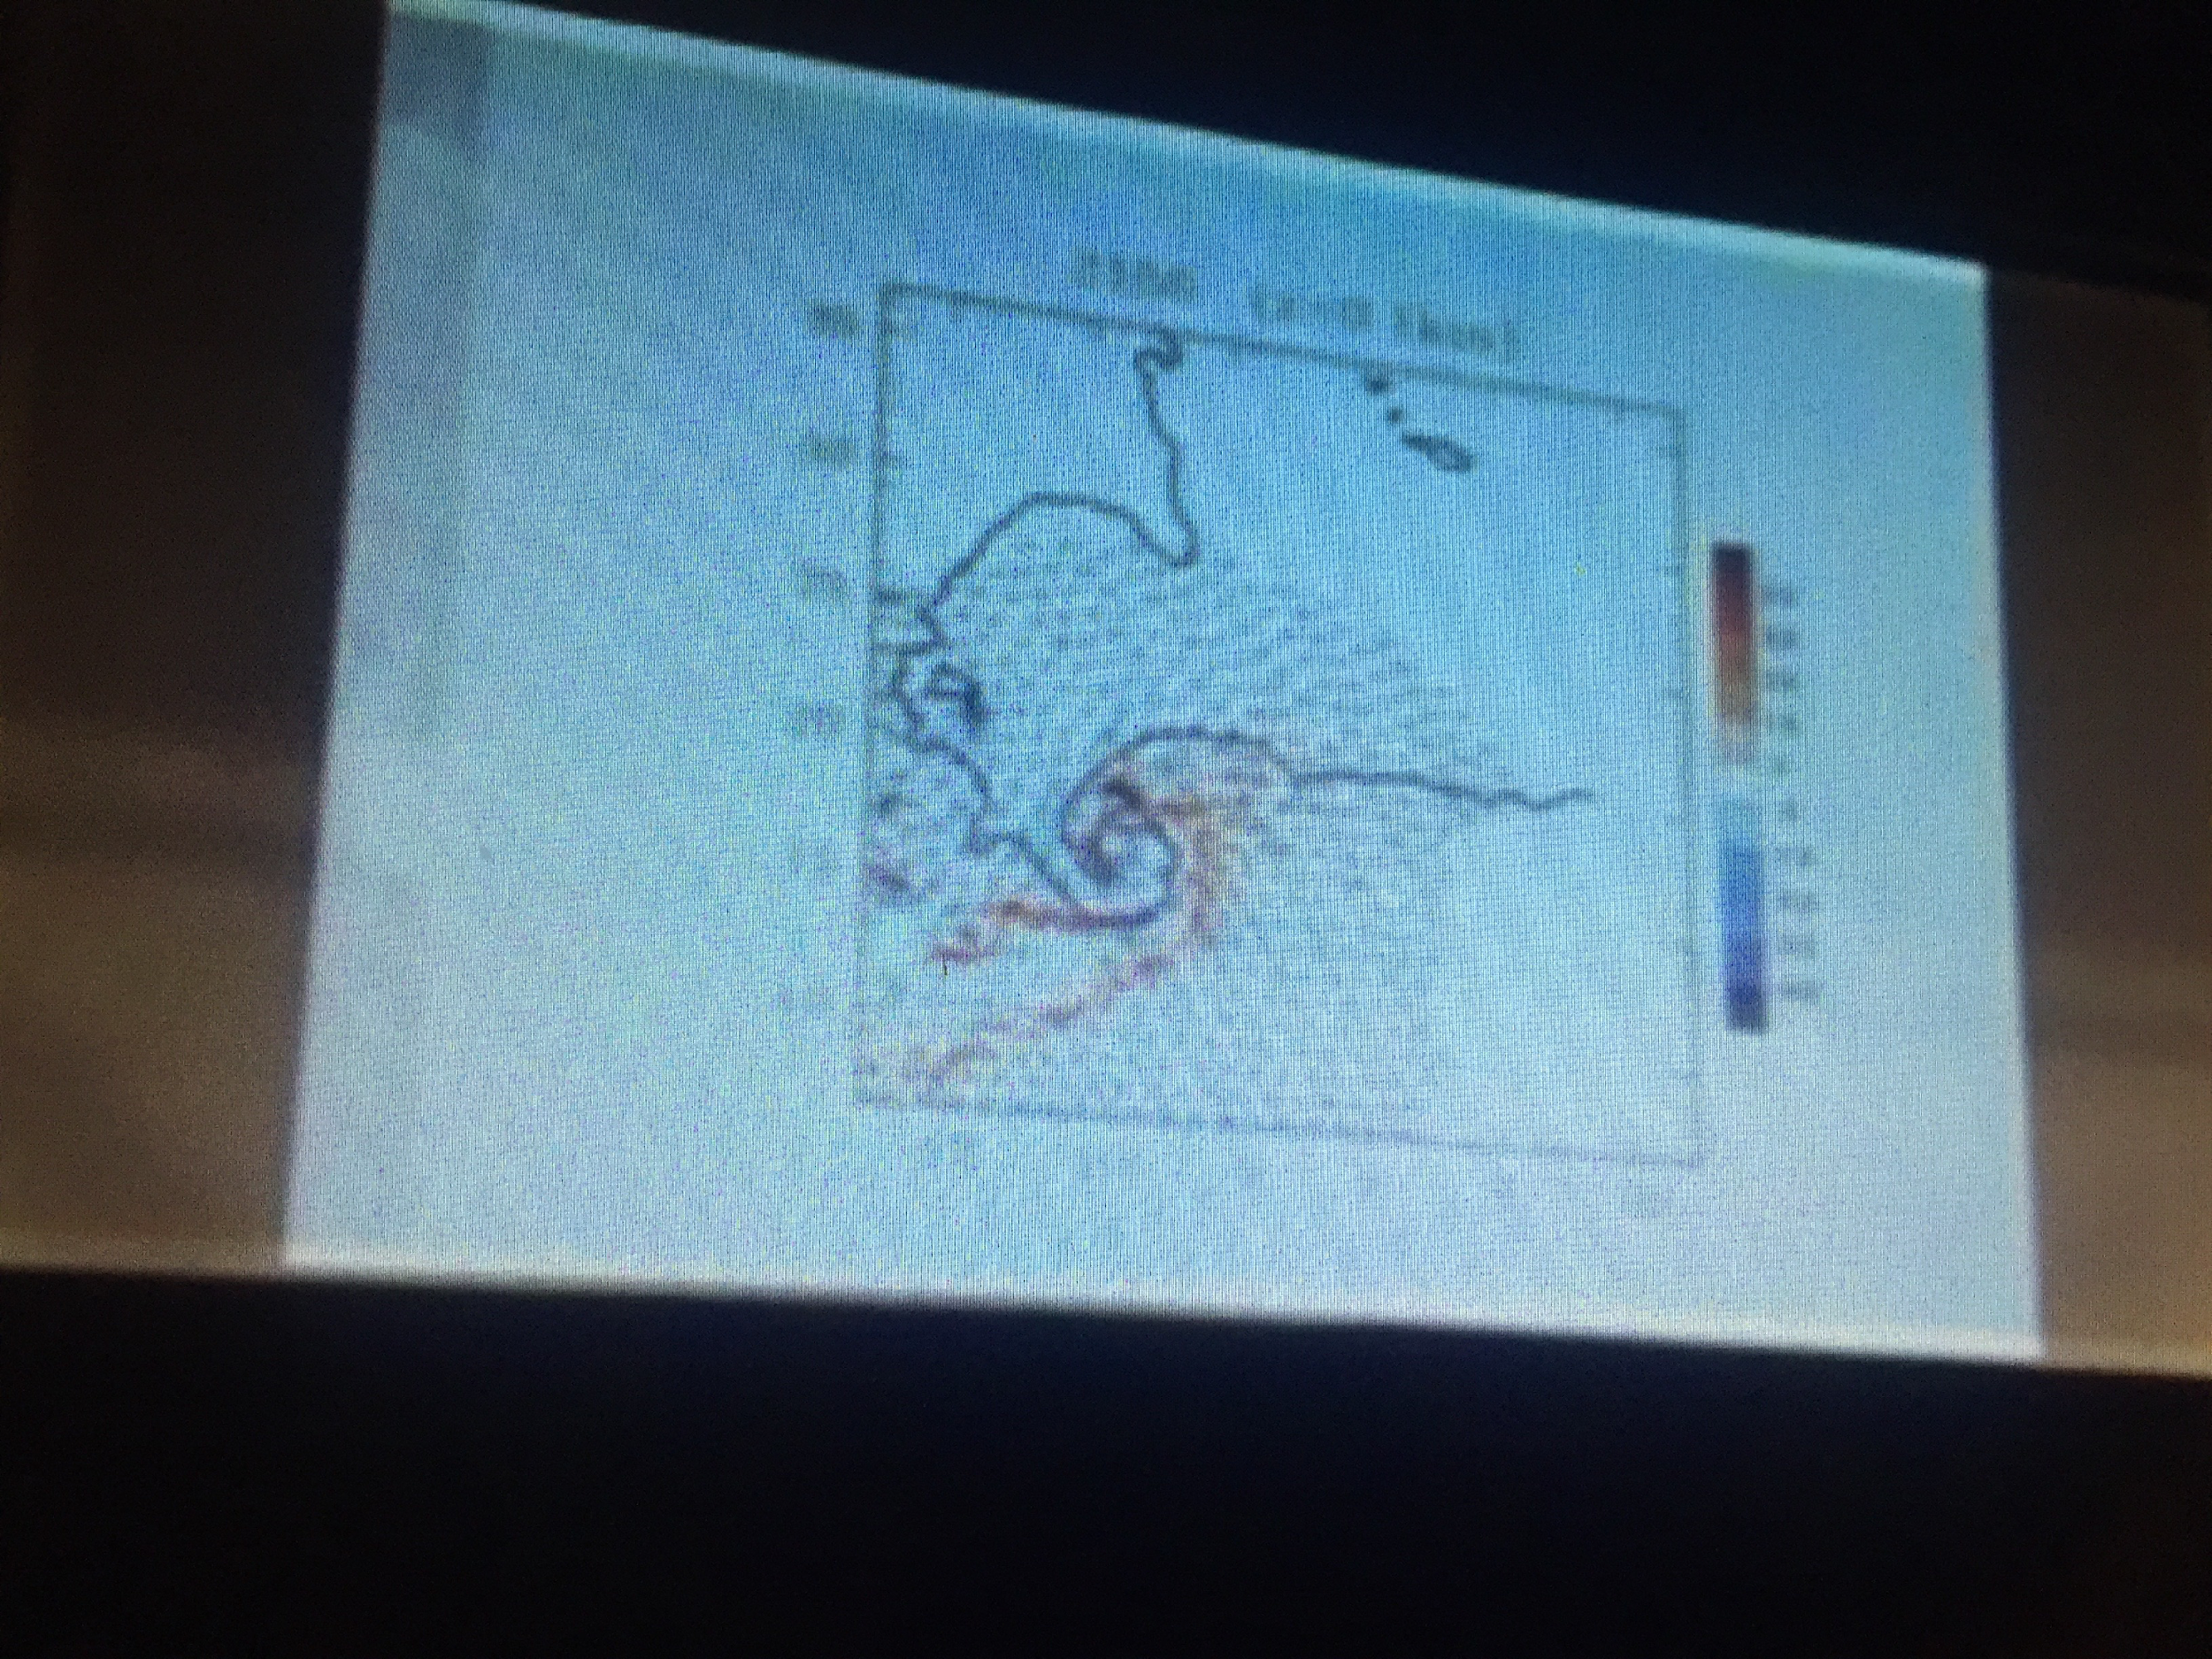 | 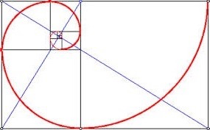

Pic.2. Concentration of two air streams in one spiral Fibonacci with square decreasing and speed increasing at least 5 -15 times ( K_{c}).

M_{H2O ~}= K_{c} V₀ B₀ H_{0w} q_{w} =~ 15 x 5.0 x 10 [ml/hour = 1.65 x 10³m/3.6 10³ sec] x 10.0 [ml= 1.65 x 10³m] x 1.65 x 10³ [m]x 1.4 10⁻³ [kg/m³] = 1,3 x10⁷ kg/sec. (3)

It is, approximately, 1300 tons of water in a second is going up and freezing to ice crystals.

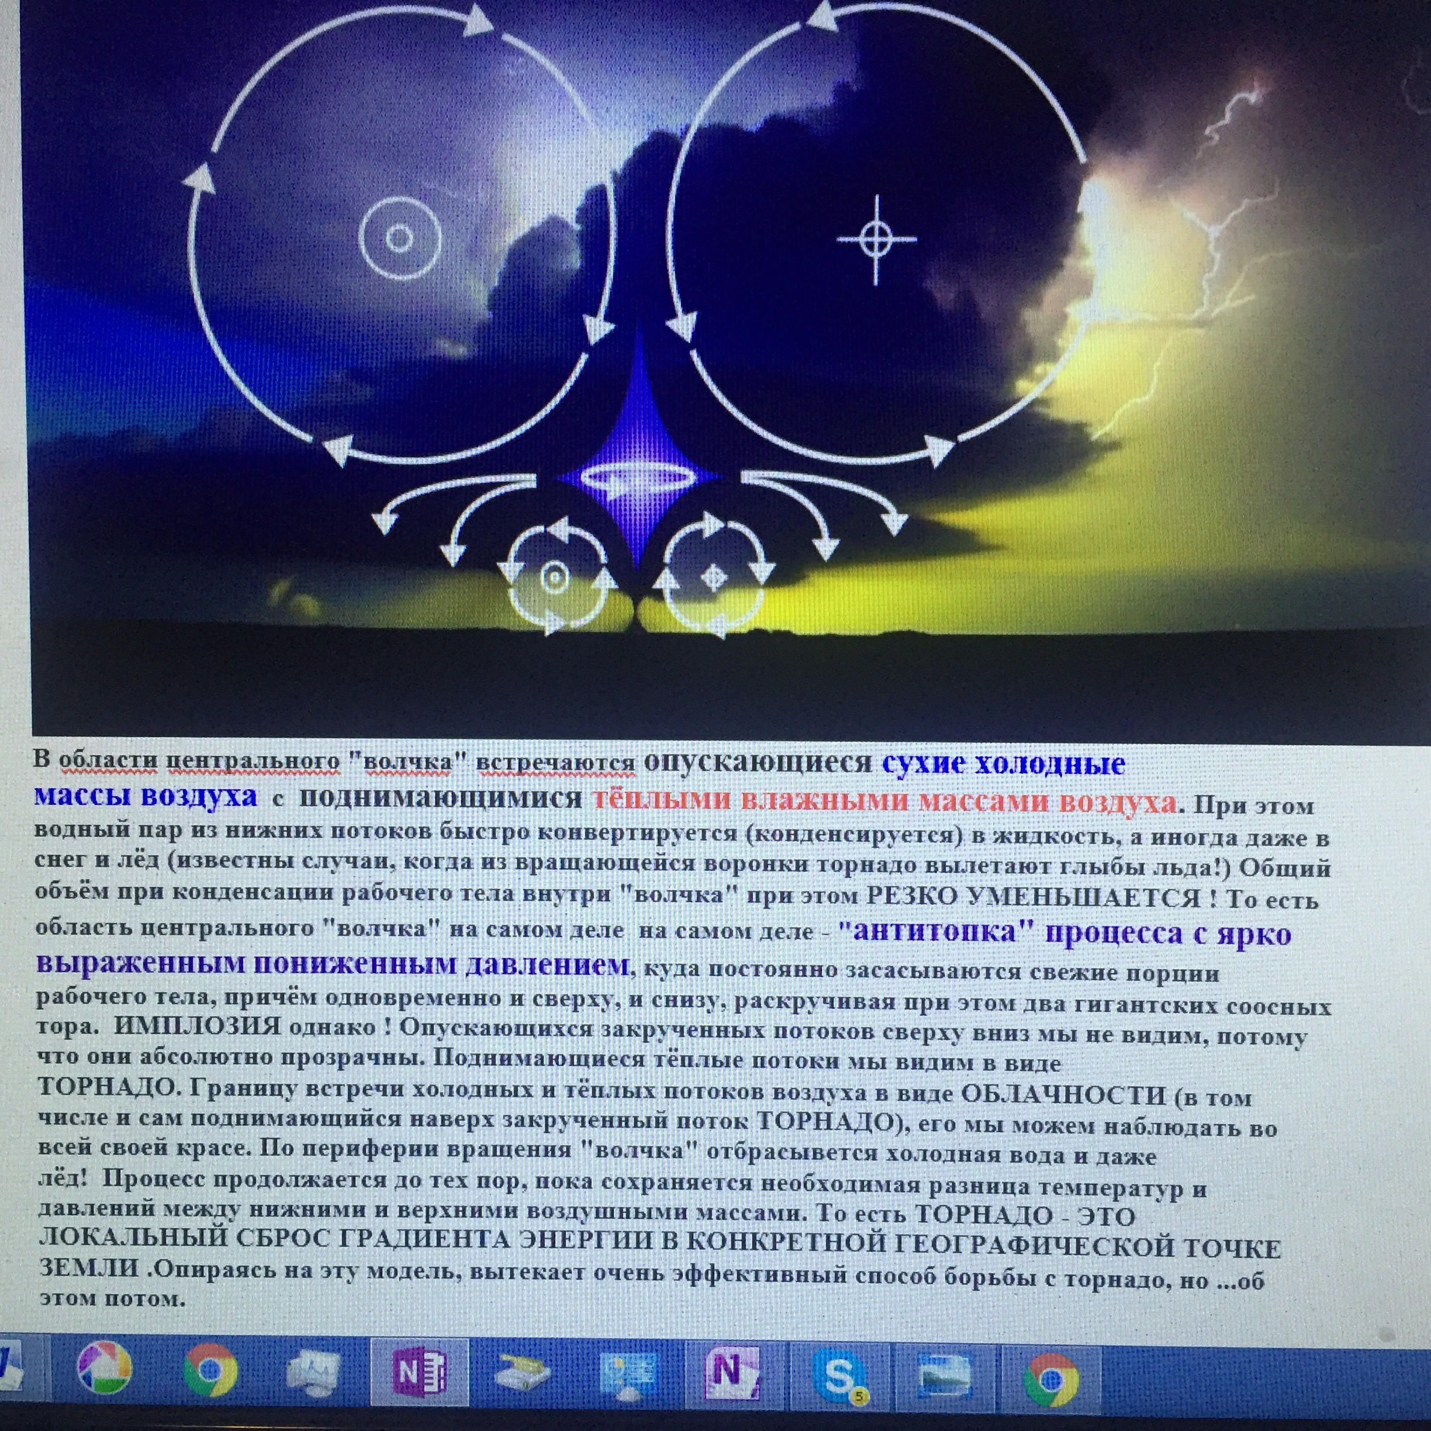  А | 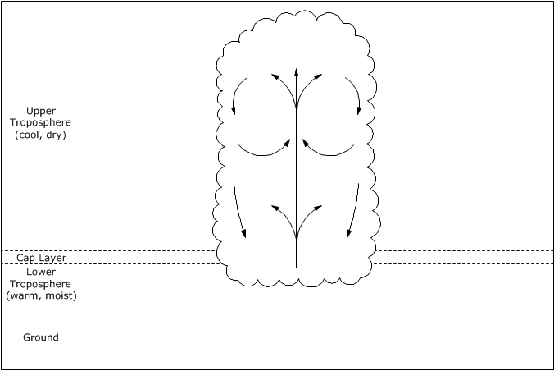  Б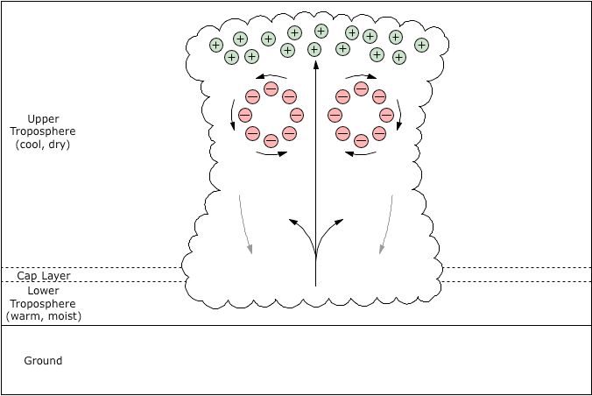

Pic. 3. Toroidal circles in structures of updraft in some researches /2, 13/

Ideas of toroidal circles of movement as a structure of updraft formation was declare in few cases of publications, examples are on Pic.3., but unfortunately they show any physical connection to have a tornado formation, or updraft vertex formation. Here is the investigation the role of very powerful natural energy vortex structure as a Toroidal Circles in updraft and mesocyclone, and the same in starting tornado formation. But this conclusion came only after a long study of physical processes inside the updraft vertex.
At the zone of freezing concentration weight of ice crystals is growing constantly. And after some critical time the mass of ice in the cubic meter, change the density of air over the limit. Ice crystals starts be heavier of air around and start fall down. The most important conclusion is about they can fall physically on two ways (pic. 4) inside, and outside of updraft ...
After all those outside and inside falls are return back up into updraft by the vertex’s coming warm air from cyclone. Then two toroidal-circles energy rotations, formed inside and outside of updraft vertex. It brings updraft of mesocyclone to stability. At the same time the updraft has the constant concentration of the mass of ice on upper level of freezing zone from there they are falling down inside and outside of updraft into two inside and outside tori-circles.
On pic. 4, 5 is shown updraft movement of positive charged water drops is going to the upper atmosphere level to the ice crystal freezing temperature that gave the negative charging ionization to the crystal ice particles in upper zone of updraft vertex of mesocyclone /5/.
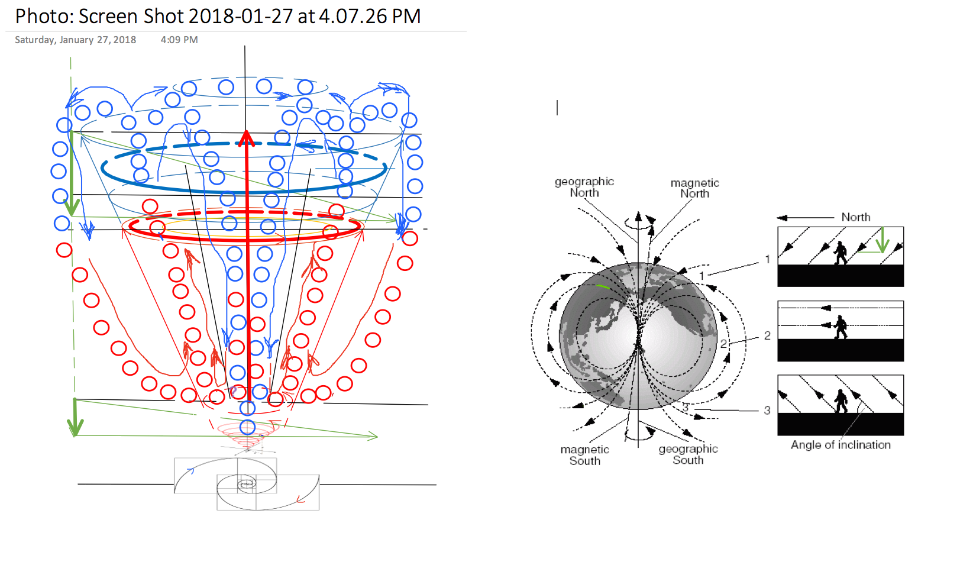
Pic. 4. Electrostatic System of Updraft creats Two Downdraft movement as concentrations of Energy of "Two Big Tori-Circles".

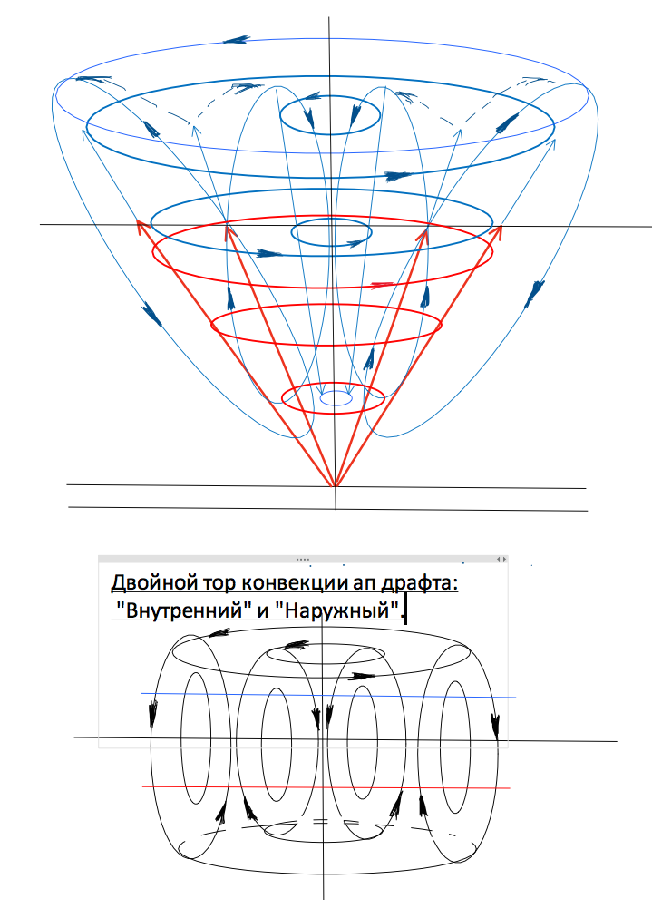

Pic. 5. Two Energy TORO-CYCLES of Mesocyclone are formed The Potential Downdraft of future tornado.

On pic. 4.5 also show a new hypothesis formation of TWO ENERGY TOROIDAL-CIRCLES, which are created by dividing the whole up movement of the concentrated ice on two DOWNDRAFTS : A -" Inside Downdraft TOROIDAL-Circle; and B -"Outside Downdraft TOROIDAL-Circle".
Those TWO DOWNDRAFTS in TOROIDAL CIRCLES are formed by the influence of a few physical processes and forces:
1. THE FIRST: Negative particles of ices on the upper high are lost influence of positive electrostatics field of rotated into vertex water drops condensate It is close to and under them 2. Also they have no difference of pressure out of vertex on upper level they fly. They, in fact, lost the potential vertex and it not any more hold them into structure of updraft vertex.
3. They lost their centripetal forces, and even opposite: they now are gotten reactive centrifugal force from vertical geo-magnet earth’s field.
4. Plus, they moved out of vertex by upper wind of the cold front. This help them run outside and down off updraft and formed cold rain zone of mesocyclone too.
5. THE SECOND: Negative fallen particles rotated inside updraft vertex concentrated around axis of vertex with gradient of increasing. They start to get strong influence from increasing of
Coulomb's forces between them and vertex of updraft’s positive rotated condensed drops on the low leyer.
6. Well known proving fact is about of low pressure zone around axis of vortex rotation. So, negative crystals are vacuumed to central zone. Those negative charged ice crystals start fall down to the center and form the second energy tori-circle.

It is the Potential Downdraft that can and after all start formed the TORNADO.

All those processes are going intense and if the gradient of mass has permanent increasing inside of all energy’s Tori-Cycles, then those rotated mass is getting a huge movement kinetics and dynamics resources. Intense process of accumulation of the “big energy” and mass of ice and water is constant until air is in taken. After all mesocyclone start be heavy. It starts slowly going down, closer to the surface of the Earth.
Very important process of this hypothesis of tornado formation is based on idea of very fast and permanent concentration with ice particles and cold condensate of water drops inside two tori - circulations. Then central downdraft vertex start be too heavy and mostly independent from updraft tori-cycles. Updraft vertex lost this central downdraft,

so IT START GOING DOWN!

Huge rotation downdraft vertex is potential with huge energy of rotated mass of ice and water. This after all is going first as a protuberance of tornado, but if energy is over limit then it transforms to tornado very fast. The structure of those transformation is shown on Pic. 6.

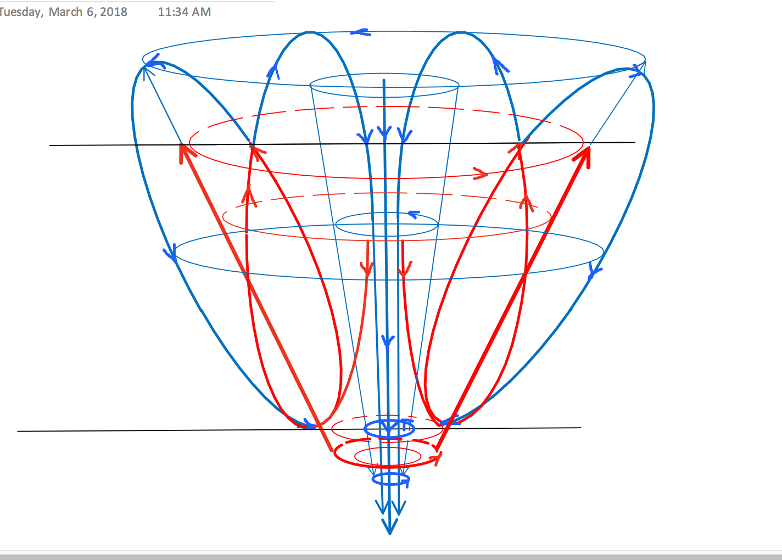
Pic. 6. Two energy tori-circles create central and outside downdrafts. Tornado is formed after “getting freedom” to fall down from central up convection of updraft.

Distractive forces:
Now we can analyze the hypothesis of the “weapon” of distraction tornado has. As a vertex that formed inside the updraft it is excepted the concentration of falling down ice crystals mixed with water. As an ice has a less density it has to be inside of separated cylinders formed by speed rotation.
1. Inside of cylinder it can has the low pressure “vacuum”, that created by very fast rotation of vertex and heavier mass of air is going out of axis under centrifugal force that decrease the pressure inside vortex..
Some researchers are excepted the hypothesis of structure of tornado as the ”ice-crystal/water-drops” mass/reviews /3,13,14…/. On this case under speed of rotation mass is going separated on two rotated cylinders – ice inside and water out of axis. Then start to be understandable the scale of increasing speed rotation of condensate in tornado structure in a lot of times than a speed of updraft. Negative charged ice crystals are all time under contraction forces of biggest in our world magnet field created by positive charged rotated water drops system of updraft (Pic. 7).
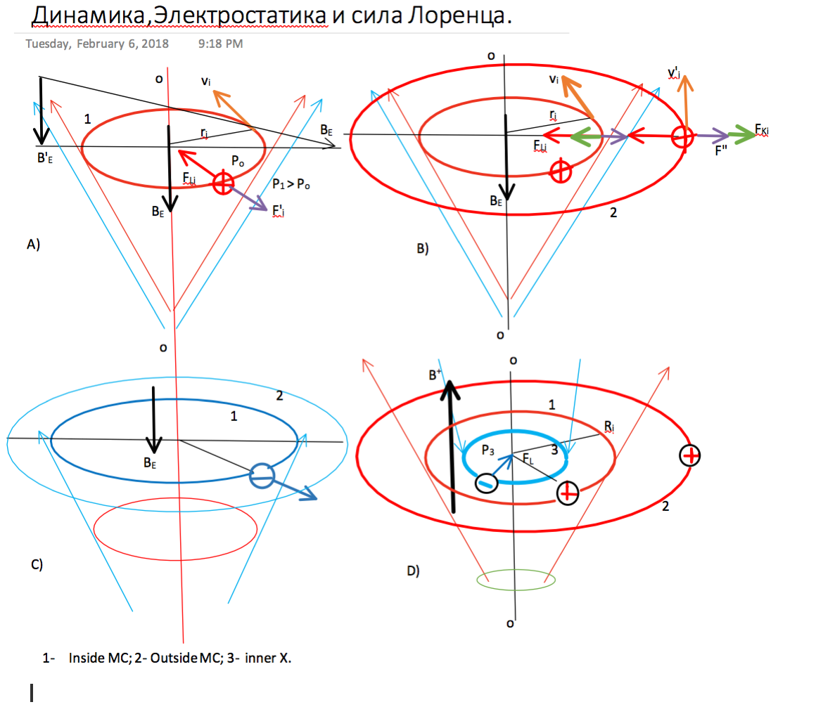

Pic.7. Electro-dynamics stabilization vertexes of updraft and tornado.

2. Now, then we can get some secrets of stability of the rotated vortexes of updraft and tornado, then we can see the huge scale of influence from the updraft’s positive electrostatics charge on the rotated ice cylinder of tornado, that create huge Lorentz force stabilized tornado by contracting negative mass rotated in center of this tornado downdraft.
3. But it also can be combination of variety mix negative (ice) and positive (water drops) charged mass concentrated in one rotated cylinder /or two different charged and separated by density/. But tremendous electrostatics positive charge of updrafts tori-circles creates both:
A- stabilization of structure;
B- and that is absolutely interesting:
the “electrical catapult bombardment blasting” movement of ice and water in rotated cylinders of tornado to earth surface , then all ice is melted inside, and positive drops are left only.
Last one can be one of most distractive sources of tornado.

4. We can calculate the level of force and pressure on some wall that has met of ice/water rotation. If density of mass of ice and water into cylinders of tornado close to
D =~ 1.0 ton /m³ ,
and speed of rotation is close to V_{t} = 100 m/sec;
then easy to calculate the force to “stop it” by wall:

F_{d} =~ MA= 1.0x10³x 10² = 10⁵ [kg/m sec²] ~= 100 Ton;
Pressure on sq. meter P= 100/1 [t/ m²]= 10⁵/ 10² ~= 1000 [kg/sm²]. (4)

5. But also now we have to see additional force - of vacuum, that starts on moment the walls of “cylinder” of vortex is stopped going behind corner or barrier of house wall/fence, roof’s corner, etc.. .
This process could form super-fast wind of “vacuum bomb” speed over sound /13/ that increase the pressure more than 3-4 times: 3000-4000 kg/sm².
6.And the last one – the force of “vertical blasting”, as hypothesis done above plus gravity. It can be calculate / by somebody /as:

F_{v} = M_{T} (g+ a_{blst+}); (5)

In result the forces of the tornado movement could be as not less than 5000 kg/sm², or even more… This force and pressure is very distractive. They can destroy any wood house, and almost any roofs, and big square of walls without inside support, etc. .
This information is not for scary someone. It is opposite: you should be informed and have a choice to get some engineering support to your life, house or business… .

LITERATURE:
1. Konstantin Meyl, From Field Vortexn to Elementary Particles. Vol.3. Potential Vortex. -2012.
2. Simulation of a supercell storm in clean and dirty atmosphere
using weather research and forecast model with spectral bin Microphysics/
Alexander Khain and Barry Lynn.

3.The Electromagnetic Nature of Tornadic Supercell Thunderstorms
Last modified: 2016-08-01 06:45:09 UTC © 2007~2017 Charles L. Chandler./http://charles-chandler.org/Geophysics/Tornadoes.php?text=full/
4.Tornadoes and Tornadogenesis. Richard Rotunno
5. Григорьев Н.Г., дисс. к.т.н., «Разработка динамических моделей для анализа вантово-стержневых систем при воздействии торнадо» 2011/
6. Arizona University. Cloud Electrification. /http://www.atmo.arizona.edu/students/courselinks/spring15/atmo589/ATMO489_online/lecture_11/lect11_cloud_electrification.html/
7. А. Г. Боев, Газоразрядная теория смерча, © 2009.
8. S. A. Arsenyev, N. K. Shelkovnikov, Excitation of tornados by squall storm;
9. Наливкин Д.В. Смерчи. – Москва: Наука, 1984. – 112 с.

10. Ron. Hypothesis of Tornadogenesis
/http://exvorte.com/
11. Tornadogenesis: Our current understanding, forecasting considerations, and questions to guide future research
Paul M. Markowski ⁎, Yvette P. Richardson
Department of Meteorology, Pennsylvania State University, University Park, PA, United States
12. E.Aseev, Generator Tornado. / http://evgars.com/arsentyev.htm /; http://evg-ars.narod.ru/index.htm.
13. "Smerch" ( МЭФ: / http://www.fund-intent.ru/Document/Show/3723 /
14. http://onlineathens.com/multimedia/sci/032808_Tornadoes-primer/index.html
15. http://onlinelibrary.wiley.com/doi/10.1029/2009JD011827/epdf
17. http://www.nssl.noaa.gov/research/tornadoes/

P. S. Sorry, for no good English edition, that done by me, and here I am looking for help. Thank you for reading.

