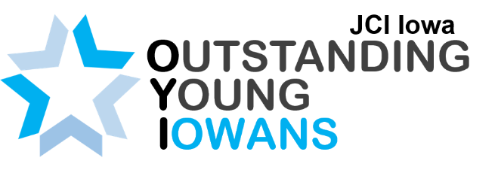
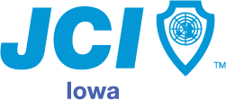
Sponsorships
JCI Iowa
225 5th Ave SW
Cedar Rapids, Iowa 52404
Email: ia@jciusa.org
https://jciiowa.org/

With your support, JCI Iowa will celebrate the honorees of the Outstanding Young Iowan (OYI) Award. This award recognizes inspiring individuals who are making a positive impact in Iowa. The program includes an OYI Panel during the JCI Iowa All-State Conference and a banquet award presentation with speeches from each of the honorees.
Saturday, August 29th, 2020 | Radisson Hotel
6:00 pm OYI & VIP Reception | 7:00 pm Awards Banquet & Dinner
JCI Iowa All-State Conferences are attended by young individuals, ages 18-40, from all across Iowa with guests from all around the country. Please join us to support the organization’s efforts on empowering and inspiring leaders at this conference and Awards Banquet. This award has been given to numerous outstanding young Iowans dating back to prior to the 1980’s to ensure individuals receive the recognition they deserve. JCI Iowa has 400 members with a network of 10,000+ in the US and 150,000+ globally in the organization and a great following of over 1,000 followers on Facebook with a reach averaging 500 people on posts. Our Instagram page is followed by 687 people from all over Iowa, the country, and worldwide. We would love the chance to share your support of this prestigious award across all of our social media platforms.
Become an Outstanding Young Iowan Award sponsor!
- $1,000 Sponsor includes:
  - Award Event specific marketing pieces, such as:
    - Printed materials
    - Social media advertisement
    - Logo on JCI Iowa’s website
    - Event press releases (print or online)
  - Opportunity to speak at the OYI Award Banquet

