Blue Media Service

Table of Contents
Getting Started 2
Live TV 2
Add Channels to Your “Favorites” 2
Parental Control and Locking out Channels 3
View Movies 4
View Series 4
View the TV Guide 4
Record Programming 5
To View Your Recordings 5
Watch Programming as Far Back as 3 Days Prior Using Catch Up 5
Recently Released Movies and TV Series 6
Cleaning App 7
Use Your Cell Phone as Your Fire Stick Remote 8

Blue Media Service
704-833-8426
https://blue-mediaservice.club/

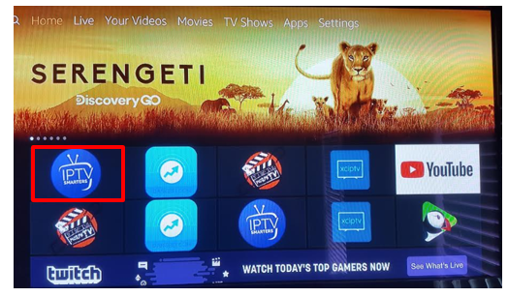
Getting Started

- Upon turning your TV on, you will see the
main screen appear with several apps.
Click on the IPTV Smarters icon.

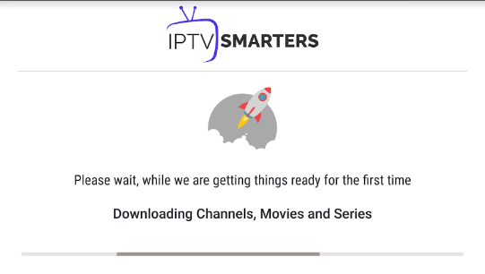
- Sometimes, you may see this screen appear first.
This means the system is uploading any changes/
additions that day. Once it is finished,
it will take you to the Live TV/Movies/Series screen.

Live TV
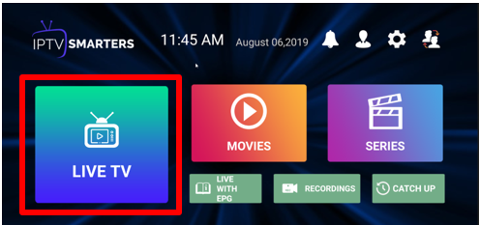
- Click on LIVE TV to take you to
your Live TV channels.

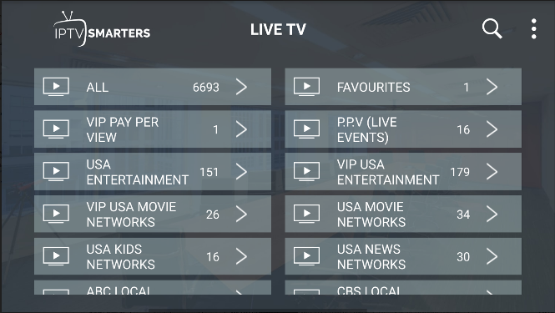
- The VIP USA Entertainment category has your
premium channels in it. The HD channels are
recommended for better quality viewing.

- There is a wide variety of categories to
choose from.

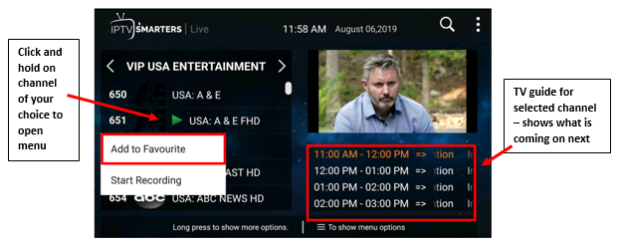
Add Channels to Your “Favorites”
- To add channels to your “Favorites,”
click and hold on the channel of your
choice to open up the menu to
“Add to Favorite” or “Start Recording.”

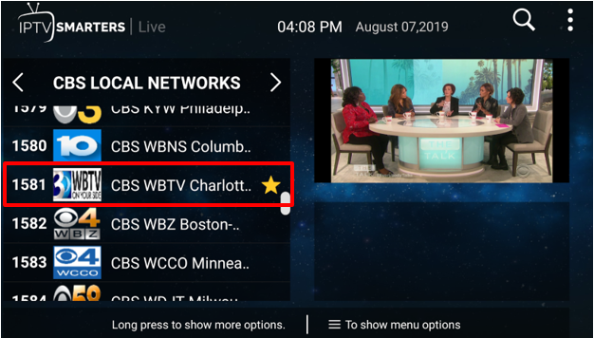
- Once you Add to Favorite, you will notice a
yellow star beside the channel.

- Local channels NBC, CBS, ABC, Fox Charlotte plays
the same programming as the local channels in
Spartanburg/Greenville county, just not the local news.
Save these Charlotte channels in your “Favorites.”

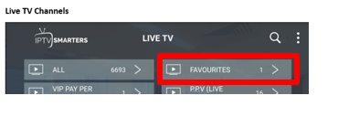

- Once you click on “Add to Favorite”
this station will appear in your “Favorites”
section on your Live TV Channels screen.
- As you add channels as favorites, you will
be able to access them easily under the
“Favorites” category.

Parental Control and Locking out Channels
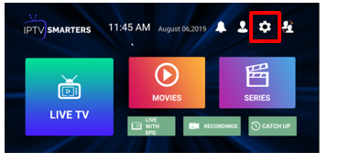
- Click on the setting icon

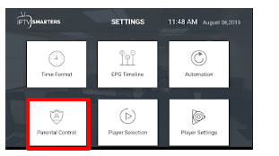
- Click on Parental Control

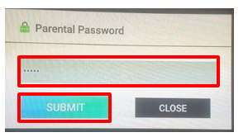
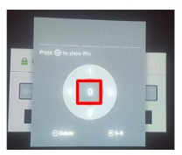
- Enter 5 zeros (00000) as the password by
using the number pad, which will appear
when you click in the password field.
- Press back button once and click on submit.

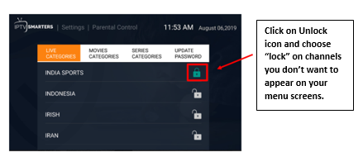
- You can lock channels out so they no longer
appear on your menu screens
- Click the Unlock icon and choose “Lock”

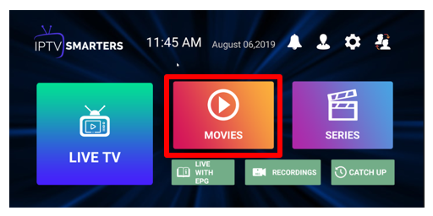
View Movies

- From the IPTV Smarters screen,
click on the Movies icon.

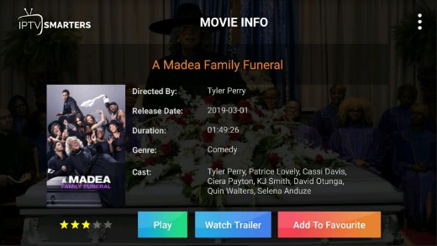
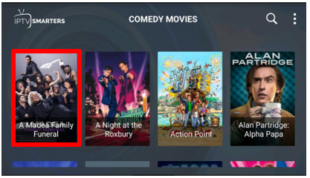
- Click on movie of your choice.

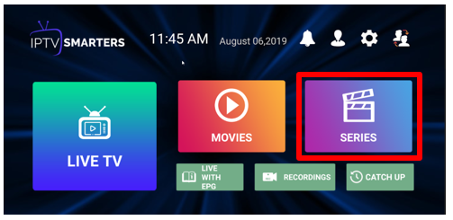
View Series

- From the IPTV Smarters screen,
click on the Series icon.

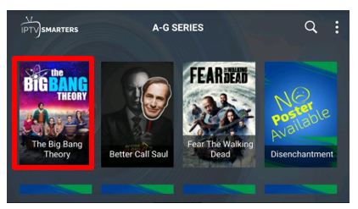
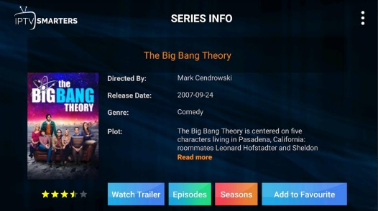
- Click on the
Series of your choice.

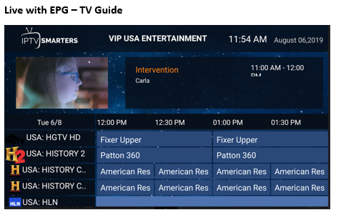
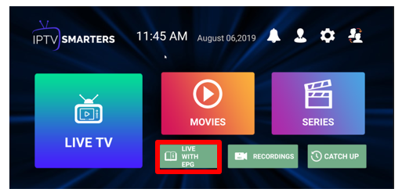
View the TV Guide

- From the IPTV Smarters
screen, click on the
Live with EPG icon.

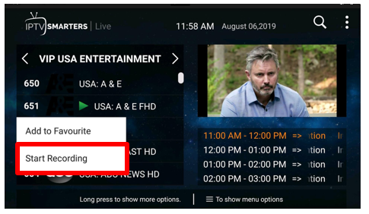
Record Programming

- You can record any programming, but recording
cannot be preset ahead. You can start recording at
the time the programming begins and set the time
out as far as needed for recording.

- To record a show or movie, click and hold on the
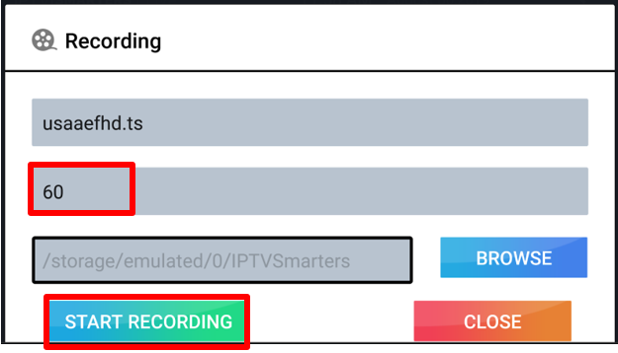
channel at the time the recording needs to start
and choose “Start Recording.”

- Enter the number of minutes of record time needed.
- Click on Start Recording.

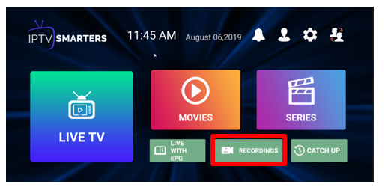
To View Your Recordings

- From the IPTV Smarters screen,
click on the Recording icon

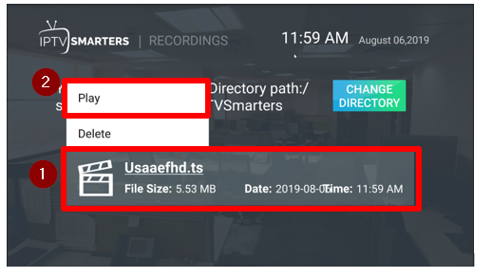
- Click on your recording listed, then click on Play.
- Click on Delete to remove the recording.

Watch Programming as Far Back as 3 Days Prior Using Catch Up
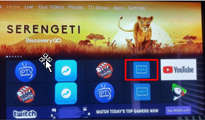
- To go back and watch movies/shows
from the past 3 days:
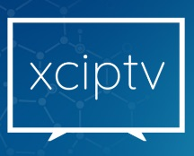
- From the main screen,
click on the XCIPTV icon

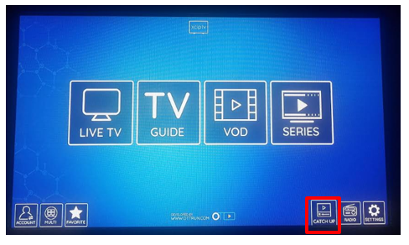
- Click on the Catch Up icon on bottom right corner.

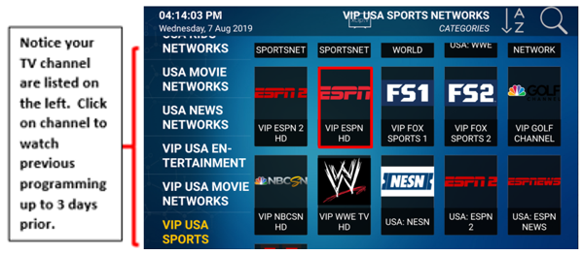
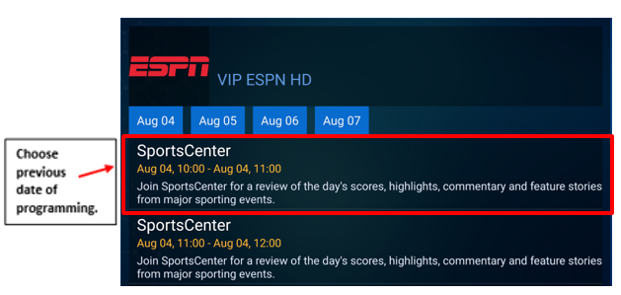

Recently Released Movies and TV Series
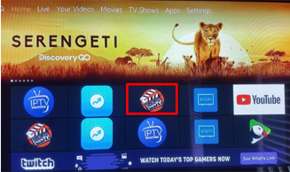
- To view recently released movies and TV series,
click on the Morph TV icon from your main screen.

- You can search for movies by clicking on
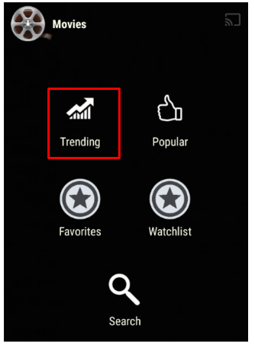
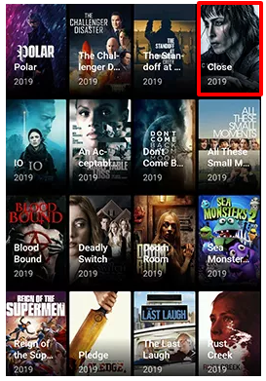
Trending, Popular, or can Search by name.

- Click on movie of choice

- A Generating Links screen will appear
- Once the links are generated, Openload will appear
- Click on Openload
- Click on link for movie

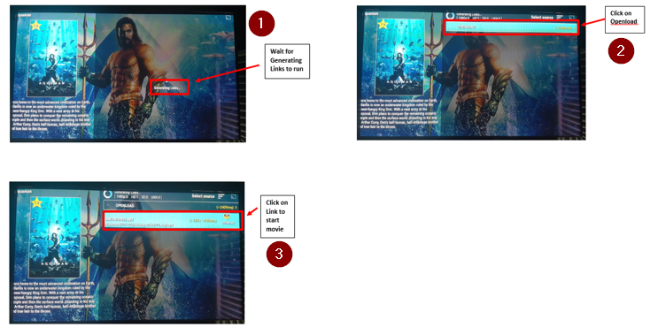

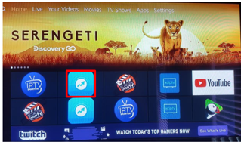
Cleaning App
- DangBei Assistant (Cleaning App)

- This is a cleaning app similar to what is used on cell
phones/computers to clean out any junk files and
free up space.
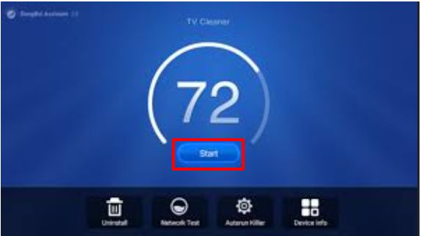
- This should be done at least once per
week or so to keep your internet running smooth.

- Click Start to run cleaner
- Click the Home button on your remote
to return to the main screen.

Use Your Cell Phone as Your Fire Stick Remote

- Download the Fire TV app onto your phone
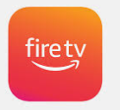

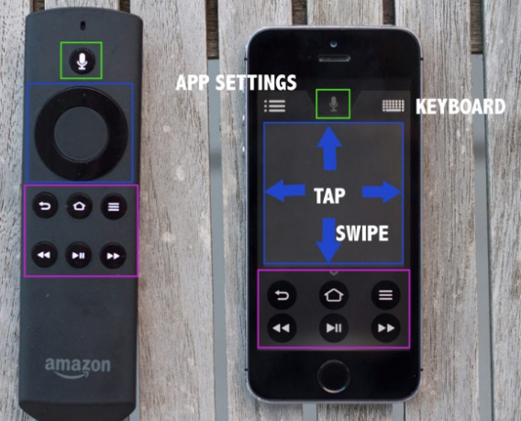

- Must be connected to WiFi to use your phone
as the remote.

- Enter 4 digit code that appears on your screen.

- Choose the appropriate Fire Stick to the TV that
you are using.

