Artistic Cremation Urns.com
How to seal and open your urn

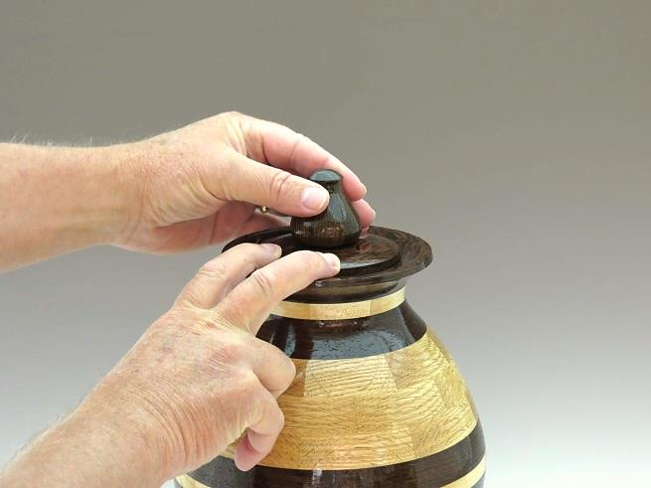

Seal:
Place the lid in the urn and secure the rim of the lid with your fingers. Carefully rotate the finial clockwise until the lid becomes snug.
Do not overtighten as this may damage the lid.

Open:
Secure the rim of the lid with your fingers and rotate the finial counter clockwise one or two complete turns. Carefully lift and remove the lid.

