How the Wild West Was Tamed
Or

Todd Turnips Terrible Tuesday

Written by John Horton

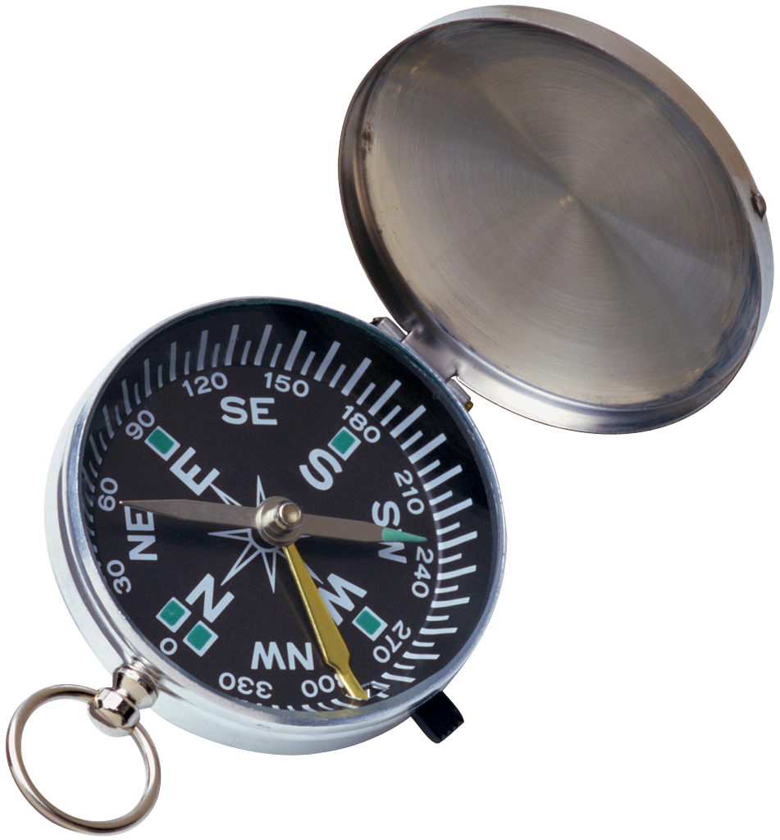

Narrator: Classroom Host Audience Helper/Host…………..
Sheriff Todd: Sheriff of Elbows Bend………………………..
Goldy: the Deputy of the town…………………………….…
Grandpa: Root Beer Saloon Owner………………………..
Big Badger: Villain……………………………………………..
Hawkeye: Part of the Big Badger Gang……………………
Doc: Doctor of Rivers Bend……………… ……………….
Rich Woman……………………………………………
Farmer…………………………………………………………

Grandpa | Hey Sheriff, you look pretty sad today. Can I get you some root beer?
Sheriff | Thank you Grandpa. You are so nice. I’m having a terrible day.
Grandpa | What seems to be the matter?
Sheriff | You see, I feel like the town isn’t listening to me anymore. Just the other day, I saw someone stealing some candy from the mercantile store. But when I got closer I tripped
Grandpa | What did you do sheriff?
Sheriff | Well, I said “Listen hear you low down candy thief! Give that candy back!
Grandpa | What happened next?
Sheriff | She laughed at me and walked away! (starts to cry)
 | (Goldy Walks in)
Grandpa | That’s too bad. Hey Goldy, what can I do you for?
Goldy | Nothing today Grandpa, I’m here looking for the sheriff
Grandpa | He’s over there in the corner, can you try and cheer him up?
Goldy | I’ll try.
Goldy | Hey partner?
Sheriff | Hey Goldy, can I get a hug?
Goldy | Boss, we aint got time for that. Big Badger and his gang are coming to town!
Sheriff | NO! Not again, they took everything from town last time they were here.
Goldy | They took my books, my horse, even my toothbrush
Sherriff | Toothbrush!
Goldy | Toothbrush!
Sheriff | I’m sorry Goldy, I just feel like my serve and protect days are over.
Goldy | But Sherriff, I need you! The town of Rivers Bend needs you!
Sheriff | Sorry Goldy, I just can’t do it.
Narrator | (SCENE FREEZE) The town was desperate for a hero. Could Goldy get the Sheriff to help?
Goldy | Grandma, I’ll be back. Don’t let him go nowhere.
 | (In walks Big Badger and his gang)
BB | We’ll look over there gang. Looks like the little Sheriff is crying himself to sleep!
Hawkeye | (brushing his teeth) Yah, I see it boss
Farmer | Why don’t you go and leave him alone!
BB | Sit down ya cow lovin farmer!
Farmer | Yes ssssss sir
BB | Hey Sheriff, why the long face
Sheriff | You see, Badger is coming to to----Ahh, you’re here!
Hawkeye | HI YA SHERIFF!
Grandpa | Now boys, I don’t want any trouble in here!
Sheriff | You’ll get no trouble from me! (runs off stage)
Farmer | Don’t look at me, I’m outta here!
Narrator | Looks like trouble in Elbow’s Bend. Who is going to save the town from these bad guys?

SCENE TWO
 | (Sheriff comes running into the Saloon)
Grandma | Hi Sherrif, what can I get ya?
Sheriff | Grandma, what are you doing here.
Grandpa | I own a couple of Root beer franchises around these parts. I’m as popular as Buffalo Wild Wings
Sheriff | I just need a root beer
Doc | Hey Sheriff, did ya hear?
Rich Woman | Yes Sheriff Have you heard the news?
Dog | Bark …. Bark…Trouble
Rich woman | Yes, ms. Jibbers. That’s right! We have had so much trouble with the Badger gang…. Yes we have… oh yes we have.
Sheriff | You mean the news about the Badger Gang
Doc | Yeah, they are back in town. Do you remember what they did to the town last time?
Rich Woman | Yes, they took all my jewels and ate off my dinner plates…. DURING LUNCH TIME.
Doc | That just aint right
Rich Woman | I know.
Goldy | (running in) Hey Sheriff, I found you.
Sheriff | Not now Goldy, I got a big problem on my hands
Goldy | The Badger Gang is going all through the town, they are takin everything!
Doc | Are you sure, like what?
Goldy | They took my bed. They took Farmer Daves Chickens, and I even heard that they took my pet Gopher
Sheriff | Goldy not your Gopher!
Goldy | Fraid so sherrif.
Doc | That does it, we got to do something!
Farmer | How about we move the whole town so they cant find us?
Goldy | That will take weeks
Doc | Besides, I hate moving!
Rich Woman | My house is too expensive to move.
Sheriff | Town, I can’t beat these guys alone.
Goldy | We are here to help! Lets all work together
Sheriff | That’s it, I got an idea. Huddle up.

Scene Three
Goldy | Ok, I saw them heading this way.
Doc | Alright.
Sheriff | Thanks for all your help everyone
Grandpa | Don’t thank us yet Sheriff
Rich Woman | Ok, I got the sign up.
Sheriff | Time to hide, here they come!
 | (Enter the BB Gang)
BB | Gang, this is going to be the easiest bank robbery yet
Hawkeye | Badger, you’re right, we
Buckey | Are you sure we want to do this, I mean…. It seems kinda mean.
BB | BUCKEY. What did I tell you. We is thieves, we need to steal.
Buckey | Oh, yeah…. Right.
Badger | There it is! The Bank
Hawkeye | Do they have toothbrushes?
Badger | No you silly snake….. they got something better….
Buckey | Yeah, they have ice cream
Badger | No you two! Stop it. We are going to rob the bank and finally go back to Wisconsin.
Hawkeye and Badger | Oh….. yeah.
Badger | Ok, gang… lets go in!
 | (The towns people come out, Goofy takes down the sign)
Everyone | Yeah!
Grandma | Sheriff, you are a real hero. Thanks for catching those varmits!
Sheriff | I couldn’t have done it without all of you.

How the Wild West Was Tamed

Or

Todd Turnips Terrible Tuesday

Written by John Horton

Narrator: Classroom Host Audience Helper/Host…………..
Sheriff Todd: Sheriff of Elbows Bend……………………….
Goldy: the Deputy of the town…………………………….…
Grandma: Root Beer Saloon Owner………………………..
Big Badger: Villain……………………………………………..
Hawkeye: Part of the Big Badger Gang……………………
Buckey: Part of the Big Badger Gang………………………...
Doc: Doctor of Rivers Bend………………………………..……
Dusty: Goofy ………………………………………………….…

Grandma | Hey Sheriff, you look pretty sad today. Can I get you some root beer?
Sheriff | Thank you Smiley. You are so nice. I’m having a terrible day.
Grandma | What seems to be the matter?
Sheriff | You see, I feel like the town isn’t listening to me anymore. Just the other day, I saw someone stealing some candy from the mercantile store. But when I got closer I tripped
Grandma | What did you do sheriff?
Sheriff | Well, I said “Listen hear you low down candy thief! Give that candy back!
Grandma | What happened next?
Sheriff | She laughed at me and walked away! (starts to cry)
 | (Goldy Walks in)
Grandma | That’s too bad. Hey Goldy, what can I do you for?
Goldy | Nothing today Grandma, I’m here looking for the sheriff
Grandma | He’s over there in the corner, can you try and cheer him up?
Goldy | I’ll try.
Goldy | Hey partner?
Sheriff | Hey Goldy, can I get a hug?
Goldy | Boss, we aint got time for that. Big Badger and his gang are coming to town!
Sheriff | NO! Not again, they took everything from town last time they were here.
Goldy | They took my books, my horse, even my toothbrush
Sherriff | Toothbrush!
Goldy | Toothbrush!
Sheriff | I’m sorry Goldy, I just feel like my serve and protect days are over.
Goldy | But Sherriff, I need you! The town of Rivers Bend needs you!
Sheriff | Sorry Goldy, I just can’t do it.
Narrator | (SCENE FREEZE) The town was desperate for a hero. Could Goldy get the Sheriff to help?
Goldy | Grandma, I’ll be back. Don’t let him go nowhere.
 | (In walks Big Badger and his gang)
BB | We’ll look over there gang. Looks like the little Sheriff is crying himself to sleep!
Hawkeye | (brushing his teeth) Yah, I see it boss
Buckey | He sure looks sad, maybe we could cheer him up.
BB | No you goof, we need to be mean to him, were the bad guys
Buckey | Oh yeah, I forgot.
BB | Hey Sheriff, why the long face
Sheriff | You see, Badger is coming to to----Ahh, you’re here!
Buckey, BB, Hawkeye | HI YA SHERIFF!
Grandma | Now boys, I don’t want any trouble in here!
Sheriff | You’ll get no trouble from me! (runs off stage)
Narrator | Looks like trouble in Elbow’s Bend. Who is going to save the town from these bad guys?

SCENE TWO
 | (Sheriff comes running into the Saloon)
Grandma | Hi Sherrif, what can I get ya?
Sheriff | Grandma, what are you doing here.
Grandma | I own a couple of Root beer franchises around these parts. I’m as popular as Buffalo Wild Wings
Sheriff | I just need a rootbeer
Doc | Hey Sheriff, did ya hear?
Dusty | Yea Sheriff can you hear?
Doc | No Dusty, DID You hear….
Dusty | Oh.
Sheriff | You mean the news about the Badger Gang
Doc | Yeah, they are back in town. Do you remember what they did to the town last time?
Dusty | Yeah, they took my hair comb
Doc, | No Dusty, that is called a toothbrush.
Dusty | Oh, yeah.
Goldy | (running in) Hey Sheriff, I found you.
Sheriff | Not now Goldy, I got a big problem on my hands
Goldy | The Badger Gang is going all through the town, they are takin everything!
Doc | Are you sure, like what?
Goldy | They took my bed. They took Farmer Daves Chickens, and I even heard that they took my pet Gopher
Sheriff | Goldy not your Gopher!
Goldy | Fraid so sherrif.
Doc | That does it, we got to do something!

Scene Three
Goldy | Ok, I saw them heading this way.
Doc | Alright.
Sheriff | Thanks for all your help everyone
Grandma | Don’t thank us yet Sheriff
Dusty | Ok, I got the sign up.
Sheriff | Time to hide, here they come!
 | (Enter the BB Gang)
BB | Gang, this is going to be the easiest bank robbery yet
Hawkeye | Badger, you’re right, we
Buckey | Are you sure we want to do this, I mean…. It seems kinda mean.
BB | BUCKEY. What did I tell you. We is thieves, we need to steal.
Buckey | Oh, yeah…. Right.
Badger | There it is! The Bank
Hawkeye | Do they have toothbrushes?
Badger | No you silly snake….. they got something better….
Buckey | Yeah, they have ice cream
Badger | No you two! Stop it. We are going to rob the bank and finally go back to Wisconsin.
Hawkeye and Badger | Oh….. yeah.
Badger | Ok, gang… lets go in!
 | (The towns people come out, Goofy takes down the sign)
Everyone | Yeah!
Grandma | Sheriff, you are a real hero. Thanks for catching those varmits!
Sheriff | I couldn’t have done it without all of you.
Dusty | Hey Look, a toothbrush!
Everyone | Dusty No!!!!

How the Wild West Was Tamed

Or

Todd Turnips Terrible Tuesday

Written by John Horton

Narrator: Classroom Host Audience Helper/Host…………..
Sheriff Todd: Sheriff of Elbows Bend………………………..
Goldy: the Deputy of the town…………………………….…
Grandpa: Root Beer Saloon Owner………………………..
Big Badger: Villain……………………………………………..
Hawkeye: Part of the Big Badger Gang……………………
Buckey: Part of the Big Badger Gang………………………...
Doc: Doctor of Rivers Bend………………………………..……
Dusty: Goofy ………………………………………………….…
Farmer………………………………………………………..

Grandpa | Hey Sheriff, you look pretty sad today. Can I get you some root beer?
Sheriff | Thank you Grandpa You are so nice. I’m having a terrible day.
Grandpa | What seems to be the matter?
Sheriff | You see, I feel like the town isn’t listening to me anymore. Just the other day, I saw someone stealing some candy from the mercantile store. But when I got closer I tripped
Grandpa | What did you do sheriff?
Sheriff | Well, I said “Listen hear you low down candy thief! Give that candy back!
Grandpa | What happened next?
Sheriff | She laughed at me and walked away! (starts to cry)
 | (Goldy Walks in)
Grandpa | That’s too bad. Hey Goldy, what can I do you for?
Goldy | Nothing today Grandpa, I’m here looking for the sheriff
Grandpa | He’s over there in the corner, can you try and cheer him up?
Goldy | I’ll try.
Goldy | Hey partner?
Sheriff | Hey Goldy, can I get a hug?
Goldy | Boss, we aint got time for that. Big Badger and his gang are coming to town!
Sheriff | NO! Not again, they took everything from town last time they were here.
Goldy | They took my books, my horse, even my toothbrush
Sherriff | Toothbrush!
Goldy | Toothbrush!
Sheriff | I’m sorry Goldy, I just feel like my serve and protect days are over.
Goldy | But Sherriff, I need you! The town of Rivers Bend needs you!
Sheriff | Sorry Goldy, I just can’t do it.
Narrator | (SCENE FREEZE) The town was desperate for a hero. Could Goldy get the Sheriff to help?
Goldy | Grandma, I’ll be back. Don’t let him go nowhere.
 | (In walks Big Badger and his gang)
BB | We’ll look over there gang. Looks like the little Sheriff is crying himself to sleep!
Farmer | Oh No its Big Badger and his gang!
Hawkeye | (brushing his teeth) Yah, I see it boss
Buckey | He sure looks sad, maybe we could cheer him up.
BB | No you goof, we need to be mean to him, were the bad guys
Buckey | Oh yeah, I forgot.
BB | Hey Sheriff, why the long face
Sheriff | You see, Badger is coming to to----Ahh, you’re here!
Buckey, BB, Hawkeye | HI YA SHERIFF!
Grandpa | Now boys, I don’t want any trouble in here!
Sheriff | You’ll get no trouble from me! (runs off stage)
Farmer | You’ll get no trouble from me neither! (runs off)
Narrator | Looks like trouble in Elbow’s Bend. Who is going to save the town from these bad guys?

SCENE TWO
 | (Sheriff comes running into the Saloon)
Grandpa | Hi Sherrif, what can I get ya?
Sheriff | Grandma, what are you doing here.
Grandpa | I own a couple of Root beer franchises around these parts. I’m as popular as Buffalo Wild Wings
Sheriff | I just need a rootbeer
Doc | Hey Sheriff, did ya hear?
Dusty | Yea Sheriff can you hear?
Doc | No Dusty, DID You hear….
Dusty | Oh.
Sheriff | You mean the news about the Badger Gang
Doc | Yeah, they are back in town. Do you remember what they did to the town last time?
Dusty | Yeah, they took my hair comb
Doc, | No Dusty, that is called a toothbrush.
Dusty | Oh, yeah.
Goldy | (running in) Hey Sheriff, I found you.
Sheriff | Not now Goldy, I got a big problem on my hands
Goldy | The Badger Gang is going all through the town, they are takin everything!
Doc | Are you sure, like what?
Goldy | They took my bed. They took Farmer Daves Chickens,
Farmer | Those were my favorite chickens
Sheriff | Thems to bad.
Goldy | They even took my pet Gopher
Sheriff | Goldy not your Gopher!
Goldy | Fraid so sherrif.
Doc | That does it, we got to do something!

Scene Three
Goldy | Ok, I saw them heading this way.
Doc | Alright.
Sheriff | Thanks for all your help everyone
Grandpa | Don’t thank us yet Sheriff
Dusty | Ok, I got the sign up.
Sheriff | Time to hide, here they come!
 | (Enter the BB Gang)
BB | Gang, this is going to be the easiest bank robbery yet
Hawkeye | Badger, you’re right, we
Buckey | Are you sure we want to do this, I mean…. It seems kinda mean.
BB | BUCKEY. What did I tell you. We is thieves, we need to steal.
Buckey | Oh, yeah…. Right.
Badger | There it is! The Bank
Hawkeye | Do they have toothbrushes?
Badger | No you silly snake….. they got something better….
Buckey | Yeah, they have ice cream
Badger | No you two! Stop it. We are going to rob the bank and finally go back to Wisconsin.
Hawkeye and Badger | Oh….. yeah.
Badger | Ok, gang… lets go in!
 | (The towns people come out, Goofy takes down the sign)
Everyone | Yeah!
Grandpa | Sheriff, you are a real hero. Thanks for catching those varmits!
Sheriff | I couldn’t have done it without all of you.
Dusty | Hey Look, a toothbrush!
Everyone | Dusty No!!!!

