c
Fall 2022
Conference

Name: ____________________________________

Class: _____________________________________

 | My favorite things in class are:  ________________________________________________________________________________________________________________________________________________________
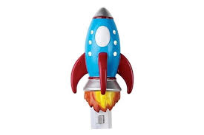 | I really like to work on:  ____________________________________________________________________________________________________________________________________________________________________________________________
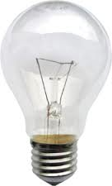 | Something I think I’m really good at is:  ____________________________________________________________________________________________________________________________________________________________________________________________
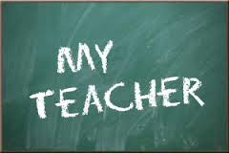 | My teacher is:  ____________________________________________________________________________________________________________________________________________________________________________________________
 | My friends in class are:  ________________________________________________________________________________________________________________________________________________________
 | Something I want to learn would be:  ________________________________________________________________________________________________________________________________________________________
 | When I grow Up I hope to be:  ________________________________________________________________________________________________________________________________________________________
Create some math problems you know how to do!

How do you feel you are doing in school?
Place an X
 |  |  | 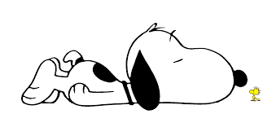
 | I’m doing great | I’m doing well. | I can do better.
Prepared and organized for class.
Participating in class.
Working quietly in class
Completing assignments in class.
Completing homework.
Reading each night at home.
Helping others.
Being a good role model.

