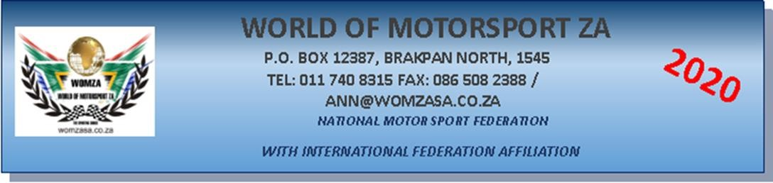

OPERATIONAL PLAN AND ENTRY FORM
I, the reader of this document, being a sane person of full contractual ability hereby declare that I agree to abide to all rules and regulations, both written and verbal, as laid down by WOMZA and according to the Government National Lockdown regulations and for all its venues.
I agree that I will not have any recourse or claim against its landlord and/or its heirs, the controlling body, management of the venue/track/club/committee, their staff, temporary and/or permanent, marshals/officials, or fellow competitors or their family for personal injuries to me or any of my family, crew, or hospitalization, and medical expenses of any nature as well as death to any of the above parties or related expenses should such a fatality occur during practice, or on the premises of RICHARDS BAY MOTORSPORT PROMOTIONS, ZCBF COMMUNITY PARK, NORTH CENTRAL ARTERIAL, ALTON, RICHARDS BAY at any time,
I further agree to indemnify RICHARDS BAY MOTORSPORT PROMOTIONS its marshals/officials and Management of any damages to my race vehicle, my tow vehicle or related equipment, i.e. trailer / tools etc.
I agree that the below application, KNOWN AS THE OPERATIONAL PLAN AND PRACTICE/EVENT INDEMNITY is subject to all the above being accepted by myself and adhered to all times and makes it binding upon myself, signing on and completing the COVID-19 scan document and agree to the additional regulations as set out.
Please note that the following regulations during the Covid-19 pandemic must be adhered to by each competitor, pit mechanic, family, staff and officials, before entrance to the track can/will be granted:
- Time schedules will determine times of practice and which group.
- Clubs to release the schedule of practice times and groups.
- person/s over the age of 60 years old may enter the venue.
- Each and every person entering the property, has to undergo his/her screening test, irrespective of how many times you may have entered the venue during any one day and/or within 7 days.
- Every Competitor, Mechanic, family member or friend need to have their own compulsory facemask.
  - Competitors wishing to keep their balaclavas on and not wear a mask, this will be accepted.
  - Removing of the balaclava, a mask must immediately be replaced.
  - Competitors shall place their sanitizing containers visibly in their tow-vehicles.
  - Regular use of sanitizing is mandatory.
- Only the competitor and the 3 Mechanic will be allowed inside the pit area. This means only 4 people per race vehicle will be allowed.
- It shall be mandatory for each race vehicle to park at least 1.5 metres away from your fellow competitor.
- Everybody entitled to be in the pit area shall main a safe distance between each other at all times.
- No extra private cars will be allowed in the pits. (Not even to drop of spares or tools)
- Hands will be sanitized before entering the pit area.
- Temperatures will be taken and recorded for controlling purposes. (Please note that if you have a high temperature, you will not be allowed to enter the venue.)
- A Covid-19 Declaration and sign on register form will be completed with every practice session.
- See Entry form regulation on Circular 1, dated 05 August 2020.
- The Race Entry fee will be R500.00 per Competitor and allows Driver plus 3 people
- Any extra tickets for Pit crew, will cost R100.00

COVID-19

COMPETITOR-
Surname:
ID Number:
Contact / Cell Number:
YES NO
Have you been in contact with any person?
Diagnosed or waiting for results that has been infected with COVID-19 in 14 days
IF YES Name and Surname
What is your relation to person?
Do you reside at same address?
What Dates were you last in Contact with this person?
Is the person still infected with COVID-19
Have you experienced one or more of the following:
- Fever
- Coughing
- Breathing Difficulty
- Dizziness
Temperature taken Date: Time:
PPE OFFICER ON DUTY

PIT CREW 1-
Surname:
ID Number:
Contact / Cell Number:
YES NO
Have you been in contact with any person
Diagnosed or waiting for results that has been infected with COVID-19 in 14 days
IF YES Name and Surname
What is your relation to person?
Do you reside at same address?
What Dates were you last in Contact with this person?
Is the person still infected with COVID-19
Have you experienced one or more of the following:
- Fever
- Coughing
- Breathing Difficulty
- Dizziness
Temperature taken Date: Time:
PPE OFFICER ON DUTY

PIT CREW 2-
Surname:
ID Number:
Contact / Cell Number:
YES NO
Have you been in contact with any person
Diagnosed or waiting for results that has been infected with COVID-19 in 14 days
IF YES Name and Surname
What is your relation to person?
Do you reside at same address?
What Dates were you last in Contact with this person?
Is the person still infected with COVID-19
Have you experienced one or more of the following:
- Fever
- Coughing
- Breathing Difficulty
- Dizziness
Temperature taken Date: Time:
PPE OFFICER ON DUTY

PIT CREW 3-
Surname:
ID Number:
Contact / Cell Number:
Have you been in contact with any person
Diagnosed or waiting for results that has been infected with COVID-19 in 14 days
IF YES Name and Surname
What is your relation to person?
Do you reside at same address?
What Dates were you last in Contact with this person?
Is the person still infected with COVID-19
Have you experienced one or more of the following:
- Fever
- Coughing
- Breathing Difficulty
- Dizziness
Temperature taken Date: Time:
PPE OFFICER ON DUTY

The above-named competitor declares that he / she will adhere to all the COVID-19 rules the company has implemented.

ANY PERSON WHO HAS ENTERED THE PROPERTY AND BREACHES REGULATIONS SHALL BE ASKED TO LEAVE THE PROPERTY AND MAY NOT RETURN UNTIL AFTER THE NATIONAL LOCKDOWN – WE HAVE A GOLDEN OPPORTUNITY AND US AS MANAGEMENT WILL UPHOLD ALL THE RULES AND REGULATIONS AS SET OUT BY WOMZA AND OUR GOVERNMENT– RESPECT US!!
SIGNATURE OF COMPETITOR DATE:
SIGNATURE OF PIT CREW1- DATE:
SIGNATURE OF PIT CREW2- DATE:
SIGNATURE OF PIT CREW3- DATE:

