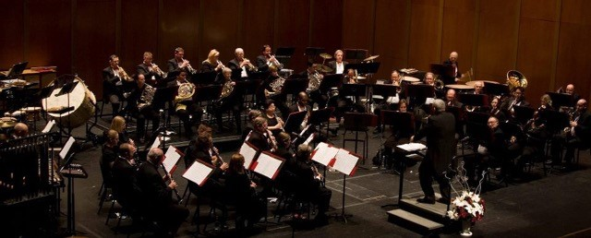

Adopt-an-Intern Program
Summer 2019
As part of our mission, Tidewater Winds provides hands-on experience to high school and college student musicians. This is only possible with your support!
Please consider “adopting” an intern to help pave the way for these students to practice and improve their craft as a part of the Tidewater Winds ensemble during the summer concert series. The rare opportunity to play in front of a live audience with seasoned musicians, helps young performers gain confidence in their performance capabilities. As a result of this experience, interns have the opportunity to morph from student to a more well-rounded musician by the season’s end.
In order to make this program possible, we need patrons to “adopt” our student musicians. A $250 contribution will allow Tidewater Winds to support a developing artist during their season with the ensemble and cover the costs associated with performances.
Donors will receive a short bio and photograph of your “adopted” musician. When attending our summer concerts, you will be able to recognize your chosen individual and see your generosity at work. You will also receive a personal note from your intern, as well as a formal thank you from the Tidewater Winds to use as a tax deduction.
If you are able to adopt-an-intern and have questions, please contact us today!
We would love to speak with you.
Thank you for helping us continue a key piece of our mission, the ongoing education of young musicians, and for supporting the musical dreams and aspirations of our upcoming artists.

Sincerely,
Michael Williams, Executive Director
ExecutiveTWW@gmail.com
757-480-0953

www.tidewaterwinds.org

