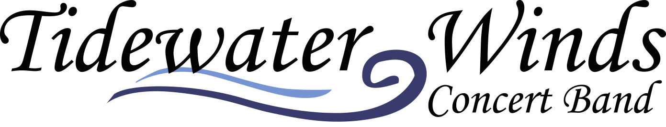
Education Programs
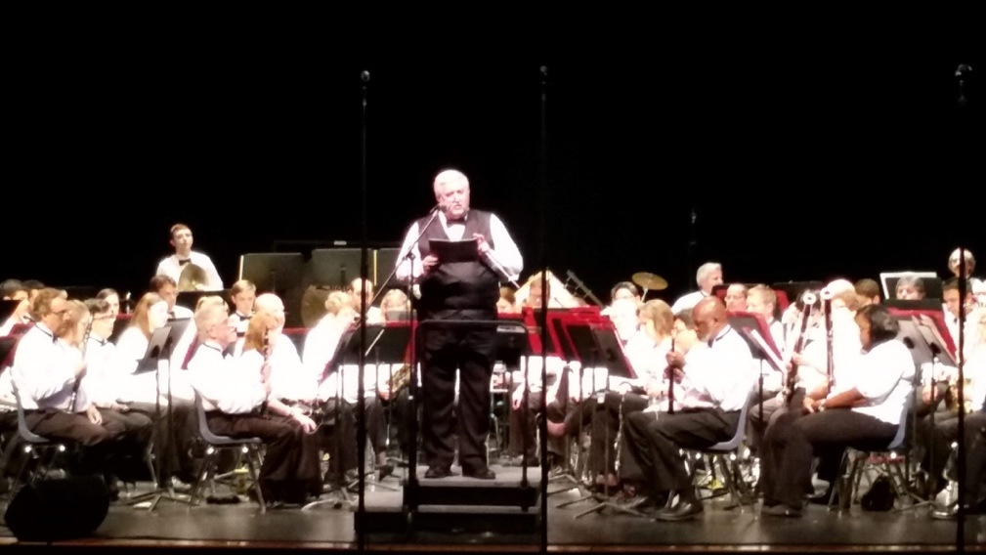

Tidewater Winds Education Program offers three elements of engagement… In-school performance, Master Classes and our Summer Student-Internship. Call for pricing.
757-480-0953 / www.tidewaterwinds.org

Pre-District Prep

All band students undergo the annual District auditions and evaluations. Tidewater Winds Band Camp prepares students in a one-day intensive to prepare each section before the big event. Our musicians break into instrumental groups to guide and enhance student’s skills before the District reviews and auditions take place. Chesapeake and Portsmouth on day 1, VA Beach and Norfolk on day 2 in late October.
Master Classes

Enhance your middle or high school band program with the section leaders of Tidewater Winds. After the members perform an opening greeting, they will then demonstrate technique and performance concepts. Your ensembles and soloists will gain valuable musical knowledge with an inspirational tone to help encourage students to excel in their instrument and to push themselves further. Ensembles receive suggestions, friendly critique and support.
School Performances

Schedule a Tidewater Winds Education Concert for your school. Available for Elementary School, Middle School or High School. Topics can be customized into our program, but all Winds Education programs begin with an opening selection, an introduction of Sousa and Concert Bands, and an exploration of instrumentation. This fun, fast-paced program keeps your students on the edge of their seat while supporting the music curriculum.
(12-piece ensemble, 45 minutes)
Summer Internships

Each summer, Maestro Brewington auditions and selects up to twenty high school and college interns to serve as part of the main Concert Band’s Full Summer Concert Season. Students being accepted are held to high standards and receive Master Classes, Private Lessons, Mentoring and Professional Concert Experiences.

757-480-0953
www.tidewaterwinds.org

