Bassoon Audition Music
Tidewater Winds
Three Excerpts:
Stravinsky: Rite of Spring
Dukas: Sorcerer’s Apprentice
Ravel: Bolero

Stravinsky: Rite of Spring
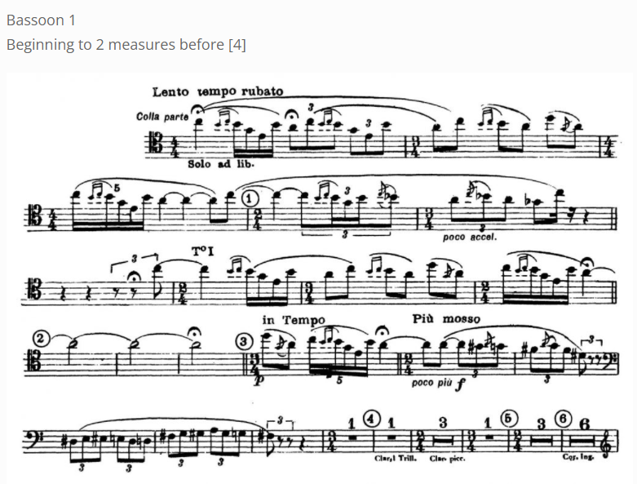

Dukas: Sorcerer’s Apprentice
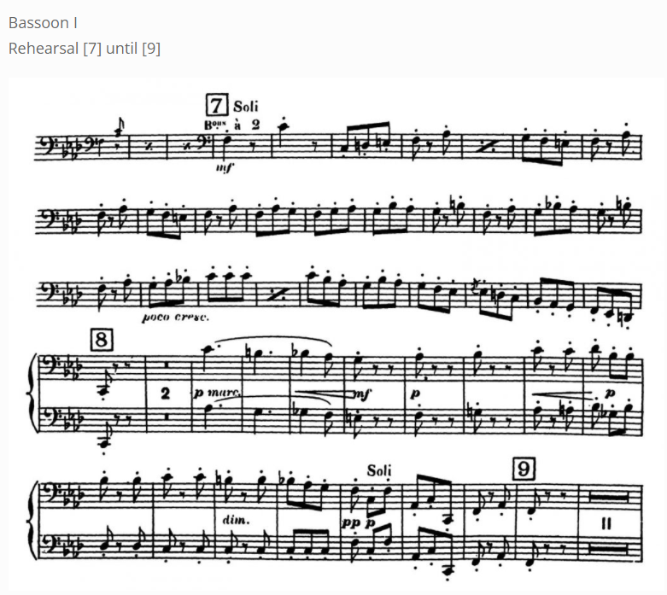

Ravel: Bolero
