For Release
2/27/23

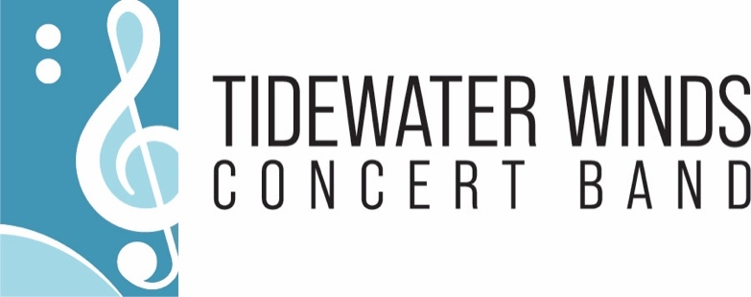

Tidewater Winds Announces the Student Matinee Performance of “The Perilous Predicaments of Pinocchio.”
A Tidewater Winds “Reading in Music Education” (R.i.M.E.) Project
Virginia Beach— 2/27/23 — Tidewater Winds announces the immediate release of ticket sales for “The Perilous Predicaments of Pinocchio”, a student matinee concert performing on April 5th at Sandler Center for the Arts, 12:15 PM Concert. , Private Schools and Public-School Groups are encouraged to attend. Tickets can only be purchased through www.tidewaterwinds.org for the sale price of $10. While the concert targets K through 3rd grade students it is appropriate for grades PreK through 5. This storyline of Pinocchio is not as dark and scary as the original, likewise, it is not the Disney version either. Instead, it explores the conflict of choice and decision making that lead to consequences, encouraging young minds to develop critical thinking skills.
“This student matinee of Pinocchio is absolutely the best model for students to enhance reading comprehension, music appreciation, and to understand outcomes and cause and effect”, said Chad McGill, Operations Manager for Tidewater Winds.

Positive Impact:
Tidewater Winds audiences have enjoyed years of concerts, but this is a new series for students, launched as a joint effort between educators and parents to re-introduce children to community activities in the arts, for socialization needs that were not available during the pandemic. We also focus on the joy of reading. This new annual series is called R.i.M.E. (Reading in Music Education) and it will musically bring stories to life for students. The 55-piece professional Concert Band will be joined onstage by our theatrical guest artists Rainbow Puppets and narrator, Kathryn Barrett. The addition of the puppets allows students to not only hear the musical journey, but to follow characters interactions. Along with the guided narration by Mrs. Barrett, students will be led through the story in a way that offers reflection, anticipation, and hope. “I am so impressed with this production! In this post-pandemic world, it is a way to ensure children can return to imagination, comprehension, and socialization through the arts”, says Kathryn Barret, former 13 News anchor and reporter.

Ticket Availability:
Tickets can only be purchased through www.tidewaterwinds.org for the sale price of $10. It is open seating, except for reserved sections for large groups and schools. Families, Homeschool Groups, Military Families, Private Schools and Public-School Groups are encouraged to attend. We are committed to providing professional and enjoyable student concerts with educational support for educators. Link is…. https://0a7032da-865c-4efb-9b16-443eca0ad86b.paylinks.godaddy.com/8c7d54c8-0651-4900-957c-23c
Founded in 1985 Tidewater Winds is the premier professional Concert Band in Hampton Roads. The full ensemble consists of 65-musicians. Their signature services include a Free Summer Concert Series touring Hampton Roads each summer, a Student Intern program, Music Education Projects, Life-Long Learning, Small Ensemble Outreaches, and Military Appreciation.
###

For more information, press only:
Michael-Kerry Williams
757-480-0953 Office
757-214-4649 Cell
executive@tidewaterwinds.org

For More Information:
www.tidewaterwinds.org

